Limits

In Mathematics, a limit is defined as a value that a function approaches the output for the given input values. Limits are important in calculus and mathematical analysis and used to define integrals, derivatives, and continuity.



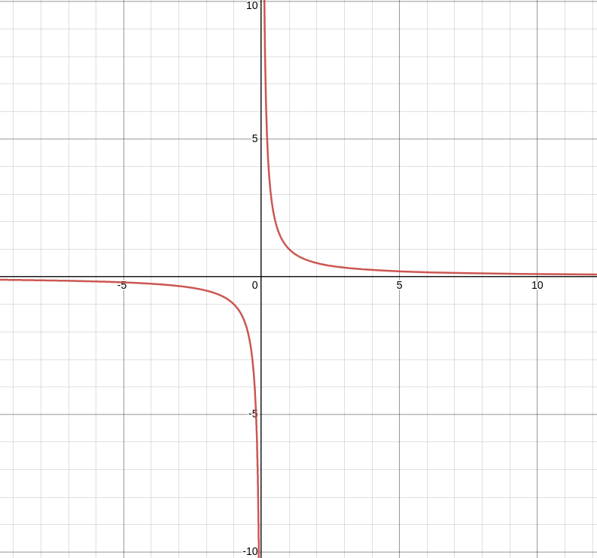

If we looking for the positive x values , just know that as x increases f(x) gets closer to 0 actually f(x) never reaches 0 it just forever keeps getting closer

therefore the fate of this function is , as x forever extends into infinity it will keep getting closer to 0 but never reach 0

the way we express a value that is forever being approached but never reached , is through a limit :

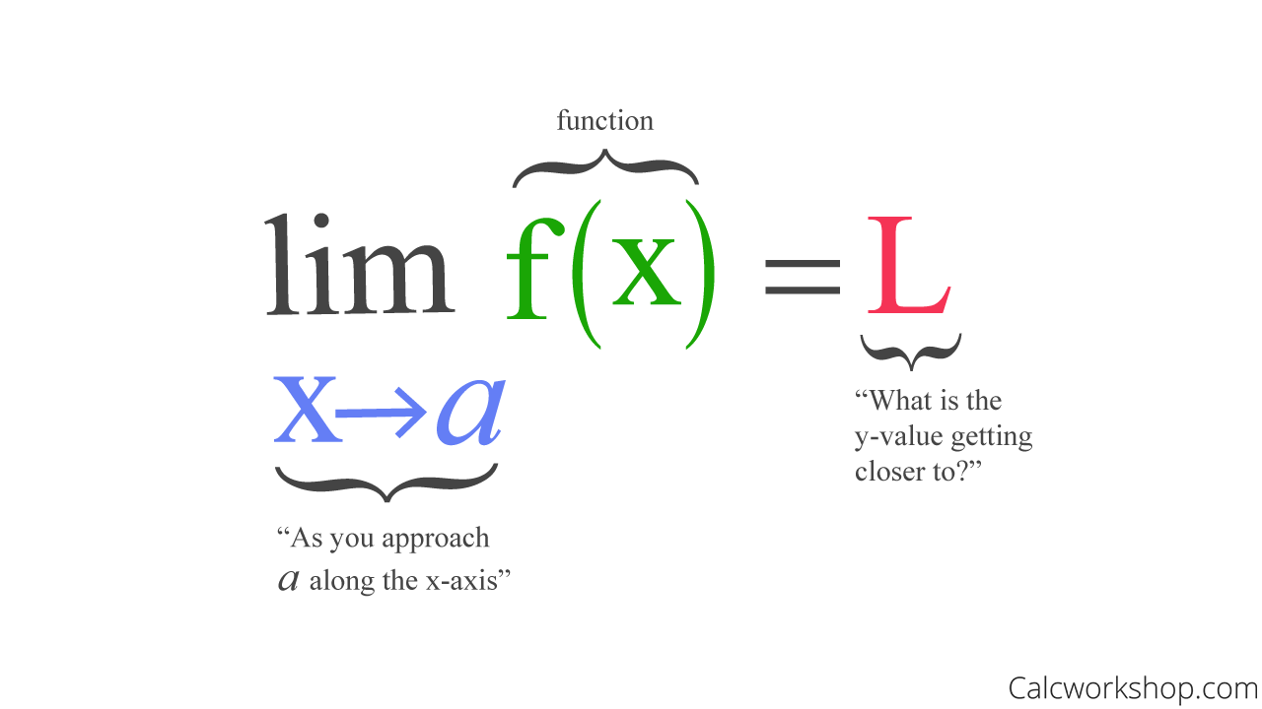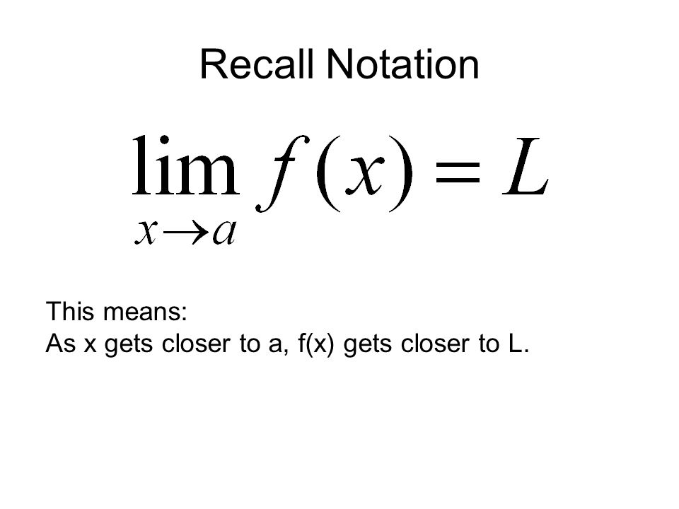

**now lets calculated in python : 1.ipynb**