Sobhan sanati

Variables

If you have been programing you most probably know what is the variable is

But in math is named placeholder for a unspecified or unknown number

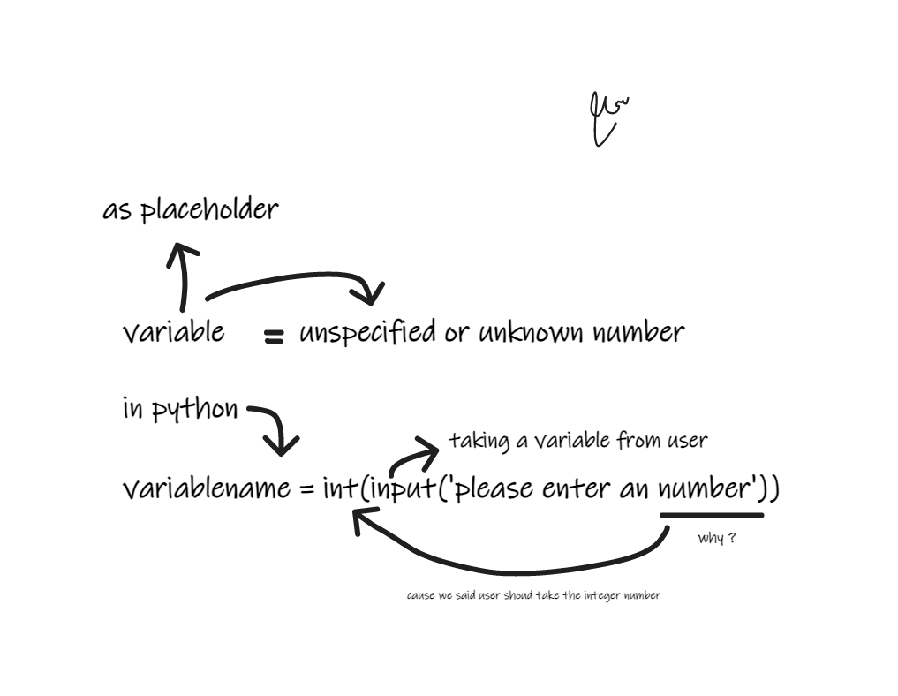You may have x variable representing any real number and you can multiply that variable without declaring

EXMP (NO.1)

We take an a variable from user as x and multiply that with 3 or we can get number from user instead of 3

X = int(input(‘please enter an number’))

Product = x \* 3 #x got multiplied by 3

Print(Product)

#result in No.1 (jupyter file)

There are some standard variables Names for certain variables types if these variable names and concepts are unfamiliar , no worries but some readers might recognize we use theta to denote the angels and beta for parameters in linear regression

Lets look for it in python code

Greek variable name in python

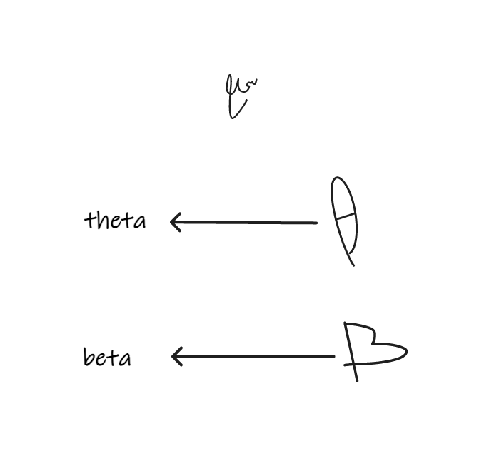File (No.2)

Also that variable names can be subscripted so that several instance of a variable name can be used for practical purposes just treat these as separate variables

For example

We have x1,x2 and so on

Just treat them as there separate variables

Example in file(No.2)

THE END