The three major security layers in an IT infrastructure are: the network, the operating system, and the application itself.

Network-level security: Security that uses firewalls. A very important part of the network-layer security, in the case of web applications, is the use of Secure Sockets Layer (SSL) to encode all sensitive information sent along the wire, but this is related more to the network protocol at the application level than to the network physical level at which firewalls operate.

Application security: This layer refers to all the constraints we establish in our applications to make sure that only the right people can do only the right things when working through the application. Application-level security, is the domain of Spring Security. Application-level security is achieved by implementing following techniques.
- Authentication: The process of authentication is to validate a particular user, using the username and password, provided him. The application takes the username/password and tries to match it against information it has stored—normally, in a database or LDAP 1 (Lightweight Directory Access Protocol) server. If match successful then user is authenticated.
- Authorization: The authorization process compares the user’s set of permissions against the permissions required to execute a particular action in the application, and if a match is found, access is granted. On the other hand, if no match is found, access is denied.
- ACLs: Access control lists (ACLs) are part of the authorization process. The key difference is that ACLs normally work at a finer grained level in the application. ACLs are simply a collection of mappings between resources, users, and permissions.

Encryption: This allows to encrypt sensible information (normally passwords, even cookies??) to secure them. There are three main kinds of encryption algorithms.
- One-way encryption: These algorithms, referred as hashing algorithms, take an input string and generate an output number known as the message digest. This output number cannot be converted back into the original string. This is why the technique is referred to as one-way encryption.
- Symmetric encryption: These algorithms provide two functions: encrypt and decrypt. A string of text is converted into an encrypted form and then can be converted back to the original string. In this scheme, a sender and a receiver share the same keys so that they can encrypt and decrypt messages on both ends of the communication. One problem with this scheme is how to share the key between the endpoints of the communication. A common approach is to use a parallel secure channel to send the keys.
- Public key cryptography: These techniques are based on asymmetric cryptography. In this scheme, a different key is used for encryption than for decryption. These two keys are referred as the public key, which is used to encrypt messages, and the private key, which is used to decrypt messages. The advantage of this approach over symmetric encryption is that there is no need to share the decryption key. So the normal scenario is the following:
  - The intended recipient of messages shares its public key with everyone interested in sending information to it.
  - The senders encrypt the information with the receiver’s public key, and send the message.
  - The receiver uses its private key to decrypt the message. No one else is able to decrypt the message as they don’t have the receiver’s private key.
Below are some of the most common Security Concerns: (See these below security concerns with example later??)
- Denial of service attacks: These attacks consist of making the target system unresponsive to its intended users. This is normally done by saturating the server with requests so that it utilizes all the server’s resources and makes it unresponsive to legitimate requests.
- Cross-site scripting and output sanitation: A kind of injection can be done where the target is the client part of the application. The idea is that the attacker can make an application return malicious code inside the web pages returned, and thus execute it in the user’s browser. This way, the attacker invisibly executes actions using the real user’s authenticated session.
- SQL (and other code) injection: Validating user input is a very important part of application security. If data is not validated, an attacker could potentially write any kind of string as input (including SQL or server-side code) and send that information to the server. If the server code is not properly written, the attacker could wreak significant havoc, as she could execute any arbitrary code on the server.

Below are some of the important security APIs offered in Java.
- Java Cryptography Architecture (JCA): This API offers support for cryptographic algorithms, including hash-digest and digital-signature support.
- Java Cryptographic Extensions (JCE): This API mainly provides facilities for the encryption and decryption of strings and also secret key generation for symmetric algorithms. It is used in spring-security-crypto module.
- Java Certification Path API (CertPath): This API provides comprehensive functionality for integrating the validation and verification of digital certificates into an application. It is used in Spring security's X509AuthenticationFilter.
- Java Secure Socket Extension (JSSE): This API Provides a standardized set of features to offer support for SSL and TLS protocols, both client and server, in Java.
- Java Authentication and Authorization Service (JAAS): This API provides service for authentication and authorization in Java applications. It provides a pluggable system where authentication mechanisms can be plugged in independently to applications.

Spring Security is a framework dedicated to providing a full array of security services to Java applications in a developer-friendly and flexible way. It has extensive array of configuration options that make it very flexible and powerful. Spring Security supports out-of-the-box integration with Lightweight Directory Access Protocol (LDAP), OpenID, Form authentication, Certificate X.509 authentication, database authentication, Jasypt cryptography etc. Spring security allows us to secure our application at different levels such as views, business layer.
Spring security is only for JVM based languages.
Spring Security comprises several modules:
- Core: This module contains the core functionality of the Spring Security project and other modules depends on it. It contains the core implementations of the system, including the JDBC authentication support, the Java Authentication and Authorization Service (JAAS) authentication provider, the access voting system, MD5 and SHA password encoders, and a lot more.
- Web: This module deals with the web-layer security of our application. This module contains the Servlet Filters that deal with the pre-processing and post-processing of Servlet requests, the Servlet Session management, the Secure Sockets Layer (SSL) support, the Remember Me support, the HTTP status code generation, and more web-related things.
- Config: This module contains the namespace definition, the XSDs, and the validation and parsing rules of the different elements of the framework. Spring Security XML configurations, is parsed and converted standard bean definitions, by this module.
- Taglibs: This module contains the taglib definitions and implementations for configuring security at the JSP level, allowing the view content to be conditionally rendered depending on the security constraints that we chose to define in the tags.
- ACL: This module contains all the logic needed for the access control list (ACL) security model available with Spring Security. It contains the database model, including the SQL DDLs (Data Definition Language), to establish the rules and relationships between domain entities and their security restrictions.
- Remoting: Leverages security support for remoting protocols. This module takes care of propagating the security context to these remote services.
- LDAP: Contains all the functionality required to connect to and authenticate against an LDAP service, including the AuthenticationProvider and UserDetails LDAP implementations. It also includes an embeddable ApacheDS server implementation for testing and development purposes.
- CAS: This is the Spring Security support for the JA-SIG Central Authentication Service (CAS) single sign-on service.
- Openid: It contains OpenID support, including the OpenID-specific AuthenticationProvider, and it leverages the openid4java library.
- Aspects: Contains an AspectJ Aspect that cuts into the execution of methods with various security annotations (@Secured, @PreAuthorize). It delegates to a configured Security Interceptor.
- Crypto: Provides various encryption, ciphering, and codec implementations, as well as some password-encoder strategies, to use in your application.
To activate Spring Security in a Java web application, we need to configure the Servlet filter (DelegatingFilterProxy) that will take care of pre-processing and post-processing the requests, as well as managing the required security constraints. Spring security generates a default login page if we try to access the URL for first time, where we can provide the username and password. We can also specify a different login screen, which spring will use instead of default.

Below are the Recipes based on a Spring MVC application, on which we will apply Spring security. Spring MVC is not mandatory to use the Spring security module. In any web application, we can apply the Spring Security features. Example application is a simple page that displays the list of employees.

Recipe-1: Securing URL Access:
Spring security handles security by applying servlet filters to HTTP requests.
- Step-1: Register ContextLoaderListener to load the root application context at startup. This step required even if, we are working with a non-Spring-MVC application.
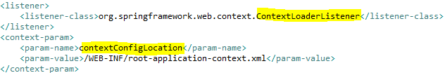

- Step-2: Register Spring MVC’s DispatcherServlet to dispatch requests. This step is specific to Spring MVC. No relation with Spring Security.
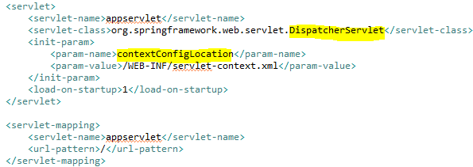

- Step-3: Register the filter, org.springframework.web.filter.DelegatingFilterProxy in web.xml. This is a servlet filter that delegates request filtering to a filter in spring’s application context.
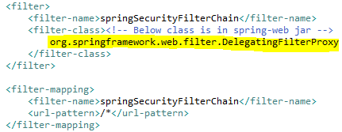
The responsibility of DelegatingFilterProxy is simply to delegate HTTP request filtering to a Spring bean that implements the javax.servlet.Filter interface. By default, it delegates to a bean whose name is the same as its <filter-name> property, but we can override the bean name in its targetBeanName init parameter. It is better to use the default name "springSecurityFilterChain".
Filter name anything other than this throws exception: org.springframework.beans.factory.NoSuchBeanDefinitionException: No bean named 'springSecurityFilterChain1' is defined. By default Spring expects the filter name to be "springSecurityFilterChain".
- Step-4: Create a separate Spring Security configuration file and mention that in contextConfigLocation context parameter.
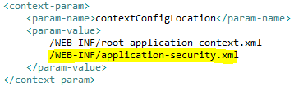
Although we can configure Spring Security in the same root-application-context configuration file, but it is better practice to have a separate Spring Security configuration file and provide the file name in contextConfigLocation context parameter for ContextLoaderListener to load it at startup.
- Step-5: Now configure Spring Security inside the application-security.xml.
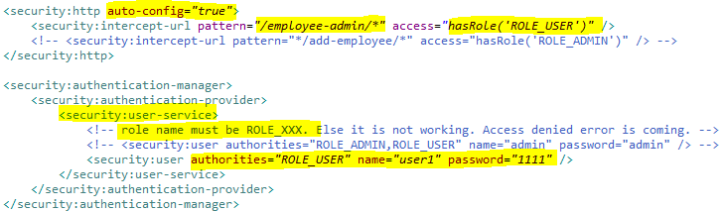

Inside the <http> configuration element, access to particular URLs are restricted with one or more <intercept-url> elements. Now need to configure authentication services in the <authentication-provider> element, which is nested inside the <authentication-manager> element. Spring Security supports several ways of authenticating users, including authenticating against a database or an LDAP repository.

Note: We can configure web application security through the <http> element. If web application’s security requirements are straightforward, we can set <http> element’s auto-config attribute to true so that Spring Security will automatically register and configure several basic security services, including the following:
  - Form-based login service: This provides a default page that contains a login form for users to log into this application.
  - Logout service: This provides a handler mapped with a URL for users to log out of this application.
  - HTTP Basic authentication: This can process the Basic authentication credentials presented in HTTP request headers. It can also be used for authenticating requests made with remoting protocols and web services.
  - Anonymous login: This assigns a principal and grants authorities to an anonymous user so that we can handle an anonymous user like a normal user.
  - Remember-me support: This can remember a user’s identity across multiple browser sessions, usually by storing a cookie in the user’s browser.
  - Servlet API integration: This allows you to access security information in our web application via standard Servlet APIs, such as HttpServletRequest.isUserInRole () and HttpServletRequest.getUserPrincipal ().

Recipe-2: Logging In to Web Applications
Spring Security enabled application requires its users to log in before they can access certain secure functions. It supports multiple ways for users to log into a web application.
By default it provides a form-based login page. Check org.springframework.security.web.authentication.ui.DefaultLoginPageGeneratingFilter, which generates the default login page.

Our application may allow for anonymous access (e.g., access to the welcome page). Spring security supports it with below configuration.
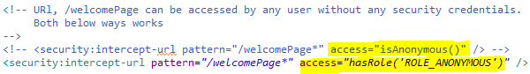
HTTP Basic Authentication:
Step-1: For basic authentication Spring Security configuration inside the application-security.xml.
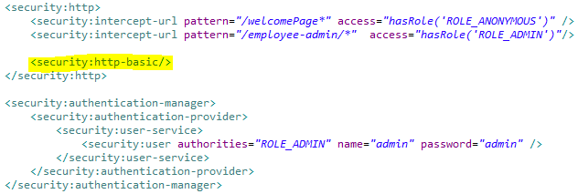
In this case, browser will typically display a login dialog or a specific login page for users to log in.

Custom web page as the login page:
Step-1: Create a LoginController and have a request mapping that will land the custom login page.

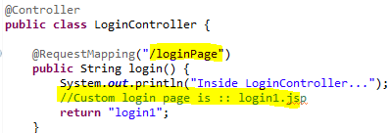

Step-2: For custom login page authentication Spring Security configuration inside the application-security.xml.
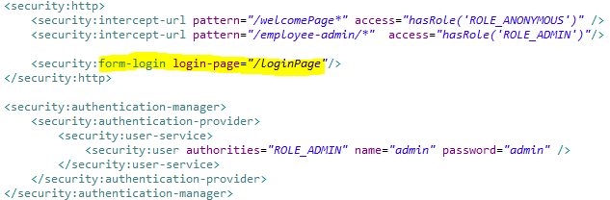
Here login-page attribute value is the request mapping given in LoginController.

Step-3: Create the custom login page login1.jsp. Highlighted things below are mandatory and expected by Spring Security.

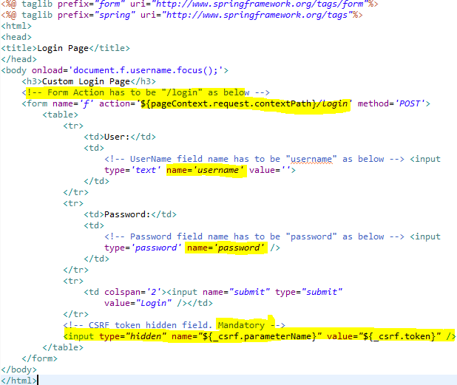
Below is the code from org.springframework.security.web.authentication.UsernamePasswordAuthenticationFilter, which mandates the above highlighted things for custom login page.

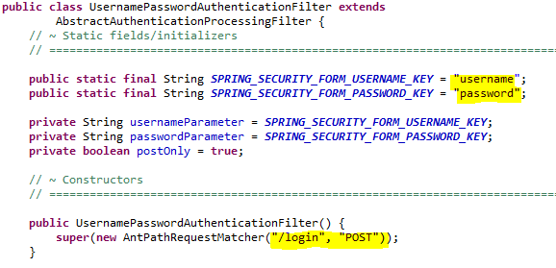
Note: When HTTP Basic authentication and form-based login are enabled at the same time, form-based login will be used.

If we requests the login page directly via its URL, by default the user will be redirected to the context path’s root after a successful login. If we have not defined a welcome page in our web deployment descriptor, we can redirect the user to a default target URL when the login succeeds.

If login fails then below is the configuration required to forward to a error page and display the error message.
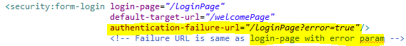

Then below is the JSTL content to add in login page to access the error message.
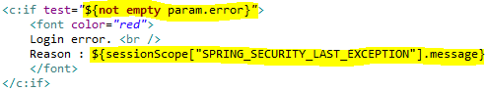

Logout Service: The logout service provides a handler to handle logout requests.
Step-1: It can be configured as below.

Below are the description of attributes used.
- Logout-url: The URL that triggers log out to occur. The default is logout URL is /logout. If CSRF protection is enabled (which is by default), then the logout request must also be a POST.
- Logout-success-url: The URL to redirect to after logout. The default is /login?logout.
- Delete-cookies: Cookies to be removed on logout success. This is a shortcut for adding a CookieClearingLogoutHandler explicitly.
- Invalidate-session: Specify whether to invalidate the HttpSession at the time of logout. This is true by default. Configures the SecurityContextLogoutHandler under the covers.

Step-2: Then in the JSP logout functionality can be added as below.
Logout Link inside the parent form:

JQuery Script to add logout functionality:
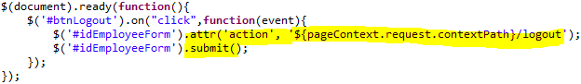

Anonymous Login: The anonymous login service can be configured via the <anonymous> element, where we can customize the username and authorities of an anonymous user, whose default values are anonymousUser and ROLE_ANONYMOUS.

Remember-Me Support: Spring Security also supports remember-me login, which is able to remember a user’s identity across multiple browser sessions so that a user needn’t log in again after logging in for the first time. It can be configured via <remember-me> element. By default, it encodes the username, password, remember-me expiration time, and a private key as a token, and stores it as a cookie in the user’s browser. The next time the user accesses the same web application, this token will be detected so that the user can log in automatically.

See sometime later?

Recipe-3: Authenticating Users:
In Spring Security, authentication is performed by one or more authentication providers. These providers authenticate users against a user repository storing user details (such as. in an application’s memory, a relational database, or an LDAP repository).

Authenticating Users with In-Memory Definitions:
If user details are mentioned in Spring Security’s configuration file (as below) then they will be loaded into your application’s memory. It is used if there are very less user and are not supposed to change frequently.
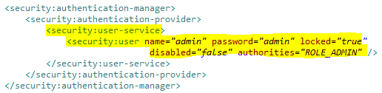
We can also externalize the user details in a properties file.

Authenticating Users against a Database:
By default, Spring Security queries user details, including authorities, with the following SQL statements, which is defined in org.springframework.security.core.userdetails.jdbc.JdbcDaoImpl:
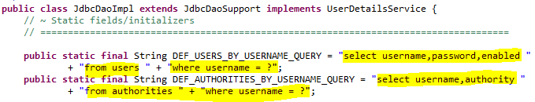
Step-1: So to use this default query, create below tables.
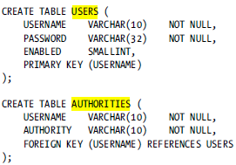

Sample data:
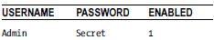

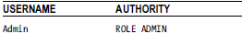
Step-2: In order for Spring Security to access these tables,declare the datasource.
Inside root-application-context.xml:
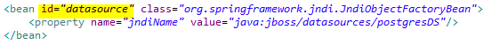
Step-3: Then configure an authentication provider that queries this database for user details.
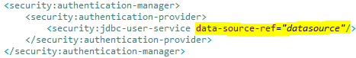

There is an extended default database table option we can use to define groups and establish authorities related to those groups instead of to individual users.
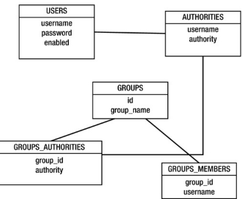
By default, below is the query used by spring, which is defined in org.springframework.security.core.userdetails.jdbc.JdbcDaoImpl.

Suppose we have our own database structure, where user details are saved, then we can provide custom SQL statements to Spring Security, to query our database for user details.
Need to provide the custom queries in the below highlighted attributes.
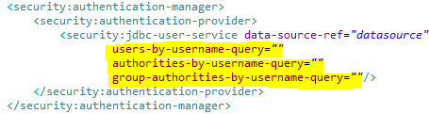

Note: Authenticating users against LDAP and OpenID can also be done in Spring Security.
Recipe-4: Password Encryption:
Spring Security offers an abstraction to encrypt passwords in the form of the interface org.springframework.security.crypto.password.PasswordEncoder in the core framework. Below is the class heirarchy for PasswordEncoder.
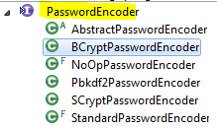
Step-1: Encode the password using the algorithm we want to use and specify the encoded password in <user password=””> or in the database (password column).

Step-2: Specify the encoder in the <security:authentication-provider>, as below.

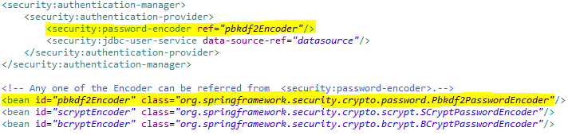

Prepare notes on each type of Encryptor algorithm??

Recipe-5: Custom AuthenticationProvider and UserDetailsService:
We can create our own authentication provider and make Spring Security use that instead of the default.

The main authentication entry point in Spring Security is the org.springframework.security.authentication.AuthenticationManager interface (in particular, the org.springframework.security.authentication.ProviderManager which implements AuthenticationManager).
ProviderManager’s main functionality is to iterate through a list of AuthenticationProvider implementations that are configured on it until one of them is able to authenticate the user (wrapped in one of the available Authentication implementation objects) or, in fact, until discovering that none of them can, at which point it throws an exception.

Default functionality: If we define <authentication-manager> and <authentication-provider> elements, as we did in earlier examples, then Spring does the below for us (by default).
- The framework instantiates two ProviderManager objects and sets one as the parent of the other. This scheme is used by the ProviderManager which is able to establish a hierarchy of authentication managers.
- The child AuthenticationManager (in form of the ProviderManager class) is queried first for authentication. If it doesn’t resolve the authentication request, it checks to see if it has a configured parent manager that it can query; if it does, it calls its authenticate method. This parent–child relationship is managed by Spring at startup time.
- In the parent–child relationship of the ProviderManager instances, both has one org.springframework.security.authentication.AuthenticationProvider List. One ProviderManager has org.springframework.security.authentication.dao.DaoAuthenticationProvider instance in the List, coming from <authentication-provider> element and other ProviderManager has org.springframework.security.authentication.AnonymousAuthenticationProvider instance in the List (which is configured when the <http> element is used and the common filters are being defined). So by default, DaoAuthenticationProvider and AnonymousAuthenticationProvider is used by Spring security.

Below are the ways to create custom authentication provider.
- Need to create an implementation of org.springframework.security.authentication.AuthenticationProvider inteface.
- We can also extend the org.springframework.security.authentication.dao.AbstractUserDetailsAuthenticationProvider abstract class,if the implementation we want to create depends on the UserDetails abstraction for authentication. (the way that DaoAuthenticationProvider works).
Most of the time, we might not need to implement a whole AuthenticationProvider, but instead we just might need to change the place from where the UserDetails is obtained. For this we need to create an UserDetails service and plug it into the AuthenticationProvider. UserDetailsService is used to retrieve UserDetails.
Step-1: Create custom UserDetailsService implementing UserDetailsService

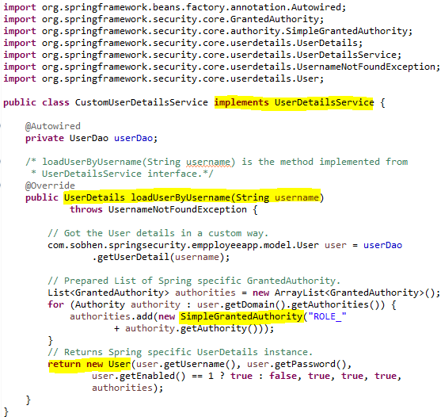
Step-2: Define the CustomUserDetailsService bean in Spring configuration.

Step-3: Hook the custom UserDetailsService to AuthenticationProvider.
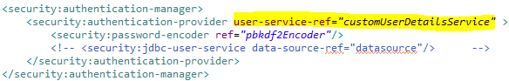

Session Management in Spring Security:
While using Spring Security we will rarely access the Session object directly for retrieving user details. Instead we will use org.springframework.security.core.context.SecurityContext interface (and its implementation class,org.springframework.security.core.context.SecurityContextImpl) and org.springframework.security.core.context.SecurityContextHolder. The SecurityContextHolder allows quick access to the SecurityContext, the SecurityContext allows quick access to the Authentication object, and the Authentication object allows quick access to the user details.

Recipe-6: Access custom User details through SecurityContext along with the default ones.

Step-1: Create a Custom UserDetails class extending org.springframework.security.core.userdetails.User class.

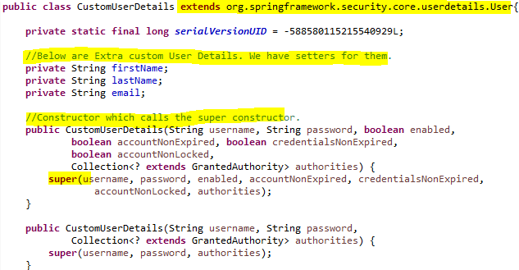

Step-2: Use the CustomUserDetails in CustomUserDetailsService and set the desired custom details.
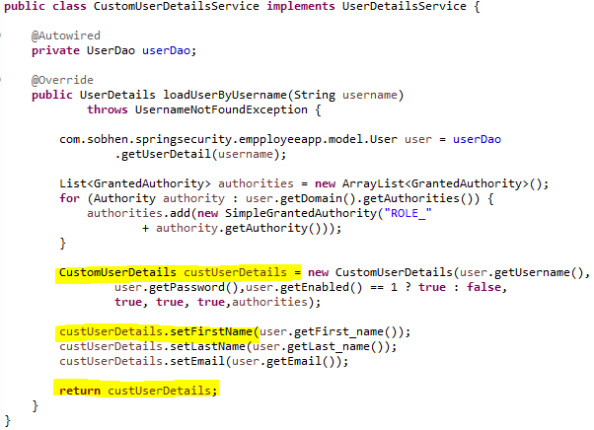

Step-3: Now we can use the SecurityContext in the Controller or any other place to retrieve the user information, including the custom ones.
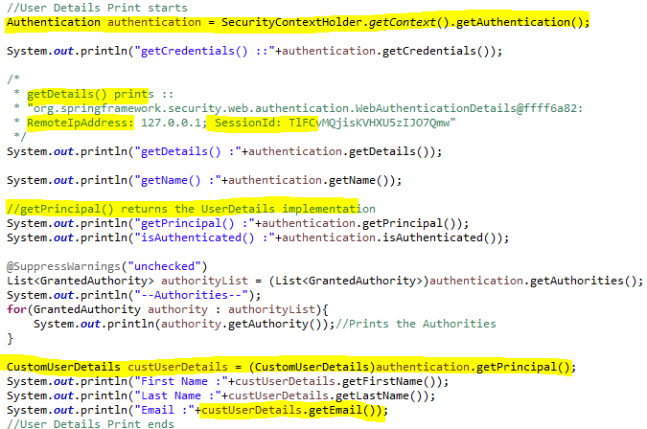
Recipe-7: Controlling "When Is The Session Created?”
We can control exactly when our session gets created and how Spring Security will interact with it. Below are the options Spring Security provides.
- Always: A session will always be created if one doesn’t already exist.
- IfRequired: A session will be created only if required (default).
- Never: The framework will never create a session itself but it will use one if it already exists.
- Stateless: No session will be created or used by Spring Security. Appropriate for REST APIs.

Step-1: It can be configured as below.

Recipe-8: Concurrent Session Control:
When a user that is already authenticated tries to authenticate again, the application can either invalidate the active session of the user and authenticate the user again with a new session, or allow both sessions to exist concurrently. By default Spring security allows one session to be active for any user at any given time. We can control this with below setting.

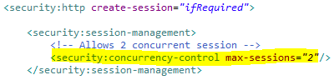
Recipe-8: Redirecting to an URL after the session has timed out:

To redirect, if the user sends a request with an expired session id.

To redirect, if the user sends a request with a session id which is not expired, but entirely invalid.
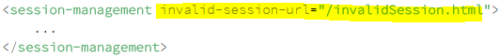

Recipe-9: Prevent using URL Parameters for Session Tracking:
Below is the Spring Security configuration for this.
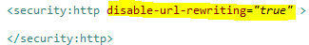
Alternatively, starting with Servlet 3.0, the session tracking mechanism can also be configured in the web.xml:
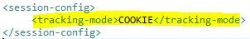
Allowed values are : COOKIE, URL, SSL
Recipe-10: Session Fixation Protection with Spring Security:
Session fixation is a vulnerability caused by incorrectly handling user sessions in a Web application. A user’s session is usually tracked by a cookie, which is assigned when the user visits the page with the Web application for the first time. The problem occurs when this cookie does not change for the duration of the browsing session; users authenticate, but their session cookie remains the same. In this case, the attacker can know the session ID that the victim is using and can gain access to the victim’s account.
The framework offers protection against typical Session Fixation attacks by configuring what happens to an existing session when the user tries to authenticate again. Below is the configuration.

By default, Spring Security has this protection enabled (“migrateSession“) – on authentication a new HTTP Session is created, the old one is invalidated and the attributes from the old session are copied over.
Other possible values are:
none: the original session will not be invalidated
newSession: a clean session will be created without any of the attributes from the old session being copied over
changeSessionId: In Servlet 3.1 (Java EE 7) and newer containers, specifying "changeSessionId" will keep the existing session and use the container-supplied session fixation protection (HttpServletRequest#changeSessionId()). Defaults to "changeSessionId" in Servlet 3.1 and newer containers, "migrateSession" in older containers. Throws an exception if "changeSessionId" is used in older containers.

Recipe-11: Prevent Brute Force Authentication Attempts with Spring Security:
Solution: We’ll keep a record of the number of failed attempts originating from a single IP address. If that particular IP goes over a set number of requests – it will be blocked for 24 hours.
Step-1: Create LoginAttemptService, which will be used to keep track of the number of wrong attempts per IP address.
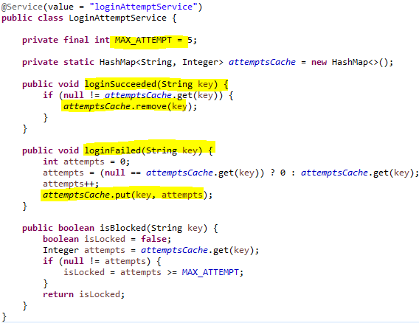
Step-2: Create AuthenticationFailureEventListener to listen to AuthenticationFailureBadCredentialsEvent events and call LoginAttemptService's loginFailed method to increase the login fail attempt for the IP address.
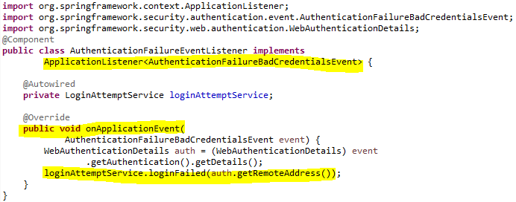

Step-3: Create AuthenticationSuccessEventListener to listen to AuthenticationSuccessEvent events and call LoginAttemptService's loginSucceeded method to remove the login fail attempt count for the IP address, from the attemptsCache.
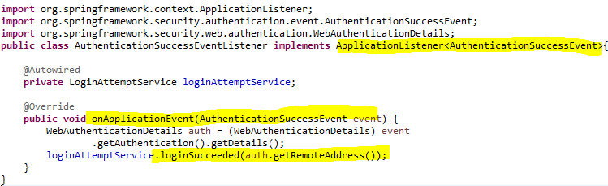
Step-4: Add an extra check in custom UserDetailsService implementation; when we load the UserDetails; to check if this IP address is blocked.
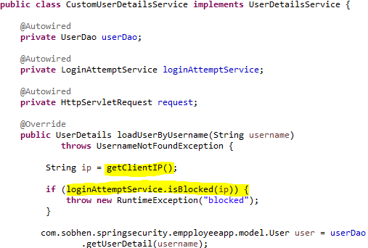
Below is the getClientIP method in the custom UserDetailsService implementation.
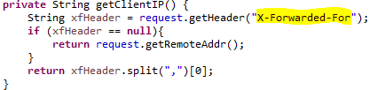

Step-5: Now add RequestContextListener in web.xml, which enable us to access the request from the UserDetailsService.
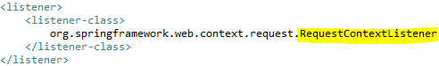

Study during revision:
- Access Control Decesion
- Securing Method Invocations
- Security in Views
- ACL

