**listen speak cry touch read sleep write smile draw eat look typ  
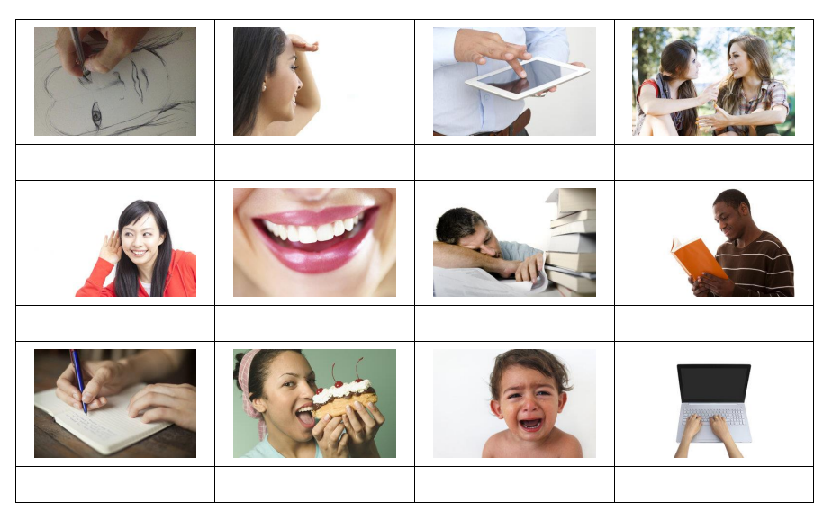**

1. We _______________ on paper when we send a letter to somebody.

2. We _______________ when we want to make a pretty picture on paper.

3. We _______________ when we are feeling really sad.

4. When we want to talk to somebody, we _______________ to them.

5. We _______________ when we are feeling tired.

6. When we want to feel something with our hands, we _______________ it.

7. We _______________ when we are really happy.

8. We _______________ on a keyboard when we send an email.

9. We _______________ three times a day when we feel hungry.

10. When we want to hear something, we _______________.