**receptionist cleaner shop assistant nurse doctor engineer  
office worker teacher hairdresser lawyer police officer**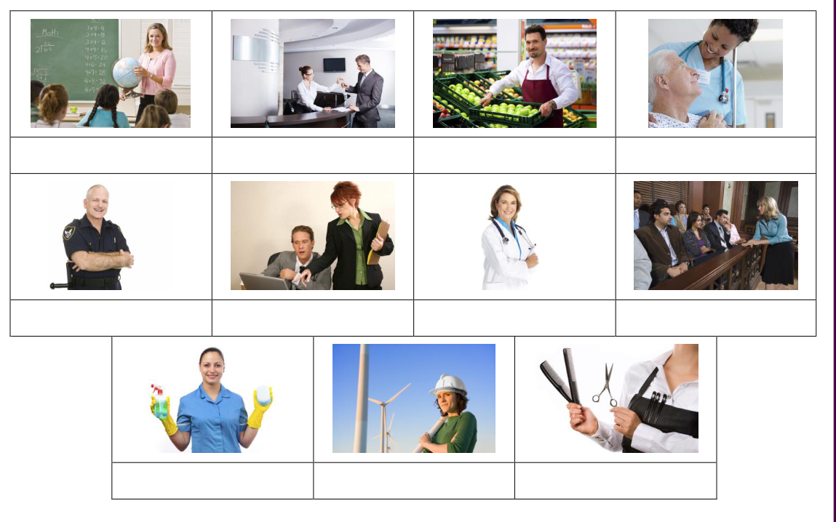

1. A ____________ works in a hospital or clinic and takes care of you when you are ill.

2. An ____________ designs and builds machines, large buildings or bridges.

3. A ____________ keeps an office, school or hotel clean and tidy.

4. Someone who works in a school classroom and helps students is called a ____________ .

5. A person who works in a court and can help people on trial is called a ____________ .

6. Someone who cuts and styles your hair to make it look good is called a ____________ .

7. Someone who helps you in a shop when you want to buy something is called a ____________ .

8. A person who works to stop crime is a ____________ .

9. A ____________ works at the front desk of a building and welcomes visitors and answers the phone.

10. An ____________ works for a company and usually uses a computer and phone.

