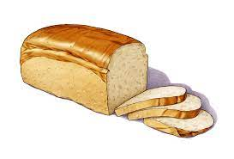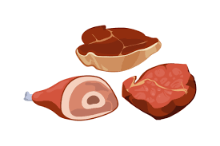**pizza ice cream meat vegetables egg  
chocolate sugar fish rice cheese bread biscuit**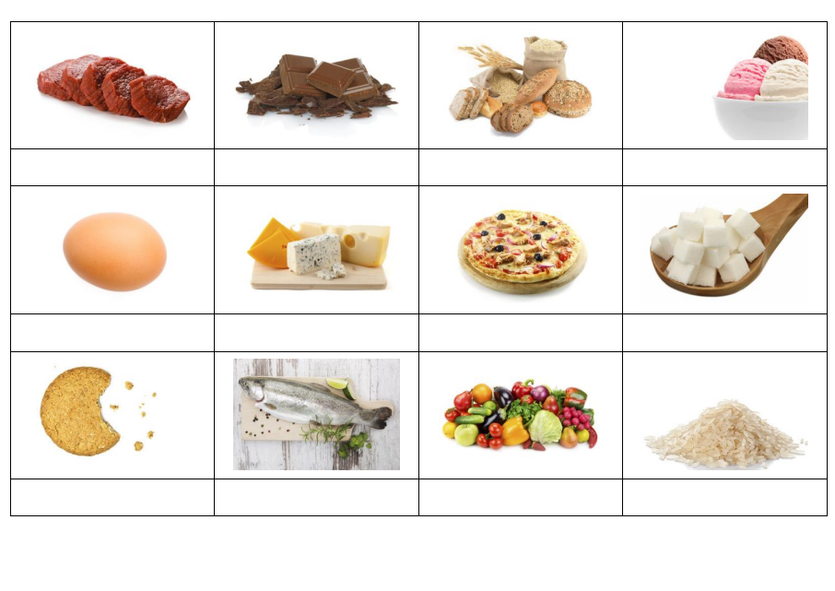  
1. _______________ is brown and sweet.

2. _______________ are all good for you.

3. A _______________ is an animal that lives in water.

4. _______________ is small, white grains and you can eat it with curry.

5. _______________ comes from an animal.

6. _______________ can be yellow or white and is made from milk.

7. Chickens lay these! They are called _______________.

8. What’s your favourite _______________? Chocolate, vanilla or strawberry?

9. _______________ comes from Italy. It has tomato and cheese on it.

10. You need _______________ to make a sandwich.