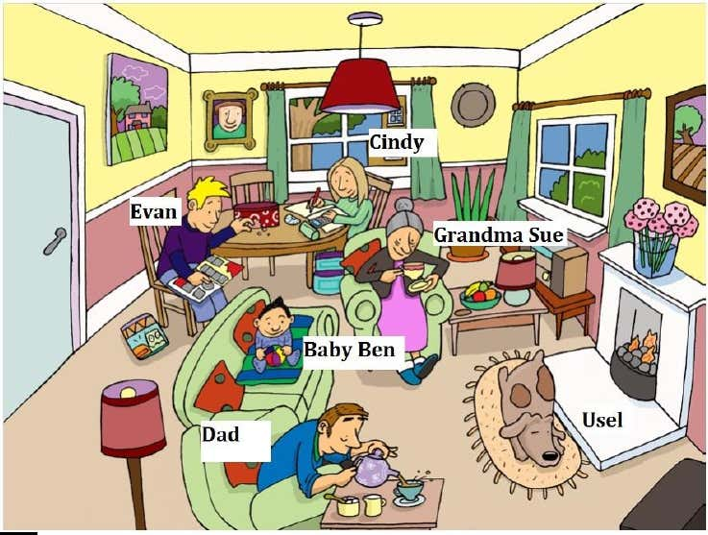

reading writing drinking playing sleeping eating  
Evan is

Dad is

Usel is

Grandma Sue is

Baby Ben is

Cindy is