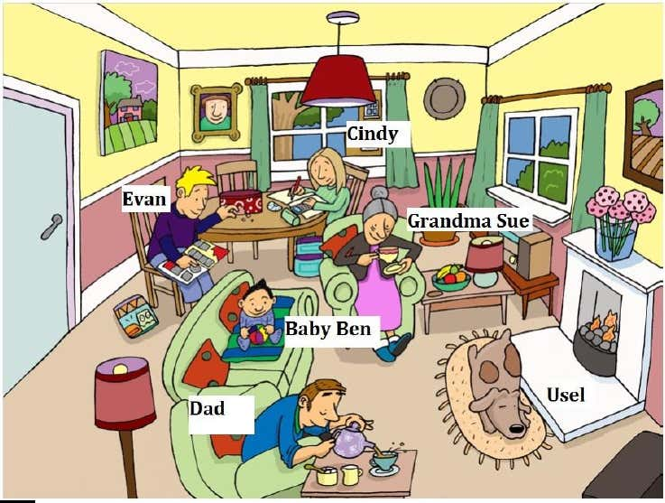

reading writing drinking playing sleeping eating  
Evan is

Dad is

Usel is

Grandma Sue is

Baby Ben is

Cindy is

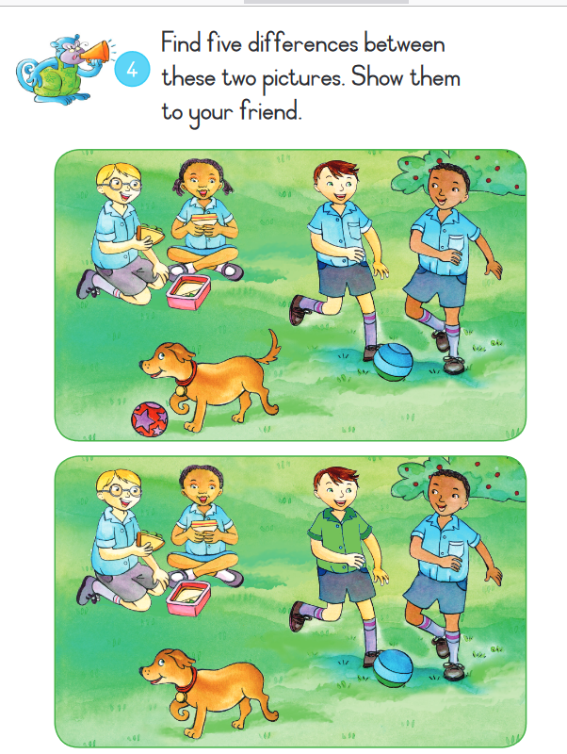Picture 1

Picture 2

**stripes ponytails ball green pocket**  
On picture 2, the boy’s shirt is

On picture 2, the girl has no

On picture 2, the dog has no

On picture 2, the ball has   
On picture 2, the boy has one

**dogs wash pineapple eight school volleybal family books**



My name is Roshan and I am nine years old. I live in a small town with my parents and my brother. We have two ______________. Every day in the morning I get up at seven o'clock. Then I wash my face. For breakfast I eat three sandwiches with ______________ jam. I go to school at ______________ o'clock. At school I work hard. My favourite subject is English. At half past twelve I eat lunch with my friends. After ______________ I go home and I talk with my mum about our day. My brother is not at home in the afternoon because he trains ______________ every day. He is very good at it. My ______________ eats dinner at five o'clock. In the evening I brush my teeth, take a shower and read ______________. I go to sleep at half past nine.

