**Which animal…?**

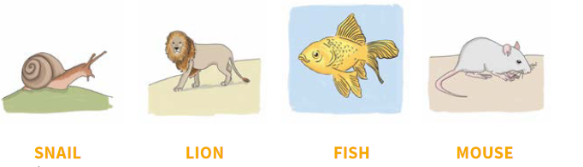

It is a dangerous animal.

It can swim.

It is a small animal.

It can’t fly.

It has got legs and a big shell.

It has got a long tail.

It can climb trees.

It isn’t dangerous.

It has got sharp teeth.