**Which animal…?**

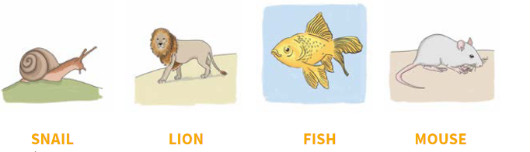

It is a dangerous animal.

It can swim.

It is a small animal.

It can’t fly.

It has got legs and a big shell.

It has got a long tail.

It can climb trees.

It isn’t dangerous.

It has got sharp teeth.

Bold True or False for these sentences.

1. You can eat salad in this restaurant. True False

2. This restaurant sells seafood. True False

3. There are four different types of pizza. True False

4. They don't have desserts in this restaurant. True False

5. The water is free in this restaurant. True False