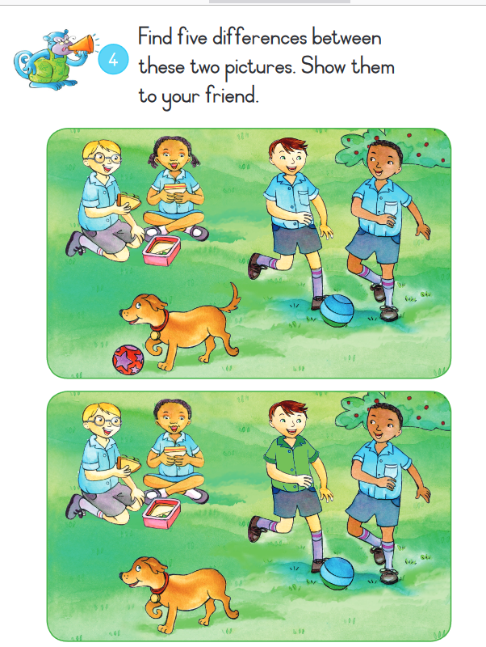Picture 1

Picture 2

**stripes ponytails ball green pocket**  
On picture 2, the boy’s shirt is

On picture 2, the girl has no

On picture 2, the dog has no

On picture 2, the ball has   
On picture 2, the boy has one