**angry thirsty sleepy hungry scared happy**

It’s hot and I’m running all day. I’m

I’m waiting for the dinner. I’m

It’s a beautiful day. I’m very

There is a snake near the road. I’m

The goats were noisy at night. I’m

I lost my homework. I’m

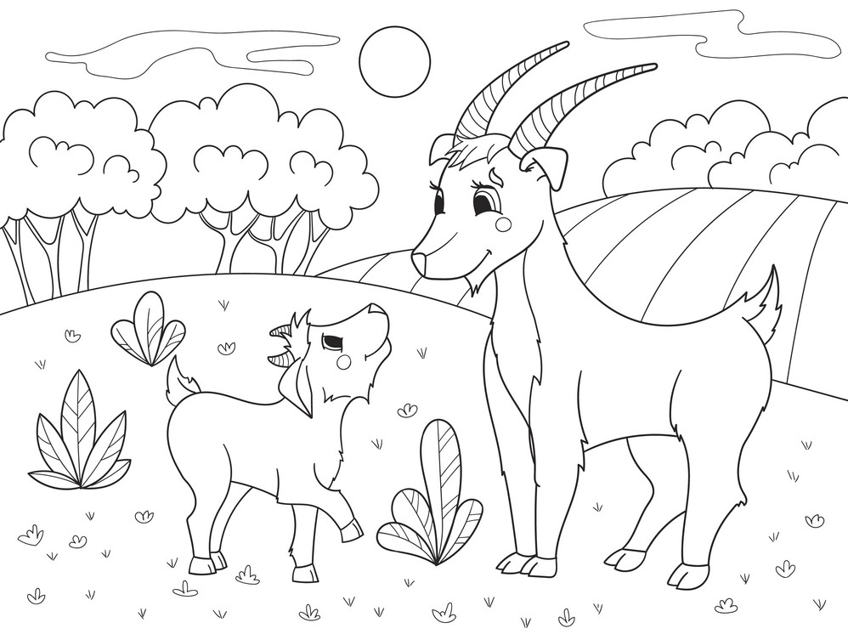  
  
**run walk fly play open write swim**  
I _________ to school 30 minutes.  
Birds _________ to warm places.  
You _____________ very far.  
Let’s _________________ volleyball.  
I ____________ during breaks at school.  
Let’s ________________ the window.  
I ________ in my notebook during the classes.  
I ____________ in the river during summer.