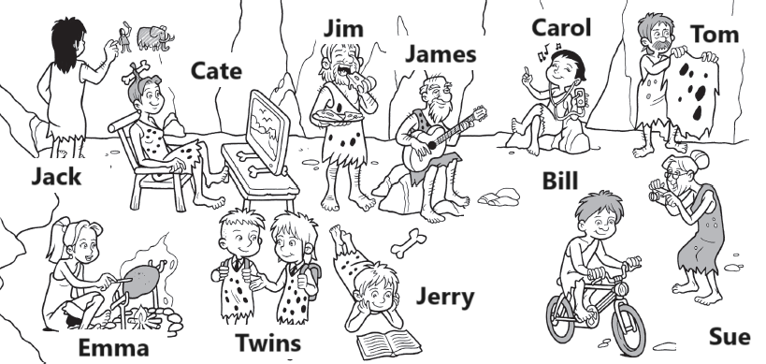

**reading a book taking a photo going to school cooking**

**drawing watching tv eating listening to music playing guitar**

**riding a bike doing a laundry**

Jack is

Cate is

Jim is

James is

Carol is

Tom is

Emma is

Twins are

Jerry is

Bill is

Sue is

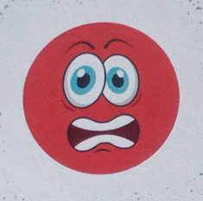

hungry angry

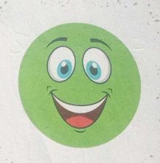

happy sad

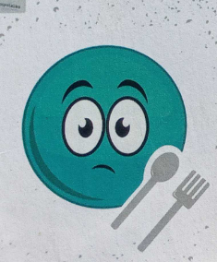

hungry thirsty

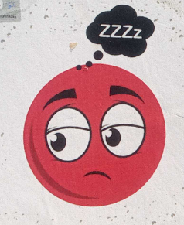

sleepy happy

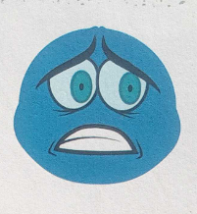

scared hungry

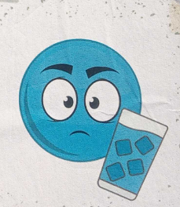

sleepy thirsty