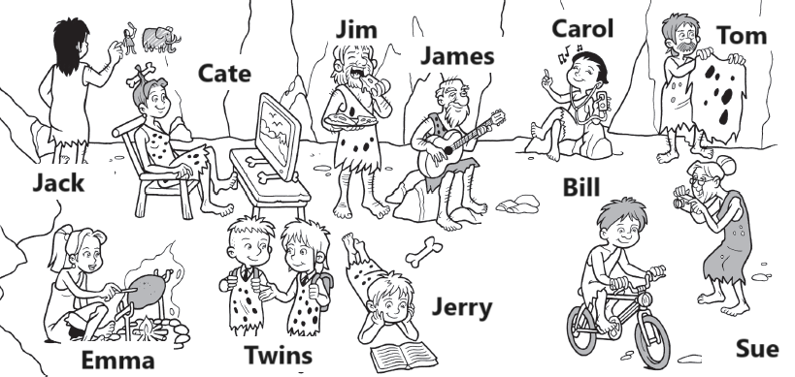

**reading a book taking a photo going to school cooking**

**drawing watching tv eating listening to music playing guitar**

**riding a bike doing a laundry**

Jack is

Cate is

Jim is

James is

Carol is

Tom is

Emma is

Twins are

Jerry is

Bill is

Sue is