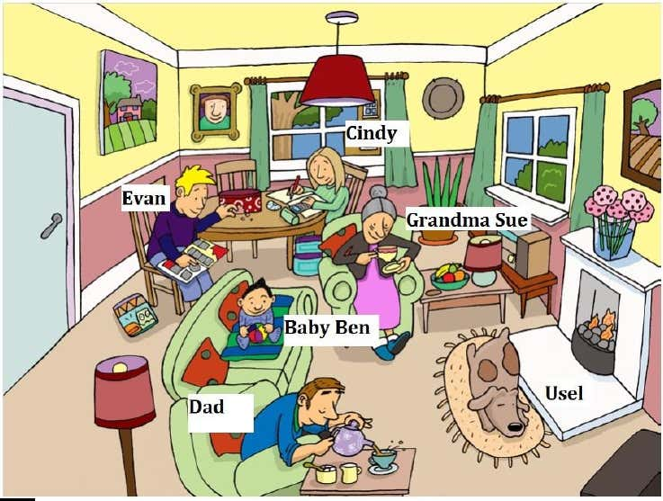

Evan is

Dad is

Daughter is

Usel is

Grandma Sue is

Baby Ben is

Cindy is