<https://hackerone.com/innogames>请测试前认真阅读测试要求，避免误踩雷区。

InnoGames

**[innogames.com](https://www.innogames.com/)**

**innogames.de**

<https://sip.innogames.com/login> 某后他地址

<https://call.innogames.com/login> 某后他地址

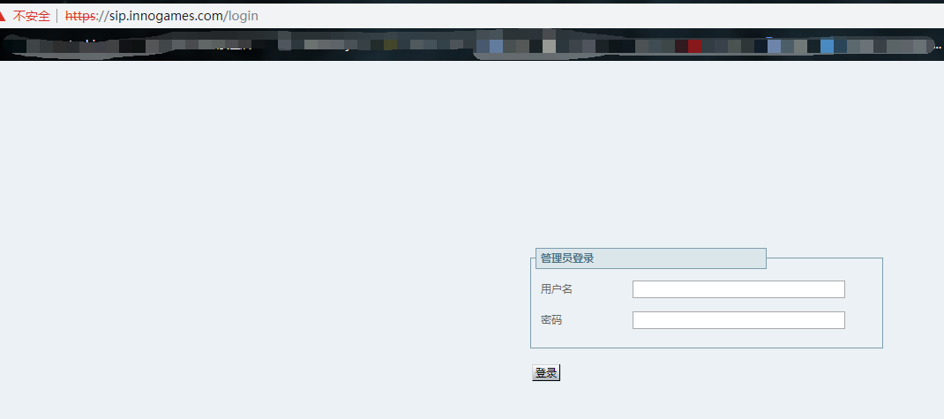

<https://tech.innogames.com/> 后台地址

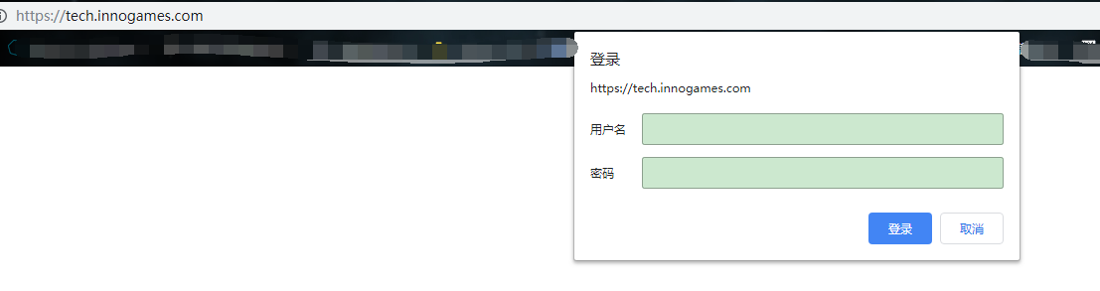

<https://login.innogames.de/login/innoforum?extra[redirect]=/> 论坛后台地址

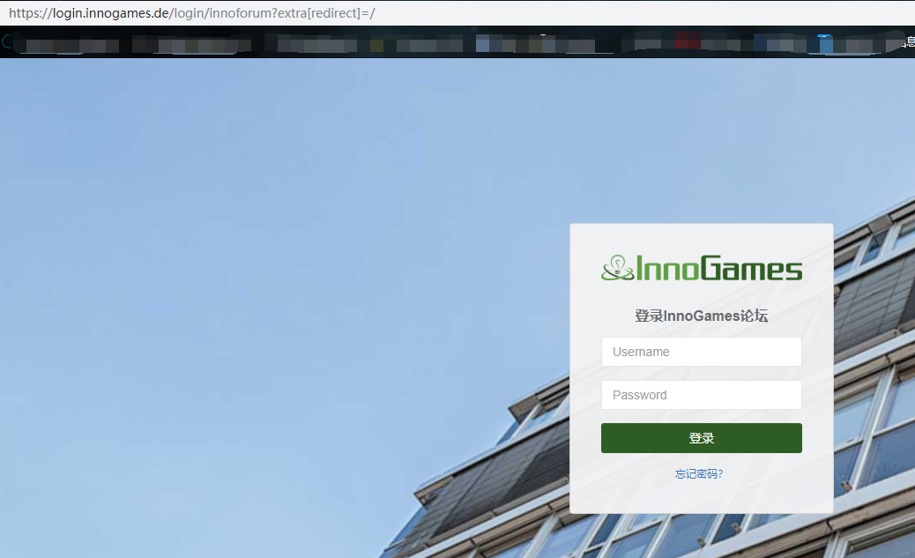

[https://conferencing.innogames.com](https://conferencing.innogames.com/) 思科平台会议后台地址

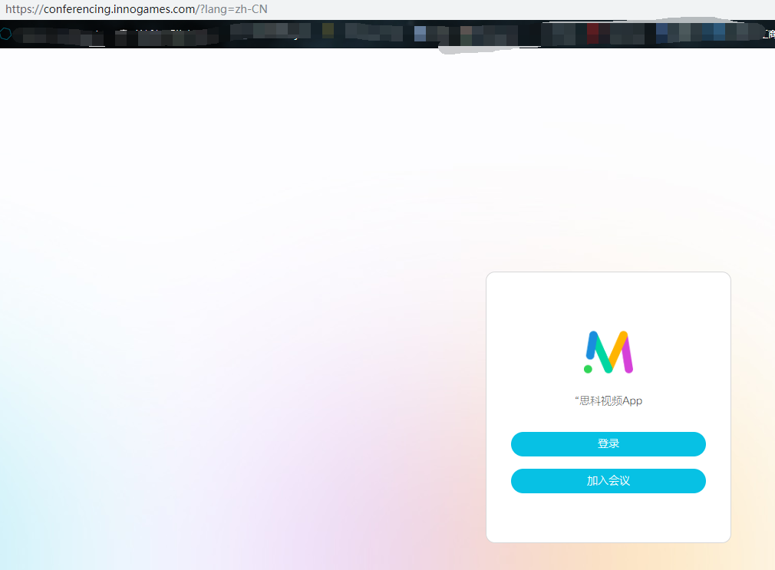

<https://legal.innogames.com/> ---> 引入到<https://ec.europa.eu/consumers/odr/main/index.cfm?event=main.home2.show&lng=HR> （ssrf 测试）

[https://jira.innogames.de/login.jsp?permissionViolation=true&os_destination=%2Fsecure%2FSessionNavigator.jspa%3Fb%3Db](https://jira.innogames.de/login.jsp?permissionViolation=true&os_destination=/secure/SessionNavigator.jspa?b=b)

[https://jira.innogames.de/login.jsp?os_destination=%2Fdefault.jsp](https://jira.innogames.de/login.jsp?os_destination=/default.jsp)

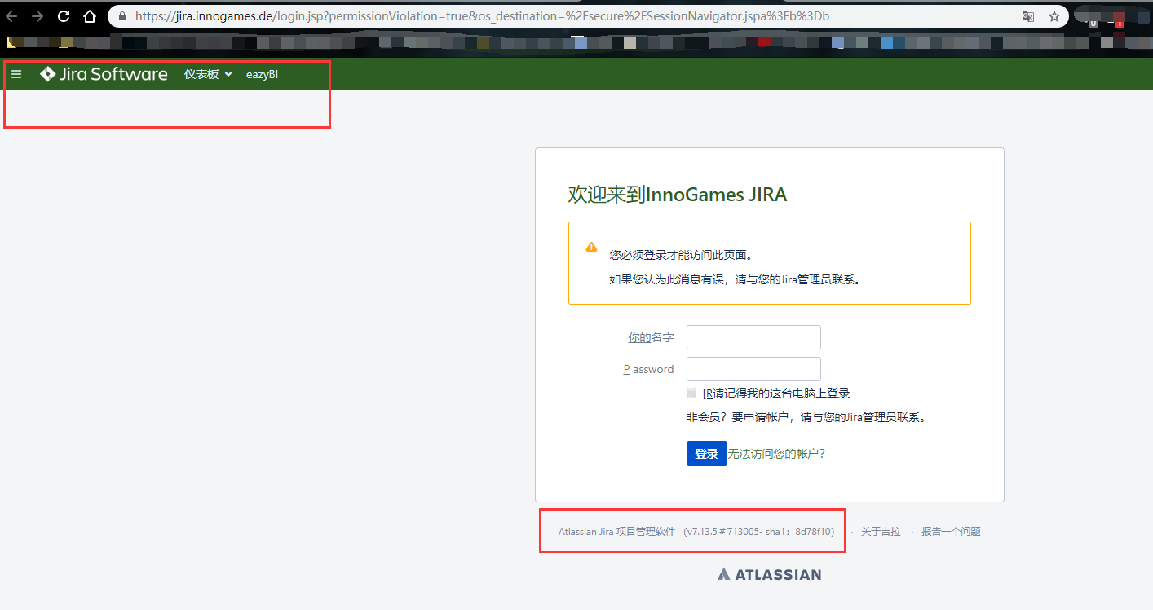

<https://sans.innogames.de/adfs/ls/idpinitiatedsignon.aspx/> 登陆后台

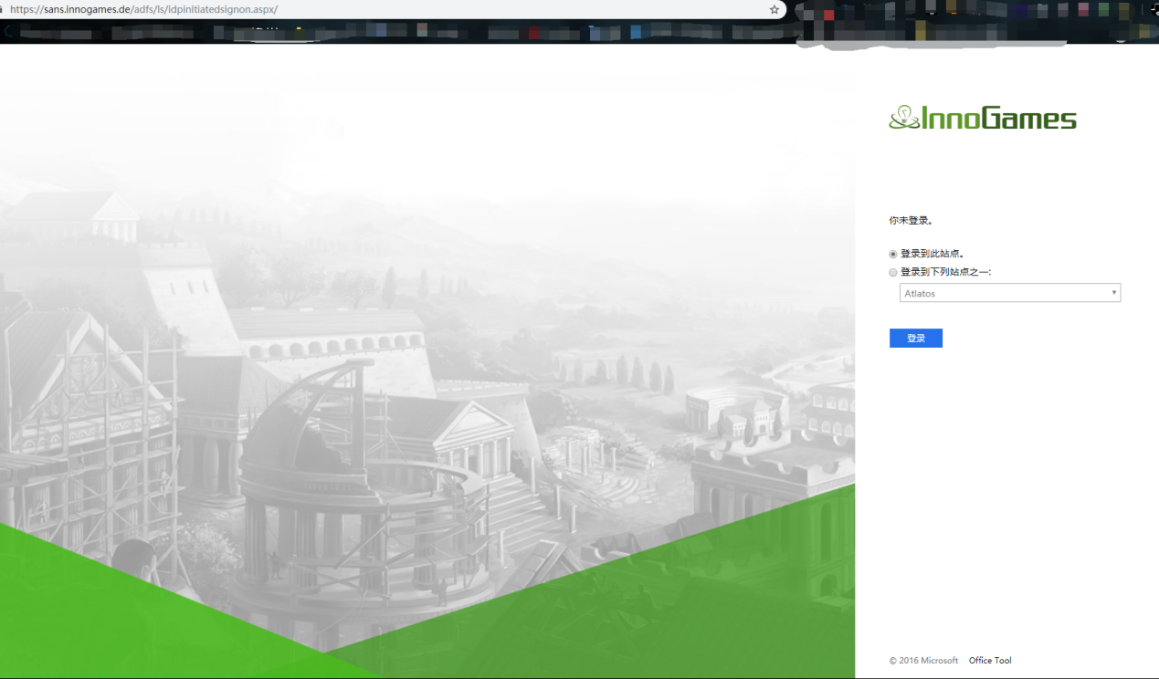

verify.innogames.com 下载文件

root@kali:~# whatweb https://www.innogames.com/

https://www.innogames.com/ [200 OK] Apache, Content-Language[en], Country[UNITED STATES][US], HTML5, HTTPServer[Apache], IP[151.101.2.217], JQuery[1.11.0], Meta-Author[InnoGames], MetaGenerator[TYPO3 CMS], Open-Graph-Protocol[website], PHP[7.1.30], PoweredBy[TYPO3], Script[text/javascript], Title[Free Online Games - Play Strategy Games and RPG Online for free!], UncommonHeaders[x-served-by,x-cache-hits,x-timer], Via-Proxy[1.1 varnish, 1.1 varnish], X-Powered-By[PHP/7.1.30]

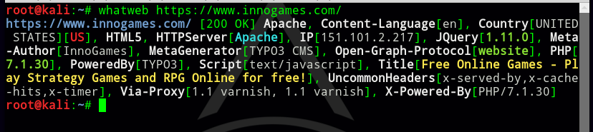

Google子域名搜索

**https://gamejam.innogames.com/ 跳转 ---> https://igjam.eu/**



<https://press.innogames.com/>

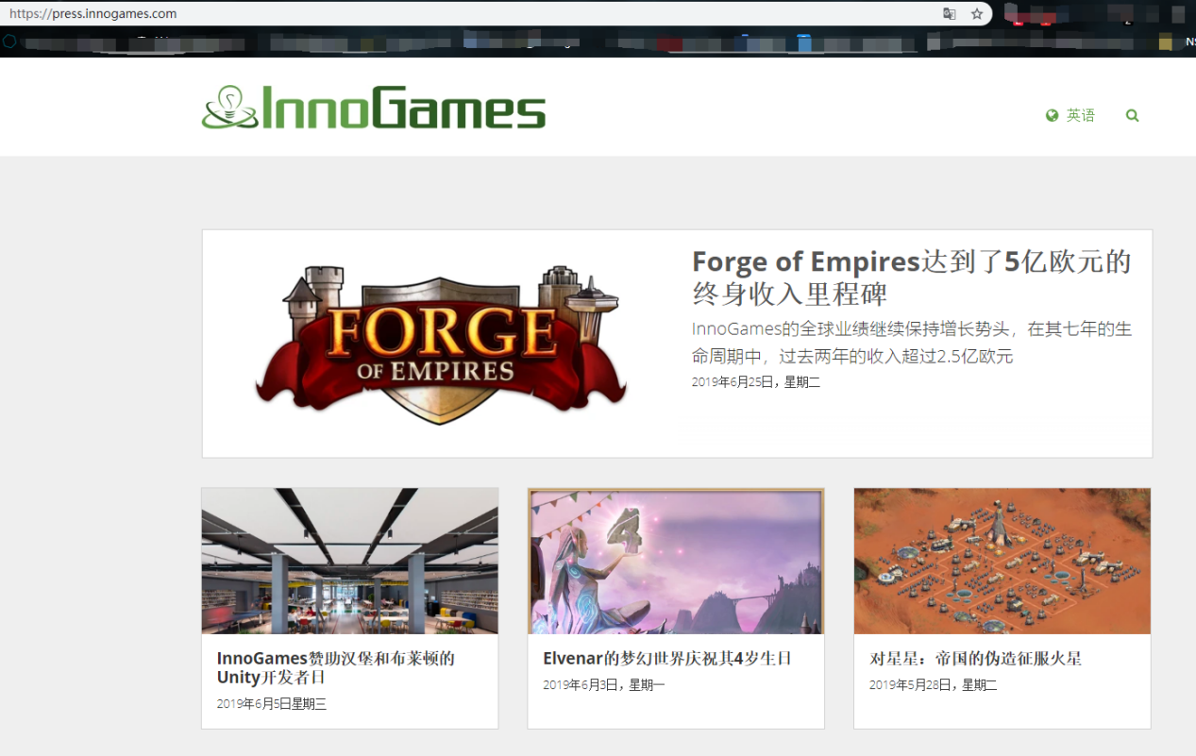

联系我们

Peter Meyenburg

公关主管

peter.meyenburg@innogames.com

494078893350

4915144349840

Dennis Schoubye

高级公关经理

dennis.schoubye@innogames.com

+ 49407889335-334

www.innogames.com

pr@innogames.com

+49 40 788 9335 0

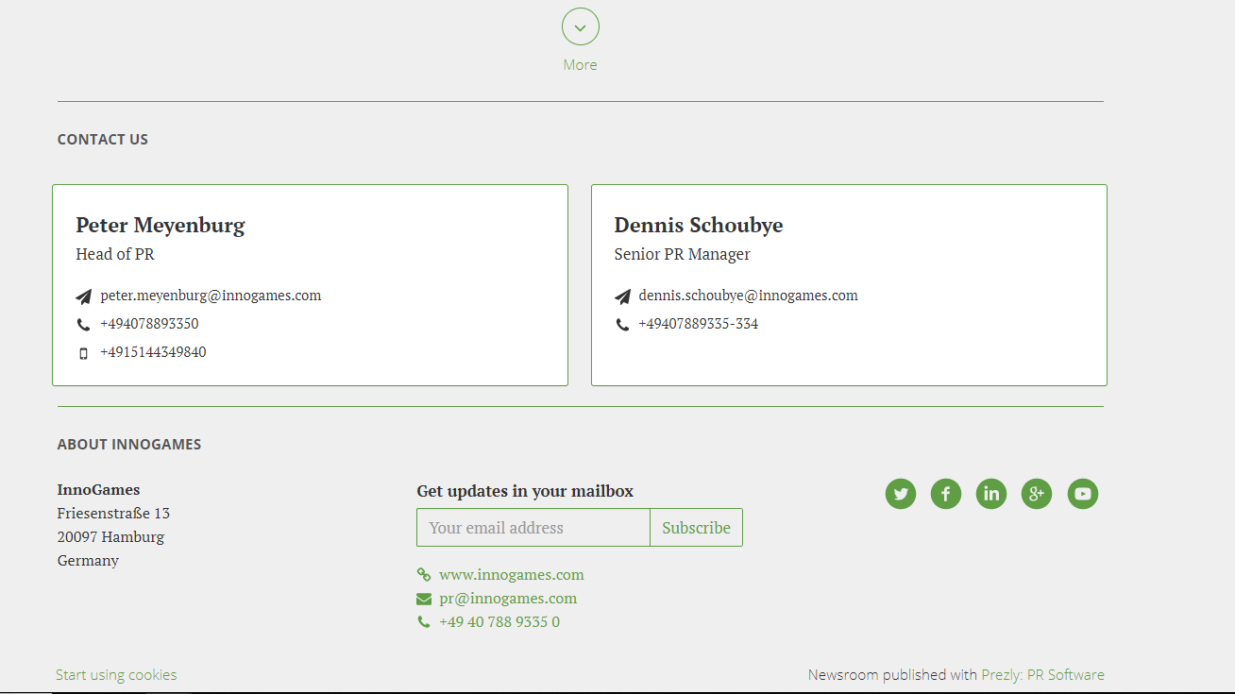

https://pn.innogames.com/ InnoGames - Affiliate Programm

<https://login.innogames.de/auth/innoforum?extra[redirect]=/> Login to InnoGames Forum

接口

<https://support.innogames.com/kb/Elvenar/fr_FR/articles?section=67>

<https://support.innogames.com/kb/Grepolis/en_US/articles?section=87>

<https://support.innogames.com/kb/TribalWars/en_US/articles?section=76>

<https://support.innogames.com/kb/Elvenar/fr_FR/articles?section=67>

<https://support.innogames.com/kb/Elvenar/nb_NO/articles?section=73>