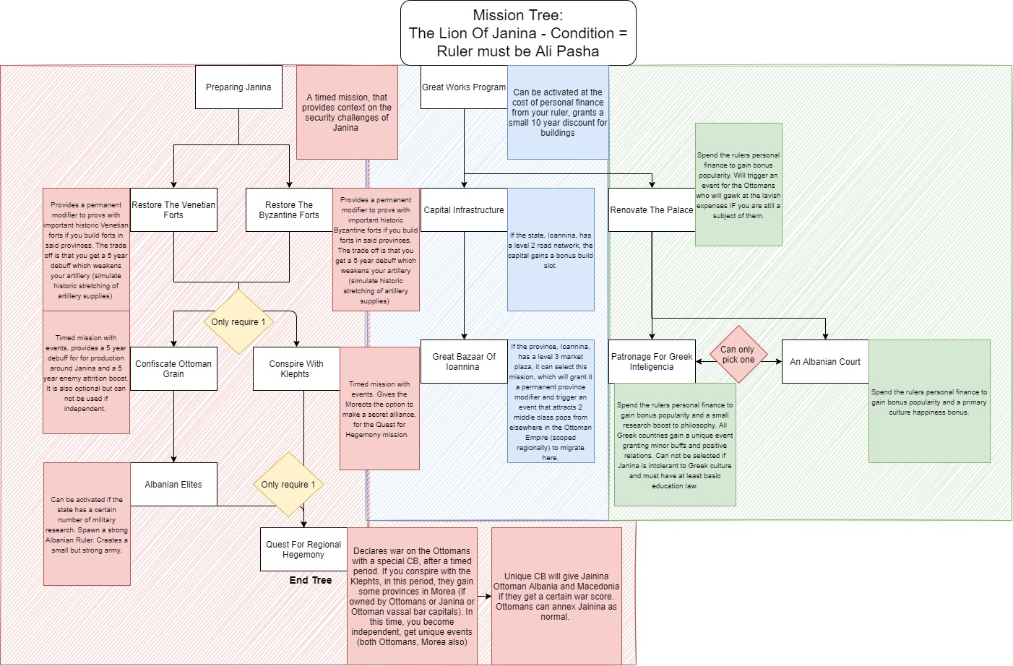
Mission Ethos

Description And Types Of Missions
The function that missions play in the mod, is to act as advanced decisions and as ways of communicating branching narratives.
It is important that missions are not deterministic, picking victors or directly scripting historical events. In terms of gameplay impact, this means that missions should not elide core game mechanics (e.g. by granting free resources), but instead complement them with additional depth.

Once the game is unpaused, history diverges in increasingly radical ways and having missions that try to very closely simulate historical events will be:
- Inauthentic to the gameplay and to players experience.
- Difficult for developers to represent, requiring increasingly complicated triggers, effects etc.
- Work against the broader mods development ethos.
- Be a poor use of time management.
Missions should also include routes for player/ai divergence, allowing for alternative routes to the historical to be taken. For example, perhaps the Ottoman Empire would embrace its feudal constitution and enshrine the system instead of a push towards centralization and more authority for its monarch?
Advanced Decisions – is an approach that allows the player/country to resolve issues that can not be easily communicated through the singular expression(s) of events or the decision system. This may be due to the additional mechanics that are inherent in the mission system, such as:
- Timed missions.
- Ability to communicate how missions can branch and how decisions can invalidate other paths.
- The provision of more advanced effects.
- Easier for players to find than events.
Narratives – are the stories that a developer/contributor feels are significant enough to model into gameplay that CANNOT be otherwise represented through the games existing systems. These stories could be:
- Generic, that are not tag specific and are often accessible by multiple countries. They often look at accomplishing something that cannot be accomplished with the mods core mechanics or to assist mechanics that are shallow. These can be broken down into the following categories:
  - Cultural missions – missions tied to the culture of your country (such as a shared mission tree for all nations with Japanese culture). They may explore cultural approaches, techniques, reforms etc that are not representable via regular gameplay.
  - Regional missions – missions tied to the region your country is the owner of (Such as a generic colonial tree for countries with a capital scope in Australia that are not aboriginal cultured and are viceroyalties/subjects or for owning specific regions). They can provide ways at managing or conquering regions/areas, in a unique or general way.
  - National/Innovation missions – Missions that are scoped to or can assist with progressing or maintaining the industrial, technological, or governmental status of countries (such as having a mission tree that can allow unindustrialized countries, outside of Europe, the opportunity to industrialize, where it can selectively progress along the lines of an already industrialized country).
- Country Specific, which are scoped directly around specific tags (countries). The main purpose of these missions is to simulate specific events or themes, in a way that does not railroad gameplay outcomes. There should be room for alternative history and for enhanced player/ai decision making.
- Thematic, are missions which take inspiration from history but are not bound by its limitations. They boil down events (potential or realized) into their basic themes and then missions are created around them.
  - For Example: German unification was a major topic post Napoleonic war but the progression towards that is indeterminable post-unpausing. Will it be diplomatically or militarily unified? Will Prussia, Austria, Saxony, Bavaria, or another country unify Germany, and will that Germany look different then what formed in history (perhaps a republican formation). Maybe the movement will result in the creation of a new diplomatic union instead of a unified country or maybe it will fail with no unification.
These missions can be country specific or overlay with multiple countries. Whilst they share some familiarities with generic missions, thematic missions usually tend to look at a historical event (or series of events) and break them up into broad themes, then builds up around that foundation.

Period Framing
The missions in the mod should be designed to account for the progression of the game and how the passage of time diverges events. It would not (for example) make sense to have a mission tree covering the Eight-Nation Alliance and the Relief of Peking, as events vary too drastically during gameplay. When thinking about making a mission tree, (especially if it is relating to a specific event instead of a generic or thematic mission tree), it can be helpful to consider when the event that is being covered occurs.

Early Progression – Missions within this period can cover specific events that:
- The conclusion of which is already in motion.
  - Example A) The Ottomans have a mission tree to assist it in resolving its feudal structure and determine its stance on its established constitution (which was established prior to the start date). The state was already attempting to amend this situation and the mission tree provides an avenue to continue that stance or reverse previous decisions.
  - Example B) The exile of Napoleon and the government of France.
- The preconditions for which have been firmly established.
  - Such as with a mission tree to address the post-congress treaty results of Poland.
Mid Progression – Missions within this period should address the way it looks at events in a more diluted way. The passage of time has firmly made changes to the world that make historical occurrences less likely to occur. Triggers will have to be made more complex for most historical event driven mission trees. There are still historical events that are worth telling within the mission format, perhaps topics including:
- Trail of tears
- The Auspicious Incident
Some historical events could be further simplified into a more thematic or generalized approach such as the USA’s manifest destiny.
Late Progression – Missions should be refocused to be either generic or thematic, instead of focused on specific events. They can take inspiration from historical events (such as the unification of Germany) but should be less reliant on specific events.
As such, Late Progression events should make extensive use of triggers so that they still feel context-rich and reflect the consequences of the player's actions. For example, a multicultural country with a communist government with a history of civil war should see very different mission trees to a monocultural one with a long-standing stable monarchy.

Balancing
Special attention should be made to balance mission effects, modifiers, and themes to ensure that:
- It does not supplant game mechanics.
- It is not overly powerful in contrast with other missions in the mod.
This balancing can be largely accomplished by taking a measured approach when implementing values. The strength of the value can be modeled based off the following factors, which should be defined as scripted modifiers or values that are called in the mission script, as opposed to being defined individually per mission:
- Permanent = Should never be strong, keep the values small, especially if military focused. Eg. 2% Irregular Infantry discipline bonus. Permanent changes should be applied very sparingly and with the possibility of removal: for example, cultural changes could be overturned by sweeping changes put in place by a future government.
- Long (over 5 years) = Can give moderately strong values but should be reasonable. Eg. 3.5% Irregular Infantry discipline bonus.
- Short (Less than 5 years) = Can give strong values BUT its important to consider if the mission justifies giving a strong bonus. Is the event in question significant enough to grant a strong bonus, considering the historic or projected impact that the event would have? It is a good idea to consult other members of the team if you want to add a strong value and explain your reasoning. Eg. 5% Irregular Infantry discipline bonus.
Another factor to consider with balancing is how the mission affects the game world and if so, is it in a fair way? Things to think about here are:
- Does the mission lead to the diplomatic/unearned annexation of countries and if so, is it justifiable?
- Does it lead to an exchange/annexation of land without working for it and why can’t this be done within existing gameplay systems?
When adding modifiers, it is worth considering if that modifier is too powerful, not just because of the value but also how it affects gameplay. This can be especially prevalent with military modifiers. Imp19c is a period of tremendous technological innovation/evolution and the mod attempts to simulate this, it would not make sense to have missions take on the role of making your armies, industry etc more powerful than what the technology trees or other mechanics can. A good example of how modifiers can be added, is the Janina fort modifiers, which add garrison growth growth/size bonuses, as small but useful benefits and works within the mods prevailing systems.

Mission Drafting
A good resource to use to draft missions is draw.io (https://app.diagrams.net/) an online tool that can be used to create diagrams. These diagrams can replicate the framework of events and provide a shell for experimenting with mission ideas before implementation. An example of a finished product is shown below:
When done with a draft mission tree, you can post it into the mission draft document (pinned in discord) and/or share it in the mission discord channel for more discussion.

