Convert Weight SOAP UI

- Create a Project
- Open SOAP UI
- Create a new SOAP Project as shown below
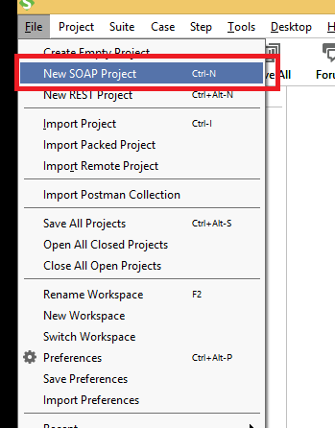

- Add the following SOAP request

http://www.webservicex.net/ConvertWeight.asmx?WSDL
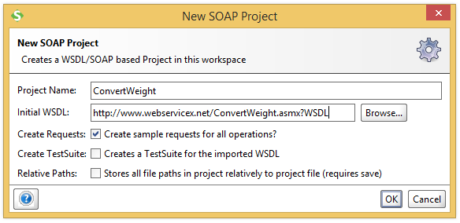

- Two operations will be displayed after accepting the WSDL

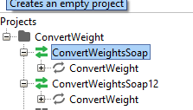

- Soap Request
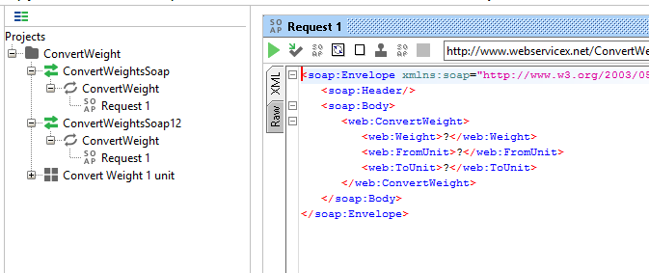

- Expand the first request (ConvertWeight) and double click on the 'Request1'. It will display the SOAP request in the XML format.
- Enter the weight, FromUnit to ToUnit
- Double click on ConvertWeightSoap, click on WSDL Content. This will give the format to enter for Request1
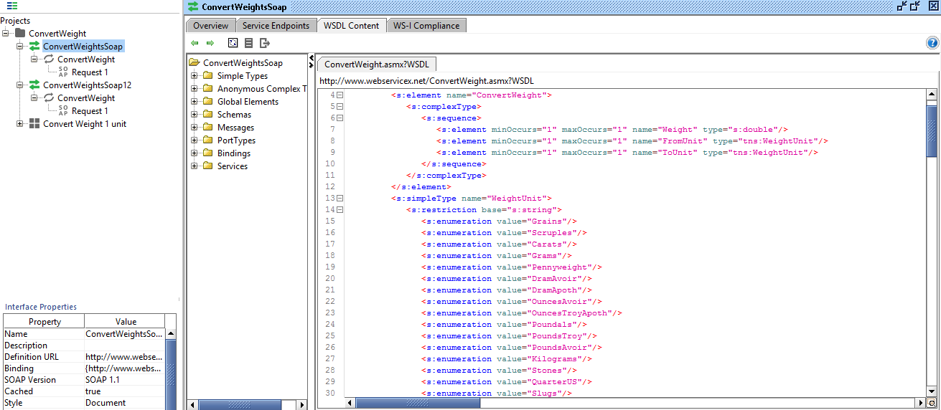

- Now enter the following to test the format in Request 1
Request:
<soapenv:Envelope xmlns:soapenv="http://schemas.xmlsoap.org/soap/envelope/" xmlns:web="http://www.webserviceX.NET/">
<soapenv:Header/>
<soapenv:Body>
<web:ConvertWeight>
<web:Weight>1</web:Weight>
<web:FromUnit>Kilograms</web:FromUnit>
<web:ToUnit>Grams</web:ToUnit>
</web:ConvertWeight>
</soapenv:Body>
</soapenv:Envelope>

- Response:
<soap:Envelope xmlns:soap="http://schemas.xmlsoap.org/soap/envelope/" xmlns:xsi="http://www.w3.org/2001/XMLSchema-instance" xmlns:xsd="http://www.w3.org/2001/XMLSchema">
<soap:Body>
<ConvertWeightResponse xmlns="http://www.webserviceX.NET/">
<ConvertWeightResult>1000</ConvertWeightResult>
</ConvertWeightResponse>
</soap:Body>
</soap:Envelope>

- Creating tests
- Right on the project and click on “New TestSuite”. Enter appropriate name for the test suite.

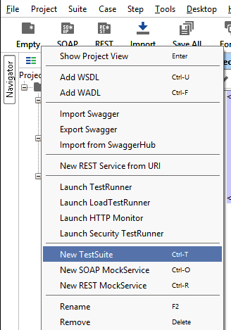

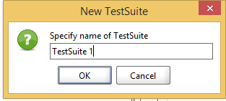

- Creating a Test Case
- Right click on created Test Suite and click on “New TestCase”
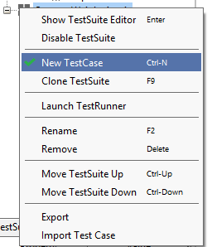
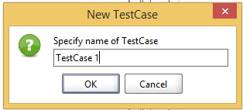

- Creating a test
- Right click on created Test case => click on Add step => SOAP Request. SOAP Is selected since this is a SOAP request.
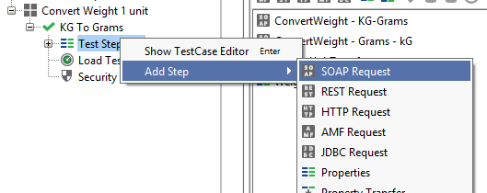

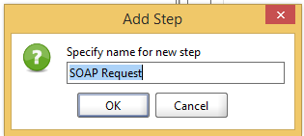
- Now select the operation where the request will be made from. This is the WSDL we selected first.
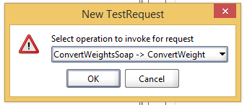

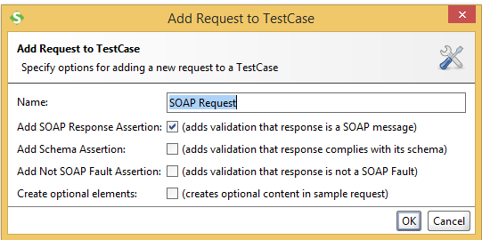

- SOAP Request – Test case
- Default SOAP Response when created, as shown below. This is same as the Request1 mentioned in Step 4.
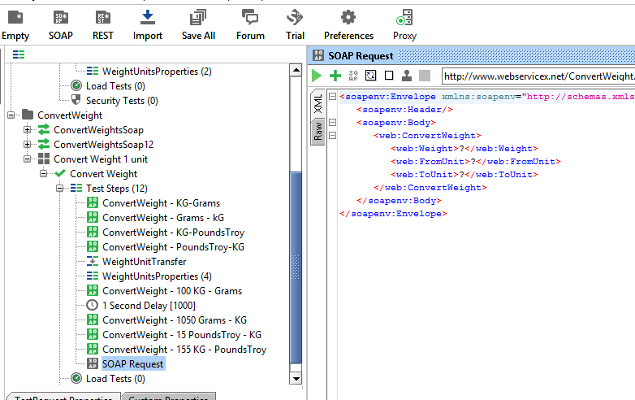

- Setting Test data for test – Custom Properties
- Click on created Test Suite => Click on “Custom Properties”, data can be added by clicking on + button.

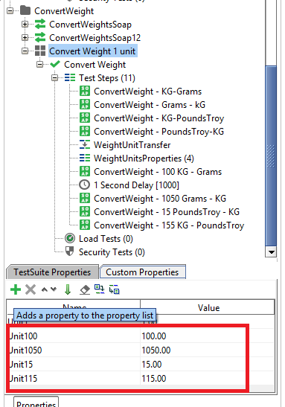
- Loading test data from Property
- It’s nice to use test data from one location rather than entering it on each tests.
- Right click on the area you want the data to be used => Get Data => Click on the test suite => click on the Property to use
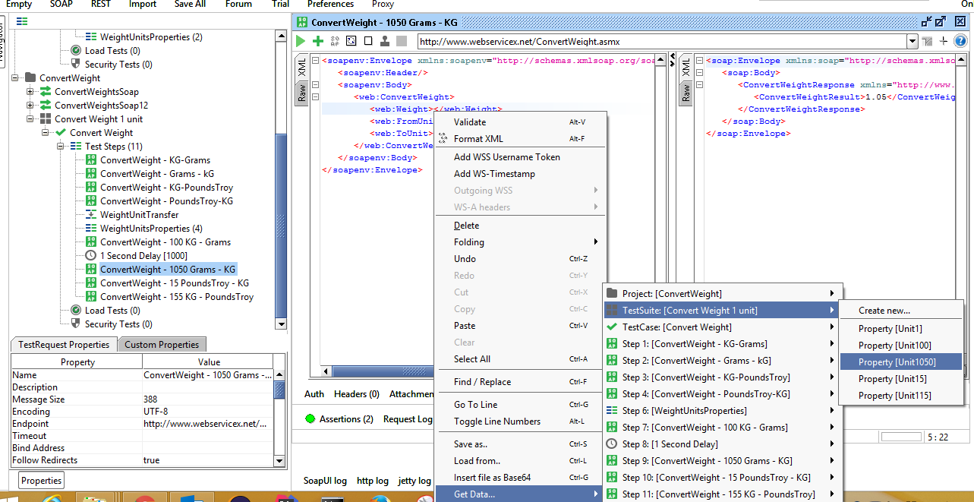

- Assertion
- It’s important to check expected and actual results are same. So there are few options available for assertion.
- Open a SOAP Request => click on the + button, Add Assertion will appear. In this example I have selected Script Assertion for these test, since I wanted to check few sums. Note: Knowledge of Groovy Scripts, XPath and Java required for this. I have provided plenty of examples with comments for Script Assertion.

- Note that the Script Assert does not have auto compile so help yourself with log.info(), this will print what the output of anything given in ().

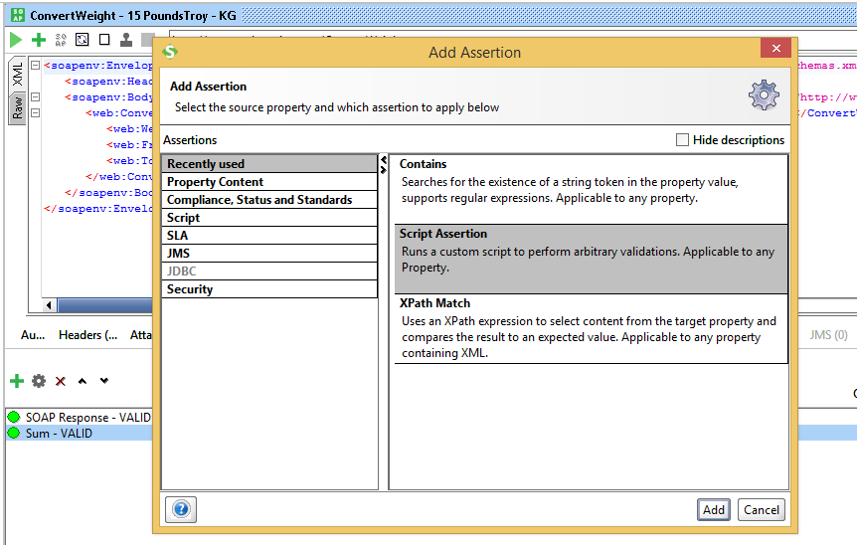

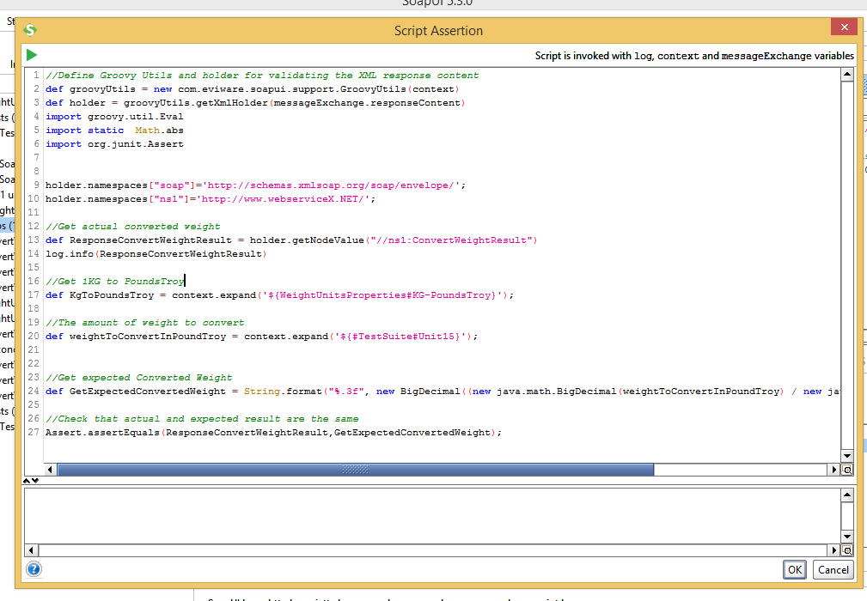
- Running the test
- Option 1 - Double click on Test Steps => click on Play button to run the steps
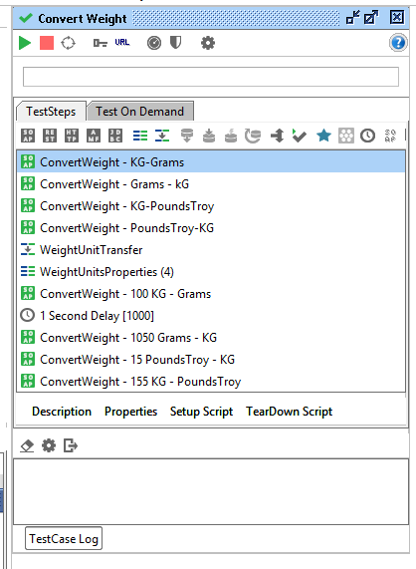
- Option 2 – Double click on individual test steps and click on Play button

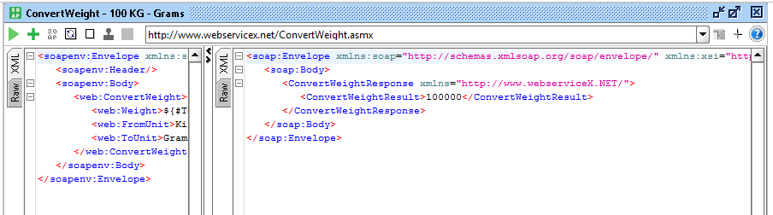
Finally, I have added “ConvertWeight-soapui-project.xml” project, import this project using SOAP UI and go through the examples.
I really recommend Grue 99 for further reading on SOAP UI - http://www.guru99.com/soapui-tutorial-project-testsuite-testcase.html

