Задание 2 ( deadline 02/04)

Ex. 1 p 38

Ex. 2a p 38 (due to the diagram + the video)

Ex. 2c p 39

Ex 3c p 39

Ex. 4b p40 (audio)

Ex 5a p 40

**Draw a sketch and write a short description.**

Ex 6a p 40 (аудио/видео файл выслать)

Ex 6с p 41

Ex 10 p 42

Ex 13a p 43

Ex 14 p 44

Ex 15 a, b, c p 44

Ex 15e p 44

Ex 16b p 45

Exercises

1

1. A process automation or automation system (PAS) is used to automatically control a process such as chemical, oil refineries, paper and pulp factories. The PAS often uses a network to interconnect sensors, controllers, operator terminals and actuators.

2. There are practical details such as mounting, connections and power supplies and also stabilization.

3. Replication and common basis of experiment are the most important points of process. So you should describe everything in detail.

2a

1. The Earth has four layers: the inner core, outer core, mantle and crust. The crust and the top of the mantle make up a thin layer on the surface of the Earth, but rather than being continuous, this layer is made up of a number of pieces, called tectonic plates.

An earthquake is caused by a sudden slip on a fault. The tectonic plates are always slowly moving, but they get stuck at their edges due to friction. When the stress on the edge overcomes the friction, there is an earthquake that releases energy in waves that travel through the earth's crust and cause the shaking that we feel.

2 Researchers found that intraplate earthquakes — which occur in the middle, instead of at the borders, of tectonic plates — are influenced by convection, or heat-driven movements, of the molten mantle beneath the planet's cold, solid crust. If the minerals in the mantle stay strong at high temperatures and pressures, it will take longer for the temperature and pressure to build up enough for an earthquake to occur.

2c

A – powdered mineral sample

B – tube of rolled rhenium

C – ceramic octahedron

D – two tungsten-rhenium thermocouple leads

E – tungsten carbide cubes

F – six secondary anvils in the press

3c

1 – B

2 – A

3 – B

4 – A

5 – C

6 – A

4b

1. Use linking words to make the stages clear, but not too many
2. Combine sentences

5a

1. First
2. Was
3. Which
4. Then
5. At
6. Which

Sketch

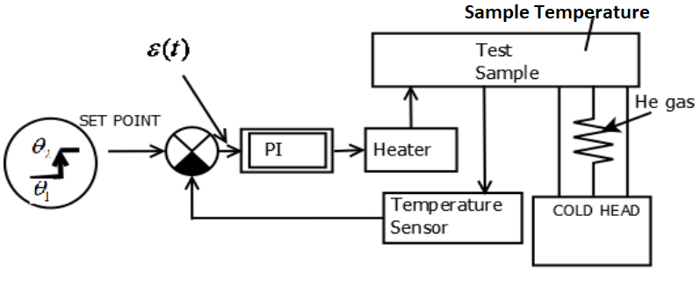

1. Set point of input element.
2. Wait for the end of transition process, i.e. temperature of sample equals to set point.
3. Change the temperature of controllable object with cold head.
4. Measure the time of transition process.
5. Identify object using computer software package.
6. Calculate the optimal controller parameters.
7. Check the accuracy of calculated parameters by repeating the experiment.

6a

2. I predicted that the behavior of experimental model will be close to mathematical model with 5% difference in properties.

3. The properties difference were far more 5%, because of the nature of process (flywheel effect).

4. With help of the graph of transition process the mathematical model was modified and recalculated.

5. The results have been used as a part of theoretical work in my studies.

6c

1. Differential stress in the olivine and perovskite samples will go up with pressure - OK
2. Perovskite will be stronger than olivine, that means, it will yield later -OK
3. For olivine, increasing the temperature will reduce yield strength - OK
4. For perovskite, increasing the temperature will reduce yield strength – NOT (X)

10

1. The difference between real object and mathematical model was a problem.
2. The nature of process (flywheel effect) caused the problem.
3. Graph of transition process helped to discover the problem.
4. Recalculating of mathematical model had solved the problem.

13a

1. Surprising
2. Similar
3. Appears
4. Possible
5. Possibly
6. Unlikely
7. Possibility
8. Likely

14

Flywheel effect: when outside temperatures are fluctuating throughout the day, a large thermal mass within the insulated portion of a house can serve to "flatten out" the daily temperature fluctuations, since the thermal mass will absorb thermal energy when the surroundings are higher in temperature than the mass, and give thermal energy back when the surroundings are cooler, without reaching thermal equilibrium. This is distinct from a material's insulative value, which reduces a building's thermal conductivity, allowing it to be heated or cooled relatively separately from the outside, or even just retain the occupants' thermal energy longer.

The lag between the actual temperature and the temperature of surrounding areas depends on many factors, that changes the time of transition process.

The best solution for this problem to make the identification process via the normal experiment. The recalculating of mathematical model is not a problem due to software that helps to automate the computation process.

15ab

1. D
2. I
3. H
4. K
5. B
6. C
7. J
8. G
9. F
10. E
11. L
12. A

15c

1. ↓
2. °C
3. K
4. ≥
5. +
6. v/v
7. w/o
8. 2:1
9. h
10. conc.

15e

1. RT
2. 378 K
3. Δ
4. K
5. ↓
6. 7
7. conc.

16b

1. share
2. notes
3. search
4. changes
5. group’s
6. safer