

**Green University of Bangladesh**

**Department of Computer Science and Engineering (CSE)**

**Faculty of Sciences and Engineering**

**Semester: (Summer, Year:2021), B.Sc. in CSE (Day)**

**Course Title: Operating System Lab**

**Course Code: CSE 310 Section: DA(PC)**

**Lab Project Name: 191902025_191902048_191902051**

**Student Details**

| **Name** | | **ID** |
| --- | --- | --- |
| **1.** | Kazi Hasnayeen Emad | 191902025 |
| **2.** | Md. Sobuj Mia | 191902048 |
| **3.** | Shaiful Islam | 191902051 |

**Submission Date : September 24, 2021**

**Course Teacher’s Name : Ms Umme Habiba**

**[For Teachers use only: Don’t Write Anything inside this box]**

| **Lab Project Status**  **Marks: ………………………………… Signature: .....................**  **Comments: .............................................. Date: ..............................** |
| --- |

Table of Contents

**Chapter 1 Introduction 3**

1.1 Introduction 3

1.2 Design Goals/Objective 3

**Chapter 2 Implementation of the Project 4**

2.1 Home Page Code

2.2 CPU Algorithm

2.2.1 First Served Scheduling Algorithm

2.2.2 Shortest Job First Scheduling Algorithm

2.2.3 Priority Scheduling Algorithm

2.2.4 Round Robin Scheduling Algorithm

2.3 Banker’s Algorithm And Deadlock Avoidance

2.4 Simulating The MFT And MVT Memory Management Technique

2.4.1 MFT Memory Management Technique

2.4.2 MVT Memory Management Technique

2.5 Exit

**Chapter 3 Performance Evaluation 10**

3.1 Results and Discussions 10

**Chapter 4 Conclusion 13**

4.1 Scope of Future Work 13

# Chapter 1 Introduction

## Introduction

This project is based on the concept of 3 types of algorithms using Bash Programming. Here User can run any type of algorithms and can understand how these algorithms actually work. The 3 types of algorithms are CPU Scheduling Algorithms, Deadlock Avoidance Algorithms and Memory Management Algorithms.

## Design Goals/Objective

Sometimes students find it very difficult to implement these algorithms using Bash Programming and there are also very limited resources on the internet on Bash Programming where they can learn the actual algorithms using bash and how it works. So we tired to cover the import algorithms using Bash Programming so that they can achieve a clear concept about the CPU Scheduling Algorithms, Deadlock Avoidance Algorithms, and Memory Management Algorithms.

# Chapter 2

# Implementation of the Project

**2.1 Home Page Code**

p=1

t=0

while [ $p ]

do

echo "1-CPU ALGORITHMS"

echo "2-Banker’s Algorithm and Deadlock Avoidance"

echo "3-Simulating the MFT and MVT Memory Management Techniques."

echo "4-Exit."

echo -n "Please Enter Your Choice: "

read s

echo " "

echo " "

k=0

case $s in

1)

echo "***CPU ALGORITHMS***"

#echo " "

echo "1-First Served Scheduling Algorithm"

echo "2-Shortest Job First Scheduling Algorithm"

echo "3-Priority Scheduling Algorithm "

echo "4-Round Robin Scheduling Algorithm"

echo -n "Please Enter Your Choice: "

read e

echo " "

if [ $e -eq 1 ]

then

fcfs

echo -n "Enter any key:"

read y

clear

echo ""

elif [ $e -eq 2 ]

then

sjf

echo -n "Enter any key:"

read y

clear

echo ""

elif [ $e -eq 3 ]

then

Priority

echo -n "Enter any key:"

read y

clear

echo ""

elif [ $e -eq 4 ]

then

Robin

echo -n "Enter any key:"

read y

clear

echo ""

else

each "Enter a valid serial number !!!"

fi ;;

2)

echo "***Banker’s Algorithm and Deadlock Avoidance***"

Deadlock

each ""

;;

3)

echo "***Simulating the MFT and MVT Memory Management Techniques.***"

#echo " "

echo "1-MFT Memory Management Techniques"

echo "2-MVT Memory Management Techniques"

echo -n "Please Enter Your Choice: "

read q

echo " "

echo " "

if [ $q -eq 1 ]

then

mft

echo -n "Enter any key:"

read y

clear

echo ""

elif [ $q -eq 2 ]

then

mvt

echo -n "Enter any key:"

read y

clear

echo ""

else

each "Enter a valid serial number !!!"

fi

;;

4)

t=1

;;

*)

echo "Enter a valid serial number !!!"

esac

if [ $t -eq 1 ]

then

break

fi

done

**2.2 CPU Algorithm**

**2.2.1 First Served Scheduling Algorithm**

**fcfs(){**

**...**

**}**

**2.2.2 Shortest Job First Scheduling Algorithm**

**sjf(){**

**...**

**}**

**2.2.3 Priority Scheduling Algorithm**

**Priority(){**

**...**

**}**

**2.2.4 Round Robin Scheduling Algorithm**

**Robin(){**

**...**

**}**

**2.3 Banker’s Algorithm And Deadlock Avoidance**

Deadlock()

{

...

}

**2.4 Simulating The MFT And MVT Memory Management Technique**

**2.4.1 MFT Memory Management Technique**

**mft(){**

**...**

**}**

**2.4.2 MVT Memory Management Technique**

**mvt(){**

**...**

**}**

**2.5 Exit**

**...**

# Chapter 3 Performance Evaluation

## Results and Discussions

First of all after running this project we will see this figure flowing

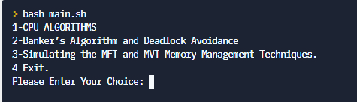

Actually this figure represents users choice which means which simulation of algorithm an users want to see. To see a simulation of an algorithm, users have to choose the corresponding value of the algorithm in this figure.

So if the user chooses 1 then another figure just like following this figure will display.

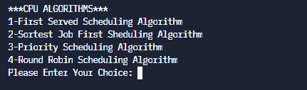

This figure represents a specific algorithm and corresponding value of the user selectable topics.

So now if the user chooses 4 then can see the output.

such as

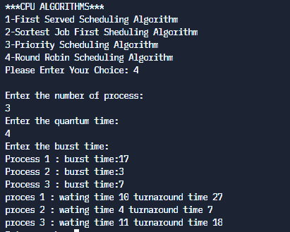

Again if user choose 2 then output will be

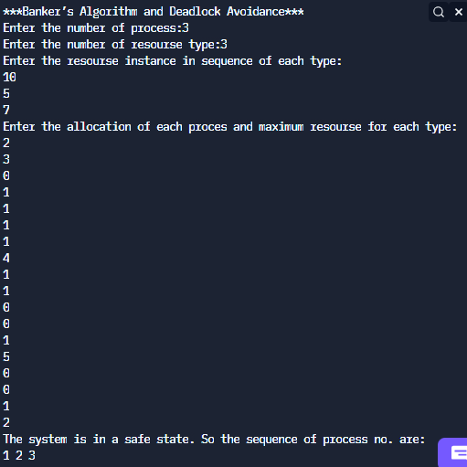

If the user chooses 3 then another figure will show

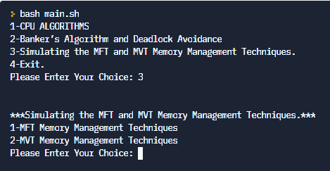

Now if the user chooses 1 then can see the simulation of the selectable algorithm.

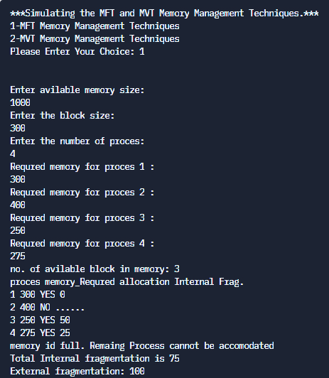

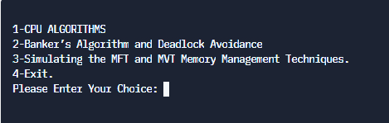

After above this figure, if the user chooses 4 then it will exit.

# Chapter 4

# Conclusion

## Scope of Future Work

We can add more algorithms such as the preemptive non preemptive version of the given CPU scheduling algorithm in this project. Also we can add GUI and more algorithms such as the preemptive non preemptive version of the given algorithm in this project.