**Deploy on AWS EC2**

1. **Create EC2**
   1. **Sign in AWS**

* 1. **Go EC2 Instances**

* 1. **Click Launch instance**

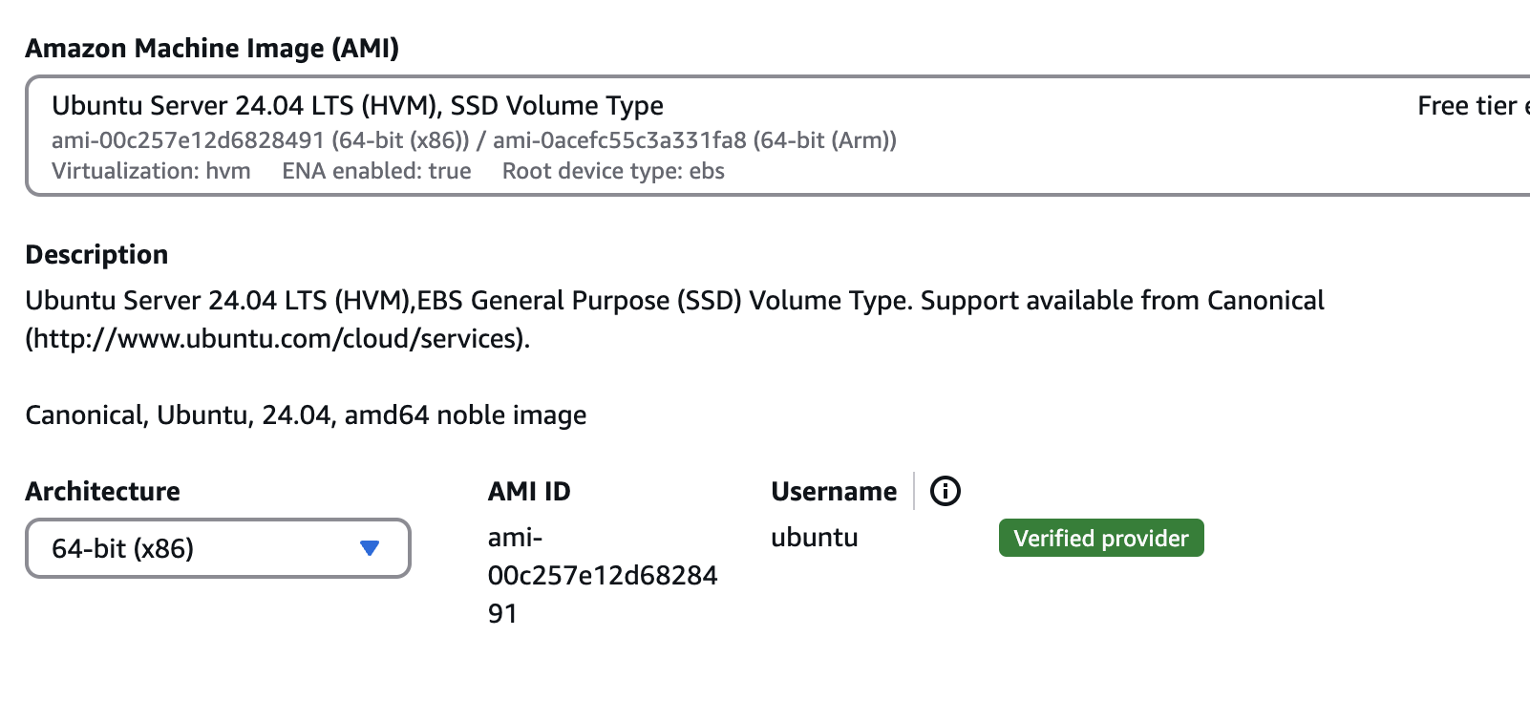

**

* 1. **Save the key pair in local directory**

* 1. **Network Setting**

Allow SSH and HTTPS

* 1. **Leave other settings as they are**
  2. **Click Launch instance**

1. **Connect with instance**

**2.1Check the instance is running**

**2.2 Open a terminal in local machine and trigger pem (key pair file), note that the password is the admin password for local machine**

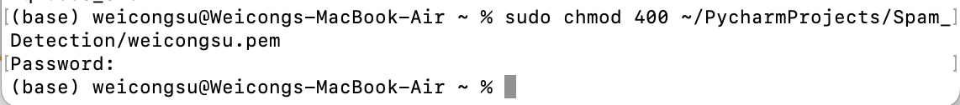

(sudo chmod 400 ~/../weicongsu.pem)

**2.3 Connect to instance via SSH**

Type ssh -i ~/PycharmProjects/Spam_Detection/weicongsu.pem [ubuntu@(**.**.***.*)](mailto:ubuntu@(**.**.***.*)) (*masked numbers can be obtained from ipv4 address for the instance)

