**TITLE (A SHORT DESCRIPTION OF THE PROJECT, BEWEEN 8 AND 12 WORDS**

|  |  |  |
| --- | --- | --- |
| Miguel Angel Zapata Jimenez  Universidad Eafit  Colombia  mazapataj@eafit.edu.co | Santiago Ochoa Castaño  Universidad Eafit  Colombia  sochoac1@eafit.edu.co | Mauricio Toro  Universidad Eafit  Colombia  mtorobe@eafit.edu.co |

# **ABSTRACT**

Para escribirlo pueden dar respuesta a estas preguntas: ¿Cuál es el problema?, ¿Por qué es importante el problema?, ¿Qué problemas relacionados hay?,

Considering new strategies to find the shortest route for a vehicle fleet that needs to deliver an inventory to a specific destination, would bring benefits in vehicle mobilization. However it is difficult to achieve that objective because there are different variants of this problem. Each one of them has a specific restriction. Such as limited load capacity, restricted hours, insufficient number of cars, and some other restrictions, which cause many algorithms to be made to satisfy those needs. In this case, backtracking can be a good solution to the problem searching the better route and eliminating the least feasible.

# **1. INTRODUCTION**

Electric vehicles have been a new alternative to reduce the air pollution from petrol or diesel cars. Electricity plays an important role, and represents zero emissions making better to the environment. However, the use of electric vehicles for charging and for passenger transport has a limitation: the driving range is limited and the battery charging time is relatively long.

# **2. PROBLEM**

The problem to be solved consists of designing an algorithm to find optimal routes for a group of electric vehicles to deliver merchandise to a set of customers. In this way, the time that takes to visit each customer, recharge the battery and finish the whole route will be minimized.

**3. RELATED WORK**

## **3.1 The Travelling Salesman (TSP)**

The travelling salesman consists in finding the shortest route for a person to complete a task given a specific group of destinations. The difficulty of this problem occurs at working with many places to visit because the algorithm must be in charge to verify the least distance or cost for each route.

The famous problem has different solutions. One of them is by using the Brute Force. This method finds the best route by comparing all possible permutations of routes to choose the shortest unique solution. In other words, it calculates the time that it takes to visit each distance, and finally choose the shortest time.

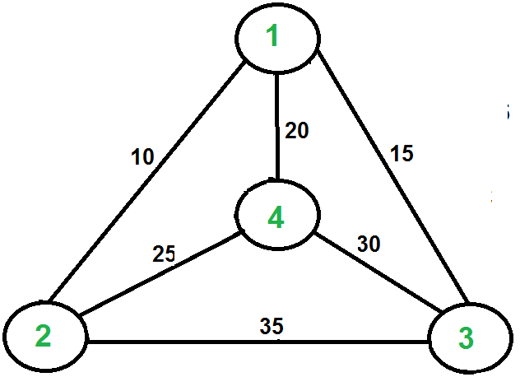

## **3.2 Profitable Vehicle Routing Problem with Multiple Trips**

The Vehicle Routing Problem(VRP) relates two variants which are the Profitable VRP and the VRP with Multiple trips. In relation with the profitability, it consists in the limitations to serve a group of customers due to the budget shortage or for insufficiency of the offer. On the other hand, with relation to the multiple trips, it means that a limited vehicle fleet has to perform several routes with a strict schedule.

The problem was solved through using two algorithms based on three-arrays: Hill Climbing algorithm and Variable Neighborhood Descent algorithm.

The Hill Climbing algorithm begins by iterating with an arbitrary solution, then tries a different solution by changing the search parameters. If the change produces a better solution, try a new one repeating the process until no improvements can be found.

The Variable Neighborhood descent algorithm performs a search by exploring distant locations or neighborhoods from the current solution and iterates until there are no further possible improvements.

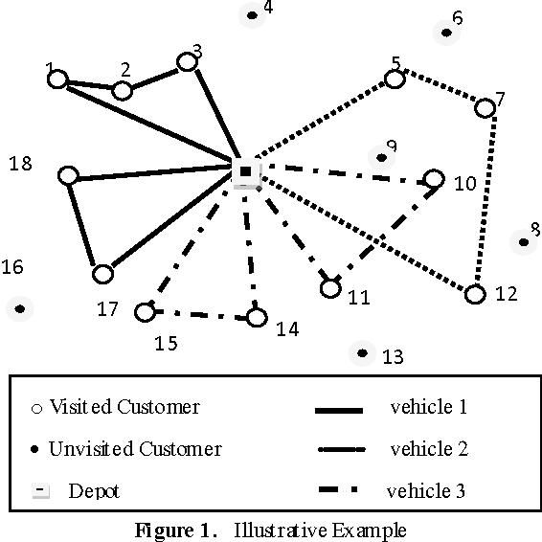

## **3.3 Capacitated Vehicle Routing Problem (CVRP)**

It consists in finding a route that does not require excessive consumption of time and resources. The difficulty is given because there is a limited load capacity and it must return to the main warehouse.

This problem has different solutions, but one of the most famous is the metaheuristics techniques, which is based on using the parameters provided by the user in order to find an efficient result. In this case, a depth search must be carried out, finding the routes that do not require too much time, in other words, backtracking must be implemented.

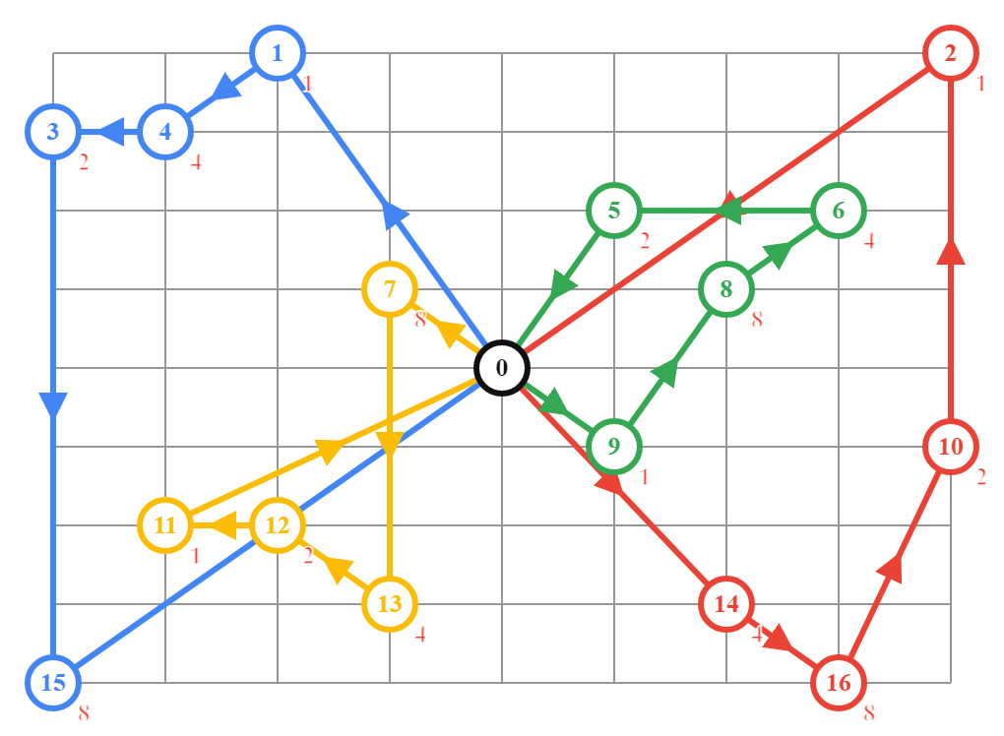

## **3.4 Heterogeneous vehicle routing problem with time windows and a limited number of resources (HVRPTW-LR):**

The problem arises when the available resources like vehicles, drivers or instruments to serve a subset of customers in a route planning are insufficient. For this reason, each route should be chosen by thinking about minimizing the travel costs and maximizing the total number of served customers.

In the first place, the solution is based in a semi-parallel insertion heuristic. In this way, it is improved by applying the Tabu Search algorithm for the exploration of each route which follows a series of patterns.

The Tabu Search algorithm increases the performance by using memory structures: At the moment of finding a potential solution it is marked as “Tabu” so the algorithm does not visit that possible solution again.

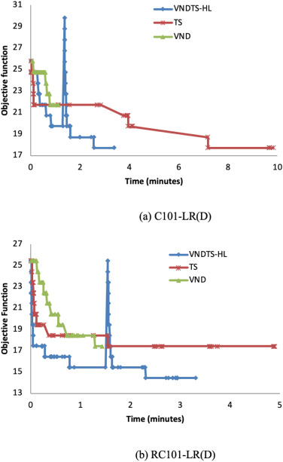

# **REFERENCES**

Reference sourced using ACM reference format. Read ACM guidelines in <http://bit.ly/2pZnE5g>

As an example, consider this two references:

1.Adobe Acrobat Reader 7, Be sure that the references sections text is Ragged Right, Not Justified. <http://www.adobe.com/products/acrobat/>.

2. Fischer, G. and Nakakoji, K. Amplifying designers’ creativity with domainoriented design environments. in Dartnall, T. ed. Artificial Intelligence and Creativity: An Interdisciplinary Approach, Kluwer Academic Publishers, Dordrecht, 1994, 343-364.