# **TITLE (A SHORT DESCRIPTION OF THE PROJECT, BEWEEN 8 AND 12 WORDS**

| Miguel Angel Zapata Jimenez  Universidad Eafit  Colombia  mazapataj@eafit.edu.co | Santiago Ochoa Castaño  Universidad Eafit  Colombia  sochoac1@eafit.edu.co | Mauricio Toro  Universidad Eafit  Colombia  mtorobe@eafit.edu.co |
| --- | --- | --- |

# **ABSTRACT**

Considering new strategies to find the shortest route for a vehicle fleet that needs to deliver an inventory to a specific destination, would bring benefits in vehicle mobilization. However, it is difficult to achieve that objective because there are different variants of this problem. Each one of them has a specific restriction. Such as limited load capacity, restricted hours, insufficient number of cars, and some other restrictions, which cause many algorithms to be made to satisfy those needs. In this case, backtracking can be a good solution to the problem searching the better route and eliminating the least feasible.

## **Keywords**

|  |
| --- |
| Heuristic, Computing Methodologies, Modeling and simulation,  Software system structure. |

# **1. INTRODUCTION**

Electric vehicles have been a new alternative to reduce the air pollution from petrol or diesel cars. Electricity plays an important role and represents zero emissions making better to the environment. However, the use of electric vehicles for charging and for passenger transport has a limitation: the driving range is limited and the battery charging time is relatively long.

# **2. PROBLEM**

The problem to be solved consists of designing an algorithm to find optimal routes for a group of electric vehicles to deliver merchandise to a set of customers. In this way, the time that takes to visit each customer, recharge the battery, and finish the whole route will be minimized.

## **3. RELATED WORK**

## **3.1 The Travelling Salesman (TSP)**

The travelling salesman consists in finding the shortest route for a person to complete a task given a specific group of destinations. The difficulty of this problem occurs at working with many places to visit because the algorithm must be in charge to verify the least distance or cost for each route.

The famous problem has different solutions. One of them is by using the Brute Force. This method finds the best route by comparing all possible permutations of routes to choose the shortest unique solution. In other words, it calculates the time that it takes to visit each distance, and finally choose the shortest time.

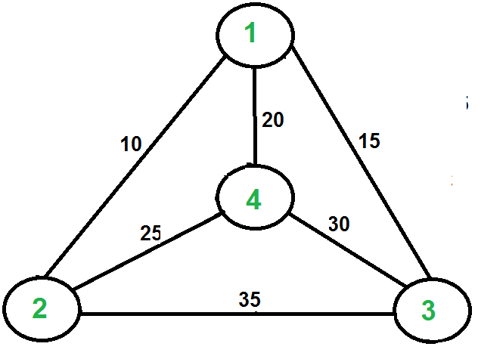

## **3.2 Profitable Vehicle Routing Problem with Multiple Trips**

The Vehicle Routing Problem(VRP) relates two variants which are the Profitable VRP and the VRP with Multiple trips. In relation with the profitability, it consists in the limitations to serve a group of customers due to the budget shortage or for insufficiency of the offer. On the other hand, with relation to the multiple trips, it means that a limited vehicle fleet must perform several routes with a strict schedule.

The problem was solved through using two algorithms based on three-arrays: Hill Climbing algorithm and Variable Neighborhood Descent algorithm.

The Hill Climbing algorithm begins by iterating with an arbitrary solution, then tries a different solution by changing the search parameters. If the change produces a better solution, try a new one repeating the process until no improvements can be found.

The Variable Neighborhood descent algorithm performs a search by exploring distant locations or neighborhoods from the current solution and iterates until there are no further possible improvements.

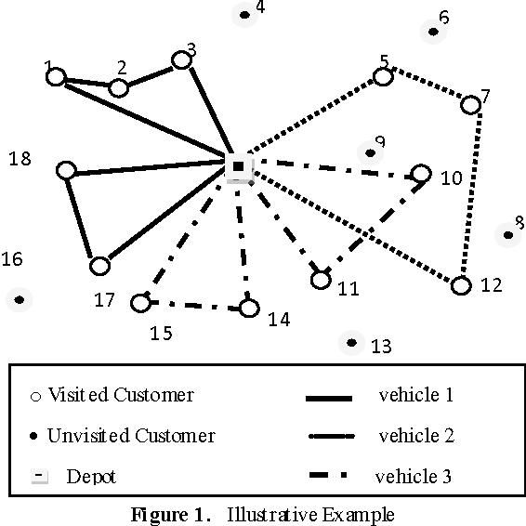

## **3.3 Capacitated Vehicle Routing Problem (CVRP)**

It consists in finding a route that does not require excessive consumption of time and resources. The difficulty is given because there is a limited load capacity, and it must return to the main warehouse.

This problem has different solutions, but one of the most famous is the metaheuristics techniques, which is based on using the parameters provided by the user to find an efficient result. In this case, a depth search must be carried out, finding the routes that do not require too much time, in other words, backtracking must be implemented.

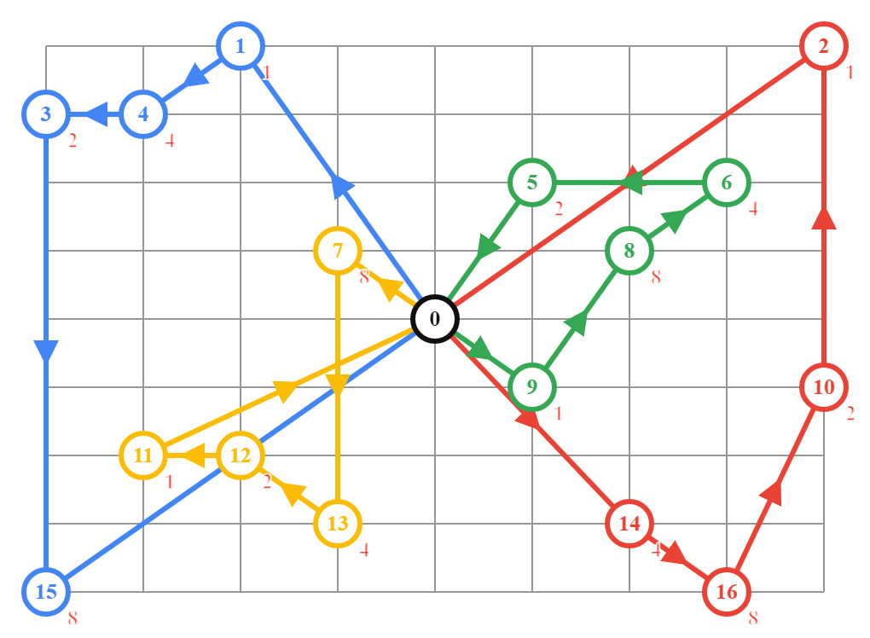

## **3.4 Heterogeneous vehicle routing problem with time windows and a limited number of resources (HVRPTW-LR):**

The problem arises when the available resources like vehicles, drivers, or instruments to serve a subset of customers in a route planning are insufficient. For this reason, each route should be chosen by thinking about minimizing the travel costs and maximizing the total number of served customers.

In the first place, the solution is based in a semi-parallel insertion heuristic. In this way, it is improved by applying the Tabu Search algorithm for the exploration of each route which follows a series of patterns.

The Tabu Search algorithm increases the performance by using memory structures: At the moment of finding a potential solution it is marked as “Tabu”, so the algorithm does not visit that possible solution again.

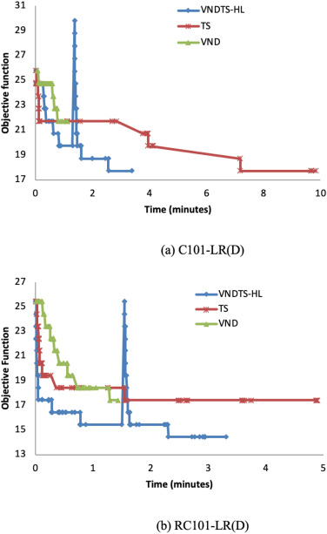

## **4. TITLE OF THE FIRST ALGORITHM DESIGNED**

## In what follows we explain the data structure and the algorithm.

## **4.1 Data Structure**

## An adjacence matrix is going to be implemented to represent the map of the city, where each node is placed. The value that are in the rows represent the distance between the nodes. (Figure 1).

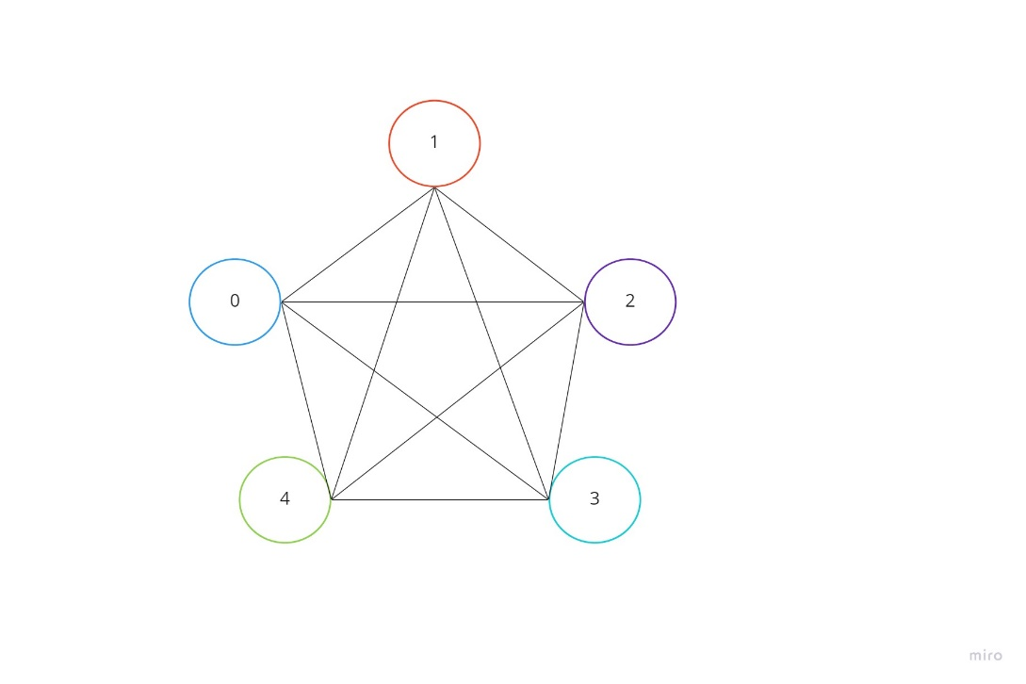

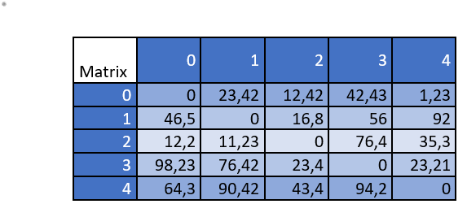

**Figure 1:** Adjacence matrix of places. Where can be seen the distance between two specific nodes.

## **4.2 Operations of the data structure**

Design the oepration of the data structure to solve the problem efficiently. Include one figure to explain each operation.

* **addArc***:* Method of adding a new arc, where each node is represented by an integer and a weight represented by a double is assigned as the distance between two nodes. (Figure 2).

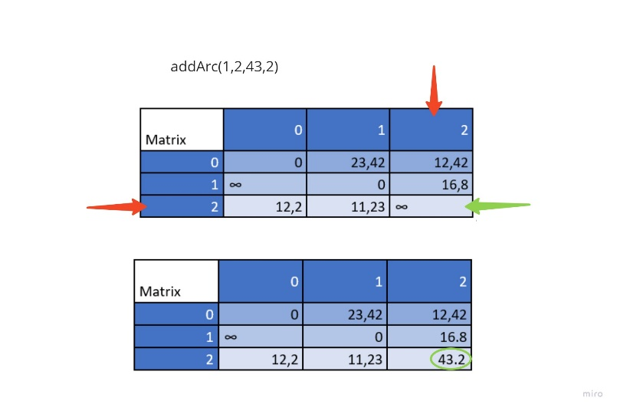

**Figure 2:** Add a weight between two nodes.

* **getWeight:** Method to obtain the weight or distance between two nodes. (Figure 3).

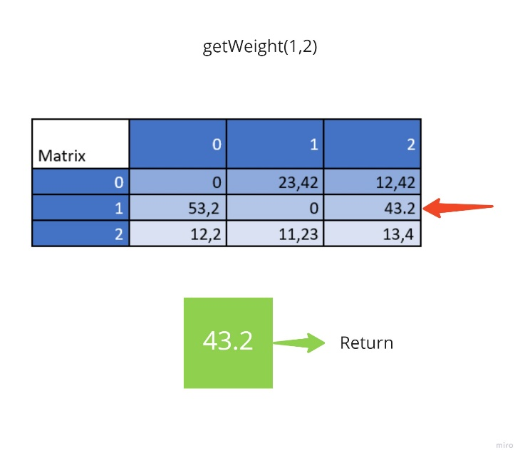

**Figure 3:** Obtain the weight of two nodes.

* **getSuccessors:** Method to obtain a list of children from a node, that is, all nodes associated to the node assigned as an argument. (Figure 4).

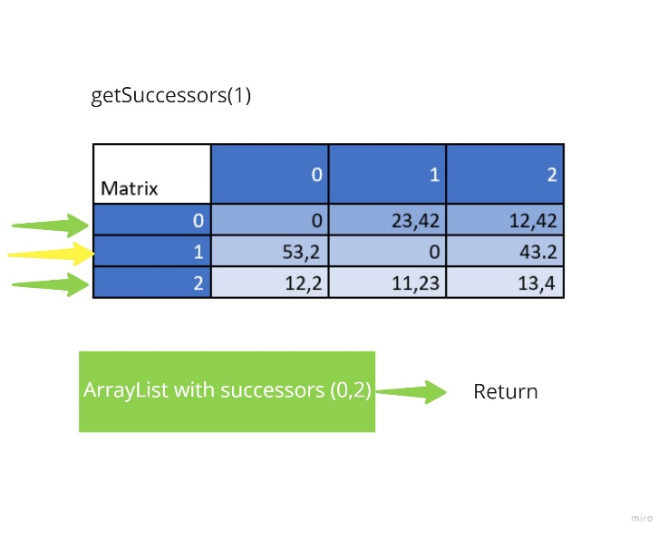

**Figure 4:** Obtain the successors of a node.

**4.3 Design criteria of the data structure**

The data structure that was considered to solve the problem was an adjacency matrix. In the first place, it was useful to represent an undirected finite graph which exemplify the city map. The elements of the matrix symbolize whether a pair of vertices are separated by a distance or not, that is, the edges in a graph. The distance value was calculated by finding the distance between two points. Furthermore, it was analyzed the efficiency in time and memory. Although inserting a new vertex or deleting has a complexity of O(v2), in this case the size of the matrix was specified when initializing, so it is no necessary to perform these operations. On the other hand, it was more important to search a distance with a complexity of O(1). In conclusion, the memory was a priority over time.

**4.4 Complexity analysis**

|  |  |
| --- | --- |
| **Method** | **Complexity** |
| addArc | O(1) |
| getWeight | O(1) |
| getSuccessors | O(n) |

**Note:** The letter n represents the number of nodes.

**Table 1:** Table to report complexity analysis.

**4.7 Algorithm**

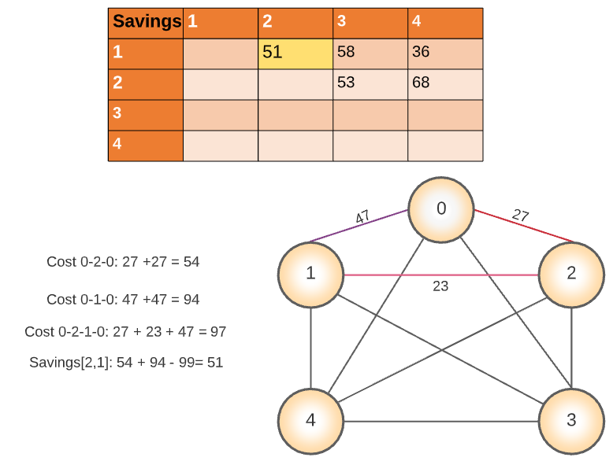

**Figure 5:** Calculations of savings for each pair of routes.

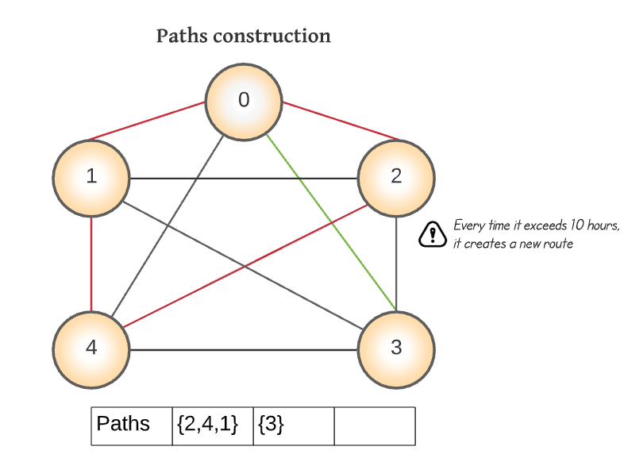

**Figure 6:** Array list representation to save a new path before exceeding the limit time.

**4.6** **Complexity analysis of the algorithm**

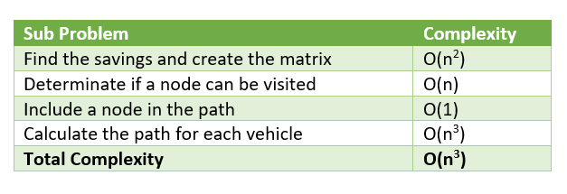**Table 2:** Complexity of each subproblem that is part of the algorithm. N represents the number of nodes in the graph.

**4.7 Design criteria of the algorithm**

The algorithm that was implemented was based in the Clarke-Wright algorithm. It is known the saving algorithm because it works by calculating the save between two routes to build different paths. The main idea is to determinate the possibility to merge two paths in a single path, after calculating how much time can be saved. The algorithm is beneficial to solve problems where the number of vehicles is not fixed. In this case, it cares more about finding an efficient route under time and battery constraints. Despite it is a heuristic algorithm which does not ensure the best solution, it is efficient to solve the problem without exceeding the maximum response time. Furthermore, during the different operations were used matrixes which allowed to search in O (1).

**4.8 Execution times**

Compute, execution time for each dataset in the ZIP file

## Measure execution time 100 times for each dataset and report average execution time.

|  |  |  |  |  |  |  |
| --- | --- | --- | --- | --- | --- | --- |
|  | ***Dataset 1*** | ***Dataset***  ***2*** | ***Dataset 3*** | ***Dataset***  ***4*** | ***Dataset***  ***5*** | ***Dataset 6*** |
| *Best case* | 4 s | 3 s | 4 s | 5 s | 6 s | 6 s |
| *Average case* | 14s | 9 s | 11 s | 12 s | 16 s | 14 s |
| *Worst case* | 24 s | 16 s | 18 s | 20 s | 26 s | 23 s |
|  | ***Dataset 7*** | ***Dataset***  ***8*** | ***Dataset 9*** | ***Dataset***  ***10*** | ***Dataset***  ***11*** | ***Dataset 12*** |
| *Best case* | 4 s | 3 s | 4 s | 5 s | 6 s | 6 s |
| *Average case* | 13 s | 10 s | 11 s | 14 s | 16 s | 14 s |
| *Worst case* | 22 s | 18 s | 19 s | 24 s | 26 s | 23 s |

## **Table 2:** Execution time of the algorithm for different datasets.

## **4.9 Memory consumption**

Measure memory consumption of the algorithm for different datasets

|  |  |  |  |  |  |
| --- | --- | --- | --- | --- | --- |
|  | ***Dataset 1*** | ***Dataset 2*** | ***Dataset***  ***3*** | ***Dataset 4*** | ***Dataset***  ***5*** |
| **Memory consumption** | 733 KB | 825 KB | 825 KB | 826 KB | 825 KB |
|  | ***Dataset 6*** | ***Dataset 7*** | ***Dataset***  ***8*** | ***Dataset 9*** | ***Dataset***  ***10*** |
| **Memory consumption** | 825 KB | 825 KB | 825 KB | 826 KB | 827 KB |

|  |  |  |  |
| --- | --- | --- | --- |
|  |  | ***Dataset 11*** | ***Dataset 12*** |
| **Memory consumption** |  | 824 KB | 826 KB |

## **Table 3:** Memory consumption of the algorithm for different datasets.

## **4.10 Analysis of the results**

Explain the results obtained. Make a table or a graph explaining the time and memory consumption.

|  |  |  |  |  |  |
| --- | --- | --- | --- | --- | --- |
|  | **Memory(KB)** | **Execution time** | **Number of clients** | **Number of vehicles** | **Total time** |
| (1) | 755 | 14 s | 320 | 33 | 159.52 |
| (2) | 826 | 9 s | 320 | 27 | 95.97 |
| (3) | 825 | 11 s | 320 | 29 | 119.29 |
| (4) | 826 | 12 s | 320 | 33 | 159.52 |
| (5) | 825 | 16 s | 320 | 27 | 95.97 |
| (6) | 825 | 14 s | 320 | 29 | 119.29 |
| (7) | 825 | 13 s | 320 | 33 | 159.52 |
| (8) | 825 | 10 s | 320 | 27 | 95.97 |
| (9) | 825 | 11 s | 320 | 29 | 119.29 |
| (10) | 826 | 14 s | 320 | 33 | 159.52 |
| (11) | 825 | 16 s | 320 | 27 | 95.97 |
| (12) | 826 | 14 s | 320 | 29 | 119.29 |

**Table 5:** Analysis of the results obtained from the algorithm execution.

# **REFERENCES**

1.AdobeAcrobat Reader 7, Be sure that the references section text is Ragged Right, Not Justified. <http://ww.adobe.com/products/acrobat/>.

2. Fischer, G. and Nakakoji, K. Amplifying designers’ creativity with domainoriented design environments. in Dartnall, T. ed. Artificial Intelligence and Creativity: An Interdisciplinary Approach, Kluwer Academic Publishers, Dordrecht, 1994, 343-364.