 

# Data

library(gapminder)

# **dplry**

library(dplyr)

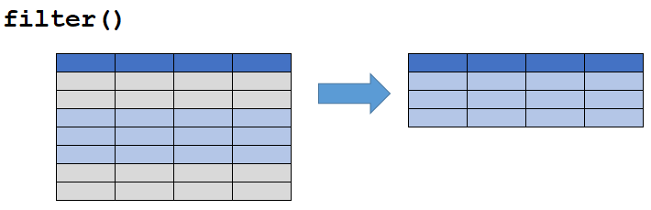

gapminder %>%

filter(year == 2007, country == "United States")

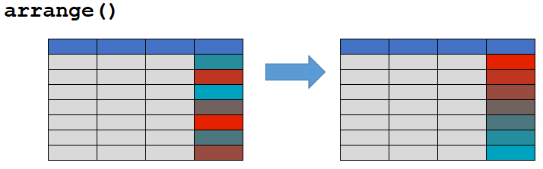

gapminder %>%

arrange(gdpPercap)

gapminder %>%

arrange(desc(gdpPercap))

gapminder %>%

filter(year == 2007) %>%

arrange(desc(gdpPercap))

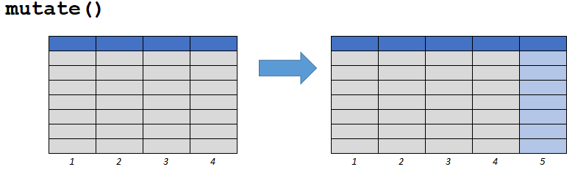

# Existing Column

gapminder %>%

mutate(pop = pop / 1000000)

# New Column

gapminder %>%

mutate(gdp = gdpPercap * pop)

# **ggplot2**

