Canton Fair 2026 · 20 media room location options
广交会 2026（第140届）· 媒体间选址 20 个方案
Twenty shortlisted rooms, halls, decks and rooftops for interviews and filmed conversations around the China Import and Export Fair Complex in Pazhou, Guangzhou. Each option carries a route map from the complex, real walking and driving times from OpenStreetMap routing, and Google Maps links. Fair traffic is a 2.2x allowance on the free-flow drive. Nothing here is booked.
Fair dates: Phase 1 15–19 Oct · Phase 2 23–27 Oct · Phase 3 31 Oct – 4 Nov 2026.

At a glance
# | Venue | Zone | Walk | Drive in fair traffic
01 | Canton Fair Complex · Official Press & Media Centre | Inside the halls | already in the building | 0 min
02 | Langham Place, Guangzhou | Across the street | 13 min walk (1.0 km) | 7 min in fair traffic
03 | Nan Fung International Convention & Exhibition Centre (NICEC) | Across the street | 13 min walk (1.0 km) | 7 min in fair traffic
04 | Courtyard by Marriott Guangzhou Pazhou | Attached to the complex | 17 min walk (1.3 km) | 9 min in fair traffic
05 | Shangri-La Hotel, Guangzhou | Across the footbridge | 19 min walk (1.4 km) | 13 min in fair traffic
06 | Pazhou Ferry Terminal riverside deck | Pazhou island | 12 min walk (0.9 km) | 13 min in fair traffic
07 | The Westin Pazhou | Attached to the complex | 22 min walk (1.7 km) | 9 min in fair traffic
08 | Canton Fair Complex · Area D (Phase IV) conference rooms | Inside the halls | 14 min walk (1.0 km) | 5 min in fair traffic
09 | InterContinental Guangzhou Exhibition Center | Next door | 15 min walk (1.1 km) | 9 min in fair traffic
10 | Poly World Trade Center Expo Hall | Next door | 25 min walk (1.9 km) | 7 min in fair traffic
11 | Guangzhou International Sourcing Centre | Pazhou island | 20 min walk (1.5 km) | 11 min in fair traffic
12 | Ali Center / Pazhou West AI & Digital Economy District | Pazhou island | 26 min walk (1.9 km) | 10 min in fair traffic
13 | Pazhou Bridge & Yuejiang Rd promenade | Pazhou island | 33 min walk (2.4 km) | 19 min in fair traffic
14 | Party Pier (Pearl River Brewery) | Canton Tower corridor | 35 min walk (2.6 km) | 10 min in fair traffic
15 | Haixin Bridge & Zhujiang New Town riverfront | Zhujiang New Town | 68 min walk (5.1 km) | 17 min in fair traffic
16 | Rosewood Guangzhou (CTF Finance Centre) | Zhujiang New Town | 62 min walk (4.7 km) | 15 min in fair traffic
17 | Canton Tower · observation decks and rotating restaurant | Canton Tower corridor | 57 min walk (4.3 km) | 15 min in fair traffic
18 | Park Hyatt Guangzhou · The Roof Bar (70F) | Zhujiang New Town | 66 min walk (4.9 km) | 16 min in fair traffic
19 | Guangzhou International Media Port (GRT) | Canton Tower corridor | 68 min walk (5.1 km) | 17 min in fair traffic
20 | Four Seasons Hotel Guangzhou (IFC) | Zhujiang New Town | 73 min walk (5.5 km) | 19 min in fair traffic

01. Canton Fair Complex · Official Press & Media Centre
广交会展馆 新闻中心（A区） · Inside the halls · 0.0 km straight line
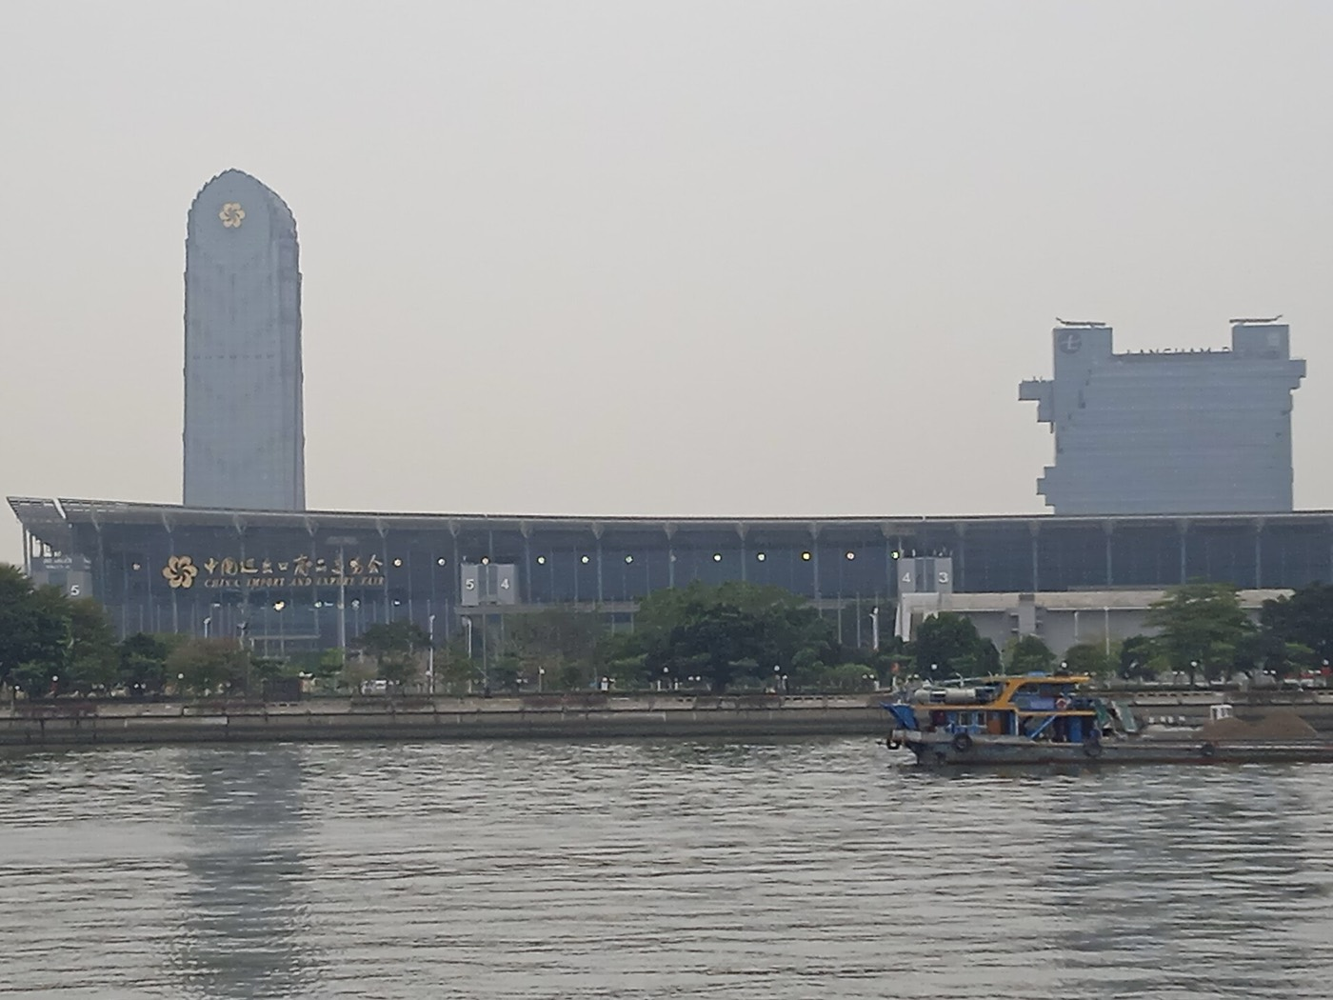  Canton Fair Complex Area A and Canton Fair Build — 中少 (CC BY-SA 4.0) | 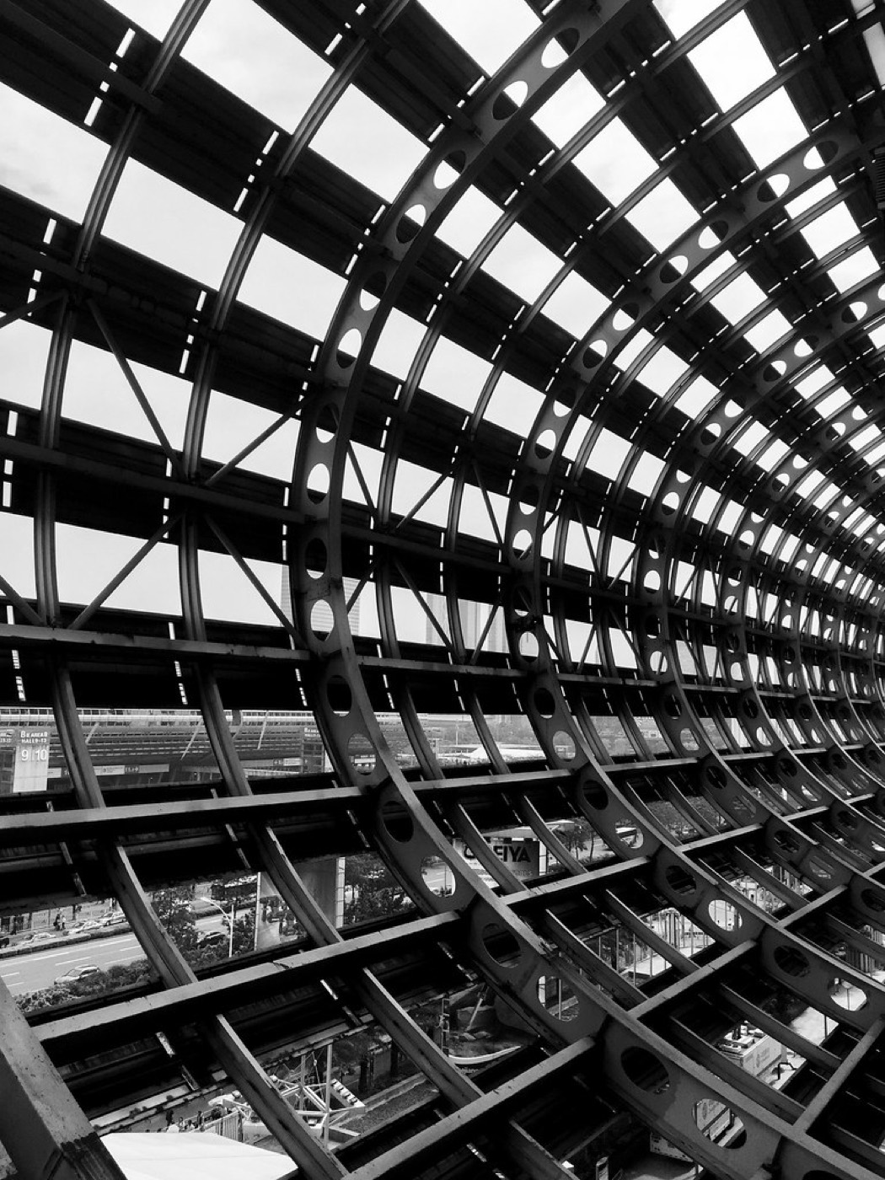  Canton Fair, Guangzhou, China — Fishyone1 (BY-NC-ND 2.0) | 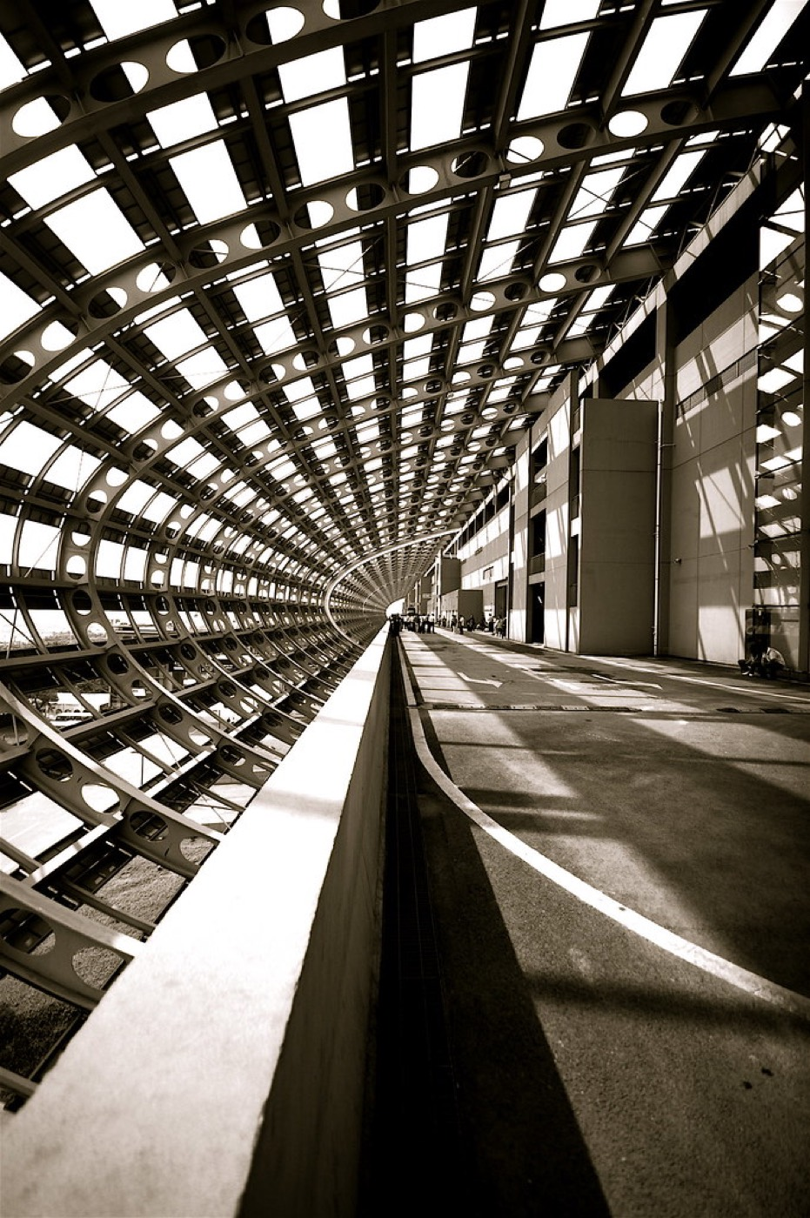  Canton Trade Fair 2 — tarotastic (BY 2.0)
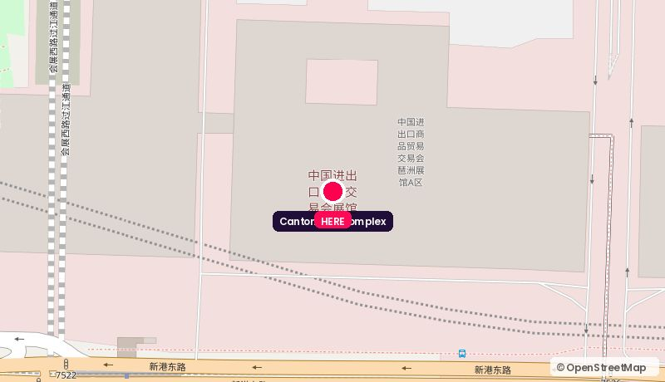
Route from the Canton Fair Complex. Map © OpenStreetMap contributors.
Address: Area A, China Import & Export Fair Complex, 380 Yuejiang Zhong Rd, Haizhu
Walk: already in the building
Drive: 0 min, allow 0 min during the fair
Backdrop: Canton Fair branding wall, hall floor through glass
Coordinates: 23.10344, 113.35412
Google Maps: https://www.google.com/maps/search/?api=1&query=23.10344,113.35412 | directions: https://www.google.com/maps/dir/?api=1&origin=23.10344,113.35412&destination=23.10344,113.35412&travelmode=driving
Tags: Free/accredited / Zero travel / No branding control
Why it works. The organiser's own press centre. Cheapest credibility in the building: accredited media are already there, and a guest walks in off the hall floor with a badge. Best for a same-day sit-down with a trade journalist.
Watch out. Controlled by China Foreign Trade Centre, so you get a slot, not a set. No branding freedom, no exclusivity, and no Canton Tower in shot.

02. Langham Place, Guangzhou
广州南丰朗豪酒店 · Across the street · 0.4 km straight line
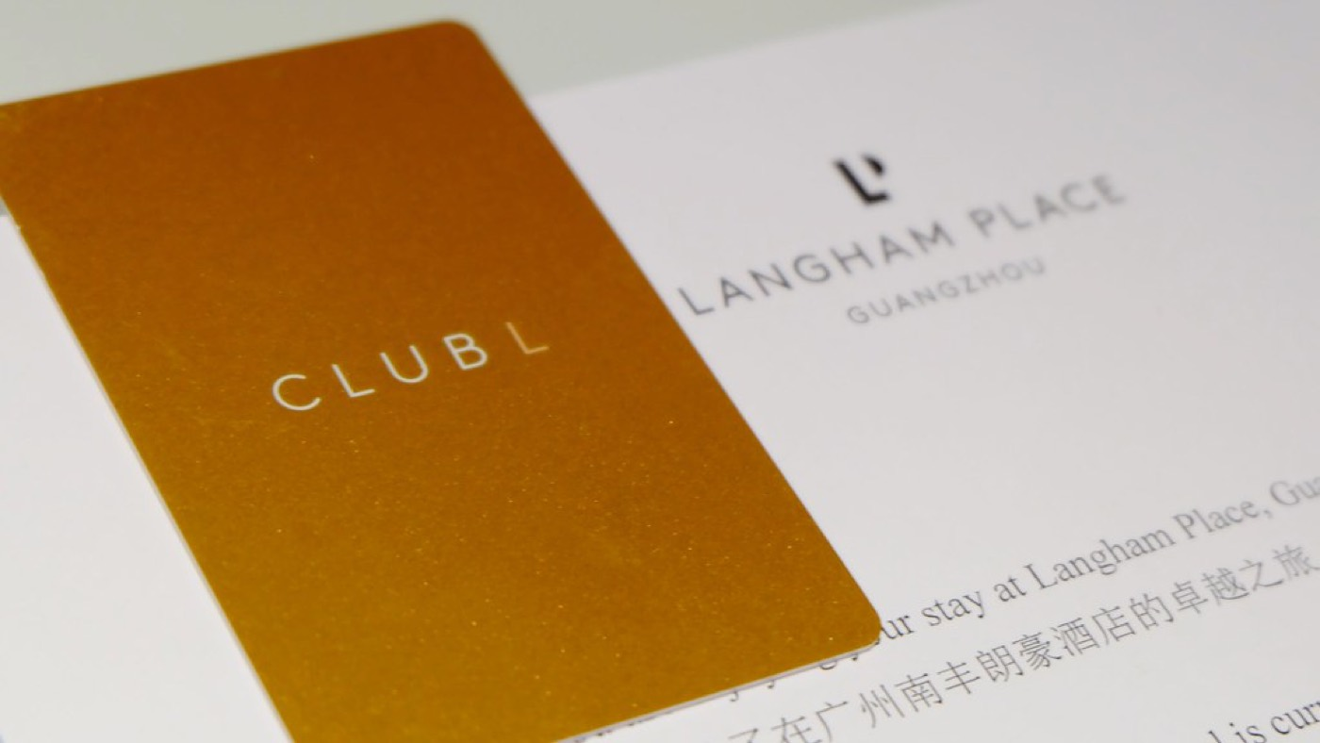  Executive Room - Langham Place Guangzhou — Matt@PEK (BY-NC-SA 2.0) | 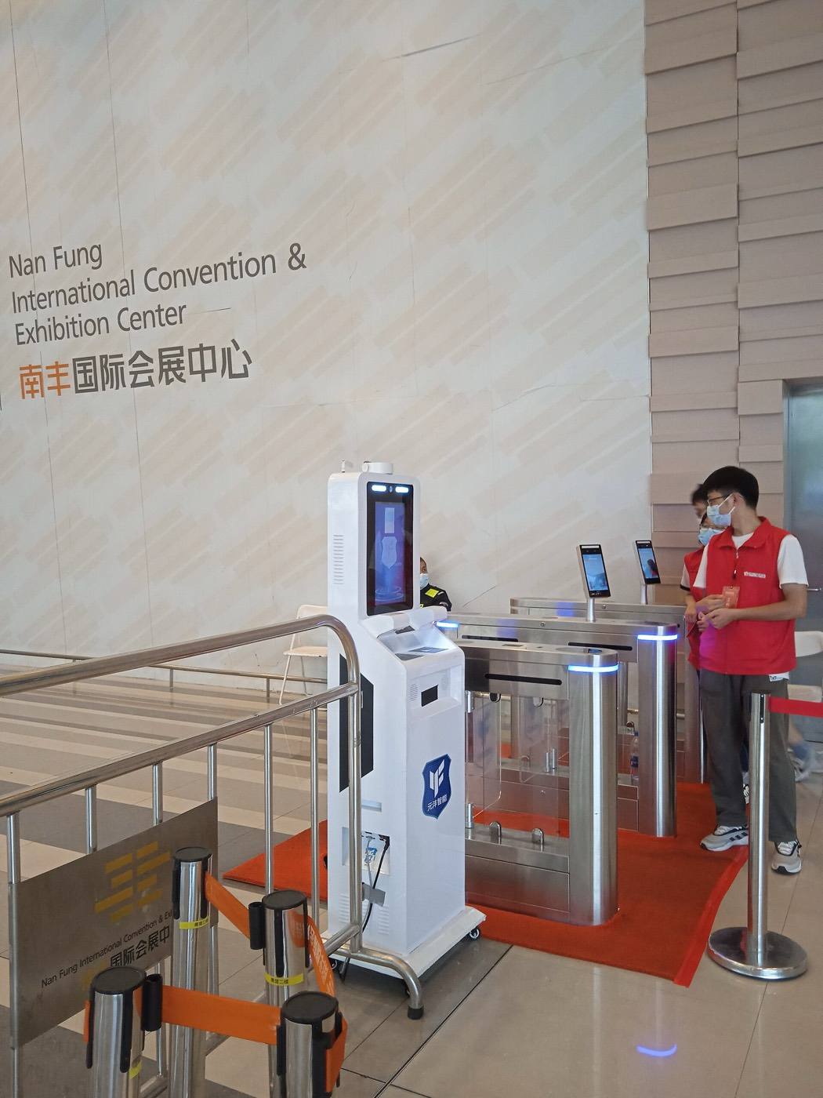  Nan Fung International Convention & Exhibition C — 中少 (CC BY-SA 4.0) | 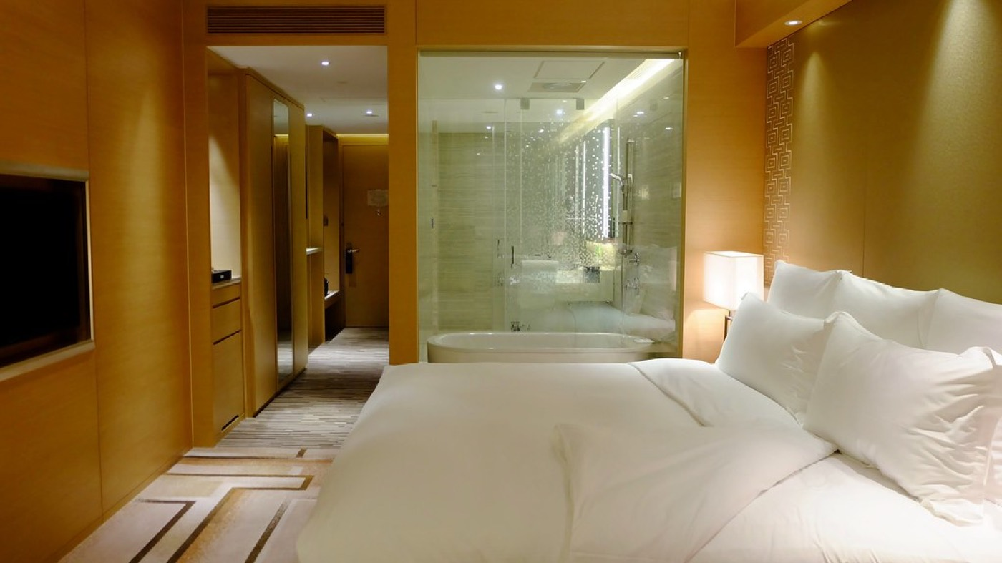  Executive Room - Langham Place Guangzhou — Matt@PEK (BY-NC-SA 2.0)
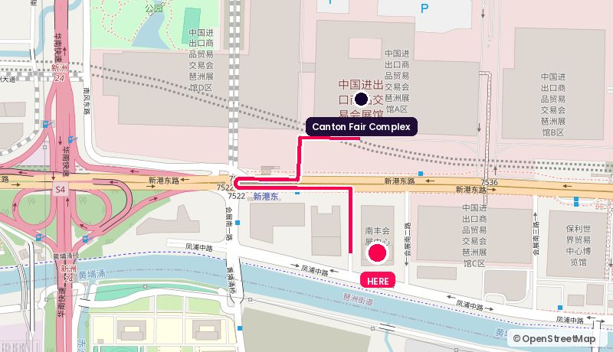
Route from the Canton Fair Complex. Map © OpenStreetMap contributors.
Address: 638 Xingang East Rd, Pazhou, Haizhu
Walk: 13 min walk (1.0 km)
Drive: 3 min drive (1.5 km), allow 7 min in fair traffic during the fair
Backdrop: Rooftop bar at night; Great Hall for a dressed set
Coordinates: 23.09947, 113.35459
Google Maps: https://www.google.com/maps/search/?api=1&query=23.09947,113.35459 | directions: https://www.google.com/maps/dir/?api=1&origin=23.10344,113.35412&destination=23.09947,113.35459&travelmode=walking
Tags: 5 min walk / Rooftop bar / Function rooms
Why it works. Directly opposite the complex, on top of the Nan Fung exhibition podium. The rooftop bar is the single easiest 'drinks-and-camera' set-up in Pazhou: you can run panel interviews by day in a function room and move the same guests upstairs for the evening piece.
Watch out. Rooftop is weather-dependent and shared with hotel guests unless you buy it out. Get the buy-out price before you build the run-of-show.

03. Nan Fung International Convention & Exhibition Centre (NICEC)
南丰国际会展中心 · Across the street · 0.4 km straight line
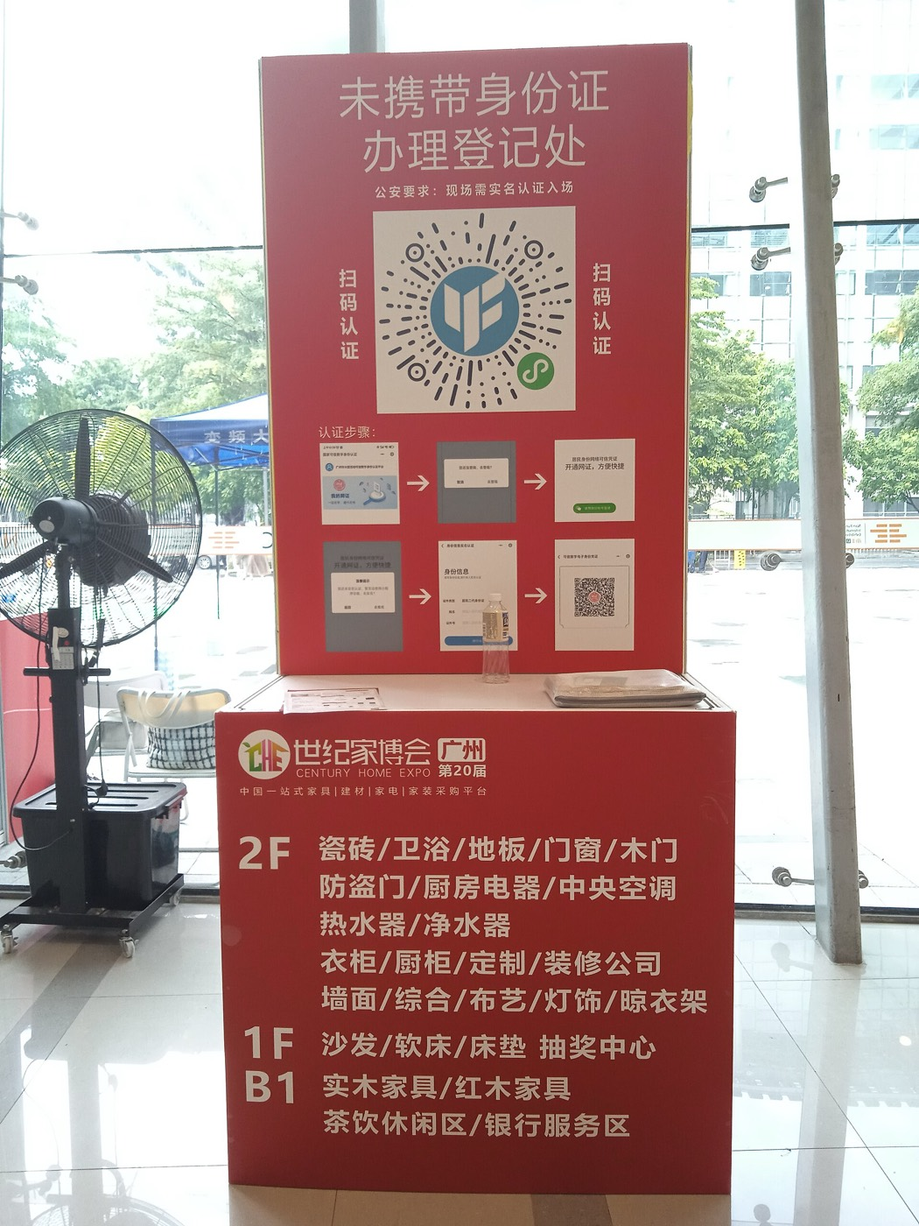  Nan Fung International Convention & Exhibition C — 中少 (CC BY-SA 4.0) | Nan Fung International Convention & Exhibition C — 中少 (CC BY-SA 4.0) | 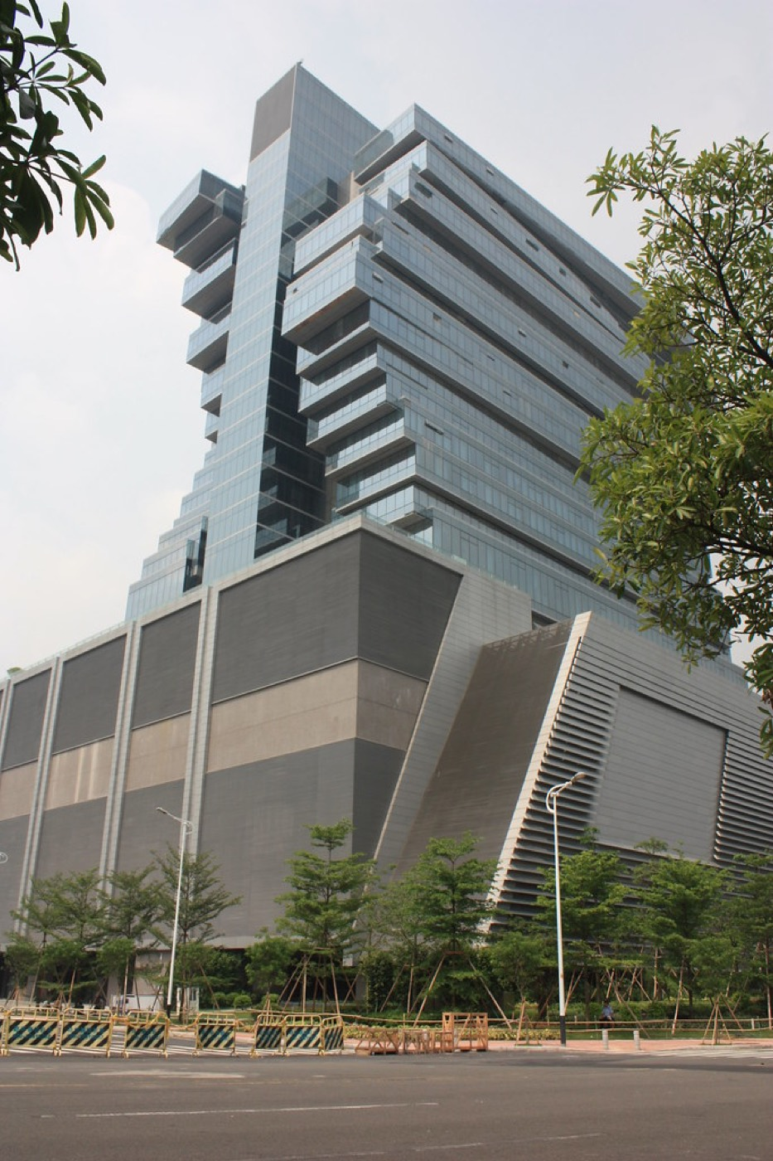  Nan Fung International Convention& Exhibition Ce — Colt International Limited (BY-NC-ND 2.0)
Route from the Canton Fair Complex. Map © OpenStreetMap contributors.
Address: 630–638 Xingang East Rd, next to Xingang Dong station Exit F
Walk: 13 min walk (1.0 km)
Drive: 3 min drive (1.5 km), allow 7 min in fair traffic during the fair
Backdrop: Blank-canvas hall: build the set you want
Coordinates: 23.09947, 113.35459
Google Maps: https://www.google.com/maps/search/?api=1&query=23.09947,113.35459 | directions: https://www.google.com/maps/dir/?api=1&origin=23.10344,113.35412&destination=23.09947,113.35459&travelmode=walking
Tags: Build your own set / 5 min walk / Metro Exit F
Why it works. Four halls, 25,000 sqm, in the same podium as Langham Place. Take a corner of a hall and build a proper studio: black drape, LED wall, two sets, holding room. This is the option if you want the media room to look like WorldFirst, not like a hotel.
Watch out. Build cost and rigging time. You are paying for square metres and a crew, not a ready room. Needs a 2-day bump-in.

04. Courtyard by Marriott Guangzhou Pazhou
广交会万怡酒店 · Attached to the complex · 0.5 km straight line
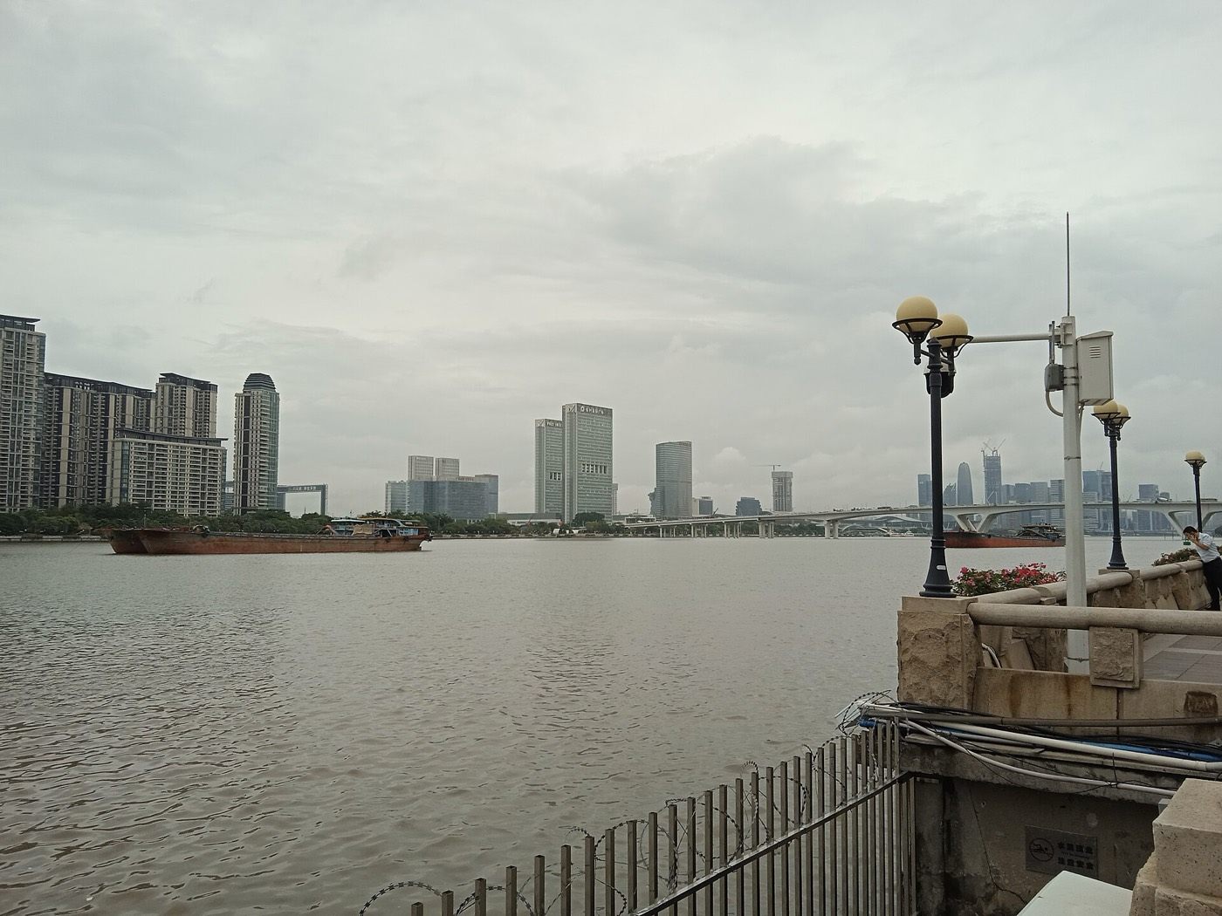  Pearl River side in Guangzhou Pazhou 20220930-02 — 中少 (CC BY-SA 4.0) | 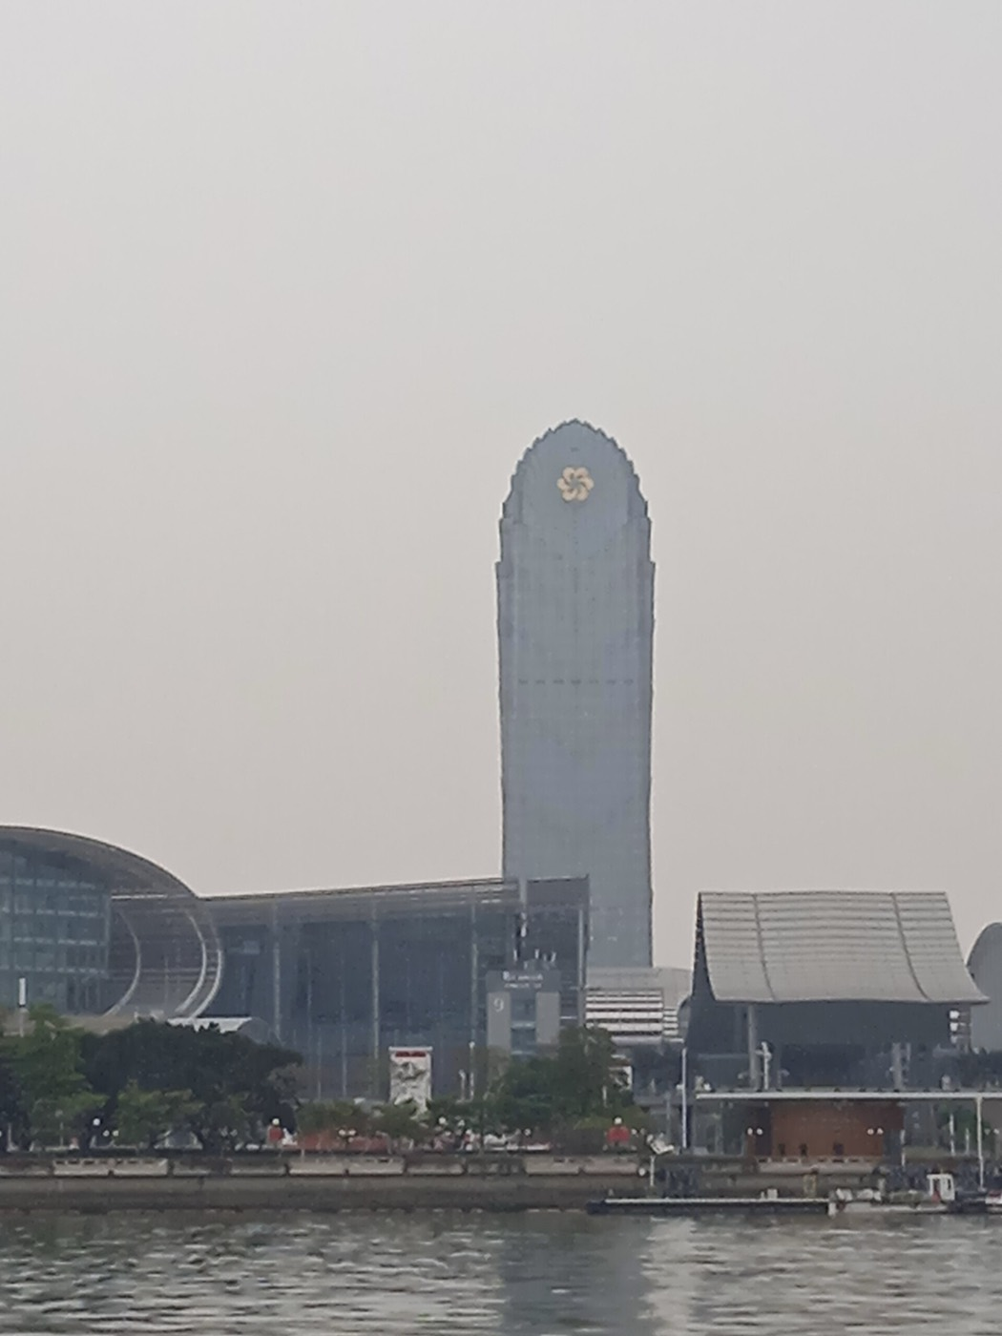  Canton Fair Complex and Canton Fair Building — 中少 (CC BY-SA 4.0) | 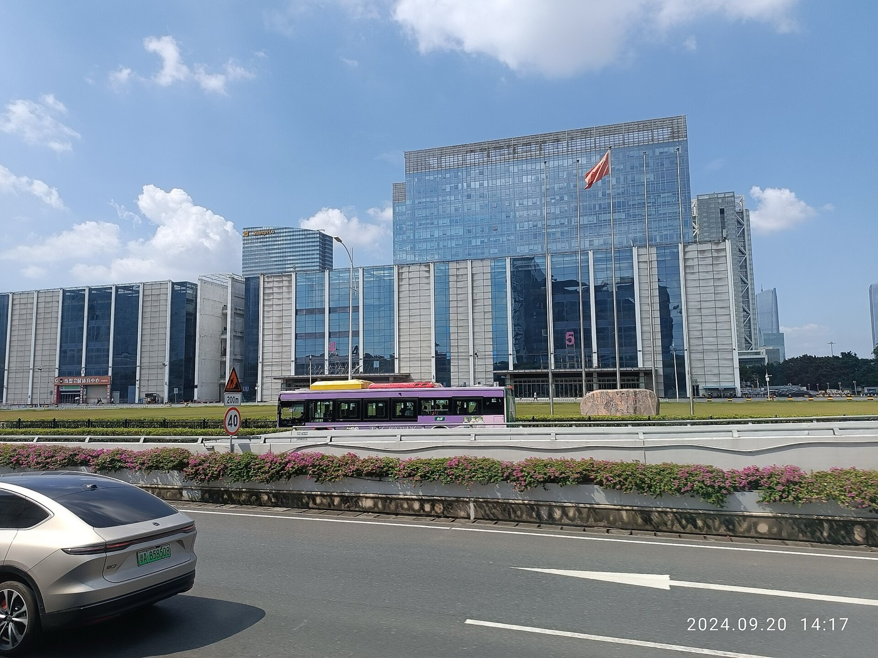  GZ Shenzhen to GZ Guangzhou interCity Tour bus v — Ghaud Lnegauk (CC0)
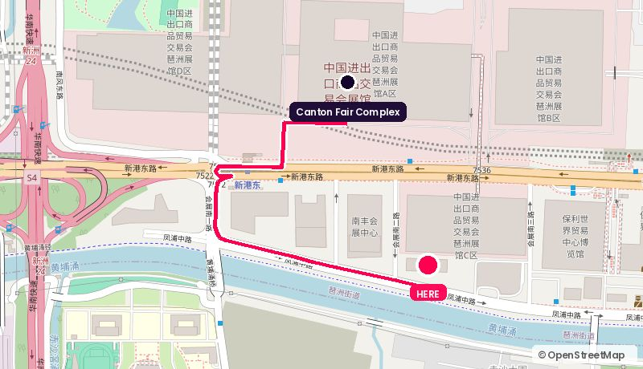
Route from the Canton Fair Complex. Map © OpenStreetMap contributors.
Address: Fengpu Zhong Rd, Pazhou, Haizhu
Walk: 17 min walk (1.3 km)
Drive: 4 min drive (2.0 km), allow 9 min in fair traffic during the fair
Backdrop: Neutral meeting rooms, easy to brand
Coordinates: 23.09895, 113.35625
Google Maps: https://www.google.com/maps/search/?api=1&query=23.09895,113.35625 | directions: https://www.google.com/maps/dir/?api=1&origin=23.10344,113.35412&destination=23.09895,113.35625&travelmode=walking
Tags: Budget-sane / Connected / Multiple rooms
Why it works. The pragmatic backup. Direct connectivity to the halls, meeting rooms at a fraction of the five-star rate, and enough of them that you can hold two in parallel: one for interviews, one as a green room.
Watch out. No view and no wow. Only worth it if the story is the guest, not the city.

05. Shangri-La Hotel, Guangzhou
广州香格里拉大酒店 · Across the footbridge · 0.6 km straight line
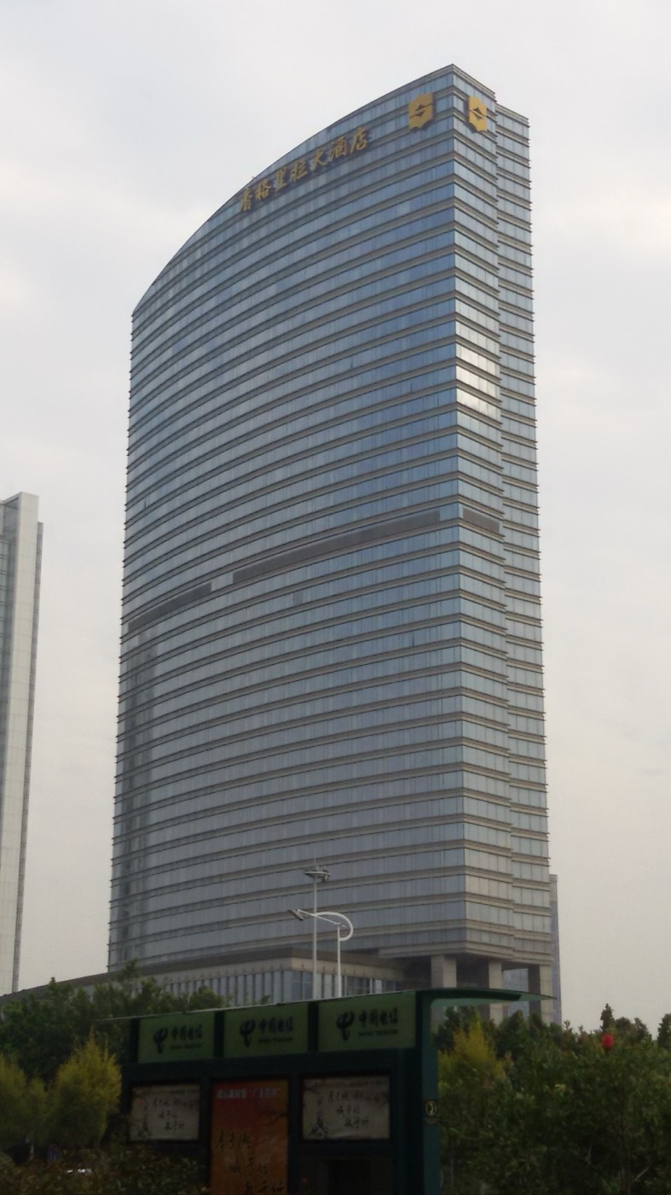  Guangzhou Shagri-La Hotel — CRCHF (CC BY-SA 3.0) | 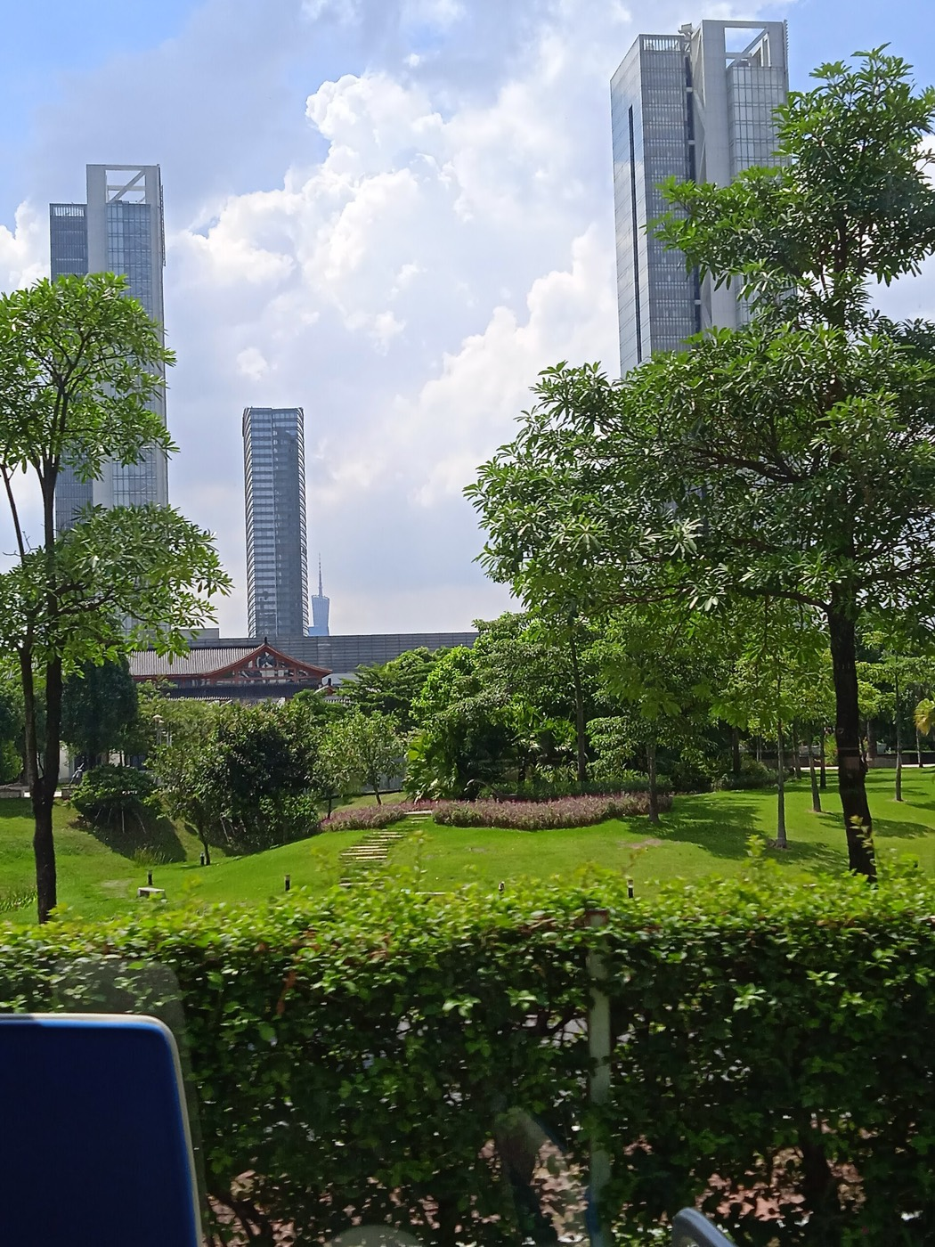  Guangzhou Poly International Plaza, Guangzhou Sh — 中少 (CC BY-SA 4.0) | Guangzhou Shagri-La Hotel — CRCHF (BY-SA 3.0)
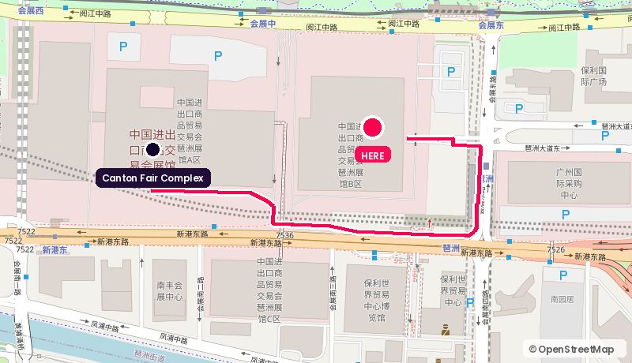
Route from the Canton Fair Complex. Map © OpenStreetMap contributors.
Address: 1 Huizhan East Rd, Pazhou, Haizhu
Walk: 19 min walk (1.4 km)
Drive: 6 min drive (3.3 km), allow 13 min in fair traffic during the fair
Backdrop: River-view rooms and riverside terrace; Canton Tower visible up-river on a clear day
Coordinates: 23.10400, 113.36010
Google Maps: https://www.google.com/maps/search/?api=1&query=23.10400,113.36010 | directions: https://www.google.com/maps/dir/?api=1&origin=23.10344,113.35412&destination=23.10400,113.36010&travelmode=walking
Tags: Footbridge to Area A / River view / Press-experienced
Why it works. The default 'serious meeting' hotel for Canton Fair. Covered walkway straight into Area A, river-facing function rooms, and the staff have run press for the fair for twenty years. Lowest-risk five-star option.
Watch out. The most requested hotel in Pazhou during the fair. If you want this, book it before you finalise the guest list.

06. Pazhou Ferry Terminal riverside deck
琶洲码头 珠江岸边 · Pazhou island · 0.6 km straight line
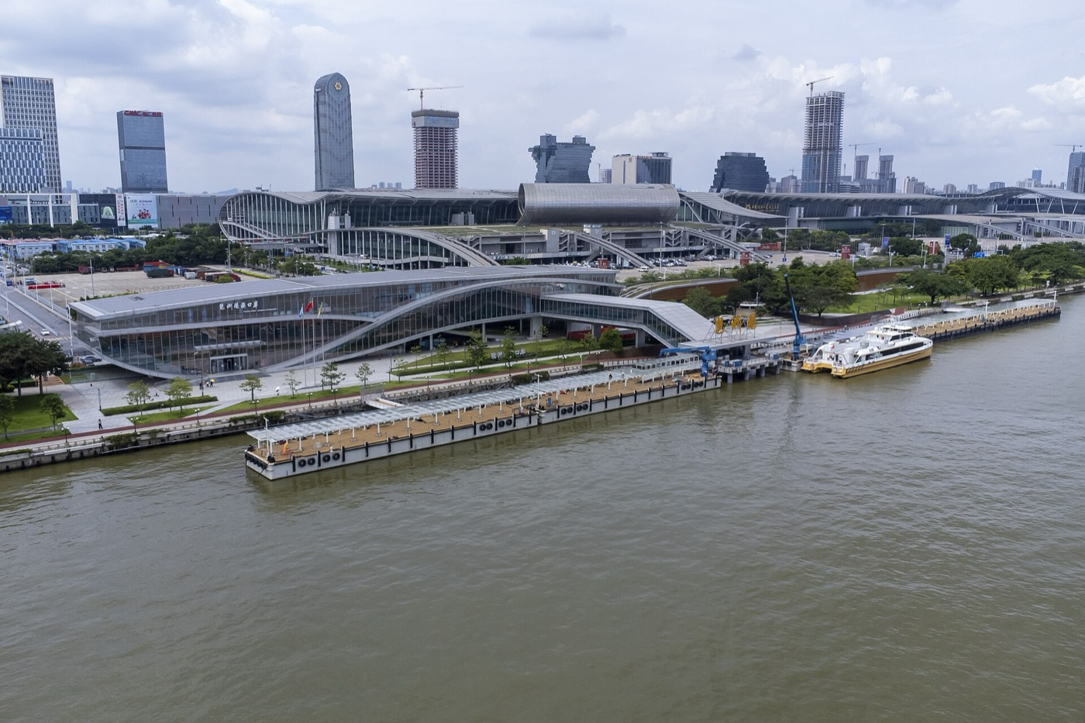  Exterior, Pazhou Ferry Terminal, Guangzhou 20230 — Tim Wu (CC BY-SA 4.0) | 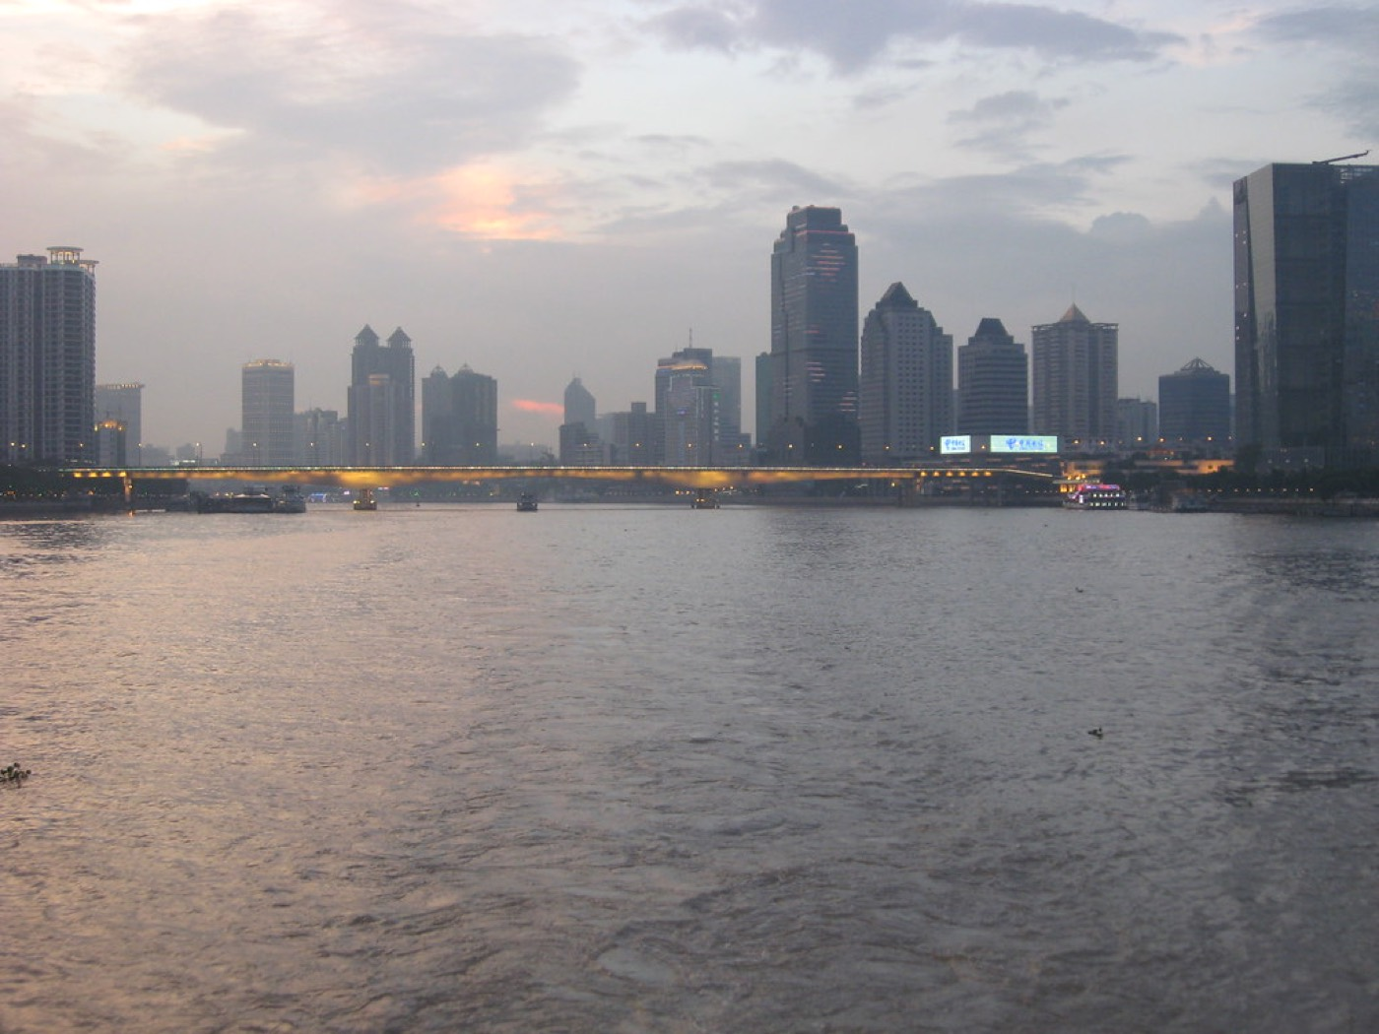  Pearl River - Guangzhou — WabbitWanderer (BY-SA 2.0) | 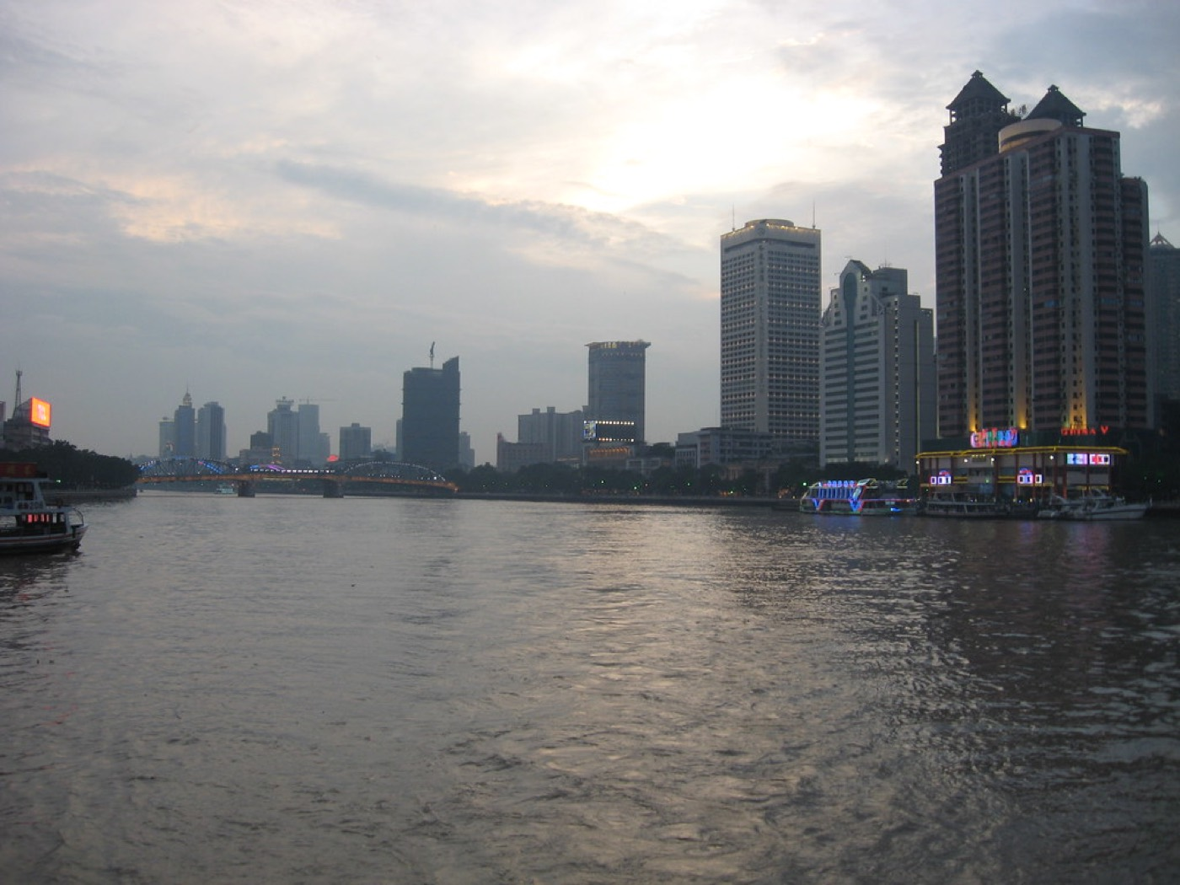  Pearl River - Guangzhou — WabbitWanderer (BY-SA 2.0)
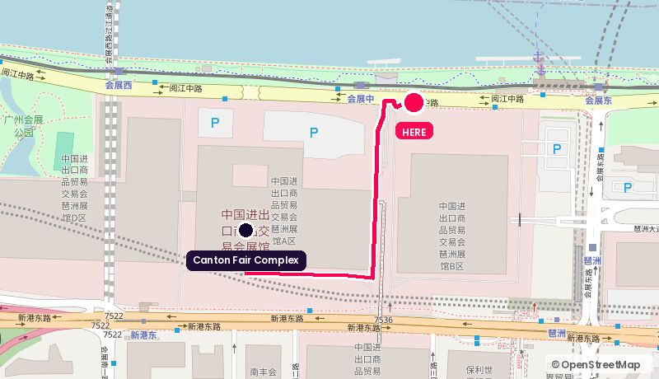
Route from the Canton Fair Complex. Map © OpenStreetMap contributors.
Address: Yuejiang Zhong Rd riverfront, north of the complex
Walk: 12 min walk (0.9 km)
Drive: 6 min drive (3.1 km), allow 13 min in fair traffic during the fair
Backdrop: Open Pearl River, ferries, Canton Tower up-river at dusk
Coordinates: 23.10650, 113.35850
Google Maps: https://www.google.com/maps/search/?api=1&query=23.10650,113.35850 | directions: https://www.google.com/maps/dir/?api=1&origin=23.10344,113.35412&destination=23.10650,113.35850&travelmode=walking
Tags: Free / Outdoor / Golden hour
Why it works. Free, outdoors, and two minutes from Area A. The strongest cheap option for a walk-and-talk or a stand-up piece with real river traffic behind the guest. Golden hour here is the best-value shot in Pazhou.
Watch out. Public space: permits for tripods and crew, no power, no weather cover, and the light window is about forty minutes.

07. The Westin Pazhou
广交会威斯汀酒店 · Attached to the complex · 0.7 km straight line
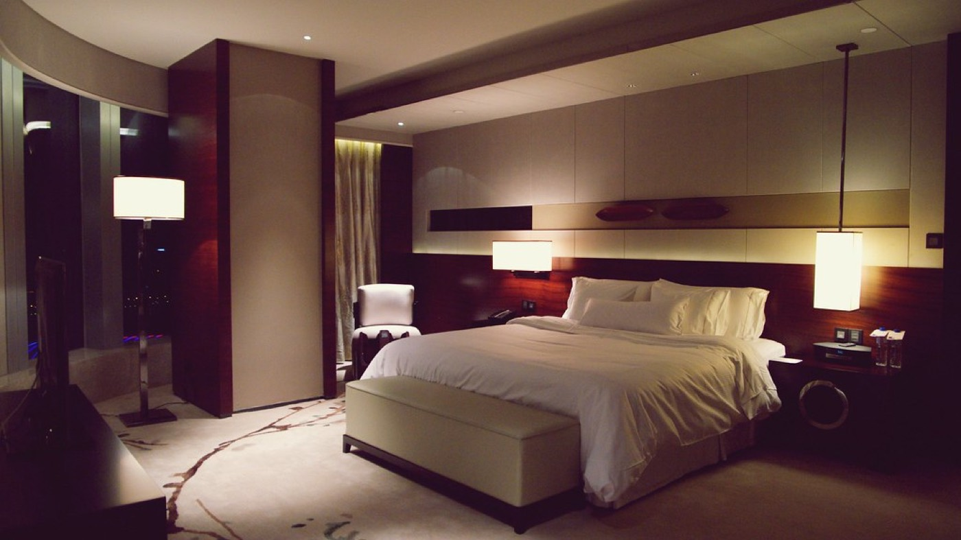  Renewal Suite - Westin Pazhou, Guangzhou — Matt@CKG (BY-NC-SA 2.0) | 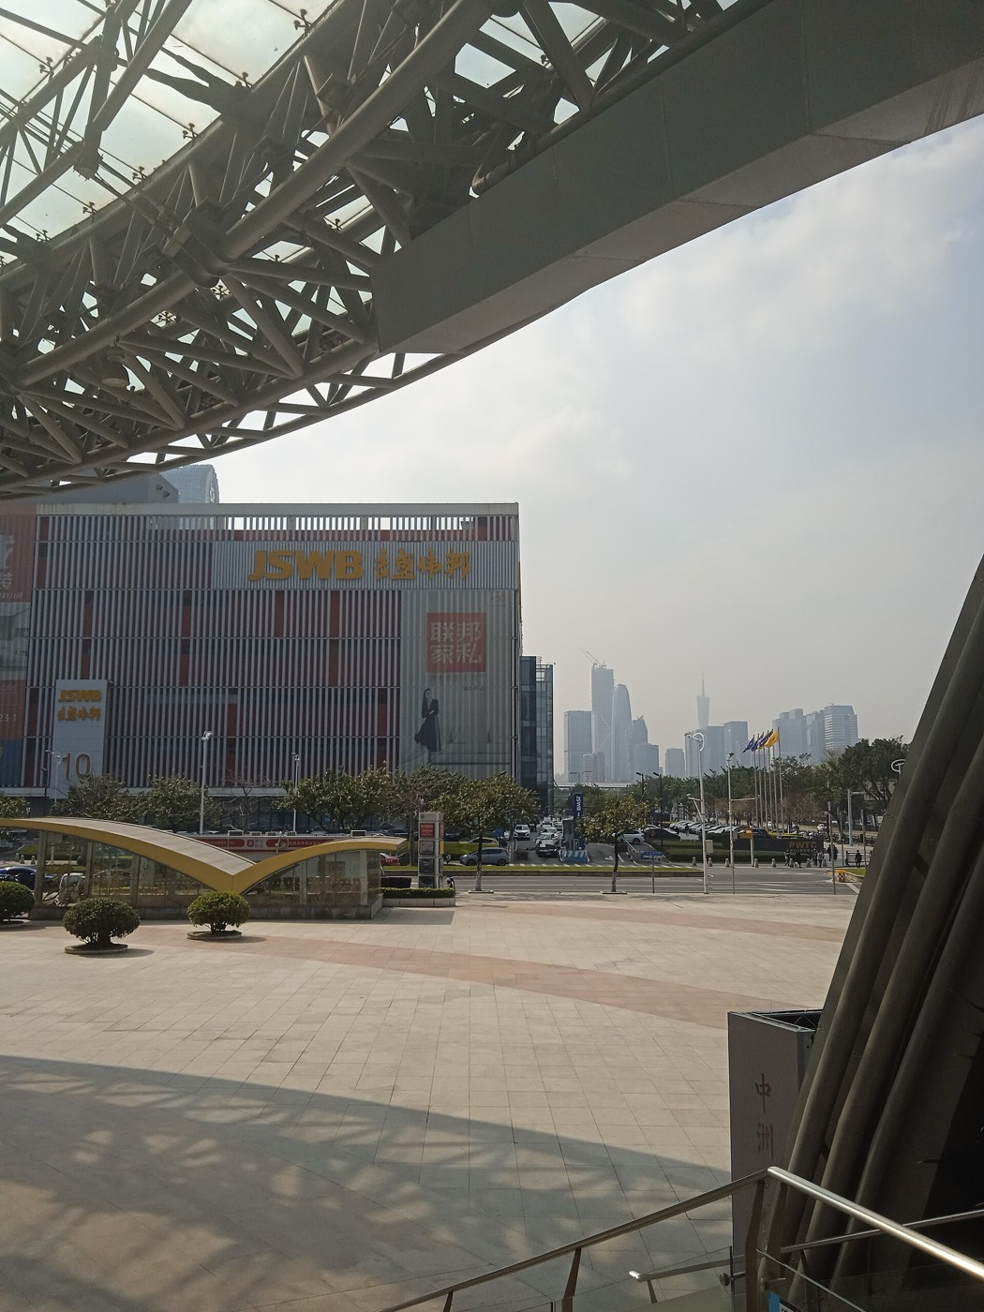  Pazhou Central Area and Pazhou West Area — 中少 (CC BY-SA 4.0) | 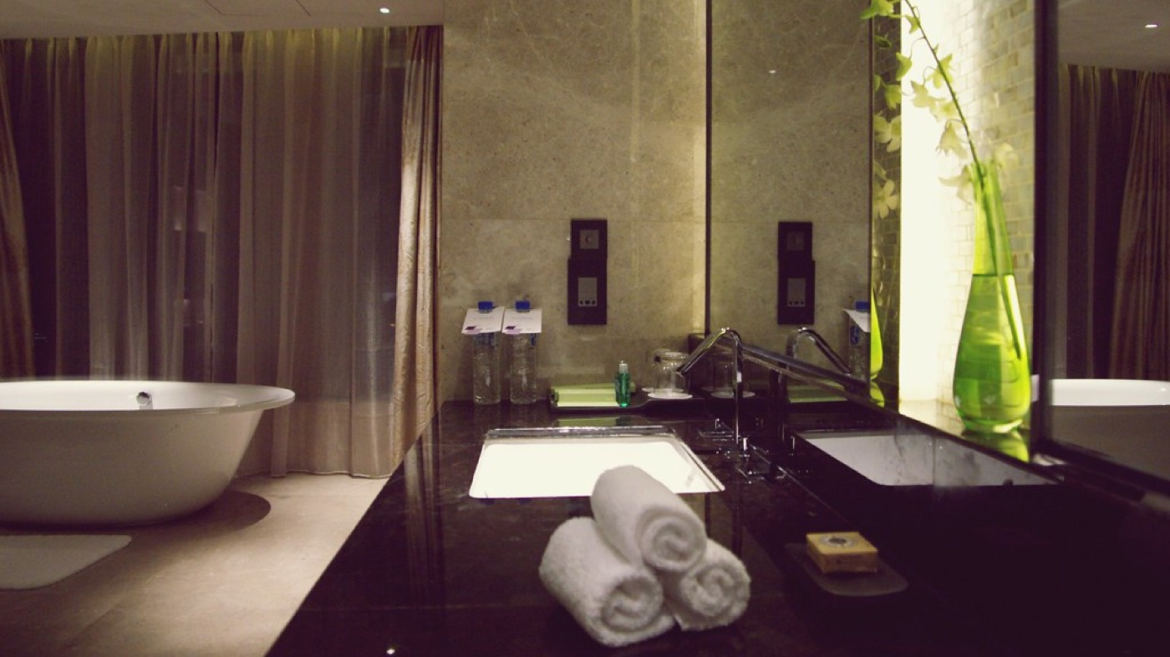  Renewal Suite - Westin Pazhou, Guangzhou — Matt@CKG (BY-NC-SA 2.0)
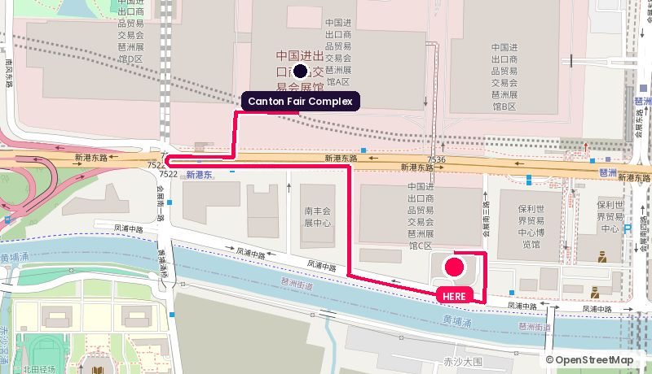
Route from the Canton Fair Complex. Map © OpenStreetMap contributors.
Address: 681 Fengpu Zhong Rd, Pazhou, Haizhu
Walk: 22 min walk (1.7 km)
Drive: 4 min drive (1.9 km), allow 9 min in fair traffic during the fair
Backdrop: Top-floor Prego with Pearl River and skyline; ballroom pre-function for a branded wall
Coordinates: 23.09870, 113.35817
Google Maps: https://www.google.com/maps/search/?api=1&query=23.09870,113.35817 | directions: https://www.google.com/maps/dir/?api=1&origin=23.10344,113.35412&destination=23.09870,113.35817&travelmode=driving
Tags: Connected to venue / 5-star / High floor
Why it works. Sits at Area C of the complex and is where a lot of senior buyers actually stay. A suite or the top-floor restaurant gives you a private room plus a high-floor window without anyone leaving the site.
Watch out. Peak fair weeks: rooms go to the hotel's own corporate bookings months out. Lock a suite in a single booking with the F&B space.

08. Canton Fair Complex · Area D (Phase IV) conference rooms
广交会展馆四期 会议区 · Inside the halls · 0.7 km straight line
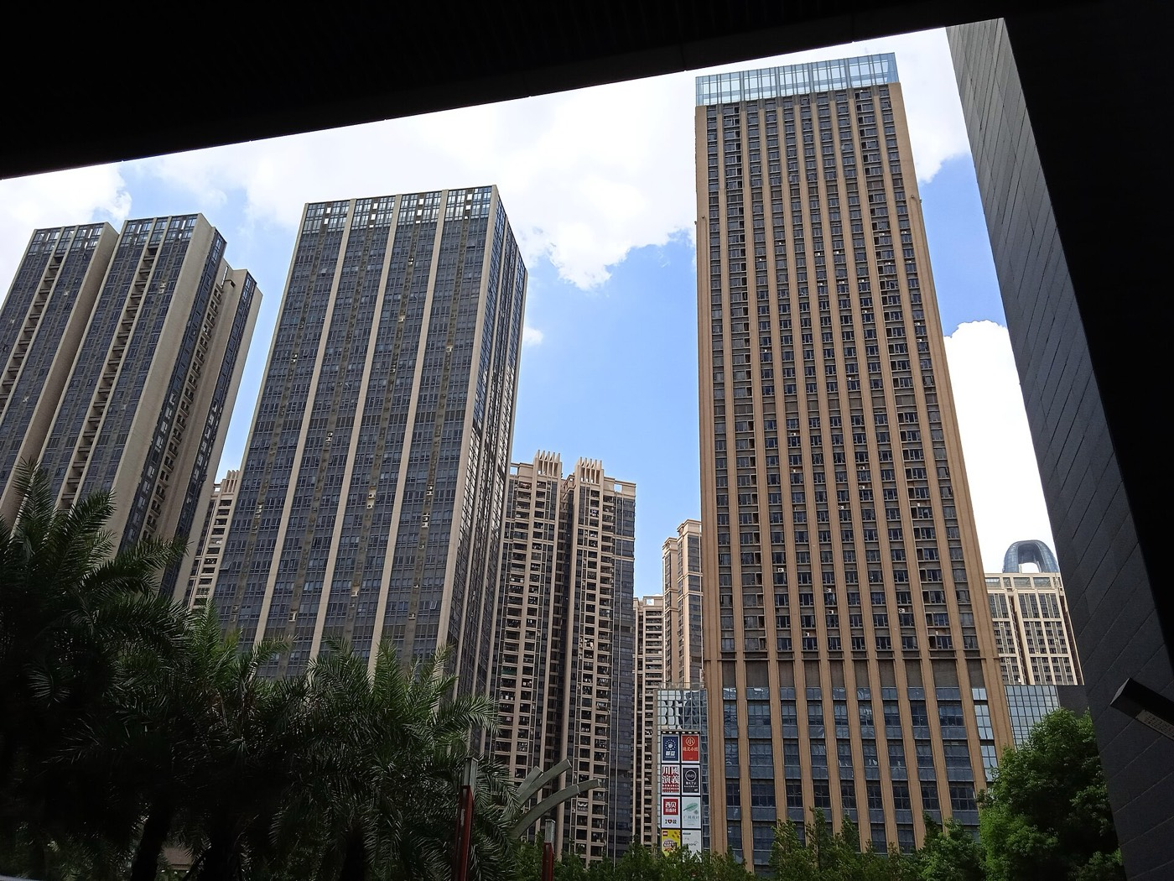  Guangzhou Pazhou Poly Plaza — 中少 (CC BY-SA 4.0) | 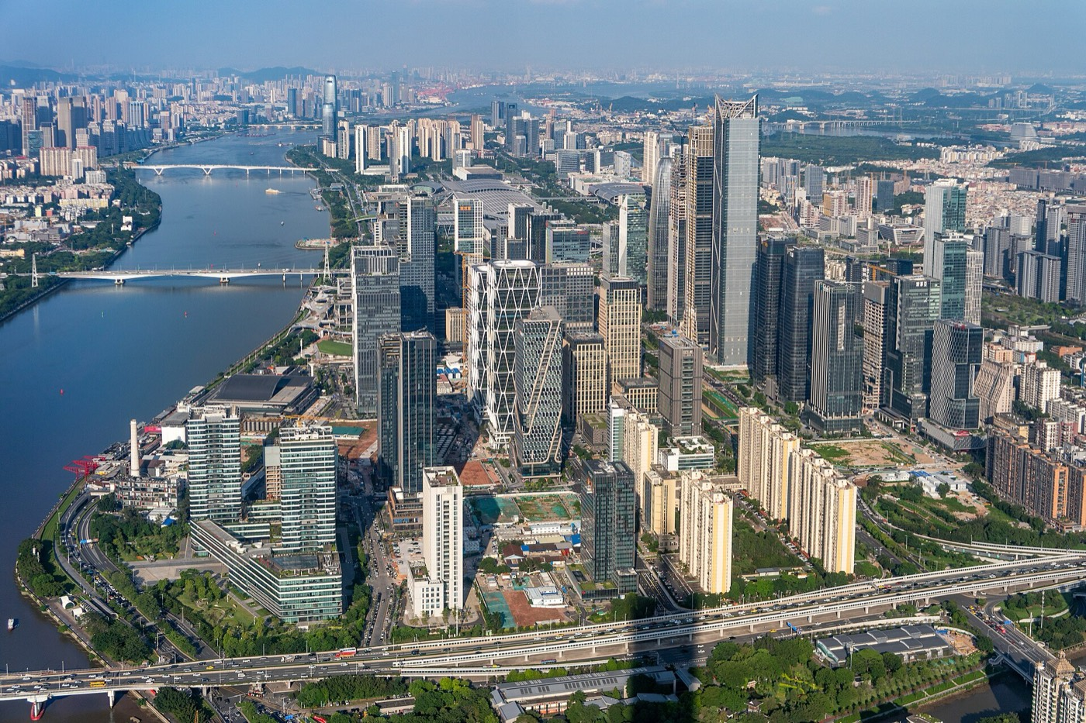  Pazhou West — Shujianyang (CC BY-SA 4.0) | 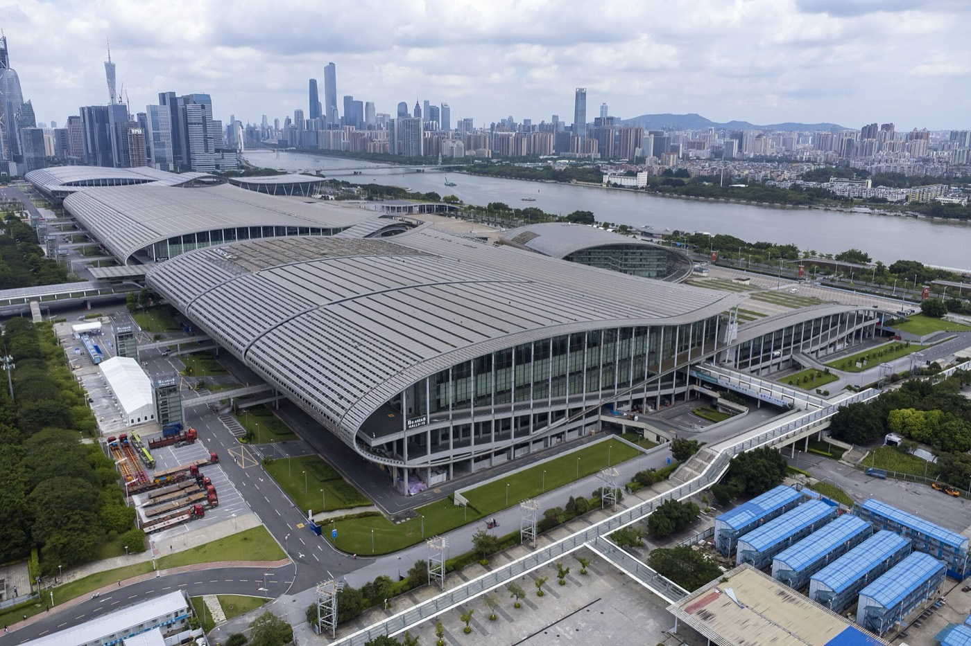  Aerial View, Zone B, Canton Fair Complex 2023070 — Tim Wu (CC BY-SA 4.0)
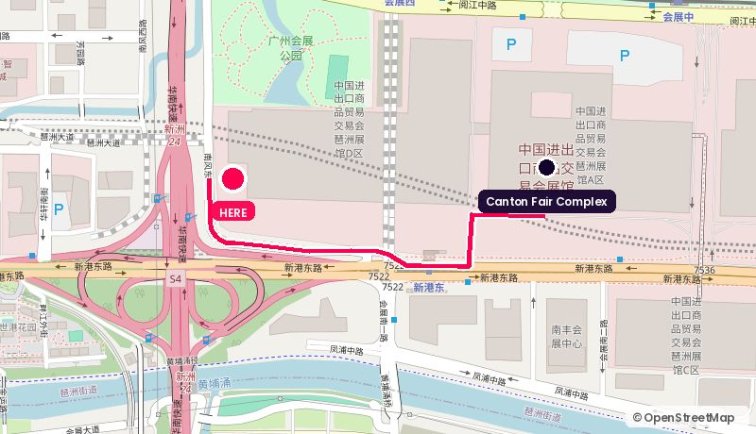
Route from the Canton Fair Complex. Map © OpenStreetMap contributors.
Address: Area D (Phase IV), China Import & Export Fair Complex, Pazhou
Walk: 14 min walk (1.0 km)
Drive: 2 min drive (1.0 km), allow 5 min in fair traffic during the fair
Backdrop: New-build glass atrium, daylight, hall traffic behind
Coordinates: 23.10320, 113.34700
Google Maps: https://www.google.com/maps/search/?api=1&query=23.10320,113.34700 | directions: https://www.google.com/maps/dir/?api=1&origin=23.10344,113.35412&destination=23.10320,113.34700&travelmode=walking
Tags: Inside venue / Daylight / Organiser-allocated
Why it works. The newest wing of the complex, opened for the 135th session. Bigger, brighter conference rooms than the legacy halls and easier to dress. Good if you want the interview to visibly happen at the fair.
Watch out. Allocation goes through the fair organiser and fills early. Confirm which rooms take a two-camera set and whether you can rig lights.

09. InterContinental Guangzhou Exhibition Center
广州保利洲际酒店 · Next door · 0.9 km straight line
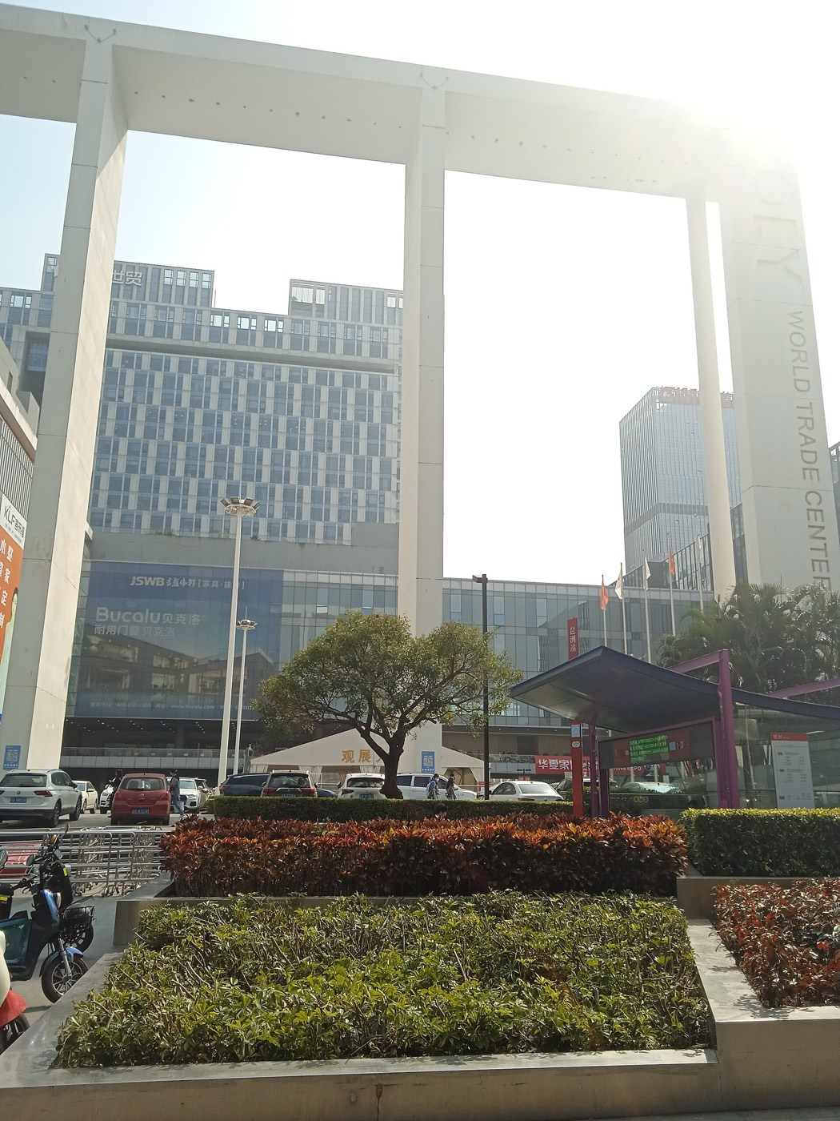  Poly World Trade Center 20230217-02 — 中少 (CC BY-SA 4.0) | Guangzhou Pazhou Poly Plaza — 中少 (CC BY-SA 4.0) | 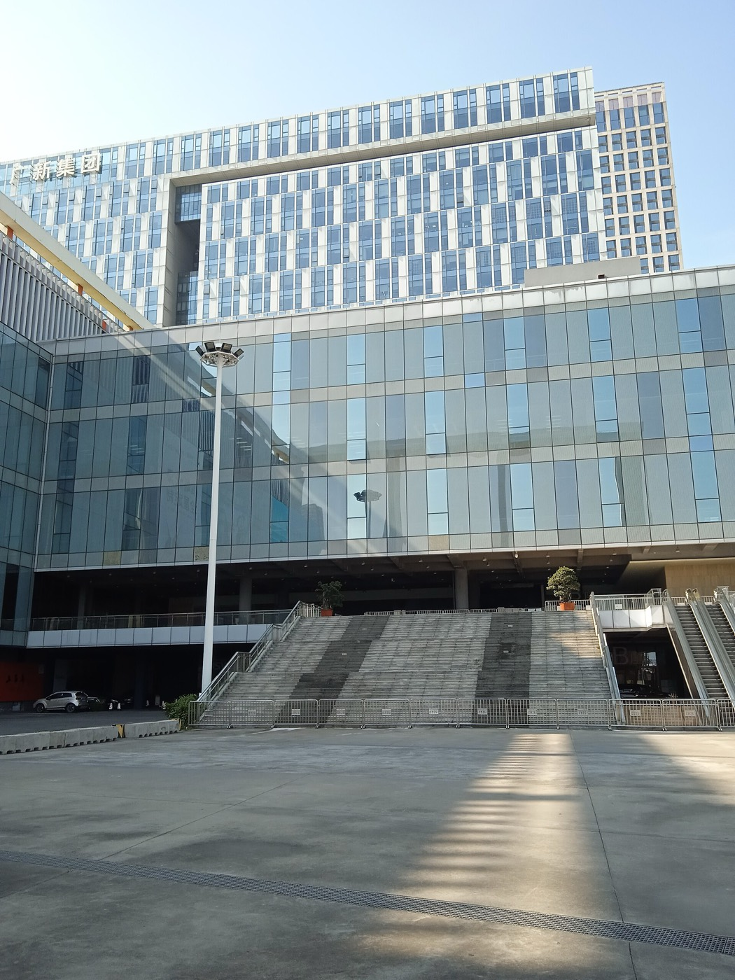  Poly World Trade Center Exterior 20230726 — 中少 (CC BY-SA 4.0)
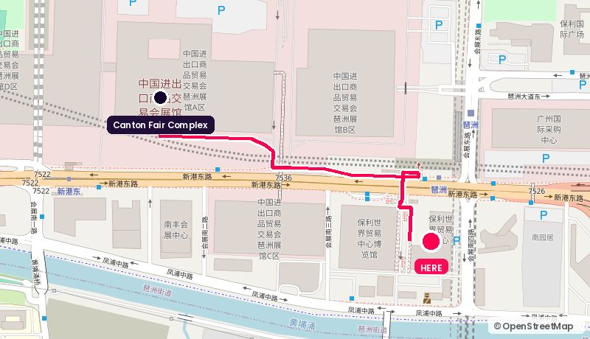
Route from the Canton Fair Complex. Map © OpenStreetMap contributors.
Address: 828 Xingang East Rd, Poly Skyline Plaza, Pazhou
Walk: 15 min walk (1.1 km)
Drive: 4 min drive (1.9 km), allow 9 min in fair traffic during the fair
Backdrop: River-facing ballroom foyer with a glass wall onto the Pearl River
Coordinates: 23.09960, 113.36200
Google Maps: https://www.google.com/maps/search/?api=1&query=23.09960,113.36200 | directions: https://www.google.com/maps/dir/?api=1&origin=23.10344,113.35412&destination=23.09960,113.36200&travelmode=walking
Tags: River-facing foyer / 11 breakout rooms / Adjacent to venue
Why it works. 1,800 sqm pillarless ballroom with natural light, a 500 sqm second ballroom and 11 multi-function rooms, and the foyer looks out over the Pearl River. Enough rooms to run a media room, a green room and a partner meeting room off one foyer all day.
Watch out. It is a working convention hotel during the fair, so confirm you are not sharing the foyer with someone else's coffee break.

10. Poly World Trade Center Expo Hall
保利世贸博览馆 · Next door · 0.9 km straight line
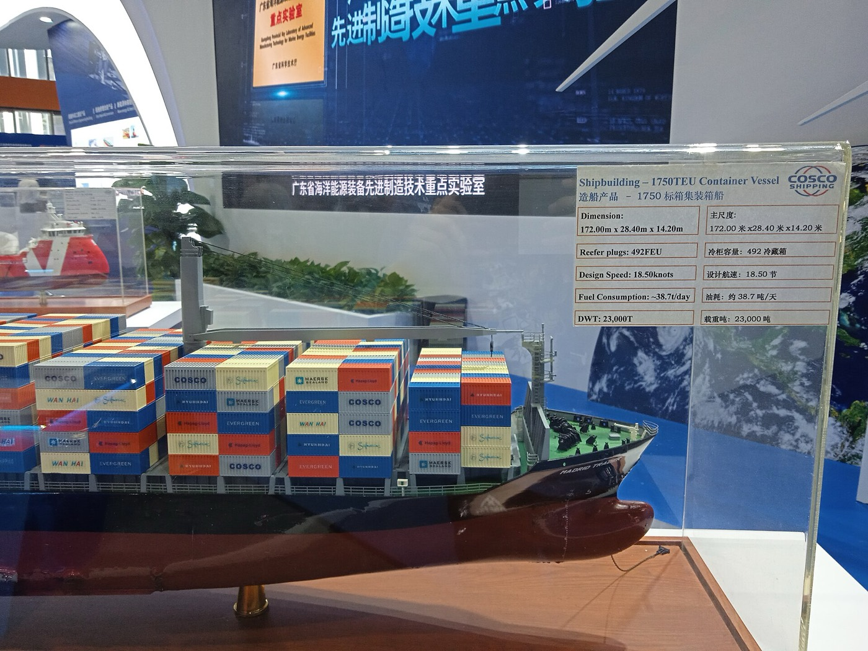  Poly World Trade Center Expo Hall 20230726-05 — 中少 (CC BY-SA 4.0) | 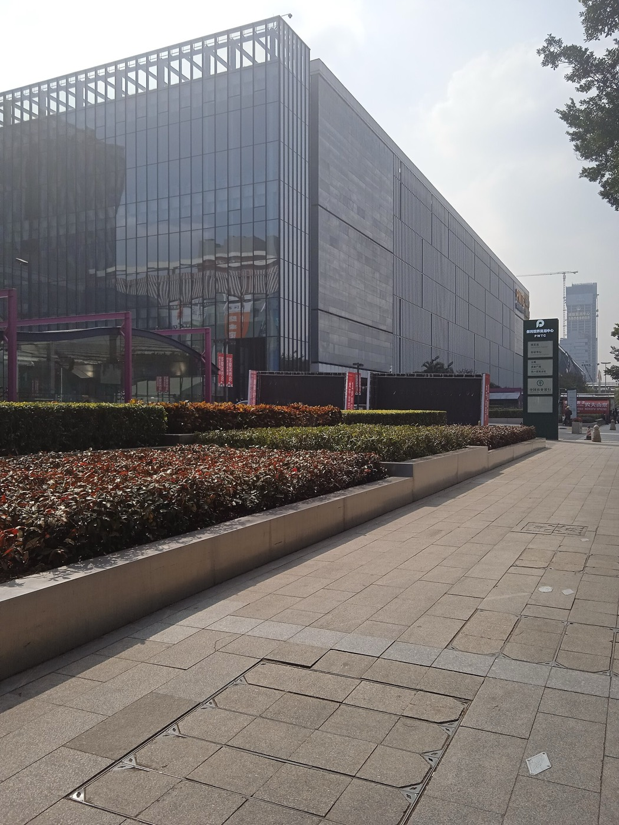  Poly World Trade Center 20230217-01 — 中少 (CC BY-SA 4.0) | Poly World Trade Center Exterior 20230726 — 中少 (CC BY-SA 4.0)
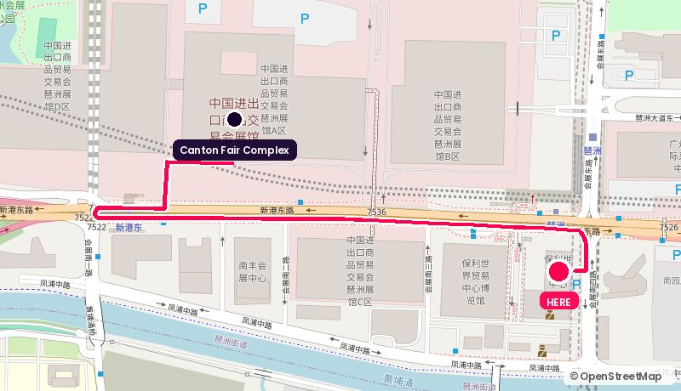
Route from the Canton Fair Complex. Map © OpenStreetMap contributors.
Address: 1000 Xingang East Rd, connected to Pazhou metro station
Walk: 25 min walk (1.9 km)
Drive: 3 min drive (1.9 km), allow 7 min in fair traffic during the fair
Backdrop: Modern expo architecture, high ceilings
Coordinates: 23.09991, 113.36229
Google Maps: https://www.google.com/maps/search/?api=1&query=23.09991,113.36229 | directions: https://www.google.com/maps/dir/?api=1&origin=23.10344,113.35412&destination=23.09991,113.36229&travelmode=driving
Tags: Metro-connected / Large format / Own calendar
Why it works. Six exhibition halls plus a metro-level hall, connected directly to Pazhou station. Same blank-canvas logic as NICEC but with its own metro entrance, which matters when you are moving guests during fair rush hour.
Watch out. Often booked by its own concurrent shows during Canton Fair weeks. Check the hall calendar before you plan anything.

11. Guangzhou International Sourcing Centre
广州国际采购中心 · Pazhou island · 1.2 km straight line
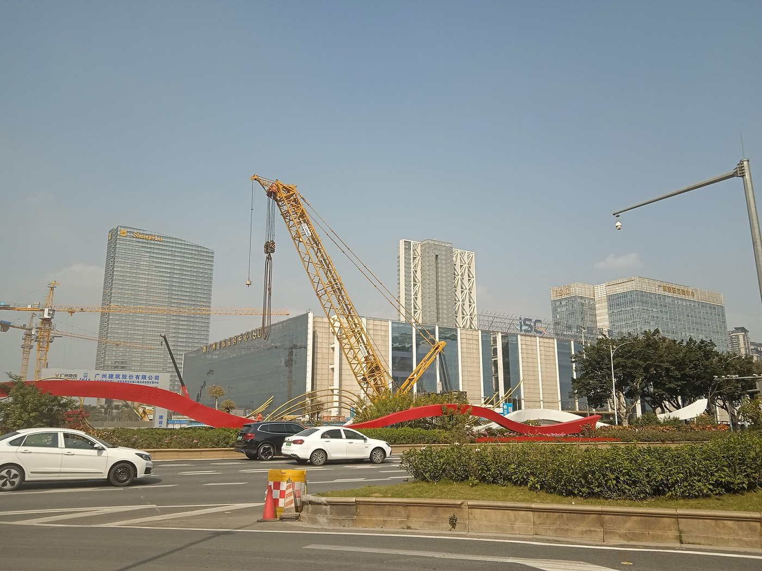  Guangzhou International Sourcing Centre 20230217 — 中少 (CC BY-SA 4.0) | 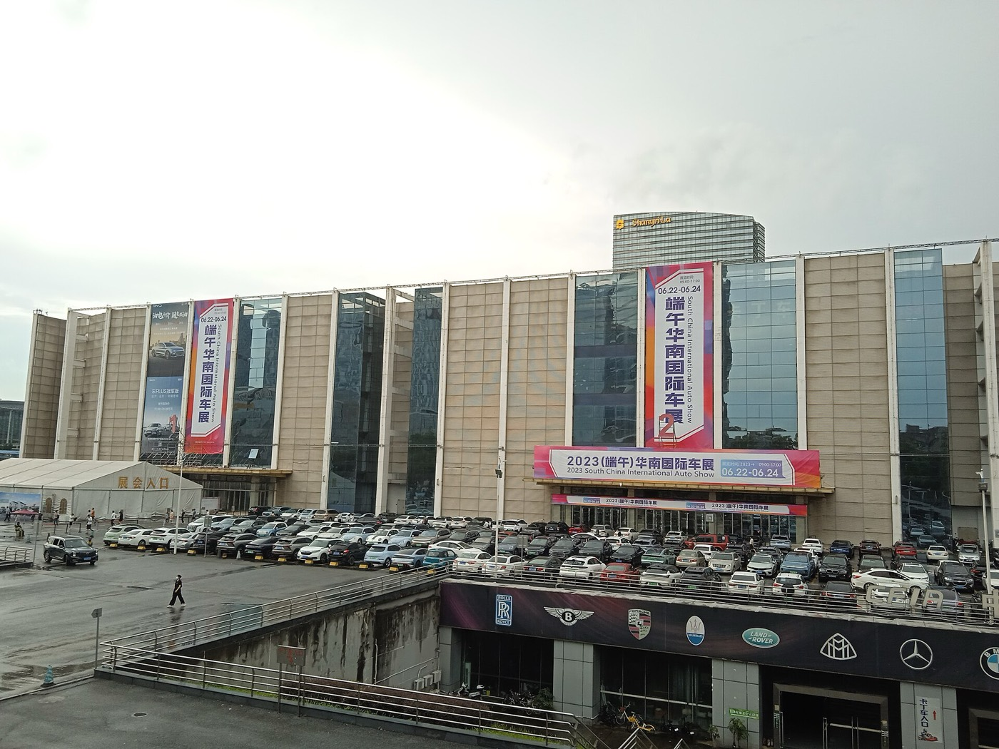  Guangzhou International Sourcing Centre 20230623 — 中少 (CC BY-SA 4.0) | 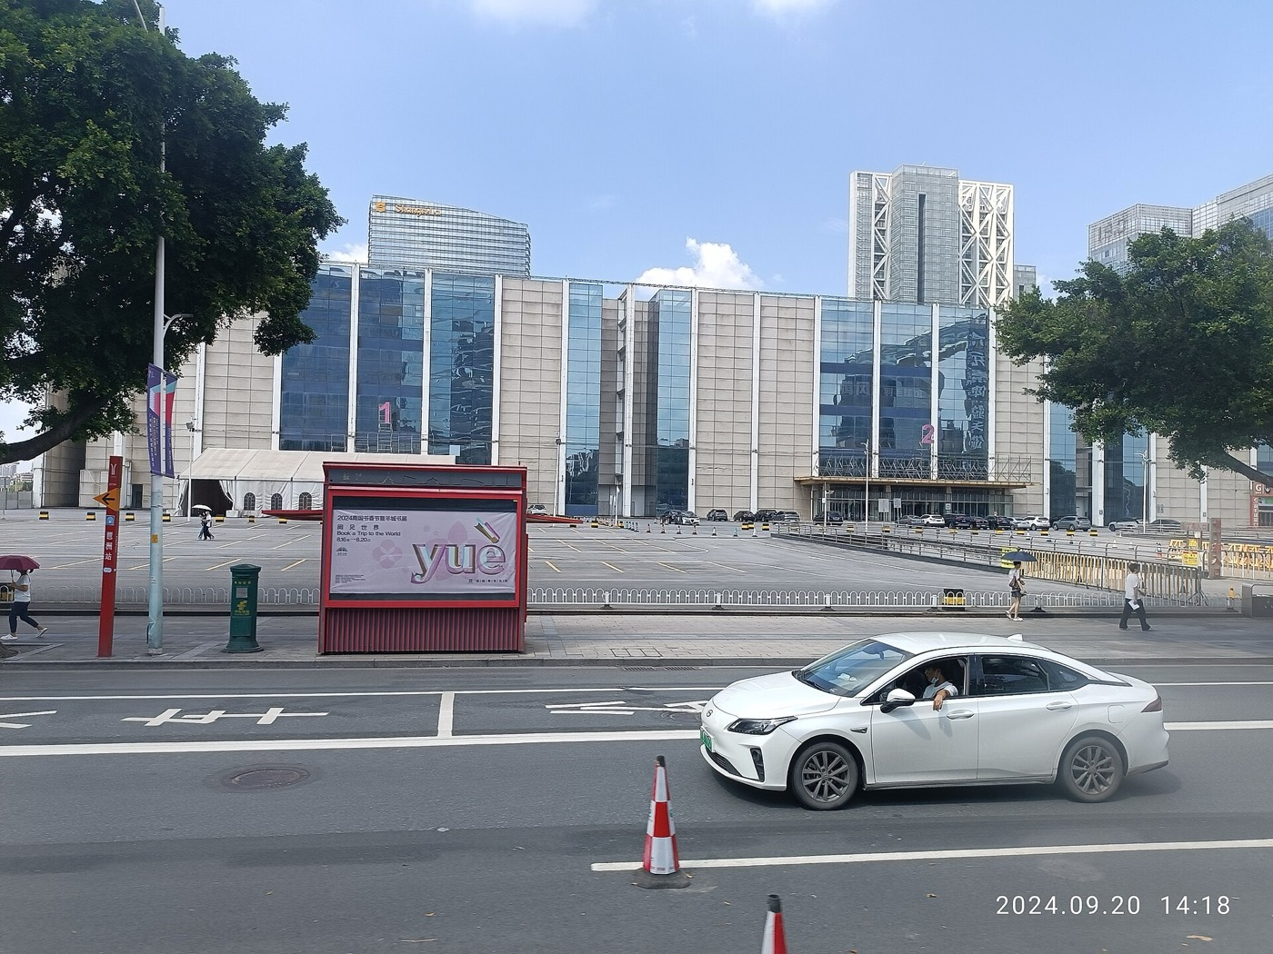  GZ Shenzhen to GZ Guangzhou interCity Tour bus v — Ghaud Lnegauk (CC0)
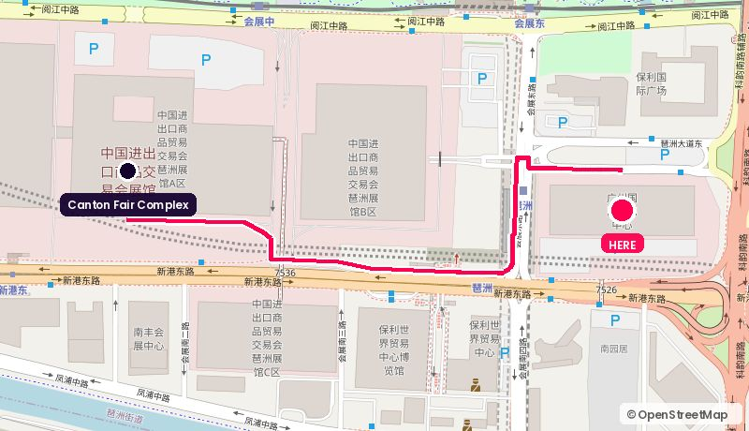
Route from the Canton Fair Complex. Map © OpenStreetMap contributors.
Address: Pazhou Da Dao East, Haizhu
Walk: 20 min walk (1.5 km)
Drive: 5 min drive (3.3 km), allow 11 min in fair traffic during the fair
Backdrop: Trade-floor architecture, corporate and neutral
Coordinates: 23.10260, 113.36544
Google Maps: https://www.google.com/maps/search/?api=1&query=23.10260,113.36544 | directions: https://www.google.com/maps/dir/?api=1&origin=23.10344,113.35412&destination=23.10260,113.36544&travelmode=walking
Tags: On-message backdrop / Quieter / BYO production
Why it works. Purpose-built sourcing and exhibition building next to the fair. Conference space that is cheaper and quieter than the hotels, and the building itself says 'trade' on camera, which fits the WorldFirst story.
Watch out. Less hospitality polish, so you bring your own catering, comfort and signage.

12. Ali Center / Pazhou West AI & Digital Economy District
阿里巴巴华南营运中心 · 琶洲西区 · Pazhou island · 1.3 km straight line
Pazhou West — Shujianyang (CC BY-SA 4.0) | Pazhou Central Area and Pazhou West Area — 中少 (CC BY-SA 4.0) | Guangzhou Pazhou Poly Plaza — 中少 (CC BY-SA 4.0)
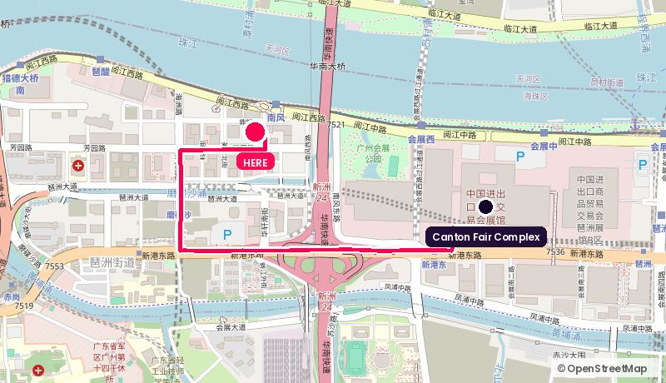
Route from the Canton Fair Complex. Map © OpenStreetMap contributors.
Address: Dingxin Rd, Pazhou West, Haizhu
Walk: 26 min walk (1.9 km)
Drive: 4 min drive (2.8 km), allow 10 min in fair traffic during the fair
Backdrop: New-build tech towers, riverside plaza, Canton Tower down-river
Coordinates: 23.10697, 113.34223
Google Maps: https://www.google.com/maps/search/?api=1&query=23.10697,113.34223 | directions: https://www.google.com/maps/dir/?api=1&origin=23.10344,113.35412&destination=23.10697,113.34223&travelmode=driving
Tags: Digital-trade story / Partner-hosted / Riverside plaza
Why it works. Pazhou West is the digital-trade cluster, where Alibaba, Vipshop and Tencent all have towers, and the riverside plaza frames Canton Tower. If the interview is about cross-border digital trade, this is the district that argues the point for you.
Watch out. Corporate campuses need a host and a security pass. Treat this as a partner-hosted shoot, not a venue you rent.

13. Pazhou Bridge & Yuejiang Rd promenade
琶洲大桥 · 阅江路江岸 · Pazhou island · 1.7 km straight line
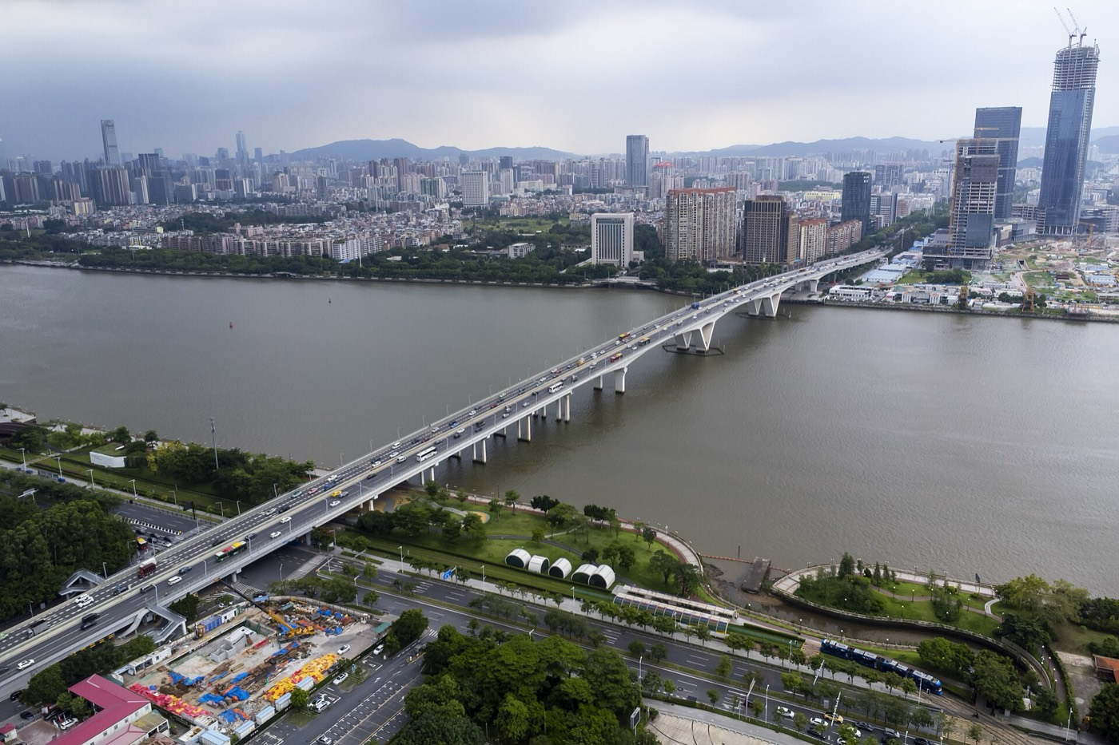  Aerial View, Pazhou Bridge, Guangzhou 20230701-A — Tim Wu (CC BY-SA 4.0) | 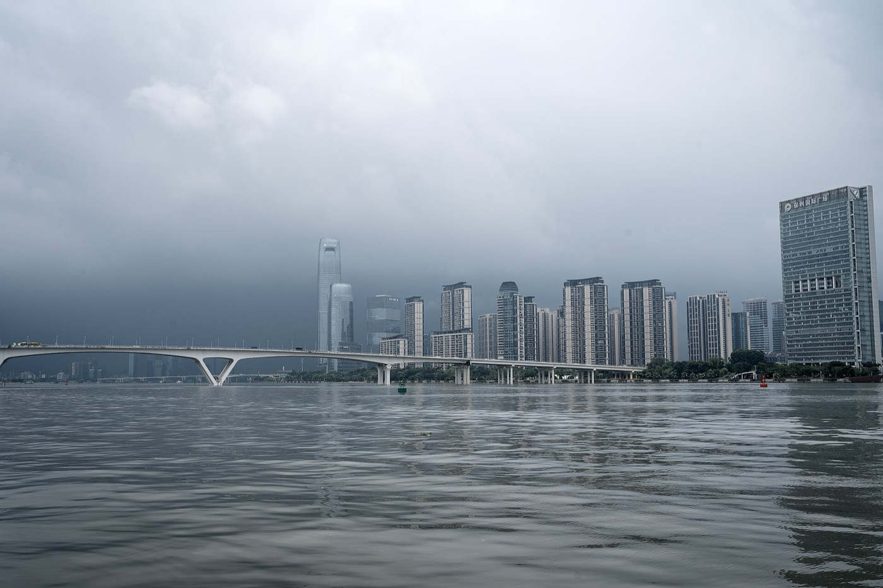  Pazhou Bridge 20230915 — 方人也 (CC BY 2.5) | 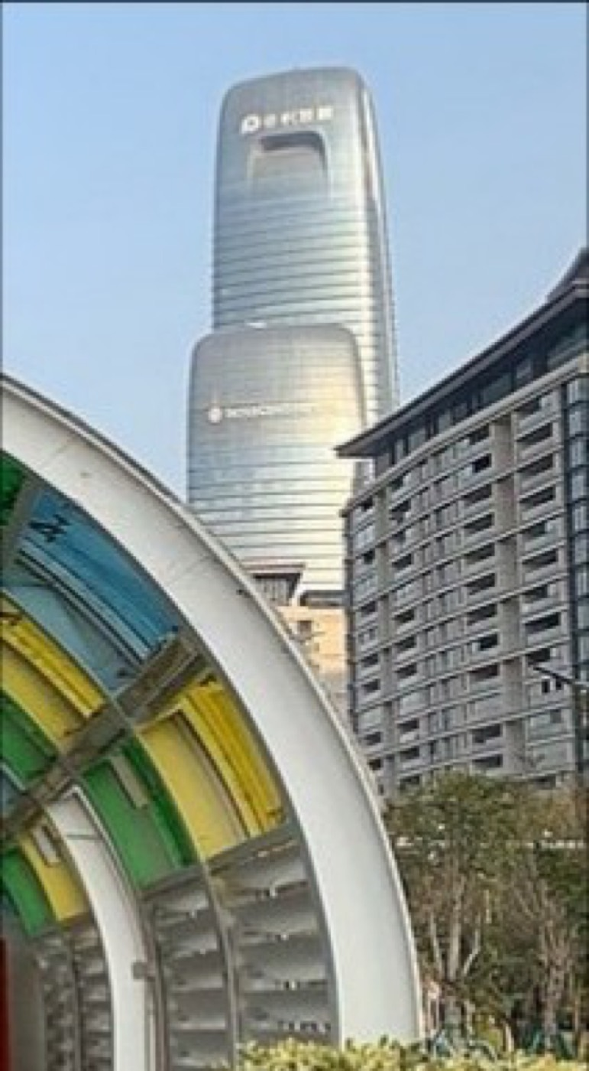  Looking from Pazhou Bridge South Station to Poly — Tim Wu (BY-SA 4.0)
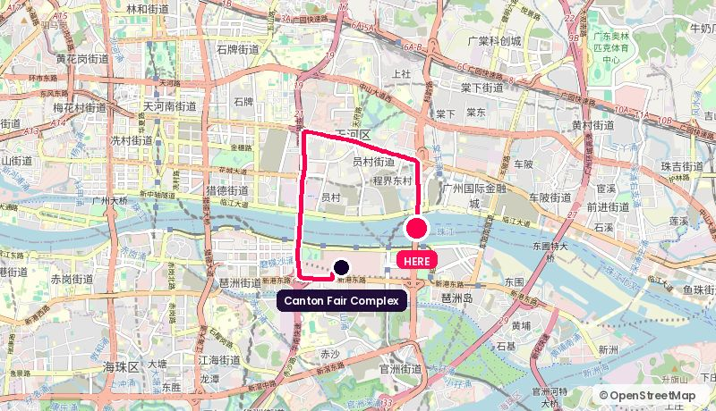
Route from the Canton Fair Complex. Map © OpenStreetMap contributors.
Address: Pazhou Bridge, Yuejiang Rd riverfront
Walk: 33 min walk (2.4 km)
Drive: 9 min drive (7.4 km), allow 19 min in fair traffic during the fair
Backdrop: Bridge, river and the Financial City skyline across the water
Coordinates: 23.11035, 113.36856
Google Maps: https://www.google.com/maps/search/?api=1&query=23.11035,113.36856 | directions: https://www.google.com/maps/dir/?api=1&origin=23.10344,113.35412&destination=23.11035,113.36856&travelmode=driving
Tags: B-roll / Free / Noisy
Why it works. A hard, graphic backdrop for a short piece-to-camera or a title sequence. Use it for B-roll and openers rather than a sit-down.
Watch out. Traffic noise kills usable audio. Radio mics and a wind kit, or plan to voice it over.

14. Party Pier (Pearl River Brewery)
珠江琶醍啤酒文化创意艺术区 · Canton Tower corridor · 2.2 km straight line
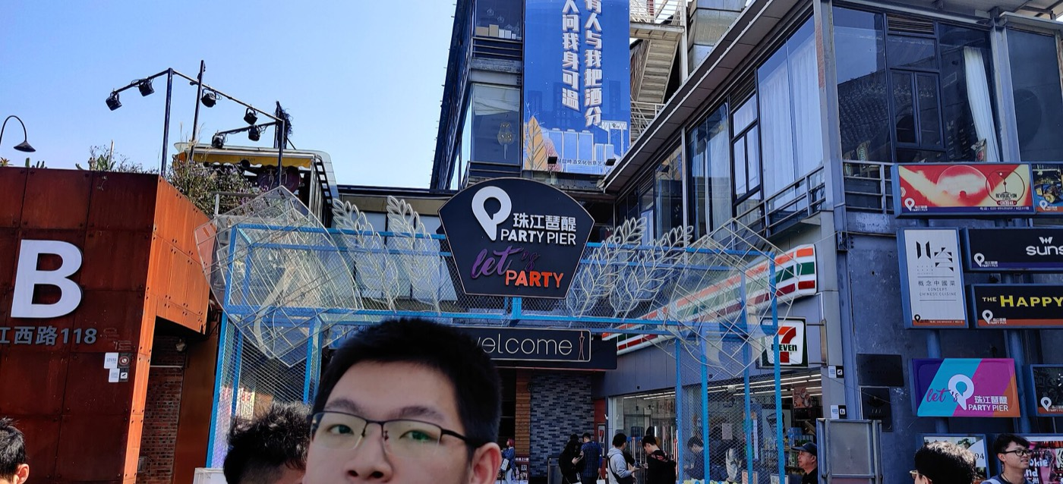  珠江琶醍街区入口 — 橙子木 (CC BY-SA 4.0) | 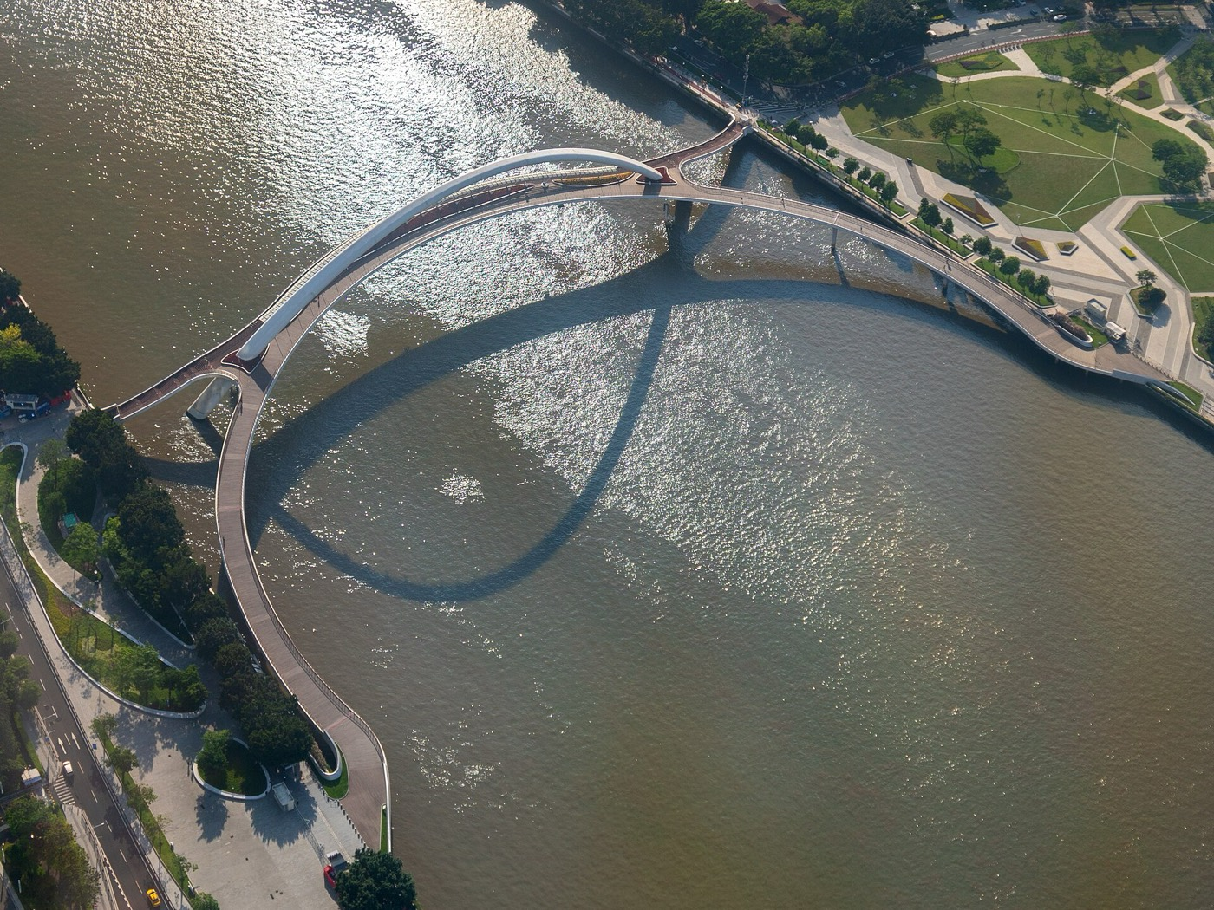  Haixin Bridge on Pearl River — Shujianyang (CC BY-SA 4.0) | 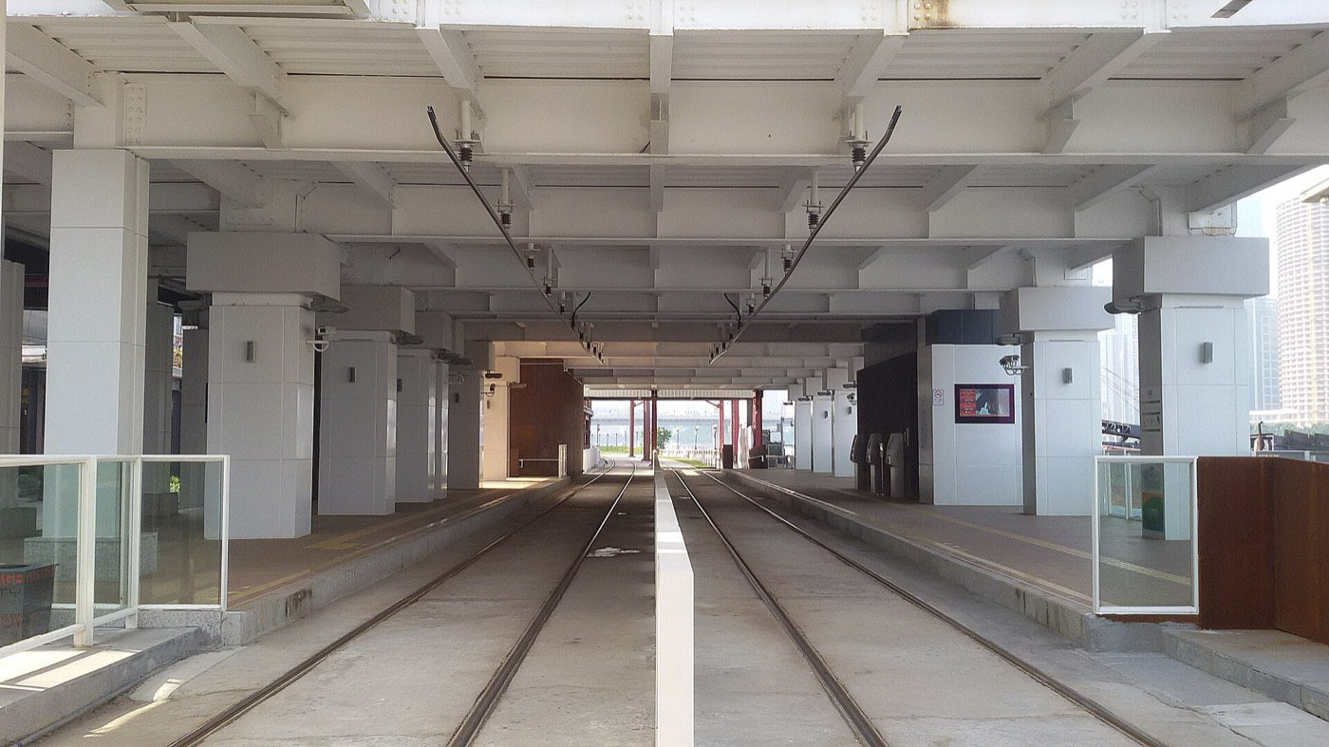  Party Pier Station Surface — WKDx417 (CC BY-SA 4.0)
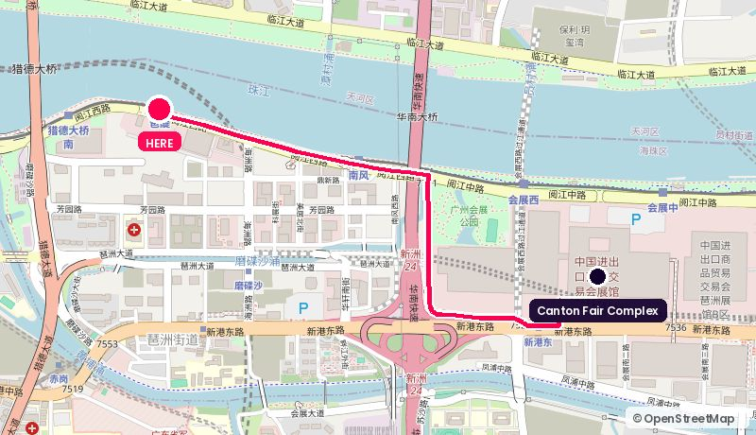
Route from the Canton Fair Complex. Map © OpenStreetMap contributors.
Address: Yuejiang West Rd riverside, Haizhu
Walk: 35 min walk (2.6 km)
Drive: 5 min drive (2.8 km), allow 10 min in fair traffic during the fair
Backdrop: Converted brewery, riverside terraces, Canton Tower across the water
Coordinates: 23.11043, 113.33423
Google Maps: https://www.google.com/maps/search/?api=1&query=23.11043,113.33423 | directions: https://www.google.com/maps/dir/?api=1&origin=23.10344,113.35412&destination=23.11043,113.33423&travelmode=driving
Tags: Creator-friendly / Canton Tower backdrop / Noisy at night
Why it works. Industrial brick, riverside terraces and Canton Tower in the background. Informal, creator-friendly, and the venues here are used to cameras. Right for KOL content and the evening social cut, not for a bank economist in a suit.
Watch out. It is a nightlife strip, so sound and crowd control after dark are real problems. Shoot the serious stuff before 6pm.

15. Haixin Bridge & Zhujiang New Town riverfront
海心桥 · 珠江新城江岸 · Zhujiang New Town · 3.3 km straight line
Haixin Bridge on Pearl River — Shujianyang (CC BY-SA 4.0) | 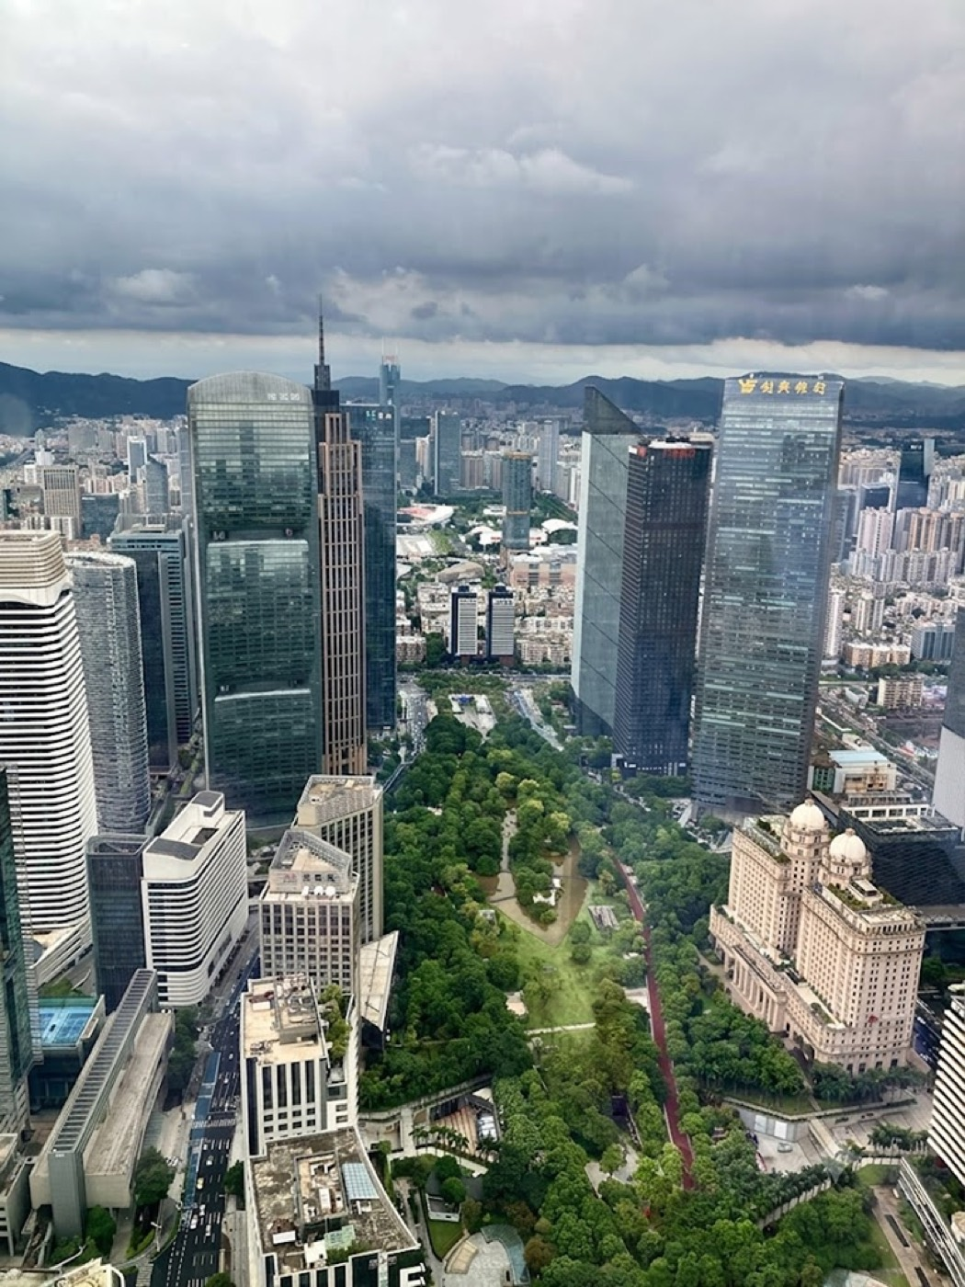  Huacheng Square and Zhujiang New Town skyline, G — Guangzhou Private Tours by (CC BY 4.0) | 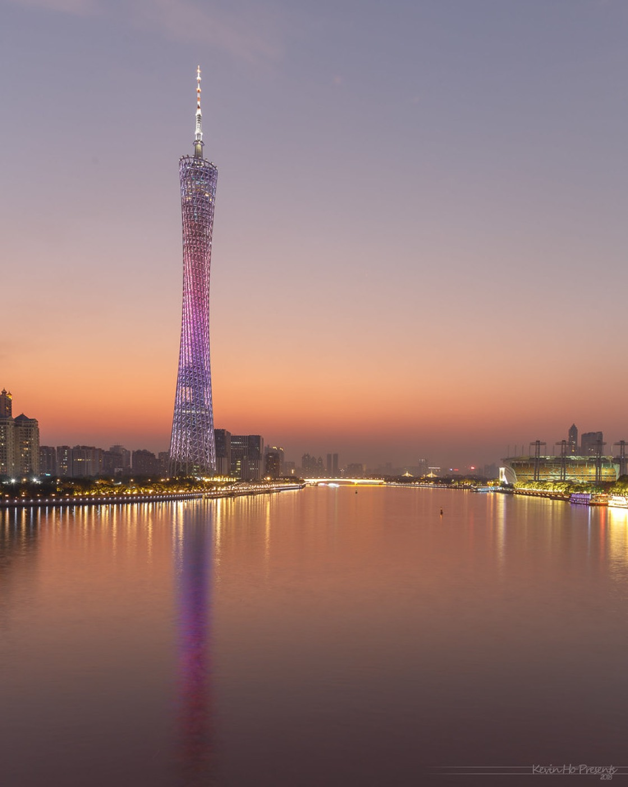  Cantontower twilight — kevinho86 (BY-NC-SA 2.0)
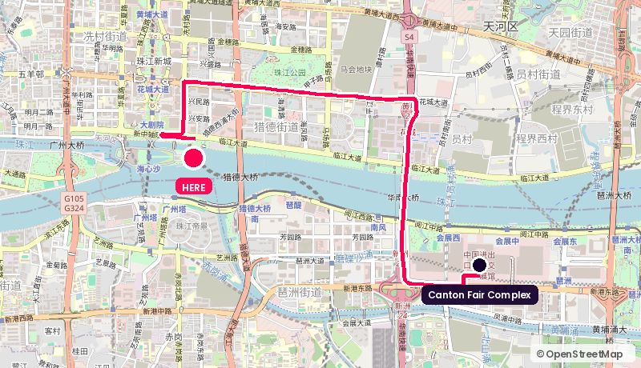
Route from the Canton Fair Complex. Map © OpenStreetMap contributors.
Address: Haixin Bridge, between Haixinsha and Canton Tower
Walk: 68 min walk (5.1 km)
Drive: 8 min drive (6.7 km), allow 17 min in fair traffic during the fair
Backdrop: Canton Tower and the full Zhujiang skyline from the pedestrian bridge
Coordinates: 23.11400, 113.32350
Google Maps: https://www.google.com/maps/search/?api=1&query=23.11400,113.32350 | directions: https://www.google.com/maps/dir/?api=1&origin=23.10344,113.35412&destination=23.11400,113.32350&travelmode=driving
Tags: Postcard shot / Free / Permits needed
Why it works. The postcard shot of Guangzhou, free, and a five-minute walk from the Canton Tower venues. Use it for the opener and the city cutaways that tie the whole media room package together.
Watch out. Pedestrian bridge with timed access and crowds. Permits for professional kit; scout the slot before committing.

16. Rosewood Guangzhou (CTF Finance Centre)
广州瑰丽酒店 · 周大福金融中心 · Zhujiang New Town · 3.4 km straight line
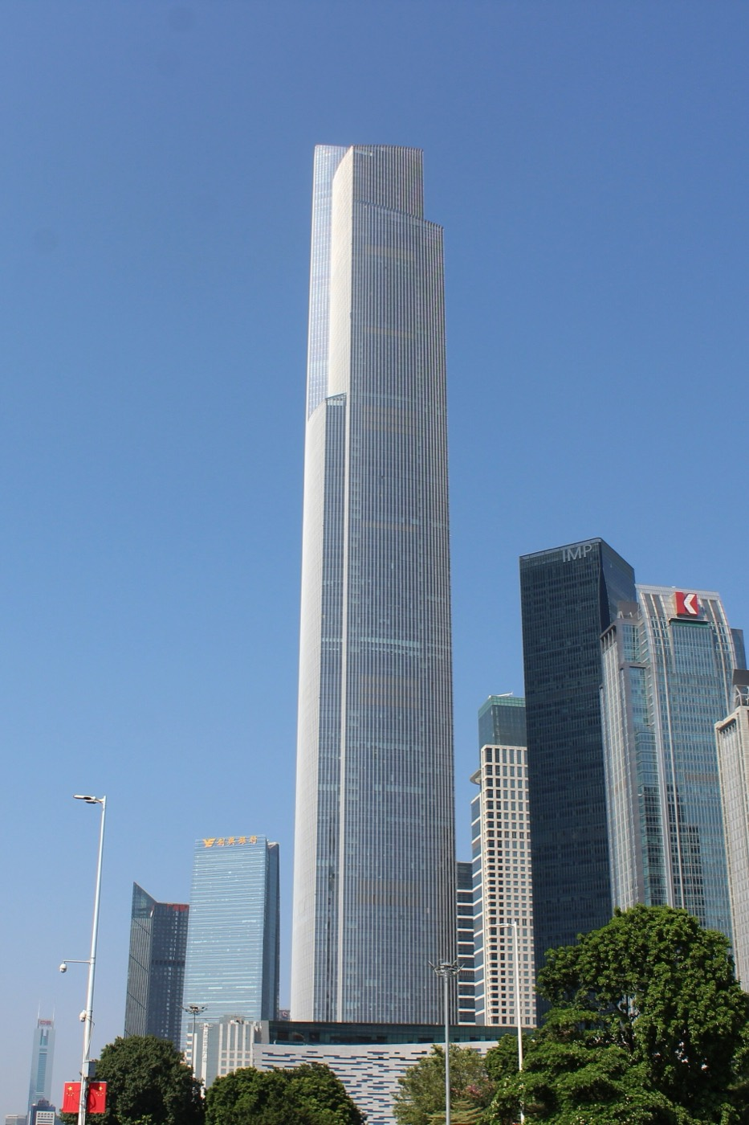  Guangzhou CTF Finance Centre 02-10-2018 — Milkomède (CC BY-SA 4.0) | 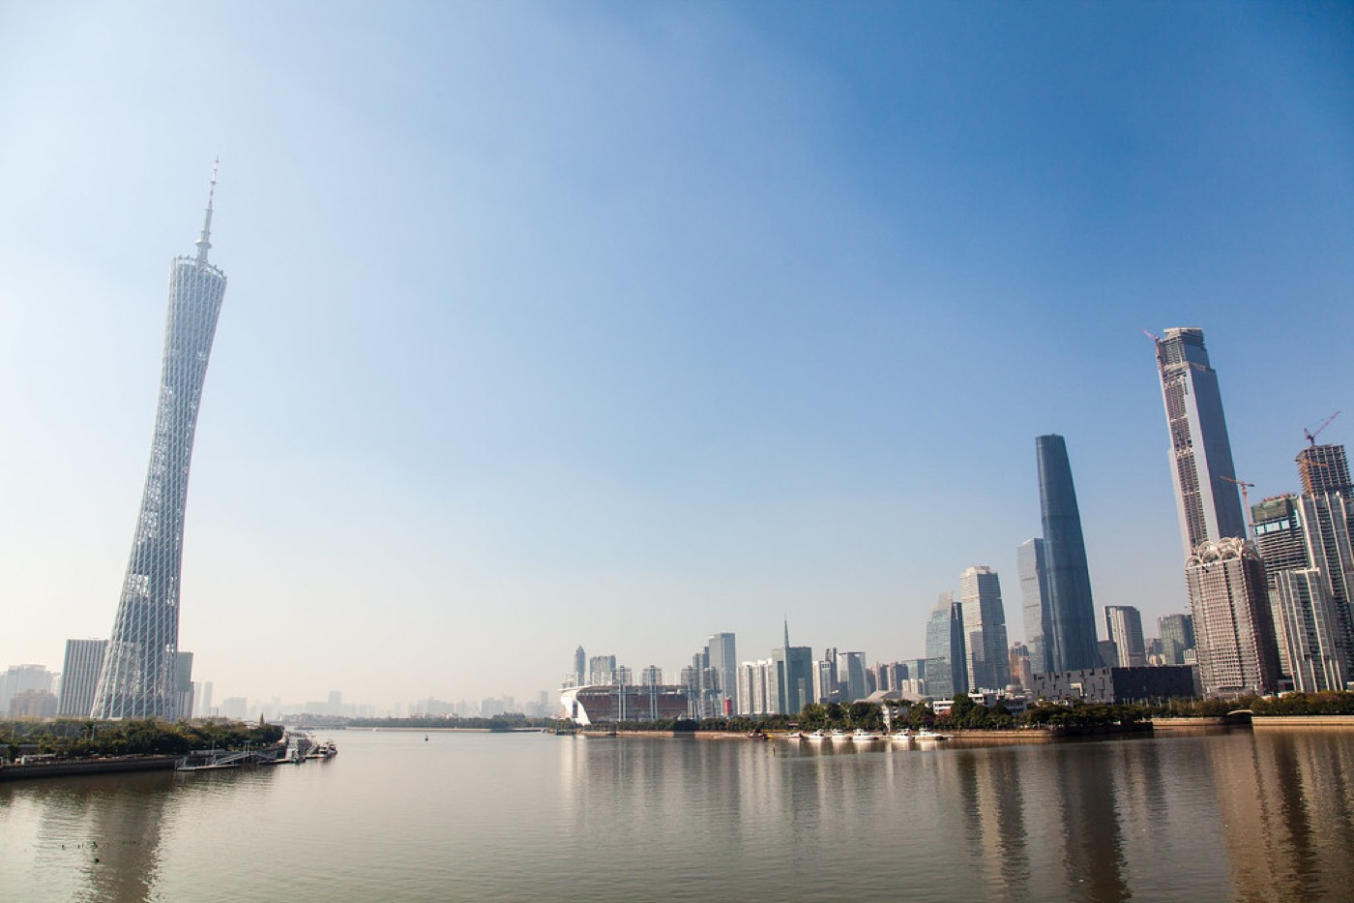  Zhujiang River — Terry Y M LIU (BY-SA 2.0) | 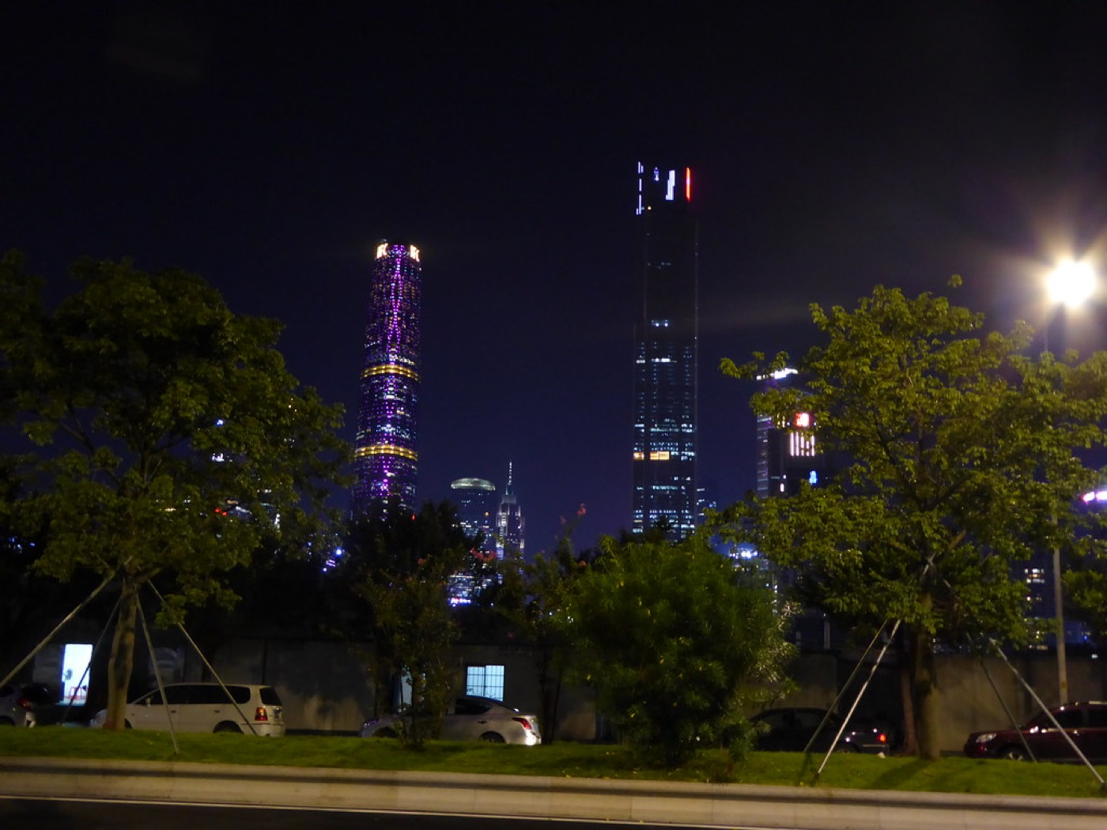  Guangzhou at Night — WabbitWanderer (BY-SA 2.0)
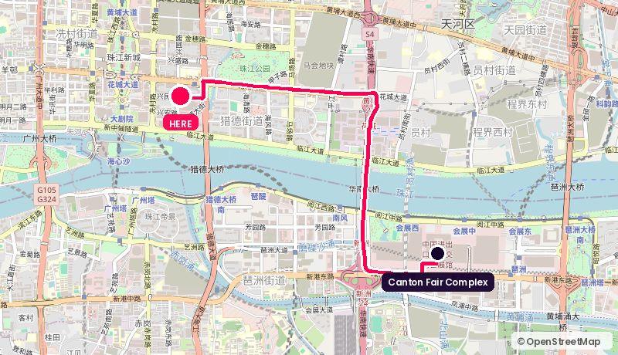
Route from the Canton Fair Complex. Map © OpenStreetMap contributors.
Address: 6 Zhujiang East Rd, CTF Finance Centre, Tianhe
Walk: 62 min walk (4.7 km)
Drive: 7 min drive (5.4 km), allow 15 min in fair traffic during the fair
Backdrop: Sky lobby at 530 m, the highest hotel in southern China
Coordinates: 23.11960, 113.32550
Google Maps: https://www.google.com/maps/search/?api=1&query=23.11960,113.32550 | directions: https://www.google.com/maps/dir/?api=1&origin=23.10344,113.35412&destination=23.11960,113.32550&travelmode=driving
Tags: 530 m / Finance framing / Far from venue
Why it works. Altitude as a statement. The 93rd-floor pool and sky lobby give a backdrop that reads 'global finance' instantly, which suits an FX or economics conversation.
Watch out. Same distance problem, and the hotel is protective of its public spaces. Expect a buy-out conversation.

17. Canton Tower · observation decks and rotating restaurant
广州塔 · 观景层 / 旋转餐厅 · Canton Tower corridor · 3.6 km straight line
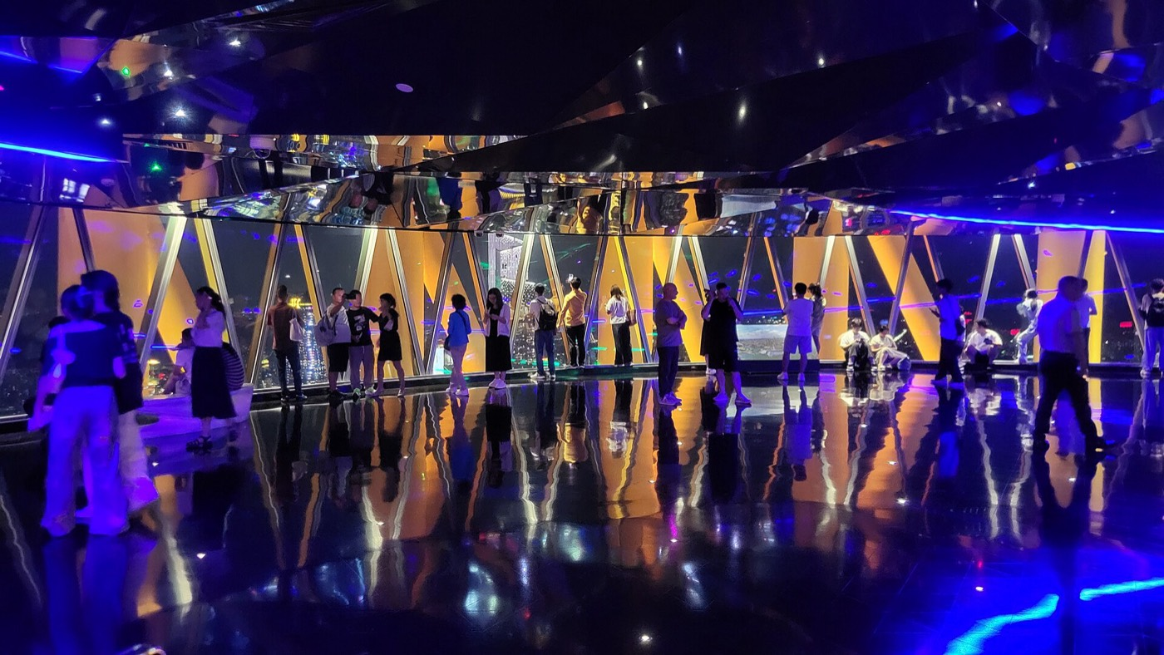  Canton Tower - 433M Sightseeing Observation Deck — Renek78 (CC0) | 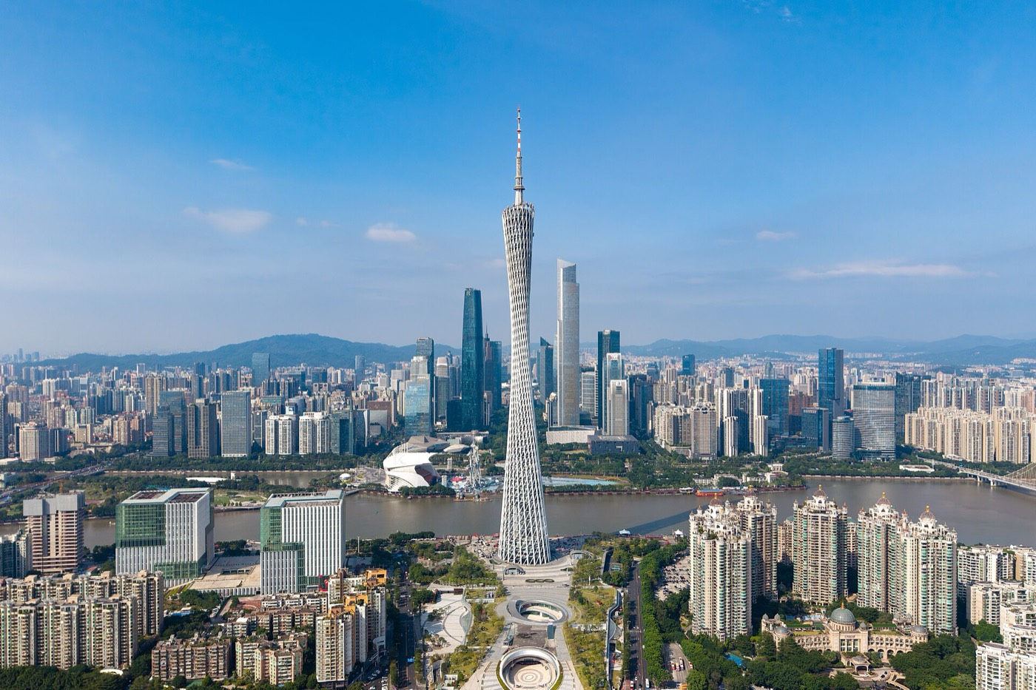  Canton Tower 20241027 — Tim Wu (CC BY-SA 4.0) | 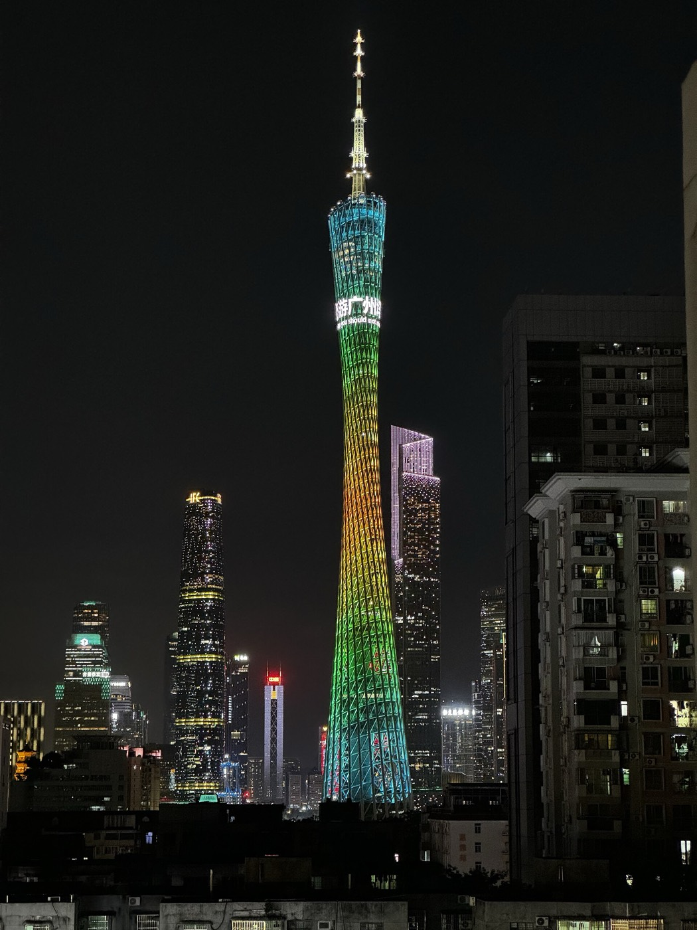  Canton Tower Light Show 20240712 02 — JULIANISME (CC BY-SA 4.0)
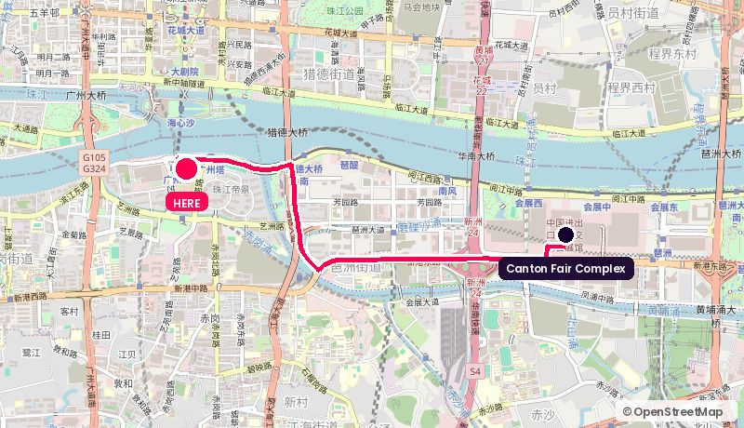
Route from the Canton Fair Complex. Map © OpenStreetMap contributors.
Address: 222 Yuejiang West Rd, Haizhu
Walk: 57 min walk (4.3 km)
Drive: 7 min drive (4.7 km), allow 15 min in fair traffic during the fair
Backdrop: The whole city, 433 m up, and you are inside the landmark
Coordinates: 23.10901, 113.31915
Google Maps: https://www.google.com/maps/search/?api=1&query=23.10901,113.31915 | directions: https://www.google.com/maps/dir/?api=1&origin=23.10344,113.35412&destination=23.10901,113.31915&travelmode=driving
Tags: Landmark / High-altitude / Glass reflections
Why it works. The backdrop is the landmark itself. The 433 m deck and the 424 m rotating restaurant give a shot nobody can argue with, and the venue has hosted corporate events for years.
Watch out. You cannot see Canton Tower from inside Canton Tower. Haze cuts visibility often. Lighting a shot against a glass curtain wall at height needs a proper crew.

18. Park Hyatt Guangzhou · The Roof Bar (70F)
广州柏悦酒店 · 顶楼酒吧 · Zhujiang New Town · 3.7 km straight line
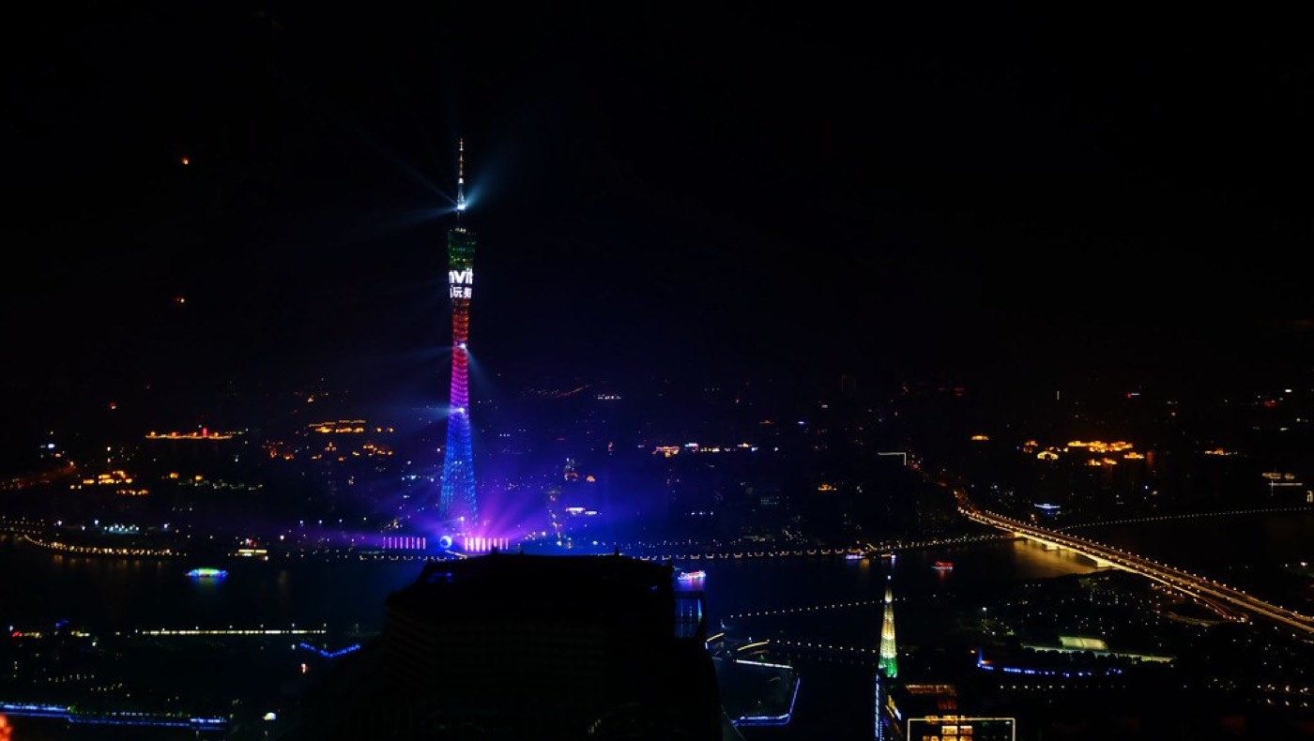  Canton Tower at night - Park Hyatt Guangzhou — Matt@PEK (BY-NC-SA 2.0) | 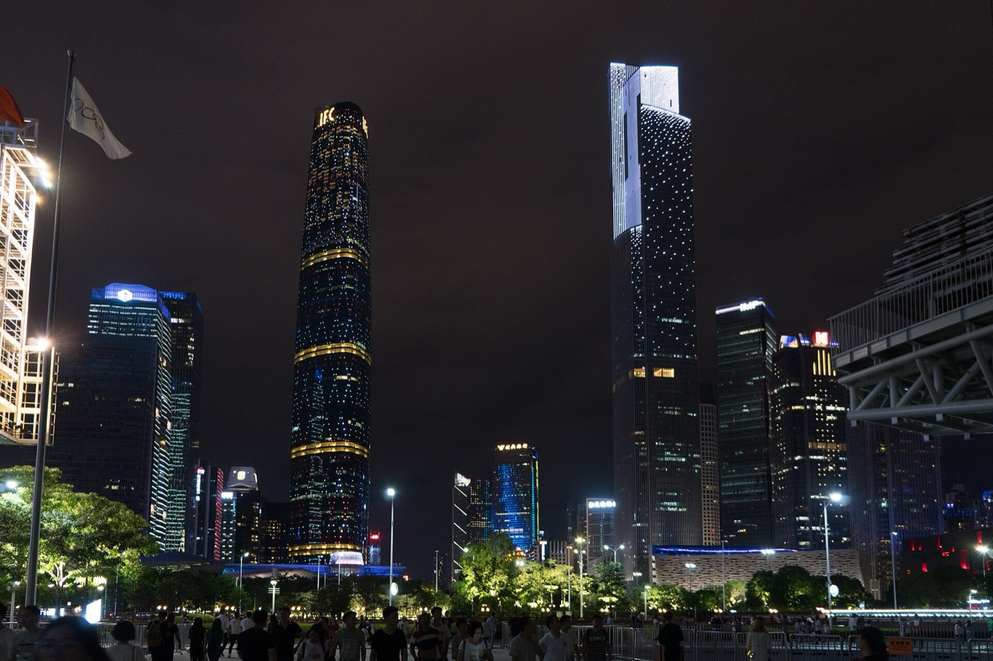  Zhujiang New Town of Guangzhou at night 01 — Shujianyang (CC0) | 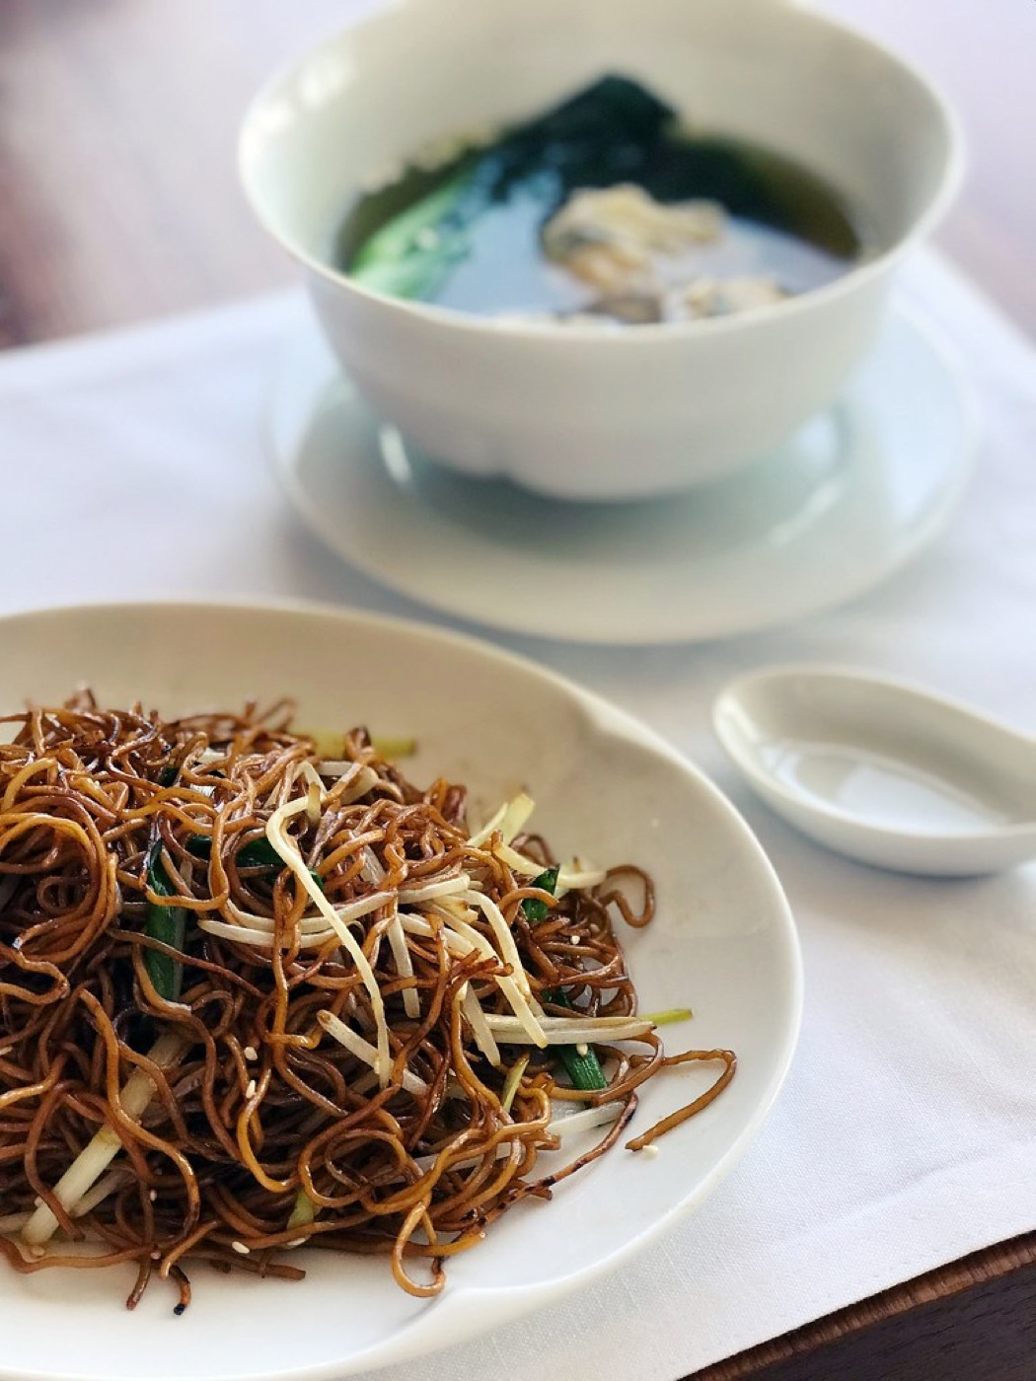  Breakfast at Dining Room - Park Hyatt Guangzhou — Matt@PEK (BY-NC-SA 2.0)
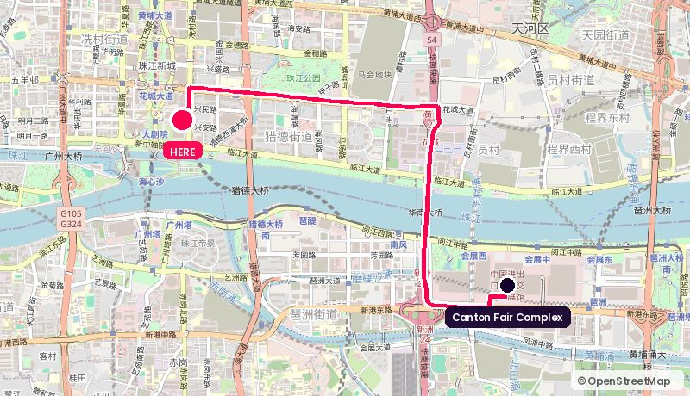
Route from the Canton Fair Complex. Map © OpenStreetMap contributors.
Address: Zhujiang New Town, Tianhe
Walk: 66 min walk (4.9 km)
Drive: 7 min drive (5.9 km), allow 16 min in fair traffic during the fair
Backdrop: Canton Tower head-on from 280 m, open air
Coordinates: 23.11860, 113.32180
Google Maps: https://www.google.com/maps/search/?api=1&query=23.11860,113.32180 | directions: https://www.google.com/maps/dir/?api=1&origin=23.10344,113.35412&destination=23.11860,113.32180&travelmode=driving
Tags: Best evening shot / Open air / Far from venue
Why it works. The highest rooftop bar in the city, looking straight across the river at Canton Tower. The single best evening establishing shot on this list.
Watch out. Twenty minutes each way in fair-week traffic, plus a lift queue. Realistically a one-hour evening window, not a working media room.

19. Guangzhou International Media Port (GRT)
广州国际媒体港 · 广州广播电视台 · Canton Tower corridor · 4.0 km straight line
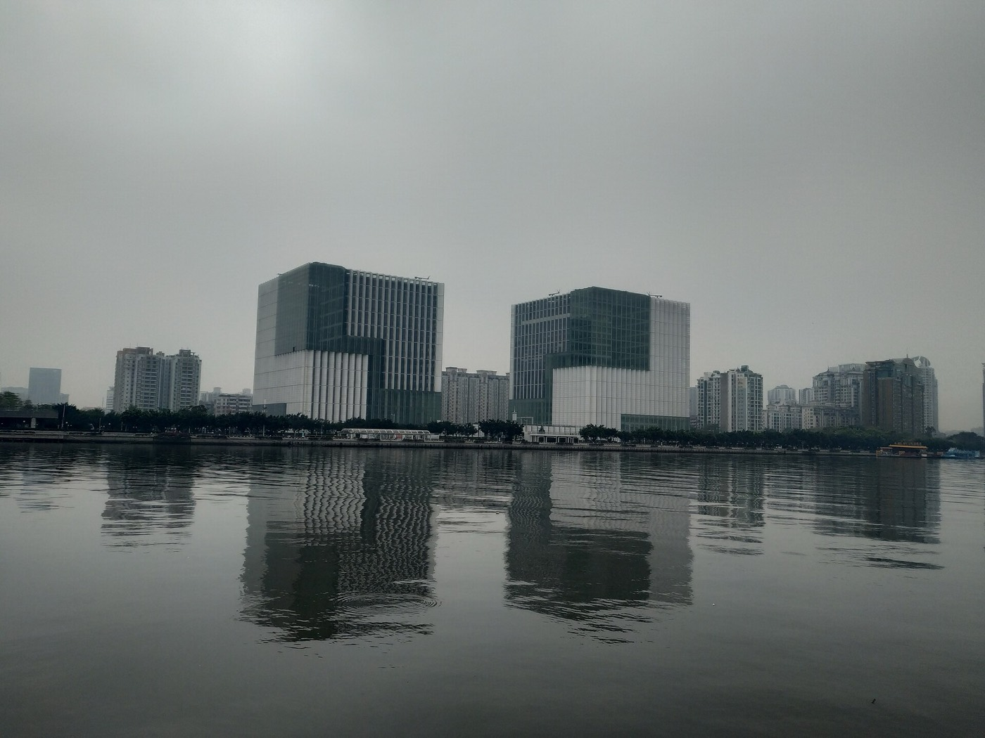  Guangzhou TV HQ — TuxStrikesBack (CC BY 4.0) | 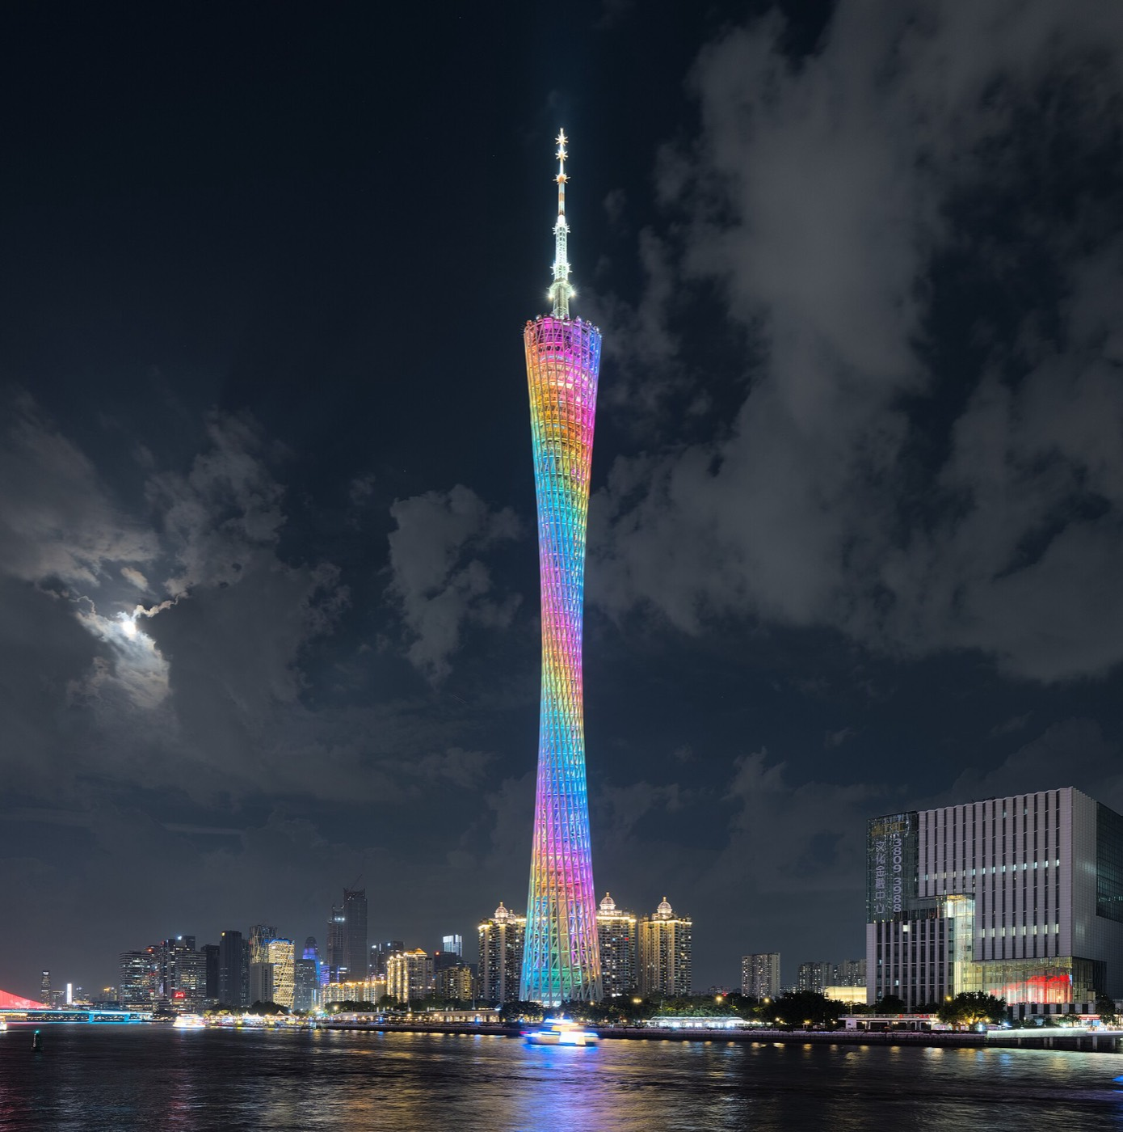  Canton Tower at night Guangzhou 2024 dllu — Daniel Lu (User:dllu) (CC BY-SA 4.0) | 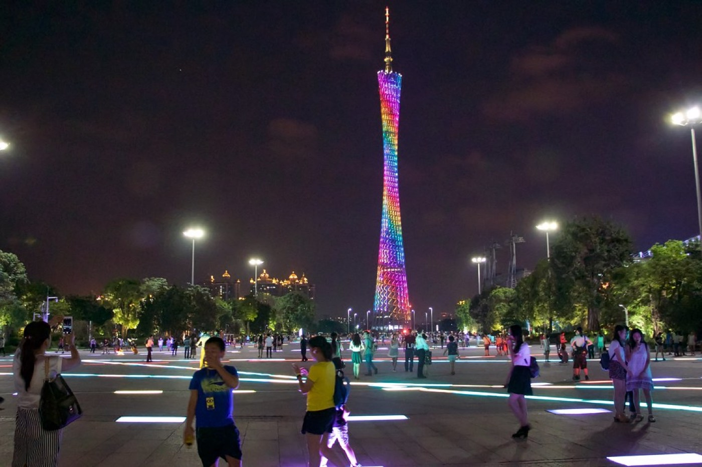  Canton Tower — assortedstuff (BY-NC-SA 2.0)
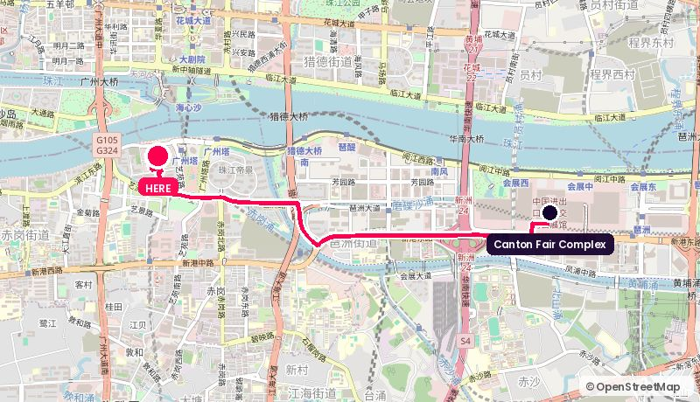
Route from the Canton Fair Complex. Map © OpenStreetMap contributors.
Address: 218 Yuejiang West Rd, Haizhu (next to Canton Tower)
Walk: 68 min walk (5.1 km)
Drive: 8 min drive (4.8 km), allow 17 min in fair traffic during the fair
Backdrop: Real broadcast studios; Canton Tower next door for exteriors
Coordinates: 23.10852, 113.31569
Google Maps: https://www.google.com/maps/search/?api=1&query=23.10852,113.31569 | directions: https://www.google.com/maps/dir/?api=1&origin=23.10344,113.35412&destination=23.10852,113.31569&travelmode=driving
Tags: Real studios / Canton Tower next door / Needs a partner
Why it works. The city broadcaster's own media complex, on the river beside Canton Tower: studios, control rooms, crew and a multi-function performance and broadcast centre. If you want the interviews to look like television rather than a hotel function room, this is the one.
Watch out. Booking runs through GRT and likely needs a media partner on the paperwork. Start that conversation now, not in October.

20. Four Seasons Hotel Guangzhou (IFC)
广州四季酒店 · 国际金融中心 · Zhujiang New Town · 4.2 km straight line
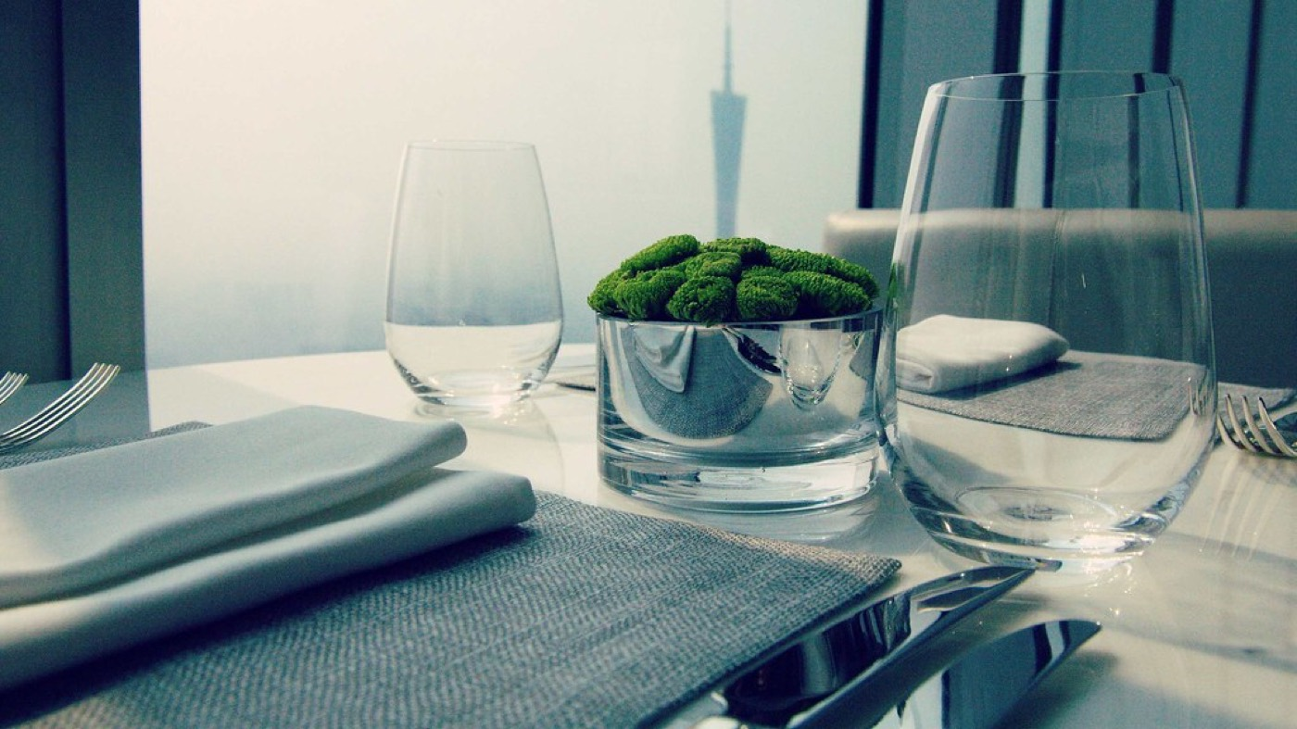  Breakfast at Caffe Mondo - Four Seasons Guangzho — Matt@PEK (BY-NC-SA 2.0) | 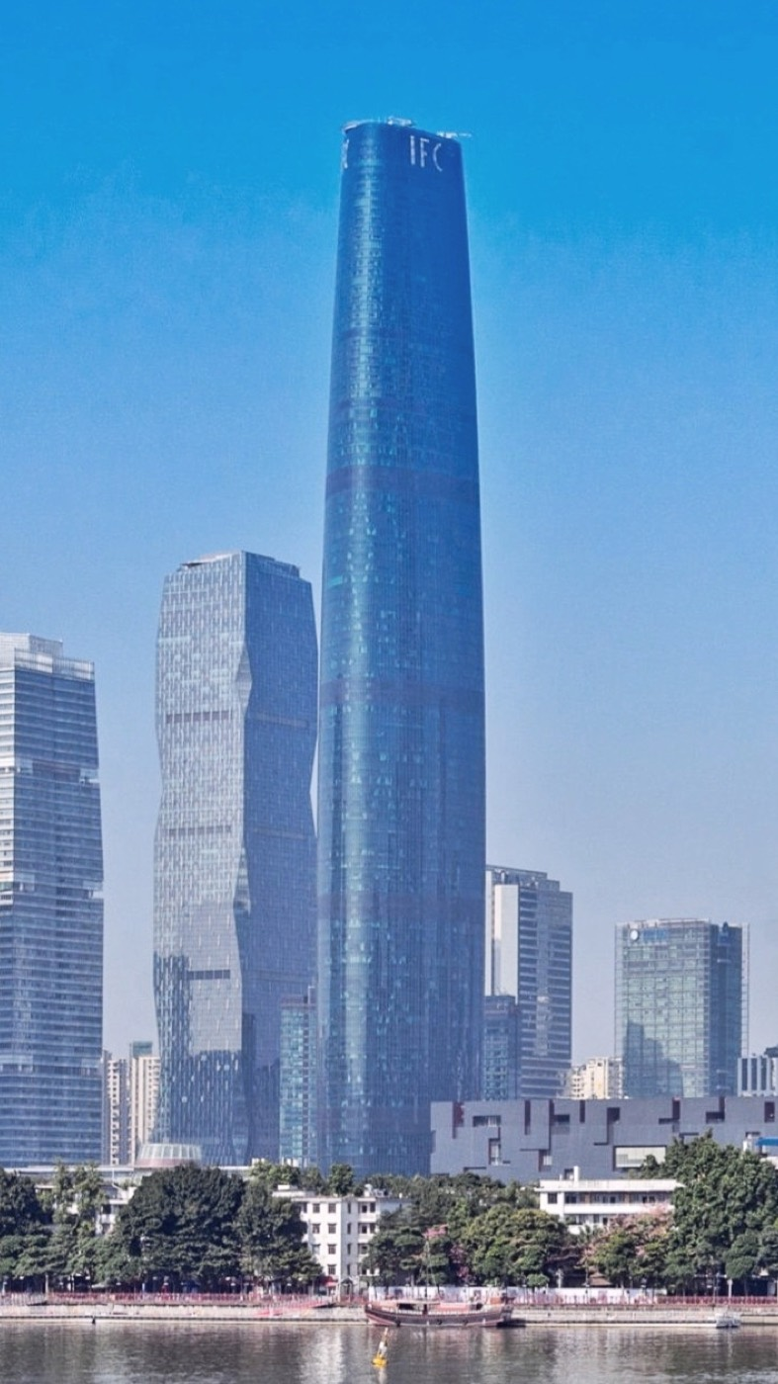  Guangzhou International Finance Center — xiquinhosilva (CC BY-SA 4.0) | 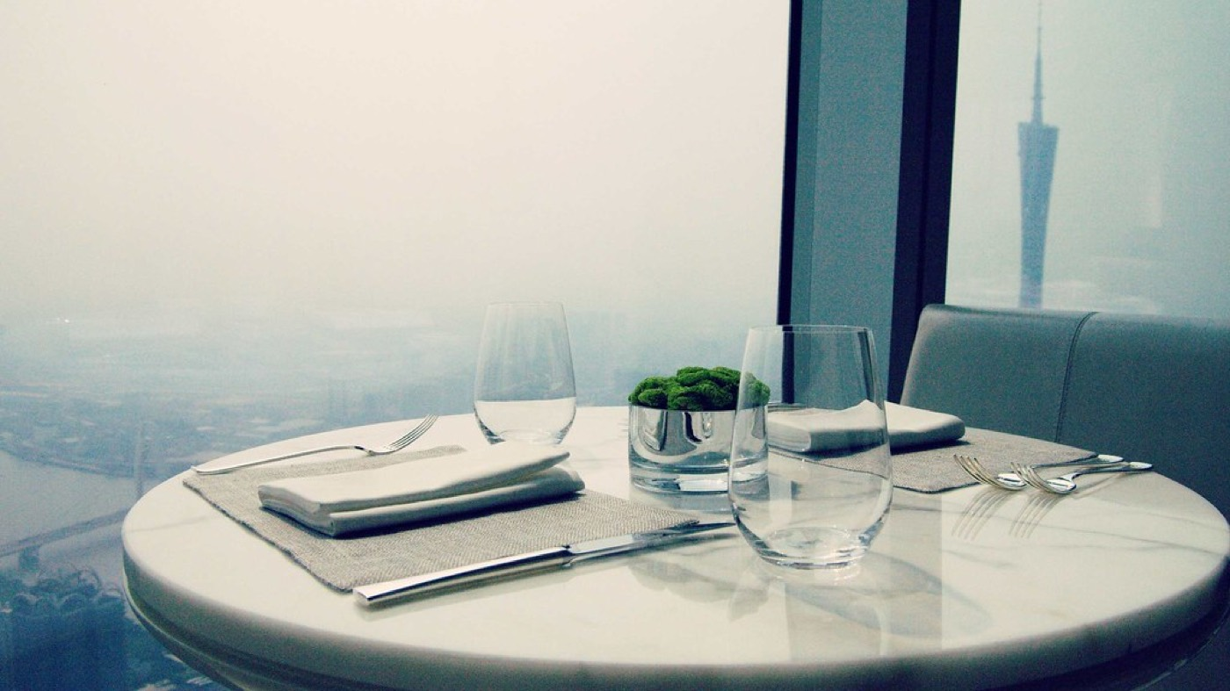  Breakfast at Caffe Mondo - Four Seasons Guangzho — Matt@PEK (BY-NC-SA 2.0)
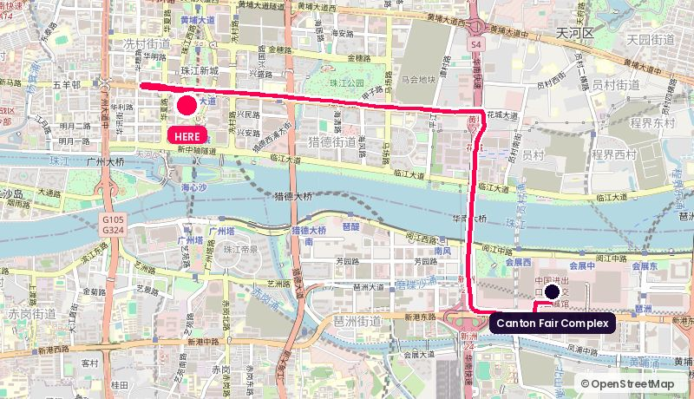
Route from the Canton Fair Complex. Map © OpenStreetMap contributors.
Address: 5 Zhujiang West Rd, IFC, Tianhe
Walk: 73 min walk (5.5 km)
Drive: 9 min drive (7.0 km), allow 19 min in fair traffic during the fair
Backdrop: Sky lobby atrium and Canton Tower across the river through floor-to-ceiling glass
Coordinates: 23.12043, 113.31797
Google Maps: https://www.google.com/maps/search/?api=1&query=23.12043,113.31797 | directions: https://www.google.com/maps/dir/?api=1&origin=23.10344,113.35412&destination=23.12043,113.31797&travelmode=driving
Tags: Guest-convenient / Canton Tower view / Far from venue
Why it works. High-floor rooms and public spaces look directly at Canton Tower. If a financial-services guest is staying in Zhujiang New Town anyway (and Mastercard or HSBC people usually are), you shoot where they already are.
Watch out. Far from Pazhou. Only justifiable if the guest's diary, not yours, sets the location.

Shortlists

If the story is the fair
- Official Press Centre (Area A)
- Area D conference rooms
- Nan Fung exhibition halls

If the story is the skyline
- Guangzhou International Media Port
- Park Hyatt Roof Bar
- Haixin Bridge riverfront

Lowest risk, fastest yes
- Shangri-La Hotel, Guangzhou
- InterContinental Guangzhou Exhibition Center
- Langham Place, Guangzhou

Still to confirm
- Fair-week availability at every hotel
- Filming permits for public riverside sites
- GRT studio access and a media partner
Route maps © OpenStreetMap contributors. Photography is Creative Commons and public domain, from Wikimedia Commons and Openverse, credited under each image. Venue details come from public sources and are not confirmed bookings.

