Monitoring Proxmox with Prometheus and Grafana
A single-node Proxmox VE homelab monitored from a dedicated VM named monitor. This guide installs Grafana first, then Prometheus, then connects them and explains what each dashboard panel shows. Replace <PROXMOX_IP> with the address of your Proxmox host and <monitor-vm-ip> with the address of the monitor VM wherever they appear.

1. Architecture
Proxmox host <PROXMOX_IP>
node_exporter :9100 host CPU, RAM, disk, network
smartctl_exporter :9633 disk SMART health

VM "monitor" (Docker Compose)
pve-exporter :9221 Proxmox API -> VM, container, storage metrics
prometheus :9090 scrapes the four targets every 15s
grafana :3000 dashboards, reads from Prometheus
Prometheus pulls metrics on a schedule. Nothing on the Proxmox host pushes data, and the API user is read-only, so a compromised monitoring VM cannot change your guests.

2. Step 1: Read-only Proxmox user and API token
Run on the Proxmox host (Datacenter, your node, Shell). The pve realm gives API access without a shell on the host.
pveum user add prometheus@pve --comment "Prometheus exporter"
pveum acl modify / --users prometheus@pve --roles PVEAuditor
pveum user token add prometheus@pve exporter --privsep 0
The last command prints the token secret once. Copy it now. With --privsep 0 the token inherits the user's PVEAuditor permissions.
The user now holds seven *.Audit privileges at / with propagate enabled. That is exactly the built-in PVEAuditor role: it can read everything and change nothing.

3. Step 2: Exporters on the Proxmox host

node exporter (host CPU, memory, disk, network)
apt update
apt install -y prometheus-node-exporter
systemctl enable --now prometheus-node-exporter
curl -s http://localhost:9100/metrics | head

smartctl exporter (disk health)
Find the current version on the prometheus-community/smartctl_exporter releases page and substitute it for VERSION.
apt install -y smartmontools
cd /tmp
wget https://github.com/prometheus-community/smartctl_exporter/releases/download/vVERSION/smartctl_exporter-VERSION.linux-amd64.tar.gz
tar xzf smartctl_exporter-VERSION.linux-amd64.tar.gz
install -m 755 smartctl_exporter-VERSION.linux-amd64/smartctl_exporter /usr/local/bin/
Create /etc/systemd/system/smartctl_exporter.service:
[Unit]
Description=smartctl exporter
After=network.target

[Service]
ExecStart=/usr/local/bin/smartctl_exporter --web.listen-address=:9633
Restart=on-failure

[Install]
WantedBy=multi-user.target
systemctl daemon-reload
systemctl enable --now smartctl_exporter
curl -s http://localhost:9633/metrics | grep smartctl_device | head
The exporter runs as root because SMART needs raw disk access, so limit port 9633 to the monitor VM (see Hardening).

4. Step 3: Install Grafana
On the monitor VM, install Docker, clone the repository and start only Grafana first:
git clone <your-repo-url> monitoring && cd monitoring
docker compose up -d grafana
docker compose ps
Open http://<monitor-vm-ip>:3000. The default login is admin / admin, and Grafana asks you to set a new password immediately. Do that before anything else.
Grafana is empty at this point. It has nothing to read until Prometheus exists.

5. Step 4: Install Prometheus and pve-exporter
Create the exporter credentials from the template and paste the token secret from Step 1:
cp pve.yml.example pve.yml
nano pve.yml
chmod 600 pve.yml
default:
user: prometheus@pve
token_name: exporter
token_value: PASTE_TOKEN_SECRET_HERE
verify_ssl: false
verify_ssl: false is acceptable on a trusted LAN because Proxmox uses a self-signed certificate. Then start the remaining services:
docker compose up -d prometheus pve-exporter
docker compose ps
Open http://<monitor-vm-ip>:9090 to confirm Prometheus is up.
The docker-compose.yml used for all three services:
services:
grafana:
image: grafana/grafana:latest
volumes:
- grafana-data:/var/lib/grafana
ports: ["3000:3000"]
restart: unless-stopped

prometheus:
image: prom/prometheus:latest
volumes:
- ./prometheus.yml:/etc/prometheus/prometheus.yml:ro
- prometheus-data:/prometheus
ports: ["9090:9090"]
restart: unless-stopped

pve-exporter:
image: prompve/prometheus-pve-exporter:latest
volumes:
- ./pve.yml:/etc/prometheus/pve.yml:ro
ports: ["9221:9221"]
restart: unless-stopped

volumes:
grafana-data:
prometheus-data:

6. Step 5: Configure Prometheus
All behaviour is defined in prometheus.yml. It has four scrape jobs:
Job | Target | What it provides
prometheus | prometheus:9090 | Prometheus's own health
node | <PROXMOX_IP>:9100 | Host CPU, RAM, disk, network
smartctl | <PROXMOX_IP>:9633 | SMART health and temperature of physical disks
proxmox | <PROXMOX_IP> via pve-exporter:9221 | VMs, containers, storage and node info from the Proxmox API

global:
scrape_interval: 15s

scrape_configs:
- job_name: prometheus
static_configs:
- targets: ["prometheus:9090"]

- job_name: node
static_configs:
- targets: ["<PROXMOX_IP>:9100"]

- job_name: smartctl
static_configs:
- targets: ["<PROXMOX_IP>:9633"]

- job_name: proxmox
metrics_path: /pve
params:
module: [default]
static_configs:
- targets: ["<PROXMOX_IP>"]
relabel_configs:
- source_labels: [__address__]
target_label: __param_target
- target_label: __address__
replacement: pve-exporter:9221
The proxmox job is the unusual one. Prometheus asks the exporter to query the Proxmox API at a target, so the relabeling moves the Proxmox address into the target URL parameter and points the actual scrape at the exporter instead.
Reload after editing the file with docker compose restart prometheus. Then open Status, Target health. All four jobs must show UP.
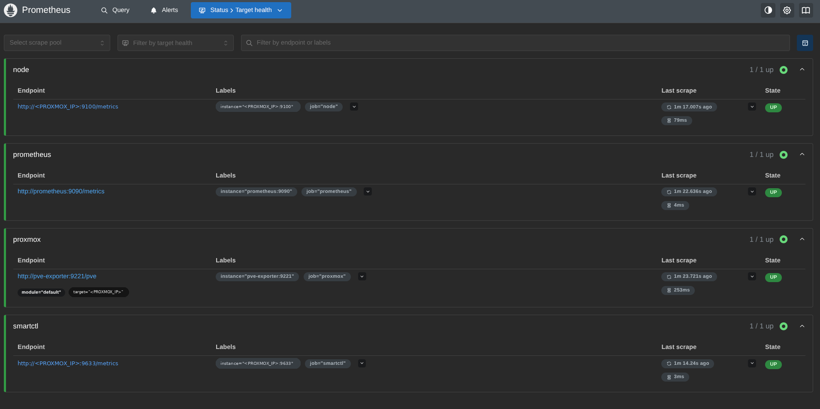
Figure 1. Prometheus target health: all four jobs up (host address redacted)
To see the raw data behind the dashboard, open the Query page and run pve_up (1 means the exporter reached Proxmox) or pve_guest_info (one row per VM and container).

7. Step 6: Connect Grafana to Prometheus
- In Grafana go to Connections, Data sources, Add data source, Prometheus.
- Set the URL to http://prometheus:9090. The container name resolves inside the Compose network.
- Click Save & test and wait for the success message.
Then import a ready-made dashboard: Dashboards, New, Import, enter ID 10347 ("Proxmox via Prometheus"), and select the Prometheus data source.

8. What the dashboard shows
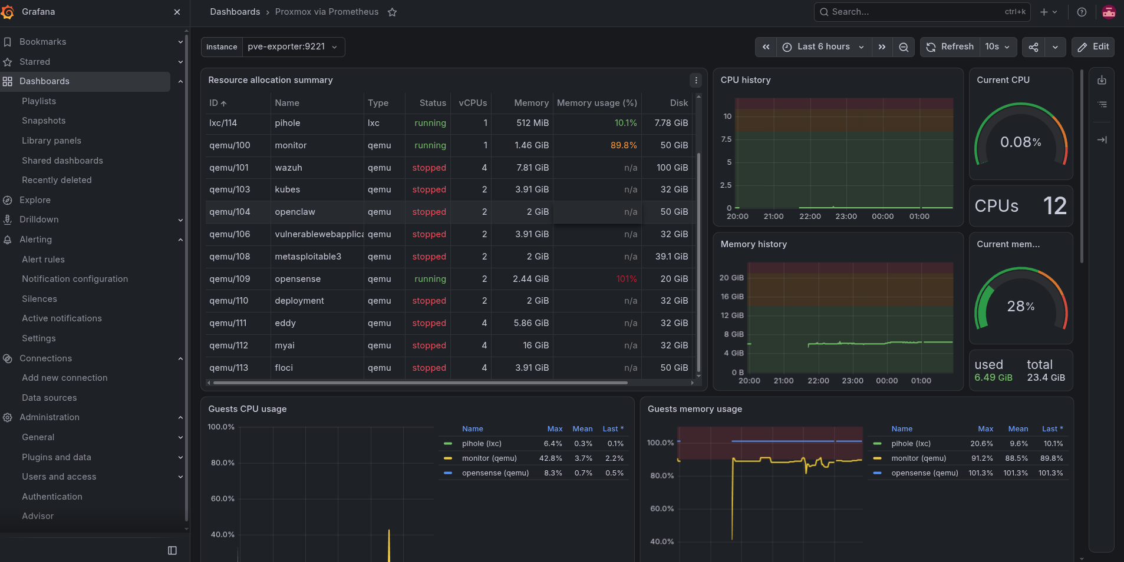
Figure 2. The Proxmox via Prometheus dashboard in Grafana
The instance dropdown at the top selects which exporter to read. Here it is pve-exporter:9221, the instance label produced by the relabeling in Step 5. Each panel is a PromQL query over metrics from the jobs above:
Panel | Source job | What it reads
Resource allocation summary | proxmox | One row per guest: ID, name, type (lxc or qemu), status, vCPUs, memory, memory usage, disk. Built from pve_guest_info joined with pve_memory_size_bytes, pve_memory_usage_bytes and pve_disk_size_bytes.
CPU history, Current CPU, CPUs | proxmox / node | Host CPU usage over time, the current value as a gauge, and the total core count.
Memory history, Current mem | proxmox / node | Host memory used and total, over time and as a gauge.
Guests CPU usage | proxmox | pve_cpu_usage_ratio per running guest, with max, mean and last in the legend.
Guests memory usage | proxmox | pve_memory_usage_bytes divided by pve_memory_size_bytes per running guest.

Stopped guests appear in the table as "stopped" with n/a usage and are absent from the usage graphs, because a stopped guest reports no CPU or memory. The metric names above are the usual ones for this exporter; to see the exact query behind any panel, open its menu and choose Edit.

9. Step 7: Create alerts
Dashboards show problems after you look at them. Alert rules in Grafana watch the same Prometheus data and notify you when something crosses a threshold.
- Go to Alerting, Alert rules, New alert rule.
- Enter a name, for example High guest CPU.
- Choose the prometheus data source, switch the query editor to Code, and enter a PromQL query.
- Under Alert condition set WHEN QUERY IS ABOVE (or below) a threshold, then click Preview alert rule condition to see what would fire.
- Choose a folder, an evaluation group and interval (1m is a good start), and a pending period so a single spike does not fire.
- Pick a contact point. Create one first under Alerting, Notification configuration (email, Telegram, Discord or a webhook).
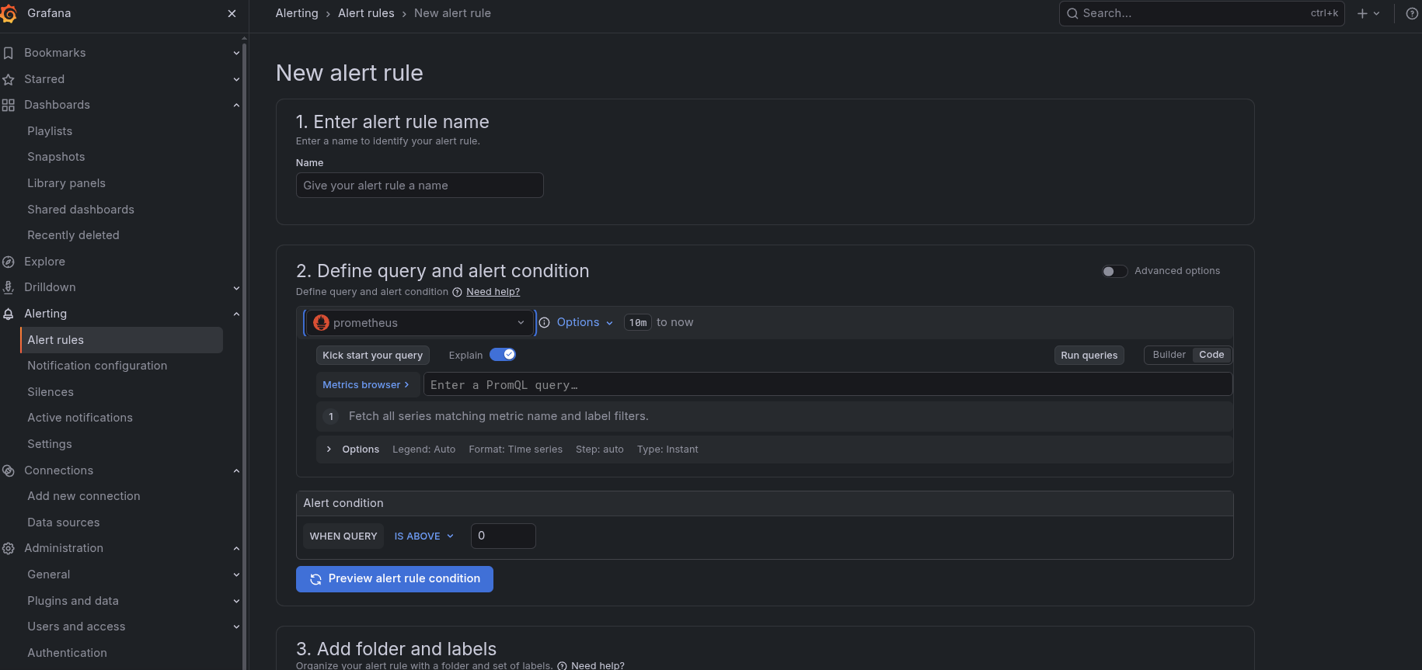
Figure 3. New alert rule form: name, query and alert condition
A saved rule shows its query, the current state of every series it covers, and the threshold. The Instances tab lists one entry per matching series.
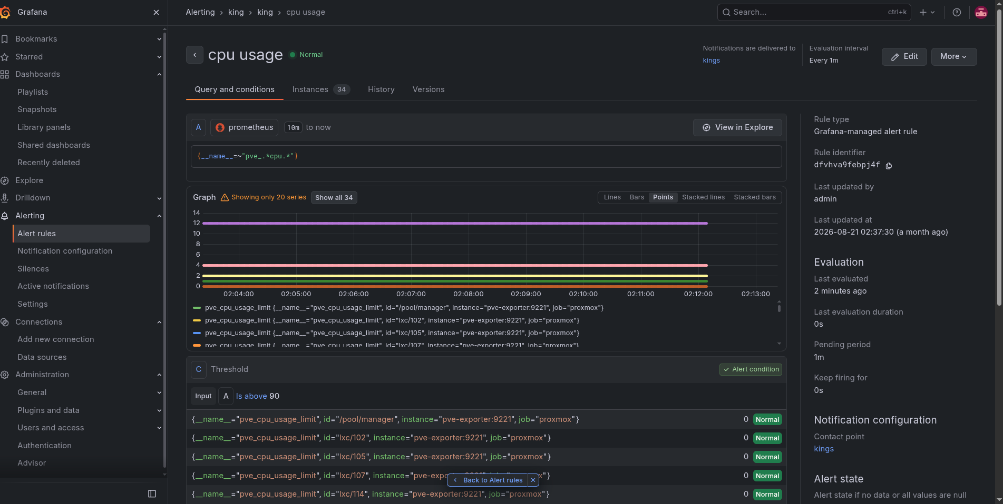
Figure 4. An existing rule: query, evaluation graph and threshold

Useful starting rules
Alert | Query | Condition
Guest CPU high | pve_cpu_usage_ratio | Is above 0.9
Guest memory high | pve_memory_usage_bytes / pve_memory_size_bytes | Is above 0.9
Proxmox API unreachable | pve_up | Is below 1
Any target down | up | Is below 1
Disk SMART failing | smartctl_device_smart_status | Is below 1

Check metric names in the Metrics browser before saving, since exporter versions can rename them. The CPU and memory rules fire per guest, so one rule covers every VM and container.

Common mistake: matching too many metrics
A regex query such as {__name__=~"pve_.*cpu.*"} matches every CPU metric, including pve_cpu_usage_limit, which is the number of vCPUs a guest has (2, 4, 12 and so on), not its usage. It also makes the instance count jump, because each metric multiplies the series. Query pve_cpu_usage_ratio directly.
Also match the threshold to the unit. pve_cpu_usage_ratio is a fraction from 0 to 1, so a threshold of 90 can never be reached. Use 0.9 for 90%, or multiply the query by 100.

10. Troubleshooting
Symptom | Likely cause and fix
proxmox target down or 5xx | pve-exporter cannot log in. Run docker compose logs pve-exporter and check the token name, secret and user.
Target UP but no VM data | The token has privilege separation on and no ACL of its own. Recreate it with --privsep 0, or grant PVEAuditor to prometheus@pve!exporter.
TLS certificate error | Set verify_ssl: false in pve.yml, or trust your CA.
node or smartctl down | Service not running or blocked. Test curl http://<PROXMOX_IP>:9100/metrics from the monitor VM and check the Proxmox firewall.
Grafana data source test fails | Wrong URL. Inside Compose use http://prometheus:9090, not localhost.
Dashboard empty | Wrong data source, or the instance dropdown points at the wrong target. Pick pve-exporter:9221.

11. Hardening and next steps
- Memory on the monitor VM. Give it enough RAM. If the dashboard shows it near 90%, raise it before Prometheus data grows, or the kernel OOM killer will pick a container.
- Guests above 100% memory. A VM can report more than 100% memory usage in the dashboard. This is usually ballooning or guest accounting, not a leak. Check the VM's balloon setting and its memory inside the guest.
- Limit exposure. Allow ports 9100 and 9633 only from the monitor VM's IP using the Proxmox firewall. Put Grafana behind a reverse proxy with TLS if it leaves your LAN.
- Retention. Prometheus keeps 15 days by default. Add --storage.tsdb.retention.time=30d to its command if you want longer.
- Alerting. Create the starter rules from Step 7 and test the contact point with a deliberately low threshold, so you know a notification really arrives.
- Secrets. Keep pve.yml out of version control. Never commit the token, and rotate it if it leaks.

