

Middle East Technical University Northern Cyprus Campus

483 Introduction to Computer Vision

Project 1

**Content Based Image Classification**

2243392 Pınar Dilbaz

2243384 Muhammed Didin

2151835 İbrahim Aydın

Supervised by

Asst. Prof. Dr. Meryem Erbilek

#### Abstract

We aimed to develop our system which is named the PIM-Tech Image Classifier using the fundamental content-based image classification (CBIC) pipeline along with grid-based histogram descriptors. The main goal of our project is to implement a CBIC system based on different types of grid-based histogram features and to make a classification using a KNN classifier. Our system consists of 3 main bases, the first of which is the histogram part. We have a choice of two different types of histograms such as grayscale intensity histogram and color histogram that is taken from the user. Secondly, we also have grid-based histogram feature extraction which can be examined into three levels, one of them is level 1 which means that grid size is 1x1, and level 2 which grid size 2x2 and finally level 3 that grid size 3x3. The user needs to choose at which level our system will work. Finally, we have the classification batch, in this part we used a KNN classifier and tried the K values of only 1, 5 and 9.

1. **Level 1**

**Grayscale Histogram**

*For Level 1 and K value is 1:*

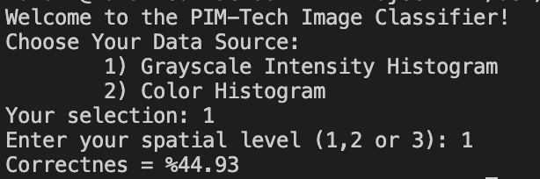

*For Level 1 and K value is 5:*

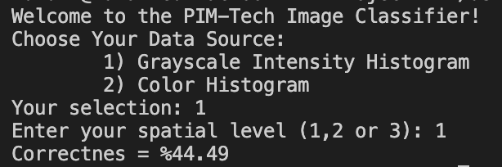

*For Level 1 and K value is 9:*

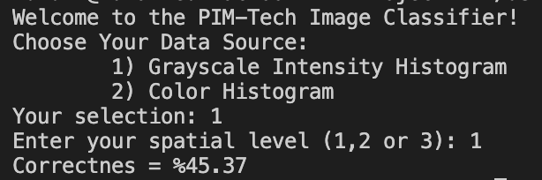

**RGB Histogram**

*For Level 1 and K value is 1:*

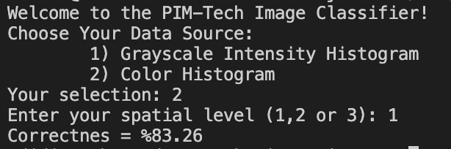

*For Level 1 and K value is 5:*

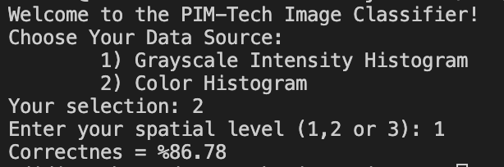

*For Level 1 and K value is 9:*

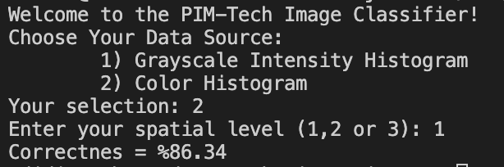

For grayscale histogram since we had enough number of images, our results came out at the correct values ​​and the bigger we had the K value, the wider we had the chance to look at it, so when K value is 9, we got the highest result.

Since we looked at more colors in the RGB histogram, it was sufficient to have a K value of 5, so we did not observe much change in K values ​​after 5.

1. **Level 2**

We pick up the best configuration which is K value 5 in Level 1.

**Grayscale Histogram**

*For Level 2 and K value is 1:*

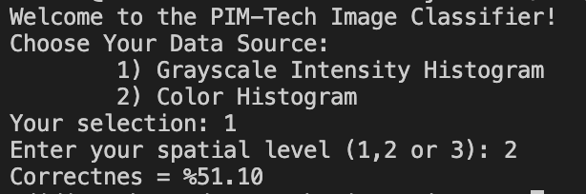

*For Level 2 and K value is 5:*

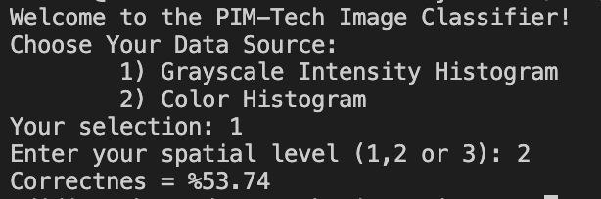

*For Level 2 and K value is 9:*

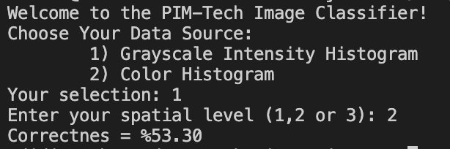

**RGB Histogram**

*For Level 2 and K value is 1:*

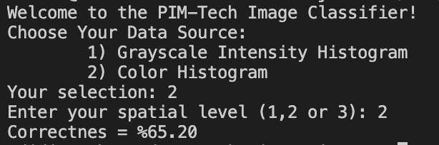

*For Level 2 and K value is 5:*

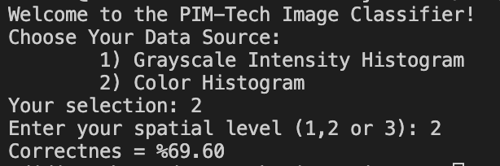

*For Level 2 and K value is 9:*

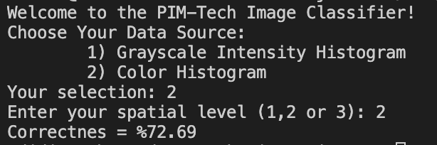

For Level 2, we divided our images into 4 parts, so we had the chance to examine it in more detail and it was enough to have a K value of 5, K values ​​after 5 showed little change, which is almost constant. We looked at more colors for RGB and this time we got our highest correctness value in K value 9.

1. **Level 3**

We pick up the best configuration which is K value 9 in Level 2.

**Grayscale Histogram**

*For Level 3 and K value is 1:*

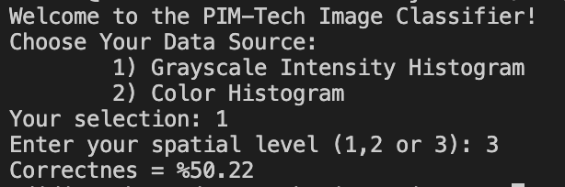

*For Level 3 and K value is 5:*

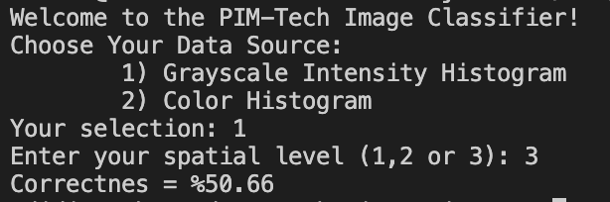

*For Level 3 and K value is 9:*

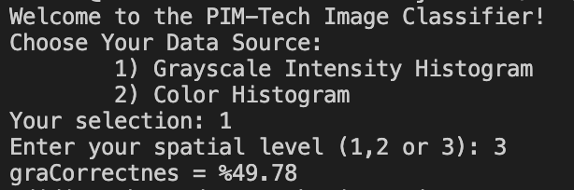

**RGB Histogram**

*For Level 3 and K value is 1:*

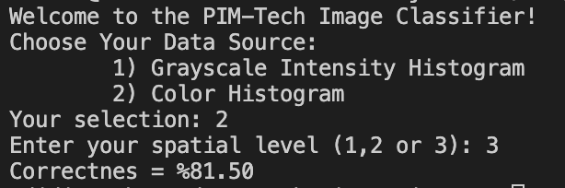

*For Level 3 and K value is 5:*

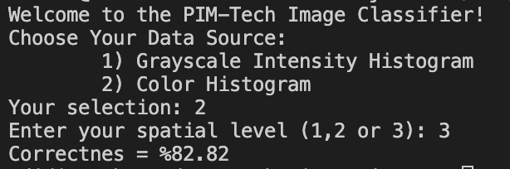

*For Level 3 and K value is 9:*

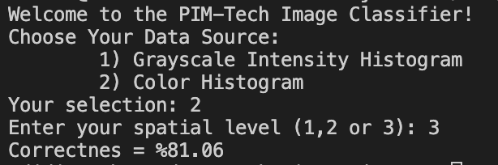

At level 3, we divided our images into 16 parts, so almost all our K values ​​gave the same result in the Grayscale histogram, because when we split the pictures into more parts, we had 16 different histograms for each unit image and our values ​​turned out to be very close to each other.

As we see in all different levels in the RGB histogram, we got a higher result, which we think is because we checked the large number of colors in the RGB histogram.

1. **Questions**

* **What do you think cause the difference between the results?**

Switching from Grayscale image to RGB image and increasing the level number causes to take more features from the image. As we got more detail from the image, our accuracy started to increase, and the amount of change resulting from changing the K numbers (number of neighbors) began to decrease. There is a noticeable decrease in the accuracy rate when moving from Level 1 to Level 2. However, when you move to Level 3, the results get closer to Level 1. We understand that we should either completely examine the picture or increase the number of parts as much as possible.

* **How did you combine the histograms in level 2 and 3?**

Using the concatenation method, we made them all into a single vector.

* **What would you think the difference between to simply sum them and to concatenate them?**

In the sum method, we think that we would lose details. So, we decided to use concatenation method.

1. **your best confıguratıon**

For reaching to the best result, you must take values from test set in the evaluate algorithm function, in the menu of our program you should select RGB color histogram (typing 2) and Level 1, number of each RGB channel bins should be 10, number of neighbors should be 5.

1. **results on test set**

**metin içeren bir resim

Açıklama otomatik olarak oluşturuldu**

* Its better when we compare from validation set. We think we reached this conclusion because the images in the test set can be distinguished more easily.