quarto.qmd
Jonathan Socoy
if(!require("tidyverse")) install.packages("tidyverse")
Loading required package: tidyverse
── Attaching core tidyverse packages ──────────────────────── tidyverse 2.0.0 ──
✔ dplyr 1.1.4 ✔ readr 2.1.5
✔ forcats 1.0.0 ✔ stringr 1.5.1
✔ ggplot2 3.5.2 ✔ tibble 3.3.0
✔ lubridate 1.9.4 ✔ tidyr 1.3.1
✔ purrr 1.1.0
── Conflicts ────────────────────────────────────────── tidyverse_conflicts() ──
✖ dplyr::filter() masks stats::filter()
✖ dplyr::lag() masks stats::lag()
ℹ Use the conflicted package (<http://conflicted.r-lib.org/>) to force all conflicts to become errors
library(tidyverse)
txhousing |>
filter(city=="Houston") |>
group_by(year) |>
summarize(sales=sum(sales)) |>
ggplot(aes(x=year, y=sales)) +
geom_line() +
ggtitle("Annual Houses Sold in Houston, TX")
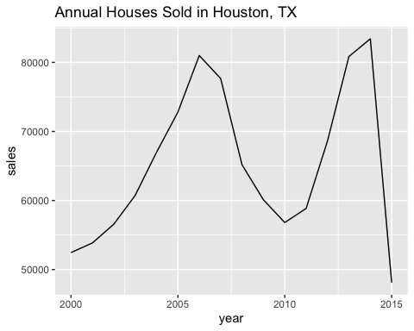
if(!require("tidyverse")) install.packages("tidyverse")
library(tidyverse)
txhousing |>
filter(city=="Houston") |>
group_by(month) |>
summarize(avg_price=sum(volume) / sum(sales)) |>
mutate(month=factor(month.abb[month],
levels=month.abb, ordered=TRUE)) |>
ggplot(aes(x=month, y=avg_price)) +
geom_bar(stat="identity") +
ggtitle("Average Price of Houses Sold in Texas by Month") +
xlab("Month") +
ylab("Average Sale Price") +
scale_y_continuous(labels = scales::dollar)
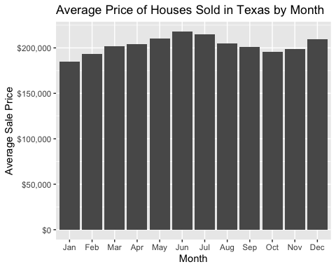
if(!require("tidyverse")) install.packages("tidyverse")
library(tidyverse)
txhousing |> filter(year==2015) |>
group_by(city) |>
summarize(avg_price=sum(volume) / sum(sales),
num_sales=sum(sales)) |>
slice_max(num_sales, n=10) |>
ggplot(aes(x=city, y=avg_price)) +
geom_bar(stat="identity") +
ggtitle("Average Price of Houses Sold in 2015 by City in Texas") +
xlab("City") +
ylab("Average Sale Price") +
scale_y_continuous(labels = scales::dollar)
