quarto.qmd

Jonathan Socoy

if(!require("tidyverse")) install.packages("tidyverse")

Loading required package: tidyverse

── Attaching core tidyverse packages ──────────────────────── tidyverse 2.0.0 ──  
✔ dplyr 1.1.4 ✔ readr 2.1.5  
✔ forcats 1.0.0 ✔ stringr 1.5.1  
✔ ggplot2 3.5.2 ✔ tibble 3.3.0  
✔ lubridate 1.9.4 ✔ tidyr 1.3.1  
✔ purrr 1.1.0   
── Conflicts ────────────────────────────────────────── tidyverse_conflicts() ──  
✖ dplyr::filter() masks stats::filter()  
✖ dplyr::lag() masks stats::lag()  
ℹ Use the conflicted package (<http://conflicted.r-lib.org/>) to force all conflicts to become errors

library(tidyverse)  
txhousing |>   
 filter(city=="Houston") |>   
 group_by(year) |>   
 summarize(sales=sum(sales)) |>   
 ggplot(aes(x=year, y=sales)) +   
 geom_line() +   
 ggtitle("Annual Houses Sold in Houston, TX")

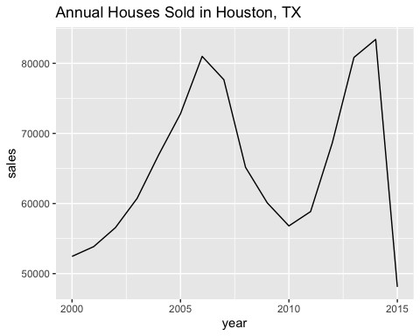

if(!require("tidyverse")) install.packages("tidyverse")  
library(tidyverse)  
txhousing |>   
 filter(city=="Houston") |>   
 group_by(month) |>   
 summarize(avg_price=sum(volume) / sum(sales)) |>   
 mutate(month=factor(month.abb[month],   
 levels=month.abb, ordered=TRUE)) |>  
 ggplot(aes(x=month, y=avg_price)) +   
 geom_bar(stat="identity") +   
 ggtitle("Average Price of Houses Sold in Texas by Month") +   
 xlab("Month") +   
 ylab("Average Sale Price") +   
 scale_y_continuous(labels = scales::dollar)

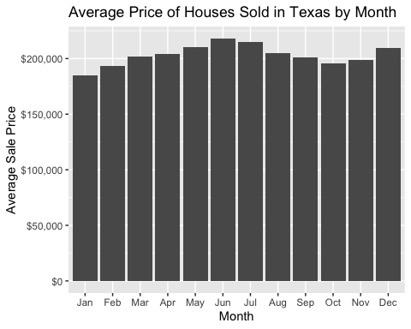

if(!require("tidyverse")) install.packages("tidyverse")  
library(tidyverse)  
txhousing |> filter(year==2015) |>   
 group_by(city) |>   
 summarize(avg_price=sum(volume) / sum(sales),  
 num_sales=sum(sales)) |>   
 slice_max(num_sales, n=10) |>  
 ggplot(aes(x=city, y=avg_price)) +   
 geom_bar(stat="identity") +   
 ggtitle("Average Price of Houses Sold in 2015 by City in Texas") +   
 xlab("City") +   
 ylab("Average Sale Price") +   
 scale_y_continuous(labels = scales::dollar)

