3.3 Layer-by-layer implementation

The 802.11ah ns-3 implementation was completed by Le Tian et al in 2016 with focus on PHY and MAC standards. This first version consisted of sub-1GHz channel models, Restricted Access Window implementation, fast association and different Modulation and Coding Scheme.

In the 2018 paper same authors presented a few extensions to this solution. These include modeling of energy consumption, radio state transitions, adaptive MCS, TIM segmentation and RAW configuration interface allowing for attach of real time RAW optimization algorithms.

This was achieved by researchers modifying four key components : The Wi-Fi Channel, Phy Layer, Mac Low and Mac High layers. Physical medium has been approximated basing on experimental research to simulate real world conditions. Propagation loss model and transmission delay were configured accordingly. Modifications in PHY layer define new PLCP frames format. Three classes have been used to adapt wifi-channel : WifiPhy/YansWifiPhy, InterferenceHelper and ErrorRateModel. The Mac High layer introduces management functions such as beacon frames generation, probing, association and partially RAW. It consists of two classes : ApWifiMac and StaWifiMac. The RTS/CTS/DATA/ACK transactions as well as DCF and EDCA are placed in Mac Low layer. Moreover it complements the RAW model in cooperation with MacHigh. Other functions it provides are packet scheduling, fragmentation, rate control as well as retransmission. Key classes for this component are MacLow, DcaTXop, EdcaTxop-n [tutaj różnica między nimi a opis dzialania i tak jest w rozdziale 2], MacRxMiddel, WifiStationManager.

Short explanation of simulation code below:

The code used to generate experiment scenario is specified in s1g-test-tim-raw.cc. In the beginning helper structures are created : Configuration config; Statistics stats; SimulationEventManager eventManager;
In particular config is responsible for handling scenario-specific parameters passed through command line. Stats accounts for statistics collection and eventManager reacts to event updates also maintaining connection with visualizer tool. Then until line 78 there are functions related to assoc_record class which maintain associacion status and station id. This is followed by populateArpCache function which takes care of ARP resolution process. RAW parameters are fetched from config file with RPSVector configureRAW funcion. TIM configuration and checking are handled by configurePageSlice (void), configureTIM (void), void checkRawAndTimConfiguration. Statistics configuration is achieved through sendStatistics with Simulator::Schedule(…). Analogously onSTADeassociated/Associated and similar contain functionality for STA to read its RAW config and also logic responsible for configuring chosen server or client on STA, depending on command line configuration. After reading, we have a set of functions used for RAW tracing. ConfigureNodes defines stations behavior depending on various event triggers.
getWifiMode and similar functions set according parameters passed by command line.
Another segment of function definitions follows, such as onChannelTransmission or OnAPPhyRxDrop which are used to specify event-based behavior of entities. For example callback to function onChannelTransmission is used to update counters which change along with channel transmission (e.g RAW slot or the transmissions counters per STA & AP). Then a whole segment of application layer configuration functions like configureTCPSensorClients defines node application characteristics. They create factory application object of type of said application, defined in external class file (TCPSensorClient.cc/h). The configured application is installed on certain nodes.

The PhyStateTrace function prints the information regarding the state of the device?
Next step is the main function in which we use above mentioned utilities.
Inside, the network is built layer-by-layer. Then the AP and STAs are created and placed randomly within area of destined radius, AP being the center of topology. Later traffic applications are configured on each device, MACs and IP adresses assigned and routing is performed. Before actual start of the simulation, the kind of statistics and logs being collected are defined. Then the simulator starts.

TODO :
How RAW config is processed from file and how to change it ?
Raw-config interface and how to

NS3-Simulation
The ns3 simulation is written in C++ (with some parts in C++11).
The project contains:
Main: the main file is responsible for the entry point, configuring and running the simulation
configureChannel: configures the yans wifi channel
configureSTANodes: configures the stations
configureAPNodes: configures the access point and hooks up trace sources
configureIPStack: configures the IP stack for both stations and AP
configureNodes: hooks up trace sources for all stations
sendStatistics: takes a snapshot of the node statistics and sends it to the visualizer
Configuration: contains the configuration for the simulation and parses the values from the command line
NodeEntry: contains all the hooked up events of the trace sources for a particular station
Statistics: manages the statistics of the simulation
NodeStatistics: contains the statistics of a particular node, which are updated in the NodeEntry.
SimulationEventManager: manages the different simulation events, serializes them and sends them to the visualizer
Helper: contains methods to pre-populate the ARP cache and route table of all nodes

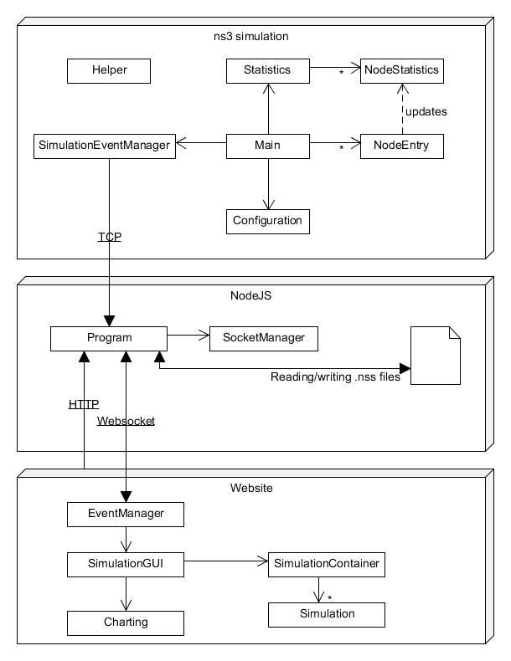
Design Structure :

Można dodać zdjęcia i konkretnie opisać co wprowadzili z artykulu implementation & validation z 2016.

Raw-config interface and how to
class S1g

main
wpisanie do RPS parametrow RAW z pliku :
config.rps = configureRAW(config.rps, config.RAWConfigFile);

configureRAW
czyta tylko z pliku
co może pisac do pliku (jakieś algo ?)

s1g-raw-control :

EstimateTransmissionInterval
wydaje się być podobne do opisanego w taroa artykule algorytmu1

rps.h/cc – tutaj okresla sie jak ma wygladac wektor rps i jego funkcje pomocnicze

Żeby włączyć TAROA : ogarnac interakcje między ap-wifi-mac.cc a s1g-raw-control.cc, zmienic to tez w skrypcie testowym. Zasymulowac dla test. Tet2 to backup.

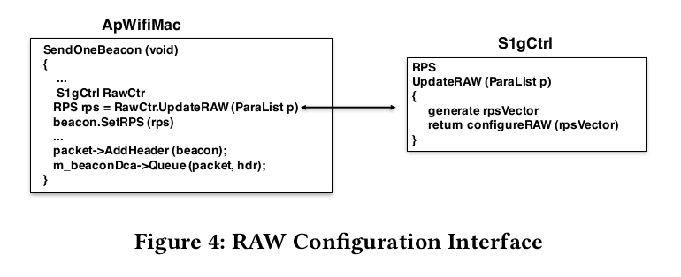
Najtrudniej / najlatwiej to z maina usunac. Pomysl wstawianie tam gdzie teraz są na sztywno/z configa parametrow obliczanych przez funkcje.

usuniecie przyrownania nraw = nsta
wykonanie symulki : ./waf --run "test --TrafficType=udp --NRawSta=1 --Nsta=10 --DataMode=MCS2_8 --simulationTime=60 --rho=2 --payloadSize=1500 --NSSFile=/home/soczysty7/Mgr_2019/mwe/RAW_EXPERIMEN/10sta_sim0.06seed_1 --seed=1 --RAWConfigFile=./OptimalRawGroup/experimental_raw10.txt --TrafficPath=/home/soczysty7/IEEE-802.11ah-ns-3/OptimalRawGroup/traffic/10sta_sim.txt" 2>&1 | tee /home/soczysty7/Mgr_2019/mwe/RAW_EXPERIMEN/10Sta_LOG
pozwala zeby były tylko 2 stacje RAW jak się dobrze ustawi rawconfig pliczek
w ten sposob mamy 8 stacji non-raw teoretycznie

Wystąpienia rzeczy z RAW w mainie :
zaznaczone na czerwono breakpointy

co mamy w s1g-raw control & skrypcie testowym:
configureRAW,
rps i rpsset
funkcje typu GetNumberOfRawGroups
są definiowane w skrypcie symulacji przy okazji kilku roznych zdazen i potem przy petlach zwiazanych z event managerem (źródłowo w rps.cc/h klasa RPS)
transmissionsPerTIMGroupAndSlotFromSTASinceLastInterval
może przydac się do liczenia Algorithm 1 z artykulu o TAROA ? Tutaj tylko wektor wypelniany zerami.
phy.Set("S1g1MfieldEnabled"
czy trzeba wlaczac to pole w beaconie zeby kontrolowac te algo w czasie rzeczywistym ?
Tutaj mamy :
WifiHelper wifi = WifiHelper::Default();
wifi.SetStandard(WIFI_PHY_STANDARD_80211ah);
S1gWifiMacHelper mac = S1gWifiMacHelper::Default();

które definiują warstwę MAC do której później wpisujemy parametry RAW z configa na sztywno które ustalono : "NRawStations", UintegerValue (config.NRawSta),
"RPSsetup", RPSVectorValue (config.rps),

Instalowanie tego na Apku : apDevice = wifi.Install(phy, mac, wifiApNode);
Jakieś dziwne callbacki / tracing aktualnej liczby grup & slotów :
Config::ConnectWithoutContext(oss.str() + "RpsIndex", MakeCallback(&RpsIndexTrace));
Config::ConnectWithoutContext(oss.str() + "RawGroup", MakeCallback(&RawGroupTrace));
Config::ConnectWithoutContext(oss.str() + "RawSlot", MakeCallback(&RawSlotTrace));

Znów pobieranie RAW parametrow z configa przez funkcje wkladajace je do enentManagera :
if (config.rps.rpsset.size() > 0)
for (uint32_t i = 0; i < config.rps.rpsset.size(); i++)
for (uint32_t j = 0;
j < config.rps.rpsset[i]->GetNumberOfRawGroups(); j++)
eventManager.onRawConfig(i, j,
config.rps.rpsset[i]->GetRawAssigmentObj(j));

Myślę że powyższe ma tylko wysyłać do wizualizatora w wypadku eventów aktualną konfigurację RAWa.
Problem jaki widzę jest taki że przypisanie na sztywno RAW-parametrów z configa Apkowi przy definiowaniu warstwy MAC. Będzie potrzebne robienie update’ow caly czas – co kazdy event.
Sensory to raczej takie zwykle do scenariusza IoT a nie wyczuwajace zmiany ruchu pod RAW.

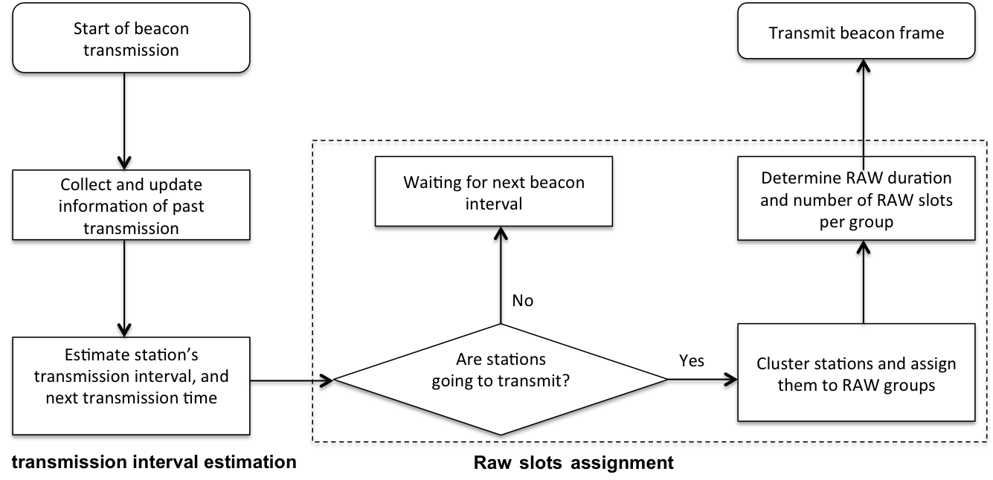
Można szukac tych wartosci stad : Table 2. Variables and notations introduced in the algorithm description.
TAROA artykul i sprawdzac czy mamy fragment kodu który by je liczyl.
Sensor::GetEstimateNextTransmissionID

Czy wystarczy odkomentować w ap rzeczy z S1gRawCtr
nie, nie wiadomo co poza tym są zle typy

