Co zostalo zmienione : ap wifi mac/ sta wifi mac mozna wrzucic obrazki i praktycznie przepisac to

In ns-3 WiFi Phy and Mac layers are constructed from four main components :
WifiChannel – handles moddeling the propagation loss and delay
WifiPhy – which is responsible for sending and receiving frames and determining interference loss,
MacLow – implements channel access logic
MacHigh – which takes care of management functions of beacon generation, associacion etc.

In PHY components authors focused on adding support for new modulation and coding schemes
MCS0 - MCS9 for channel bandwidths 1, 2, 4, 8 and 16 Mhz. The second novelty in phy layer was the propagation loss approximation coherent with experimental indoor and outdoor measures for 802.11ah networks [Impl: Hazmi et al. [5].].

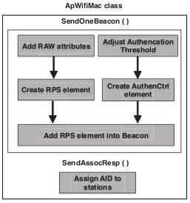
Finally the MAC layer has been expanded to support additional features : fast association, TWT
[tu bd trzeba dodac wiecej z tego extension artykulu], and RAW. Especially MacHigh component is responsible for defining new behavior of nodes in ApWifiMac and StaWifiMac classes. The class related to AP adds new functionality in order to create RAW-regulating RPS element and authentication control element needed in fast association. Both are injected in relevant Beacon frame and sent through SendOneBeacon(). Also AIDs need to be assigned in a new way according to improved TIM hierarchy scheme [more from extension].

The StaWifiMac has also new functionality integrated in it.
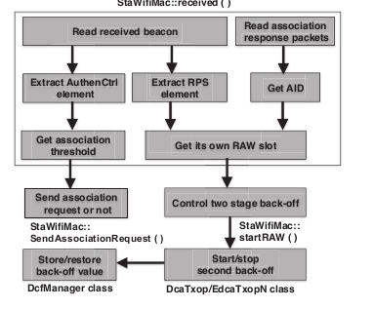
This is mainly needed to implement TWT sleep schedule and logic for extracting new elements from beacon. It has to be performed with each receive (beacon ?) event and indicated for station to act accordingly. The more advanced modification of back-off scheme is included to maintain subscribing to correct/assigned RAW slot.
Albo ”Together RAW information and the AID determine the RAW
slot stations belong to and control the two stage back-off, making sure stations are allowed to access the channel during their own RAW slot.”

DcaTxopN, EdcaTxopN and DcfManager napisac
ze sa rowniez modyfikowane ?

Jak działa interfejs to mozna z rozdz.3 poprzedniego wyciagnac z tych dziwnych notatek.
Skłaniam sie ku zwyklym badaniom i pojsciu w ilosc i rozwoj ciekawych analiz : zmieniajmy co sie da (tak zeby dzialalo) i analizujmy konsekwencje eksperymentow.

