
internationaloffice.berkeley.edu

Optional Practical Training 24 Month STEM Extension
Application Deadline
Your complete OPT STEM Extension application must be received by USCIS on or before your 12 month OPT expiration date. The earliest you can submit this form is 3 months (90 days) before the end date of your 12 month OPT EAD.

BIO 24 Month STEM I-20 Request Instructions (See STEM Tutorial for USCIS submission instructions.)
- Review the OPT 24 Month Extension tutorial at: http://internationaloffice.berkeley.edu/students/training/f-1/extension
- Log in to https://io.berkeley.edu/ssu DIRECTLY BEFORE you submit your STEM application to BIO to (Most processing delays are due to failure to update all new required fields in SSU.)
  - Update all current/previous OPT employment and your current address/email/phone.
  - Upload a copy of your current EAD card
  - Upload a copy of your fully completed I-983 Form pages 1-4 for your STEM employer.
  - Students changing STEM employers- See page 2 of this form for additional instructions and required SSU updates.
- Print out this page and submit to Berkeley International Office with:
  - Post-Completion Services Fee: Attach check or money order made payable to “UC Regents”. Fee: $225 until 12/23/2016; $300 after 12/23/2016.
- Mail this completed form with check or money order and supporting documents to: Berkeley International Office, 2299 Piedmont Ave., Berkeley, CA 94720-2321. You may also email this form and supporting documents to internationaloffice@berkeley.edu and send the check/money order via mail. Proper check/money order formatting on pg 3.
Student Information

Family Name: | Given Name:
Birth Date (Month/Day/Year): | UCB ID Number:
Days of unemployment since the start date of your OPT EAD: | UC Berkeley OPT Degree Major(s):
STEM Employer Change
- Are you applying to change your current 24 Month STEM employer? Yes No
STEM Degree Information  - STEM Degree Level: Bachelor’s Master’s Ph.D  - Did you receive your STEM degree at UC Berkeley? Yes No  - If NO, then at what school? | Prior STEM Extension Usage  - Have you ever had an OPT STEM Extension before? Yes No  - List the dates of your previous STEM Extension:  - What was the degree level for your previous STEM Extension?  Bachelor’s Master’s Ph.D
Primary Email Contact:  (This email should match your primary email in SSU.) | Telephone:
“I have read the STEM OPT Application Guide . I understand the responsibilities required for maintaining F-1 status during my period of STEM OPT authorization as stated on the reverse and in the STEM OPT Application Guide and I am responsible all reporting requirements. “
Signature of Student: Date:
Employer Information Log in to SSU and be sure you have updated all current and previous OPT employment and your current address.
STEM Employer’s Name:  City/State:  Hours per week: |  | Is your employer enrolled in E-Verify? Yes No  Does your employer have an EIN number? Yes No  Is this employment volunteer/unpaid, employment through a temp agency or consulting firm, or self- employment ? Yes No
I-20 Delivery Information
How would you like your I-20 delivered?  Pick up in our office.  By regular mail.  By FedEx express mail  Please follow FedEx instructions at http://internationaloffice.berkeley.edu/express_mail | Street Address in U.S. to receive I-20:
 | City: | State: | Zip Code:
 | Telephone number at delivery address (for FedEx):
For BIO use only PAID ◻ NOT PAID ◻

Payment ◻ Check ◻ Money Order # ___________ Payer: ◻ Student ◻ Other. Name: ____________________

internationaloffice.berkeley.edu
Maintaining Status on OPT 24 Month STEM Extension

General
  - You can continue working in the U.S. up to 180 days while the application is pending, even if your OPT EAD has expired.

Unemployment Allowance
- Students on post-completion OPT are allowed up to 90 days of unemployment. Students who receive a 24-month extension are given an additional 60 days of unemployment for a total of 150 days over their entire post-completion OPT period.
- Travel outside of the United States while unemployed will count as unemployment against the 90/150-day limits.
- If a student travels while employed either during a period of leave authorized by an employer or as part of their employment, the time spent outside the United States will not count as unemployment.
Address / Simple Employer Updates within 10 days
The following information must be reported to Berkeley International Office at https://io.berkeley.edu/ssu during the STEM OPT period of authorization. You are required to update the following information within 10 days of any changes:
- Legal Name Changes
- A change in residential address, phone or email
- Changes in Employer information including update to E-Verify Employer name and/or address
- Start Date of Employment
- Date of exiting the U.S (if you exit the U.S. prior to the end date of your OPT with no intent to return & resume OPT)
Change in STEM Employer within 10 days
If you change employers during your 24-Month STEM period you just submit a new OPT 24-Month STEM Extension request to Berkeley International Office- no fee required. You must also log in to https://io.berkeley.edu/ssu to 1) Add the new employer information. 2) Add an end date to your previous employer. 3) Update your address/phone/email. 4) Upload a copy of your STEM EAD. 5) Upload a new I-983 form for the new employer. 6) Upload the Final Evaluation from I-983 page 5 for your previous employer.

Material Changes to I-983
See the OPT Address & Employer reporting page for instructions on how to submit these updates. Both STEM OPT students and employers must report material changes to, or deviations from, the student’s formal training plan. These include:
- Any change of the employer’s EIN number, resulting from a change in the employer’s ownership or structure.
- Any reduction in student compensation that is not tied to a reduction in hours worked.
- Any significant decrease in hours per week that a student engages in a STEM training opportunity.
- Changes to the employer’s commitments or student’s learning objectives as documented on the Form I-983.

6-Month Validation Reports & 12 Month Evaluations
Be advised that your F-1 record may be terminated for failure to submit these required updates. See the OPT Address & Employer reporting page for instructions
- Students on OPT STEM must also submit a “Validation Report” every 6 months starting from the date the extension starts and ending when the student’s F-1 status ends or the extension ends, whichever is first.
- OPT STEM Students must also submit a 12 and final, 24-month Evaluation Report (page 5 of the I-983 Form). Final evaluations are also required if you leave an employer. Submit your annual evaluations at https://io.berkeley.edu/ssu .

Employer’s Reporting Requirement

If your employment is terminated for any reason, your employer is required to notify Berkeley International Office within 5 days. You must inform your employer of the reporting requirements at the end of your employment. Ask them to email Berkeley International Office at Internationaloffice@berkeley.edu with the following text in the subject line of the email:
“OPT Employment Termination.” The information below must be included in the email message:
- Student-employee’s name
- Student’s SEVIS ID number (if available)
- Start and end date of OPT employment

internationaloffice.berkeley.edu

Proper Check or Money Order Formatting for STEM Post-Completion Services Fee

Check
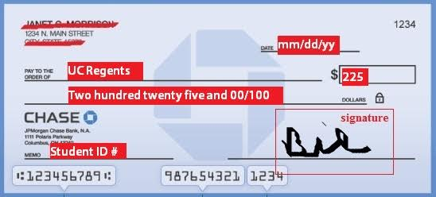
Fee Change
$225 until 12/23/2016 $300 after 12/23/2016

Money Order
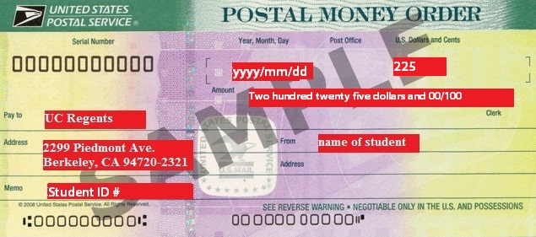

Cashiers Check
