**INFINIDAT**

**Introduction**

Infinidat was founded in 2011 by a team of storage industry experts focused on returning business value to customers by eliminating the compromises between performance, availability, and cost, at multi-petabyte scale for enterprise storage. The Infinidat team, spanning generations of storage industry experience and previous product successes, has become an industry leader by developing a better, faster way to store and protect multiple petabytes of data, with the highest possible availability, at the lowest possible cost. All of this work was done with a single goal in mind – enable customers to spend less on their infrastructure and focus more on innovation, growth, and competitive advantage.

Too often, organizations cannot collect all the data they want or take full advantage of all the data they have, due to high costs and poor designs of enterprise legacy storage systems.To address these challenges, Infinidat’s world-class team of enterprise storage inventors and innovators combined proven approaches for reliability, availability, and data integrity with new approaches for performance, cyber resilience, and ease of use. The result is a technology foundation and set of solutions rooted in the fundamental requirements for powerful enterprise storage that also embraces leading-edge innovation

**Project Summary**

|  |  |
| --- | --- |
| Website | [www.infinidat.com](http://www.infinidat.com) |
| Organization/Foundation Name | INFINIDAT - The Standard in Enterprise Storage |
| License | Yes |
| Brief Description | Infinidat is the storage solutions standard in the enterprise delivering industry-leading, innovative, enterprise storage solutions to meet today’s most demanding workloads. |

**Key Features**

* **Unmatched, Real-world Application-** Infinidat’s platforms are powered by Neural Cache which uses deep learning techniques of AI/ML to intelligently place data in a tiered storage design to cost-effectively optimize read cache hit rates to create exceptional I/O performance in mixed workload environments. Neural Cache optimizes data placement over time to minimize read cache misses and quickly adapts to new applications and workloads based on data usage behaviors. As a result, Infinidat platforms seamlessly respond to these changes, resulting in unmatched, real-world application performance.

* **Exploit AIOps and Accelerate DevOps with Infinidat InfiniOps-**

Infinidat’s InfiniOps tools and capabilities simplify the integration and utilization of powerful features of our platforms so you can more easily exploit AIOps, accelerate DevOps, and reduce integration risks. AIOps include the in-the-array features of Infinidat’s Neural Cache as well as out-of-the-array AIOps, such as Infinidat’s InfiniVerse® which provides detailed global awareness of end-to-end storage telemetry as well as sophisticated analytics. Extensive integration with AIOps and DevOps ecosystem partners and Host PowerTools simplify deployment and integration with enterprise environments.

* **InfiniSafe® for Comprehensive Cyber Resilience Capabilities-**

Award-winning InfiniSafe extends comprehensive cyber resilience capabilities to the Infinidat portfolio. This technology leverages immutable snapshots, creates a local or remote logical air gap, establishes a fenced forensic environment, and provides near-instantaneous recovery from cyberattacks. With InfiniBox and InfiniBox SSA, immutable snapshot recoverability is both guaranteed and guaranteed in under a minute. InfiniGuard immutable snapshots are guaranteed in less than 20 minutes.

* **Guaranteed SLAs for Performance, 100% Availability, and           Cyber Storage Resilience-** Infinidat stands behind our solutions with guaranteed service level agreements (SLAs). The performance guarantee assures customers of specific application workload performance that delivers the best primary storage performance in the industry. Customers are assured of uptime with our 100% availability guarantee for primary storage that goes beyond the typical “9’s” promised by other vendors. Finally, Infinidat provides cyber storage guarantees of both the immutability of our snapshots and recoverability of those immutable snapshots at under a minute on InfiniBox/InfiniBox SSA and under twenty minutes with InfiniGuard. Infinidat puts the customer first with clear assurances with critical enterprise storage infrastructure guarantees.

**ARCHITECTURE**

The Infinidat enterprise storage solution is based upon the unique and patented Infinidat Storage Architecture™ (ISA). The Infinidat Storage Architecture is a fully abstracted set of software-driven storage functions layered on top of very low-cost commodity hardware. By shipping the software with a highly tested hardware reference platform, Infinidat can deliver the first true enterprise-class software-defined storage.

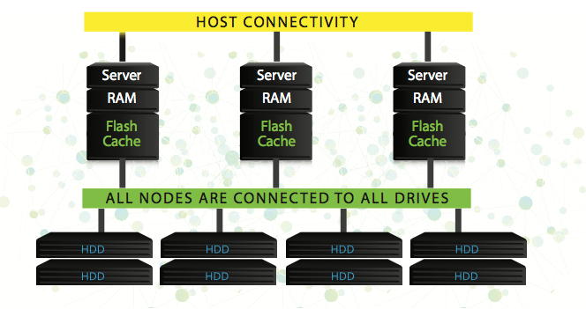

**DESIGN PRINCIPLES**

**When designing a storage architecture to meet modern data center needs, multiple requirements must be satisfied:**

**CATEGORY REQUIREMENT**

|  |  |
| --- | --- |
| **Reliability** | Businesses operate 24x7; downtime is not tolerated |
| **Capacity** | Exponentially increasing volumes of data, accelerated by digital transformation, disaggregated big  data architectures, artificial intelligence (AI), and machine learning (ML) |
| **Performance** | As data scales, performance must keep pace to provide the same (or better) results in the same  (or shorter) timeframes |
| **Simplicity** | Administrators expect simple operations, wide ecosystem integration, and built-in tools to  transition to DevOps models to spend less time managing storage, and more time on applications  and business process |
| **Consolidation** | Point technologies are a thing of the past; modern storage should accommodate all use cases for  maximum efficiency, simplicity and cost savings |
| **Cost** | Budgets aren’t scaling in line with capacity and performance growth requirements; a disruptive  change in architecture is required |

**OTHER INFORMATION**

Investors and customers have clearly embraced Infinidat’s approach to innovation. With corporate headquarters inHerzliya, Israel, and U.S. headquarters in Waltham, Massachusetts, Infinidat has established a healthy business with consistent revenue growth. Infinidat’s investors include TPG Growth and Goldman Sachs, with the total investment to date totaling $325M, establishing a post-funding valuation of $1.6B. The global customer install base covers a multitude of vertical industries including healthcare, financial services, and cloud service providers.

Today, Infinidat has filed for more than 140 patents, strong revenue growth, and an expanding team of technical professionals dedicated to the success of our customers in their efforts to innovate and grow.