MinIO

**INTRODUCTION:**

MinIO is an open source distributed object storage server written in GO, designed for private cloud infrastructure providing s3 storage functionality.It is the best server which is suited for storing unstructured data such as photos, videos, log files, backups, and container.

Minio offers high performance,s3 compatible object storage. Native to kubernetes, MinIO is the only object storage suite available on every public cloud, every kubernetes distribution, the private cloud and the edge. MinIO is software-defined and is 100% open source under GNU AGPL v3.

**PROJECT SUMMARY:**

| Website | https://min.io/ |
| --- | --- |
| Organization name | MinIO |
| License | Affero General Public License Version 3 (AGPLv3). |
| open\proprietary | open |
| Source path | https://github.com/minio/minio |
| Brief description | MinIO is a high performance, object storage system.Their open source, software-defined, Amazon S3 compatible object storage system is optimized for the private cloud. |

**PROJECT DETAILS:**

KEY FEATURES:

* Fast, scalable and Immutable object storage for commvault.
* Faster Multi-Site Replication and Resync.
* Transparent data compression on MinIO.
* Bitrot protection.
* Encryption.

**ARCHITECTURE DIAGRAM:**

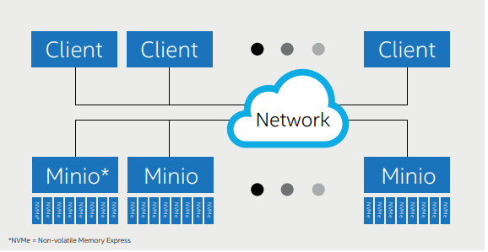

Minio consists of a server, an optional client, and an optional software development kit (SDK).

**CURRENT USAGE:**

* GitLab
* Travel-wallet
* Sendcloud
* Wadiz
* Dixa

**TECHNICAL DETAILS:**

* Minio’s horizontal scalability provides scaled out object storage that eliminates rebalancing and integrates heterogeneous infrastructure and hardware.
* Minio is the world's fastest object store with published GETs/PUTs results that exceed 325 GB/sec and 165 GB/sec on 32 nodes of NVMe drivers and a 100Gbe network.