**NETAPP DATA FABRIC**

**INTRODUCTION**:

NetApp Data Fabric is a comprehensive data management solution that provides organizations with the ability to manage and protect their data across on-premises, hybrid, and multi-cloud environments. The Data Fabric includes a range of products and services that enable data mobility, data protection, data governance and data management. The goal of the Data Fabric is to provide a seamless experience for organizations to move and manage data across different environments and platforms, while ensuring data security and compliance. The NetApp Data Fabric solution is designed to help organizations meet their data management and compliance needs, while reducing the complexity and costs associated with managing data across different environments.

**Project Summary**

|  |  |
| --- | --- |
| Website | <https://www.netapp.com/>. |
| Organization/Foundation Name | NETAPP |
| License | Commercial |
| Open/Proprietary | Proprietary |
| Brief Description | NetApp Data Fabric is a comprehensive data management solution that provides organizations with the ability to manage and protect their data across on-premises, hybrid, and multi-cloud environments. |

**Project Details**

**Key Features**

* **Data Mobility**: Enables organizations to easily move data between on-premises, hybrid, and multi-cloud environments.
* **Data Protection**: Provides a range of data protection options, including backup, disaster recovery, and replication, to help organizations protect their data from loss or corruption.
* **Data Management:** Includes features for data storage, data protection, data governance and data management such as NetApp ONTAP, Cloud Volumes, Cloud Data Fabric, and more.
* **Cloud Data Services:** Enables organizations to use a single platform to manage data across multiple cloud providers, including AWS, Azure, and Google Cloud.
* **File and Object Storage:** Provides file and object storage services that can be used to store, manage, and protect data in on-premises, hybrid, and multi-cloud environments.
* **Flexible Licensing:** Offers a flexible licensing model that allows customers to start with a basic license and then add additional features and capabilities as needed.
* **Automation and orchestration:** With the help of APIs and integration with other tools, NetApp Data Fabric enables automation of various data management tasks, reducing complexity and costs.

**Architecture**

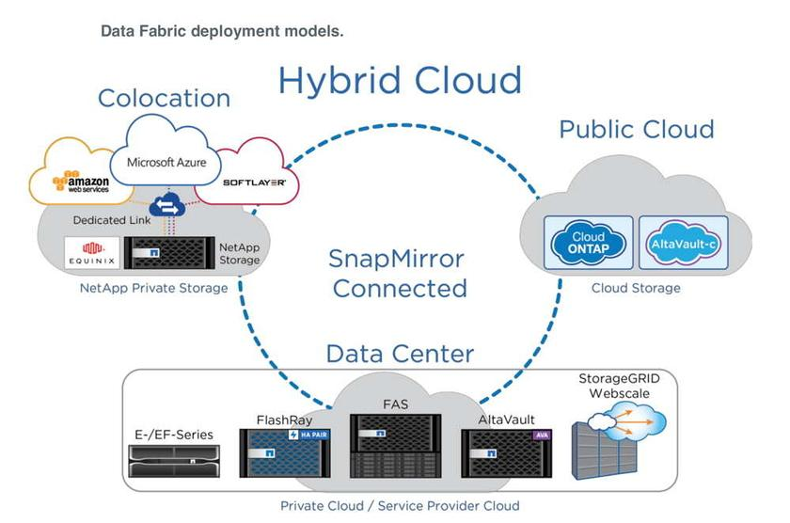

The architecture of NetApp Data Fabric is designed to provide a seamless and efficient experience for organizations to move and manage their data across different environments and platforms. The architecture consists of several components, including:

1. **NetApp ONTAP:** The foundation of the Data Fabric, ONTAP is a proprietary software that provides the data storage, data protection, and data management capabilities for the Data Fabric.
2. **Data Fabric Manager (DFM):** A centralized management console that provides a single point of control for the Data Fabric, enabling organizations to easily discover, understand, and manage their data across different environments.
3. **Cloud Volumes ONTAP (CVO):** A software-defined storage solution that enables organizations to run ONTAP in the cloud, providing the ability to easily move and manage data between on-premises and cloud environments.
4. **Cloud Data Services:** A set of services that provide data protection, data governance, and data analytics capabilities for the Data Fabric.
5. **Cloud Backup Services:** A set of services that provide data protection and disaster recovery capabilities for the Data Fabric, including backup and replication of data to the cloud.
6. **Cloud Control Plane:** A set of services that provide the ability to manage and monitor the Data Fabric across different environments and platforms, including on-premises, hybrid, and multi-cloud.
7. **Cloud Connectors:** A set of connectors that allow the Data Fabric to integrate with other data management solutions, including those based on open source software.

The Data Fabric architecture is designed to be flexible and scalable, allowing organizations to easily add or remove components as needed to meet their specific data management needs.

**Usage**

NetApp Data Fabric is used by organizations across a wide range of industries to manage and protect their data across on-premises, hybrid, and multi-cloud environments. The data fabric powered by NetApp simplifies and integrates data management across cloud and on-premises environments to accelerate digital transformation.The data fabric powered by NetApp delivers consistent and integrated data management services and applications (building blocks) for data visibility and insights, data access and control, and data protection and security, as shown in the figure below.

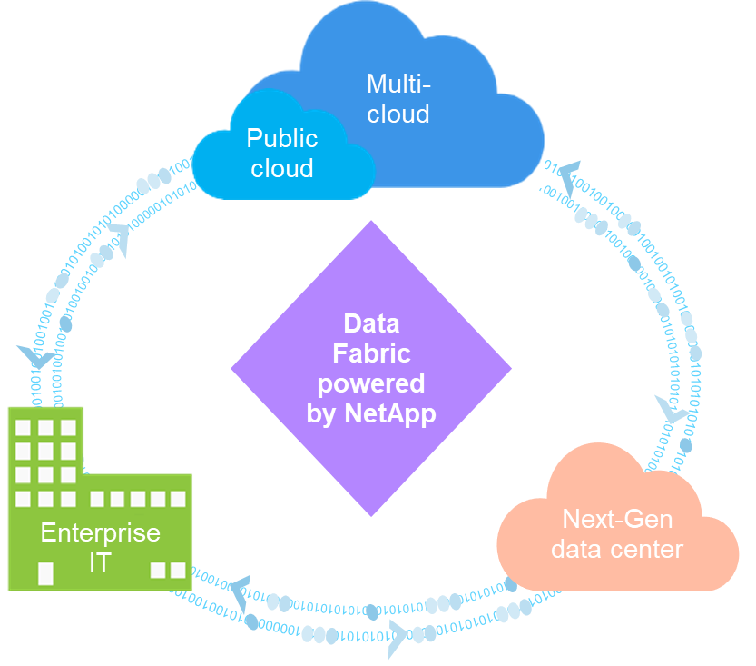

The data fabric powered by NetApp provides the following nine proven use cases for customers:

* Accelerate analytics workloads
* Accelerate DevOps transformation
* Build cloud hosting infrastructure
* Integrate cloud data services
* Protect and secure data
* Optimize unstructured data
* Gain data center efficiencies
* Deliver data insights and control
* Simplify and automate

**NetApp NFS direct access**

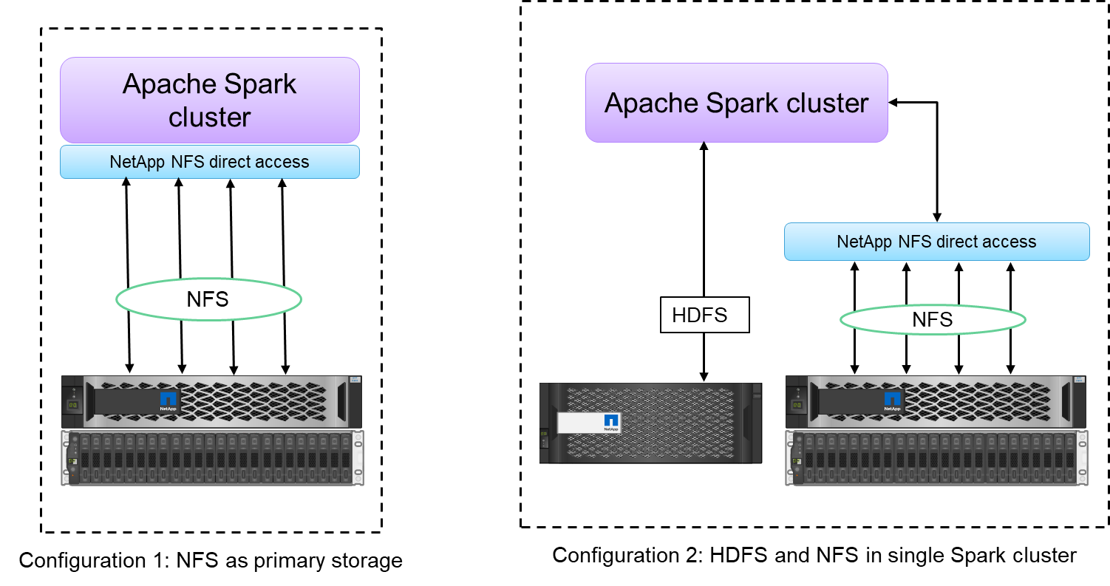

The NetApp NFS direct access (formerly known as NetApp In-Place Analytics Module) (shown in the figure below) allows customers to run big data analytics jobs on their existing or new NFSv3 or NFSv4 data without moving or copying the data. It prevents multiple copies of data and eliminates the need to sync the data with a source. For example, in the financial sector, the movement of data from one place to another place must meet legal obligations, which is not an easy task. In this scenario, the NetApp NFS direct access analyzes the financial data from its original location. Another key benefit is that using the NetApp NFS direct access simplifies protecting Hadoop data by using native Hadoop commands and enables data protection workflows leveraging NetApp’s rich data management portfolio.

**Building blocks for big data**

The data fabric powered by NetApp integrates data management services and applications (building blocks) for data access, control, protection, and security, as shown in the figure below

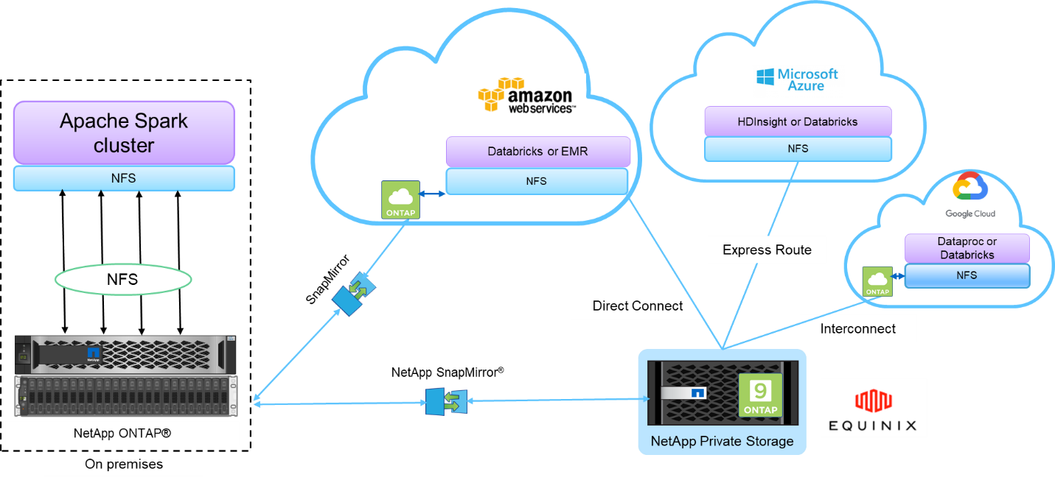

The building blocks in the figure above include:

* **NetApp NFS direct access:** Provides the latest Hadoop and Spark clusters with direct access to NetApp NFS volumes without additional software or driver requirements.
* **NetApp Cloud Volumes ONTAP and Cloud Volume Services:** Software-defined connected storage based on ONTAP running in Amazon Web Services (AWS) or Azure NetApp Files (ANF) in Microsoft Azure cloud services.
* **NetApp SnapMirror technology:**Provides data protection capabilities between on-premises and ONTAP Cloud or NPS instances.
* **Cloud service providers:**These providers include AWS, Microsoft Azure, Google Cloud, and IBM Cloud.
* **PaaS:**Cloud-based analytics services such as Amazon Elastic MapReduce (EMR) and Databricks in AWS as well as Microsoft Azure HDInsight and Azure Databricks.

**REFERENCE:**

**https://www.netapp.com/data-fabric/what-is-data-fabric/**