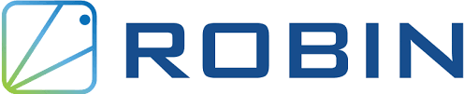

**Robin.io , a rakuten symphony company, is a Kubernetes-based platform (kubernetes, open source for automating software deployment ) that automates the deployment and lifecycle management of Data and Network applications.**

**Robin extends efficiency and portability of kubernetes to all applications, even complex Big data , Databases ,AI/ML and custom Apps.**

**Robin.io is among the companies that offer infrastructure multi cloud solutions for operators, enabling them to transform,manage and monetize their edge network infrastructure.**

***PROJECT SUMMARY:***

| ***Website*** | ***https://www.robin.io/*** |
| --- | --- |
| ***Organization*** | ***Robin systems*** |
| ***License*** | ***NotOpenSource*** |
| ***Open/proprietary*** |  |
| ***Source Path*** |  |
| ***Brief Description*** | ***Robin designs and develops application software , it provides hyper-converged kubernetes platform for information technology and business initiatives for big data and databases.*** |

***PROJECT DETAILS:***

**Key features:**

* ***Automate all aspects of critical day-2 operations to run databases, big data, time series and message queue services in production on Kubernetes.***
* ***Highest performing storage and data management for any Kubernetes on-premises or in any cloud.***
* ***Run Containers and VM on kubernetes and manage their lifecycle using one common interface.***
* ***Application Deployment and lifecycle management.***
* ***Consistent storage experience across different environments. Allow easy migration and portability of apps along with their data across different cloud environments.***

**Architecture :**

***It is a fully cloud-native and microservices-based architecture that is multi-access, multi - platform, and multi-cloud.***

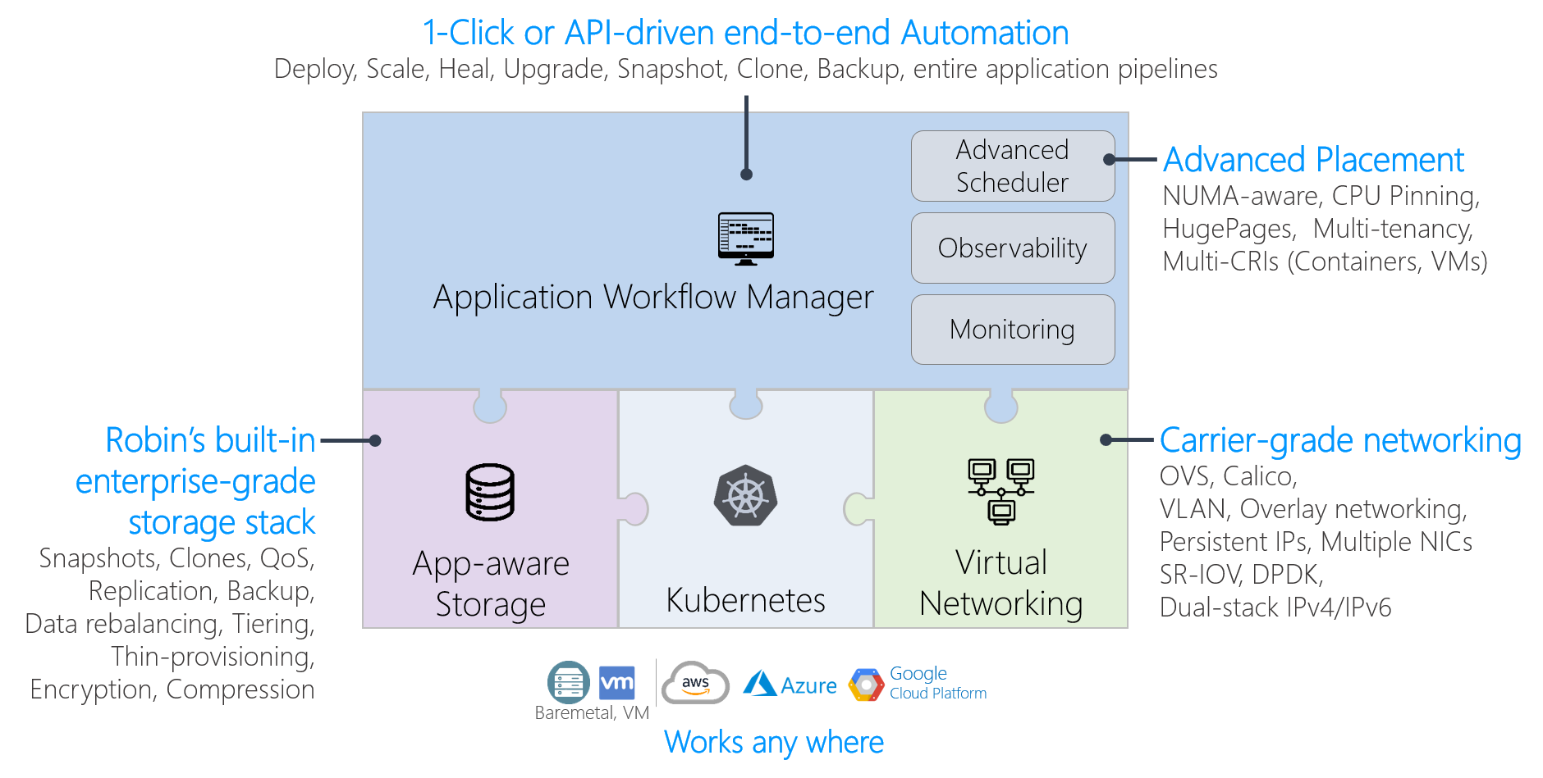

*High level architectural view of robin platform*

* ***Application workflow manager:***

***The management and tracking of tasks performed or temporarily halted due to an issue are simplified.It automatically records information for each activity and provides tools to report information about each task.***

* ***App - aware storage :***

***Application awareness is a term for systems that have built in information or “awareness” about individual applications,in order to better interact with these applications.***

* ***Kubernetes:***

***It automates operational tasks of container management and includes built-in commands for deploying applications,rolling out changes to your applications up and down to fit changing needs , monitoring your applications, which makes it easier to manage applications.***

***Robin Products:-***

* ***ROBIN CLOUD NATIVE PLATFORM (CNP)***

***For RAN, core, MEC, OSS and BSS use cases***

***Kubernetes platform optimized for running RAN, core and MEC applications, with special focus on zero-touch deployment and life cycle automation***

* ***ROBIN CLOUD NATIVE STORAGE (CNS)***

***For databases, big data, message queues, timeseries, AI/ML use cases***

***Highest performing cloud-native storage stack for any Kubernetes on-premises or in any cloud with special focus on application-aware data management and operational automation***

* ***ROBIN MULTI DATA CENTER AUTOMATION PLATFORM (MDCAP)***

***For metal-to-service automation use cases***

***Highly scalable infrastructure-to-service orchestrator to manage bare-metal servers, network elements, network functions and apps across 100,000+ servers and 10,000+ clusters, and data centers and clouds.***

***Why To Choose Robin?***

***Deploy stateful apps on Kubernetes***

* ***Highest performing storage and data management for any Kubernetes on-premises or in any cloud. Automate all aspects of critical day-2 operations to run databases, big data, timeseries and message queue services in production on Kubernetes.***

***Deploy 4G/5G RAN and core at scale***

* ***Bring cloud agility to deploy 4G and 5G RAN (DU, CU-CP and CU-DP) on COTS hardware in minutes. Enable centralized orchestration of 10s of thousands of cell-sites and base-band units.***

***Deploy and manage apps at the edge***

* ***Deploy complex storage and network-intensive apps on edge clusters with ease. Enable scalable automation of rollout, upgrade, and auto-heal apps at edge locations.***

***Common platform to run containers and VMs***

* ***Run containers and virtual machines on Kubernetes directly on bare-metal. Enable consistent and common lifecycle management of containers and virtual machines.***

***Common data management platform for hybrid & multi-cloud***

* ***Consistent storage experience across different environments. Allow easy migration and portability of apps along with their data across different cloud environments.***

***Automate day-2 operations***

* ***Bring cloud agility to your bare-metal infrastructure. Centrally manage 10s of thousands of Kubernetes clusters from edge to cloud to private data centers. Create repeatable and robust workflows to automate all network and IT operations.***