# **Open Source Project**

# **TensorFlow**

TensorFlow is an open-source software library for dataflow and differentiable programming across a range of tasks. It is a symbolic math library and is used for machine learning applications such as neural networks. It was developed by the Google Brain team and was released under the Apache 2.0 open source license.

TensorFlow is widely used for developing and training machine learning models and has a strong community of developers who contribute to its development and maintenance. The library provides a high-level API for building and training models, as well as a low-level API for fine-tuning and customizing models.

TensorFlow has support for multiple programming languages including Python, C++, Java, Go, and Rust. It also supports a wide range of platforms including Linux, macOS, Windows, iOS, and Android.

Overall, TensorFlow is a highly flexible and scalable platform for developing and deploying machine learning models. Its popularity and strong community make it a valuable resource for researchers and practitioners in the field of machine learning.

**TensorFlow’s area of work includes:**

Deep learning

Neural networks

Image and speech recognition

Natural language processing

Predictive modeling

Generative models

***Features of TensorFlow include:***

A flexible architecture that allows users to build and train machine learning models with ease

Efficient computations using TensorFlow’s graph-based execution engine

Ability to run on a variety of platforms including CPU and GPU-based systems, as well as mobile devices

Large community support, with many tutorials, pre-trained models, and tools available online

***Related Links :***

TensorFlow has a large and active community of developers and users, with many resources available online. Here are some related links:

Official TensorFlow website: <https://www.tensorflow.org/>

TensorFlow tutorials and examples: <https://www.tensorflow.org/tutorials>

TensorFlow GitHub repository: <https://github.com/tensorflow/tensorflow>

TensorFlow API reference: <https://www.tensorflow.org/api_docs/python/>

TensorFlow community resources: <https://www.tensorflow.org/resources>

***TensorFlow COMMUNITY CHANNELS***

TensorFlow has a large and active community of developers and users, who communicate and collaborate through various channels. Here are some of the most important ones:

***TensorFlow Community Meetings:*** TensorFlow holds regular community meetings, where developers and users can discuss new features, get updates on the latest developments, and provide feedback. The schedule and agendas for these meetings can be found on the TensorFlow website.

***TensorFlow Stack Exchange:*** Stack Exchange is a Q&A platform where users can ask and answer questions related to TensorFlow and other topics. The TensorFlow Stack Exchange can be found at <https://stackoverflow.com/questions/tagged/tensorflow>.

***TensorFlow GitHub Repository:*** TensorFlow’s GitHub repository is the primary source for the TensorFlow codebase and other related projects. Users can submit issues, contribute to the code, and collaborate with other contributors on GitHub. The TensorFlow GitHub repository can be found at <https://github.com/tensorflow/tensorflow>.

***TensorFlow Discourse:*** TensorFlow’s Discourse is an online forum for TensorFlow users and developers to ask questions, discuss topics, and share information. The TensorFlow Discourse can be found at <https://discuss.tensorflow.org/>.

***TensorFlow Slack Channel:*** TensorFlow has a Slack channel, where users and developers can chat and collaborate in real-time. The TensorFlow Slack channel can be found at <https://slack.tensorflow.org/>.

***TensorFlow Twitter Account:*** TensorFlow has an official Twitter account, where users can follow updates, news, and other information related to TensorFlow. The TensorFlow Twitter account can be found at <https://twitter.com/TensorFlow>.

By participating in these channels and meeting, you can stay up-to-date with the latest developments in TensorFlow, as well as connect with other users and developers in the community.

***PROJECT ORGANISATION:***

TensorFlow is an open-source project developed by the Google Brain team. It is not part of any specific foundation or sub-foundation, but is instead maintained and supported by a large and active community of developers and users.

TensorFlow is released under the Apache 2.0 license, which allows anyone to use, modify, and distribute the code for any purpose, as long as they follow the terms of the license. This open and collaborative approach has helped TensorFlow grow into one of the most widely used machine learning frameworks in the world. In addition to the community-driven development of TensorFlow, Google also provides support and resources for the project, including funding for development, hosting infrastructure, and technical expertise. This combination of community and corporate support has helped TensorFlow become one of the leading machine learning frameworks available today.

***TensorFlow Understanding chart:***

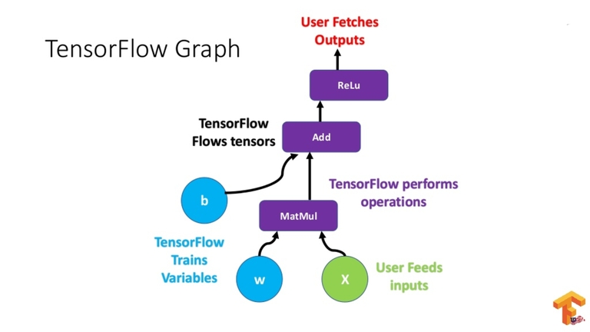

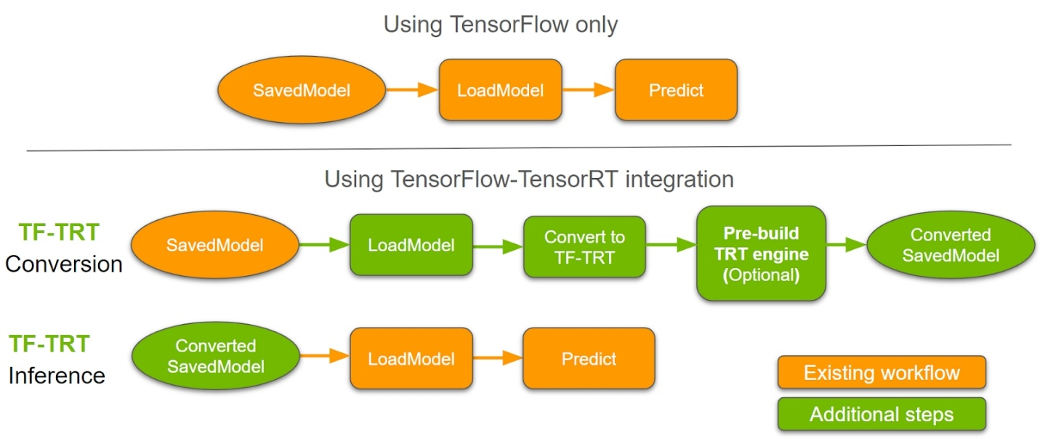

***SODA FOUNDATION CHART***

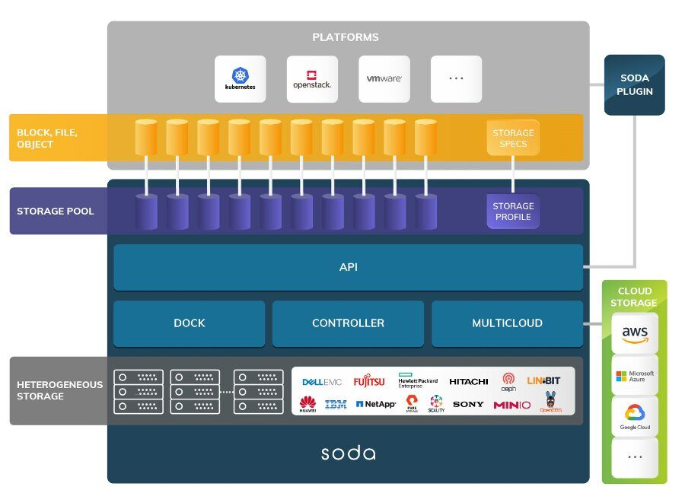SODA (SODA Open Data Autonomy) is evolving to realize a challenging goal of building a unified framework for data and storage management. It connects the application platforms and solutions to the backend storages seamlessly, be it on prem or cloud through a unified API layer. This enables the application platforms to focus on building more valuable use cases rather than worrying about managing the underlying storage backends and data management.

SODA Foundation India group is to address the storage and Data management challenges in the industry and provide an open and unified “One Data Framework”.

***SODA Foundation Projects :***

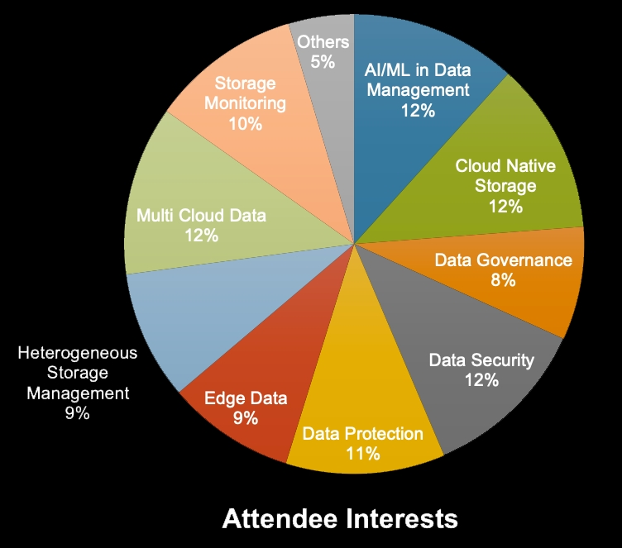

***Projects***

1. ***Terra :***

***SDS Controller***

***Terra is an open source storage management and automation project.***

[***https://www.sodafoundation.io/projects/terra/***](https://www.sodafoundation.io/projects/terra/)

***2 .Delfin:***

***Heterogeneous Storage Monitoring***

***Delfin is an open source storage monitoring and alerting toolkit***

[***https://www.sodafoundation.io/projects/delfin/***](https://www.sodafoundation.io/projects/delfin/)

1. ***Strato :***

***Multi Cloud Data Management***

***Strato is an open source tool to control data in multi cloud IT environments.***

[***https://www.sodafoundation.io/projects/strato/***](https://www.sodafoundation.io/projects/strato/)

1. ***Kahu:***

***Container Data Protection***

***Kahu is a cloud native tool to backup and restore, perform disaster recovery, and Migrate Kubernetes cluster resources and persistent volumes.***

[***https://www.sodafoundation.io/projects/kahu/***](https://www.sodafoundation.io/projects/kahu/)

1. ***Como: Virtual Data Lake***

***COMO is a multi cloud virtual data lake providing a centralized repository with a***

***Single common interface for data stored in any public or private cloud.***

[***https://www.sodafoundation.io/projects/como/***](https://www.sodafoundation.io/projects/como/)

***References link:***

<https://www.tensorflow.org/api_docs/python/tf>

<https://github.com/tensorflow>