**Project name:**

## Truenas core

**Introduction**: TrueNAS CORE Developer(s): iXsystems

Stable release: 13.0-U3.1 / November 16, 2022; 2 months ago Repository :github.com/truenas Edit this at Wikidata Operating system:FreeBSD

Platform:x86-64 (v9.2.1.9 was the last release that supported 32-bit.[1]) Type:Computer storage

License:BSD license Website:truenas.com/truenas-core

# Project Analysis Template

<<Truenas core>>

### Introduction

1. The TrueNAS range includes free public versions (TrueNAS CORE, previously known as FreeNAS), commercial versions (TrueNAS Enterprise), and Linux versions (TrueNAS SCALE). It also oﬀers hardware, from small home systems to large petabyte arrays, based on the above versions.
2. TrueNAS supports Windows, macOS and Unix clients and various virtualization hosts such as XenServer and VMware using the SMB, AFP, NFS, iSCSI, SSH, rsync and FTP/TFTP protocols. Advanced TrueNAS features include full-disk encryption and a plug-in architecture for third-party software

# Project summary

**website** : <https://www.truenas.com/download-truenas-core/>

**Organization/ foundation name** : TrueNas Enterprise

**License**: TrueNAS CORE Software is authorized for use on any TrueNAS Device. TrueNAS Devices can include hardware provided by iXsystems or third parties. TrueNAS Devices may also include virtual machines and cloud instances. TrueNAS CORE software may not be

commercially distributed or sold without an addendum license agreement and express written consent from iXsystems.

**Proprietary**: TrueNAS supports Windows, macOS and Unix clients and various virtualization hosts such as XenServer and VMware using the SMB, AFP, NFS, iSCSI, SSH, rsync and FTP/TFTP protocols. Advanced TrueNAS features include full-disk encryption and a plug-in architecture for third-party software.

**Open Source** : TrueNAS CORE will always be completely Open Source and free. TrueNAS Enterprise and iXsystems support are available for more critical storage applications. The upgrade from FreeNAS to TrueNAS CORE is as simple as clicking a button in the UI. The upgrade is free and the software is still Open Source.

### Brief description:

TrueNAS Open Storage Logo Menu

TrueNAS Open Storage Logo Menu

TrueNAS M-Series TrueNAS CORE

World’s Most Popular Storage OS Free and Open Source

Uniﬁed Storage Built on OpenZFS Installs on Hardware or VMs Community-Supported Download TrueNAS CORE OVERVIEW

FEATURES

RESOURCES

DOWNLOAD OVERVIEW FEATURES

RESOURCES

DOWNLOAD

Overview

Experience Storage Freedom

TrueNAS® CORE (formerly known as FreeNAS®) is the world’s most popular storage OS because it gives you the power to build your own professional-grade storage system to use in a variety of data-intensive applications without any software costs. Simply install it onto hardware or a VM and experience the true storage freedom of open source storage.

Share Files. Serve Media. Store Anything.

TrueNAS CORE can be used from the home to the oﬃce to the data center for a variety of data-intensive use cases. IT professionals, photographers, designers, audio/video producers and editors, developers, and any user serious about storing and protecting lots of data can take advantage of TrueNAS CORE. Pair it with your favorite backup software to archive large quantities of infrequently used data oﬀ of your local devices and even sync and push data to the cloud.

Nothing Protects Your Data Like ZFS

At the heart of TrueNAS is the self-healing OpenZFS ﬁlesystem. Previously only available on the highest-end enterprise storage systems, TrueNAS gives you direct, user-friendly access to ZFS. With its built-in RAID, powerful data management tools, and ability to automatically detect and repair silent data corruption (and bit rot), TrueNAS and OpenZFS ensure data integrity from start to ﬁnish.

Go Beyond “NAS”

More than a traditional “Network Attached Storage”, TrueNAS is Uniﬁed Storage that integrates seamlessly into any environment with a variety of ﬁle, block, or object access protocols. You can also expand its functionality with a variety of free plugins, like Plex Media Server, NextCloud, Zoneminder surveillance, and many others.

Manage Your Data Like a Pro

Unlimited snapshots, clones, and replication add additional layers to safeguard your data from human error or external threats like ransomware. Add system memory (DRAM) and ﬂash to supercharge performance. Use built-in data compression to maximize space.

Manage it all from a user-friendly web interface.

Join the TrueNAS Community

Need help? TrueNAS CORE has detailed documentation and a global community of over 250,000 to learn from and collaborate with.

If your data is critical or you simply need professional support, TrueNAS Enterprise and the full line of TrueNAS storage appliances provide enhanced features and the

around-the-clock support necessary to keep your storage online.

Features

TrueNASCORE Infographics

TrueNAS CORE & ENTERPRISE Software Features Data Sheet Resources

TrueNAS CORE & ENTERPRISE Software Features Data Sheet TrueNAS Software Status Page

# Project Details

## Key features

Every TrueNAS model supports data corruption protection, replication, ﬁle and block protocols, inline storage optimization, thin and thick provisioning, online capacity

expansion, storage controller redundancy, hot spares, and redundant power and cooling.

## Architecture

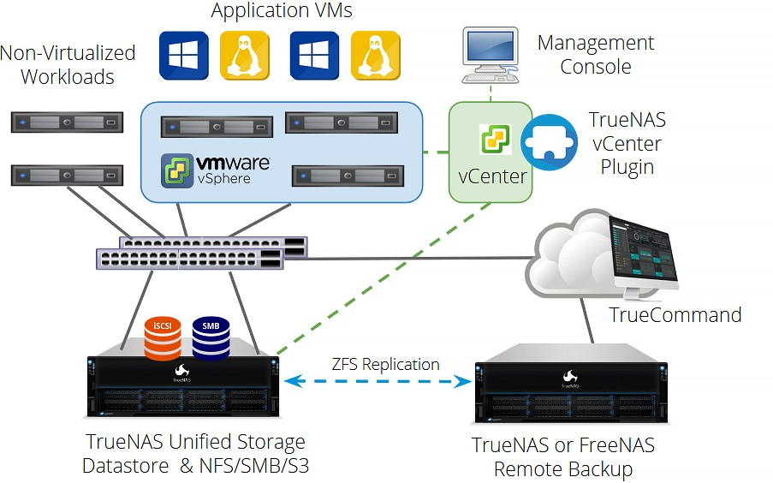

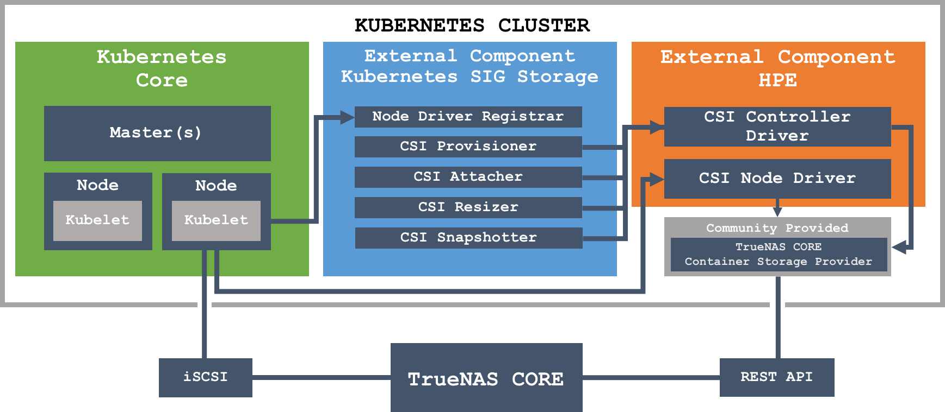

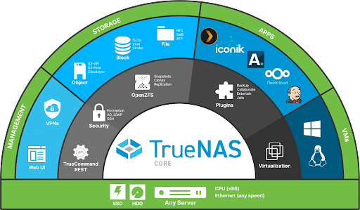

### Current usage

TrueNAS® CORE (formerly known as FreeNAS®) is the world's most popular storage OS because it gives you the power to build your own professional-grade storage system to use in a variety of data-intensive applications without any software costs.

### Technical details

Minimum Hardware Requirements Processor Memory Boot Device

2-Core Intel 64-Bit or AMD x86_64 processor 8 GB Memory 16 GB SSD boot dev

### Other information

***Overview***

Experience Storage Freedom

TrueNAS® CORE (formerly known as FreeNAS®) is the world’s most popular storage OS because it gives you the power to build your own professional-grade storage system to use in a variety of data-intensive applications without any software costs. Simply install it onto hardware or a VM and experience the true storage freedom of open source storage.

Share Files. Serve Media. Store Anything.

TrueNAS CORE can be used from the home to the office to the data center for a variety of data-intensive use cases. IT professionals, photographers, designers, audio/video producers and editors, developers, and any user serious about storing and protecting lots of data can take advantage of TrueNAS CORE. Pair it with your favorite backup software to archive large quantities of infrequently used data off of your local devices and even sync and push data to the cloud.

Nothing Protects Your Data Like ZFS

At the heart of TrueNAS is the self-healing OpenZFS filesystem. Previously only available on the highest-end enterprise storage systems, TrueNAS gives you direct, user-friendly access to ZFS. With its built-in RAID, powerful data management tools, and ability to automatically detect and repair silent data corruption (and bit rot), TrueNAS and OpenZFS ensure data integrity from start to finish.

Go Beyond “NAS”

More than a traditional “Network Attached Storage”, TrueNAS is Unified Storage that integrates seamlessly into any environment with a variety of file, block, or object access

protocols. You can also expand its functionality with a variety of free plugins, like Plex Media Server, NextCloud, Zoneminder surveillance, and many others.

Manage Your Data Like a Pro

Unlimited snapshots, clones, and replication add additional layers to safeguard your data from human error or external threats like ransomware. Add system memory (DRAM) and flash to supercharge performance. Use built-in data compression to maximize space.

Manage it all from a user-friendly web interface.

Join the TrueNAS Community

Need help? TrueNAS CORE has detailed documentation and a global community of over 250,000 to learn from and collaborate with.

If your data is critical or you simply need professional support, TrueNAS Enterprise and the full line of TrueNAS storage appliances provide enhanced features and the around-the-clock support necessary to keep your storage online.

Features

TrueNASCORE Infographics

TrueNAS CORE & ENTERPRISE Software Features Data Sheet Resources

TrueNAS CORE & ENTERPRISE Software Features Data Sheet TrueNAS Software Status Page

### End of the project