**Step 1)**

We will download the patch files and also all of the files needed to do labeling from here

Go to the directory:

Dropbox/Shared/Images/MasterMarathonImages/Caroline

Download the zip file: web-Indianapolis.zip

Unzip the file to a directory you choose

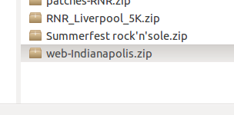

If you don't already have the original images, go to directory: Dropbox/Shared/Images/MasterMarathonImages/Caroline

and download the images file:

Indianapolis-Monumental-Mile-Combined.zip

Unzip the files somewhere

You will need the path you unzipped these original images for the next section.

**Step 2)**

Go to the directory:

Dropbox/Shared

Download the file: biblabel.zip

unzip the file to a directory you choose

open the folder that you just unzipped and open up index_david.html using a text editor (like notepad) so that you can see the code or any other tect editot that you want.

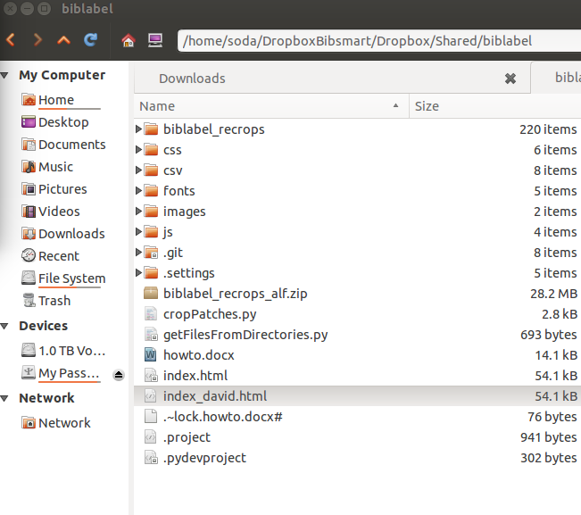

scroll down to line 223 of the file and put the directory of where you downloaded the originals race files. It should look similar to the image below.

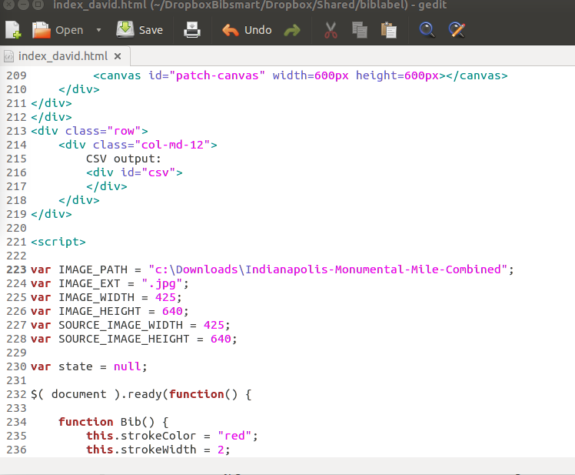

Save the file.

**Step 3)**

Open up index_david.html using firefox by copying and pasting the path of the file into firefox and clicking enter. You should see something similar to the image below.

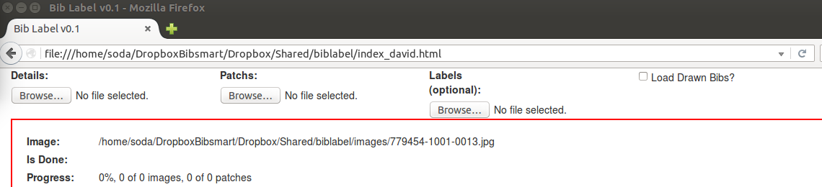

Load the detail file by clicking on the “Browse button” underneath the word “Details” and navigate to the file in your “web-indianapolis” folder that you downloaded and unzipped. The file is called:

resultsDetailed-Indianapolis-Combined85-Combconv-FINAL.csv

Click open

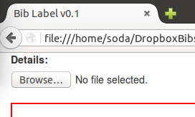

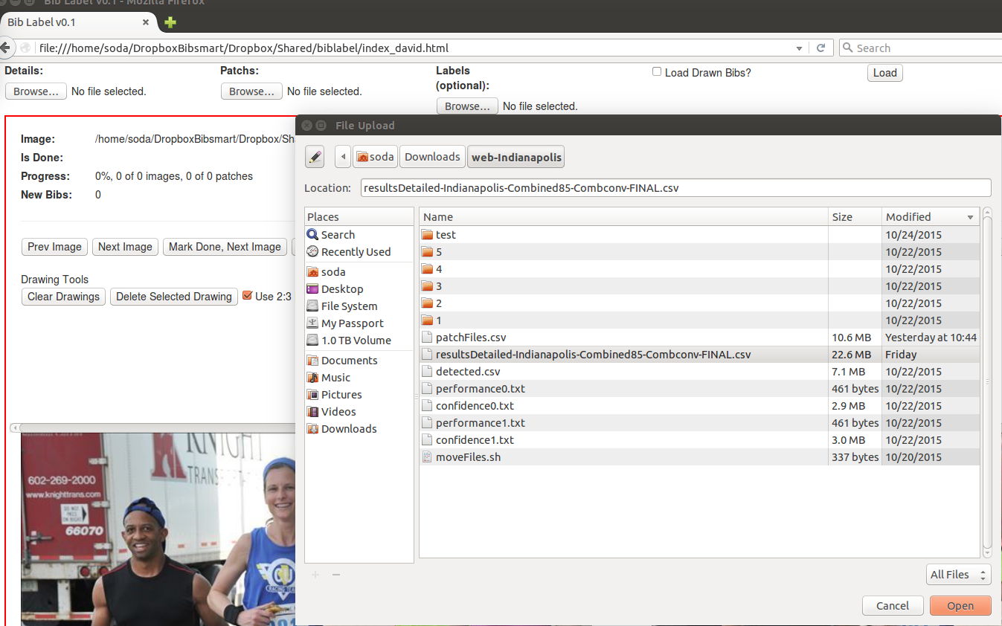

The details section should look like the image below now:

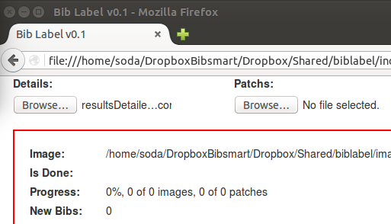

**Step 4)**

We will do the same thing for the patches file by click on the “Browse” button underneath the “Patches” label.

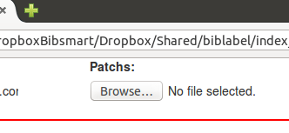

Load the patches.csv file in the “web-indianapolis” folder.

The result should look like the image below:

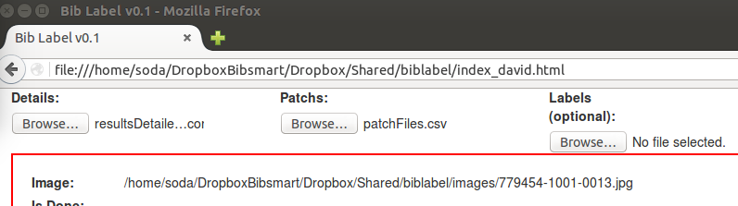

**Step 5)**

After both files have been loaded, click the “Load” button. It will load all the images and their bibs that were detected. It should look like the image below:

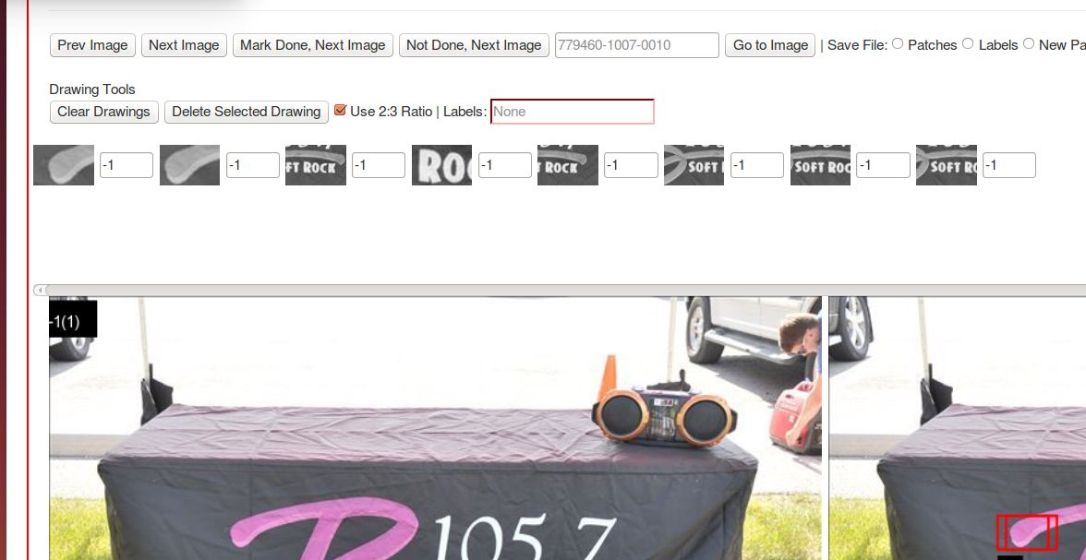

The textbox section labeled “Labels” is where all the labels will be. If there are no labels in the left image then that box should be “none”.

If there are labels in the image then that box should contains the labels separated by commas if there's more than one. Add or remove labels as necessary.

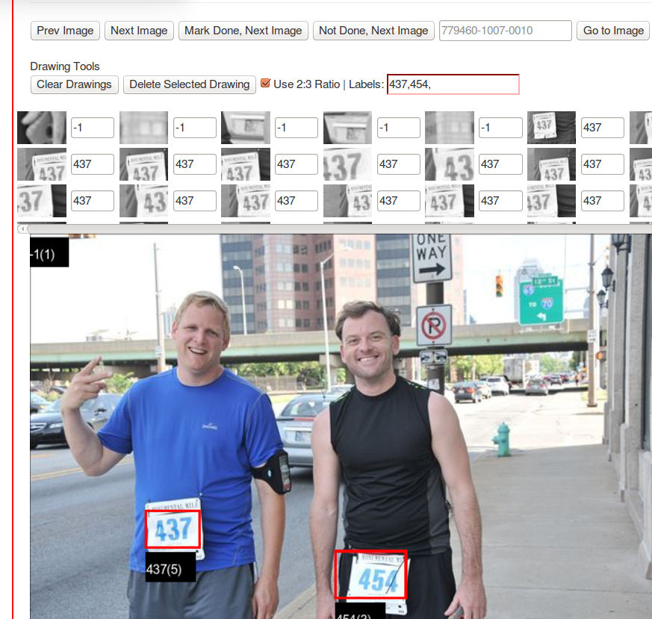

When you are done labeling or want to save your labeling work. Enter the name of the file and choose the “labels” option and press save.

