Jenkins GitHub Integration

Step 1: Right Click on project share project in eclipse.

Step 2: Create Git Repository

Step 3: Git Push the existing project.

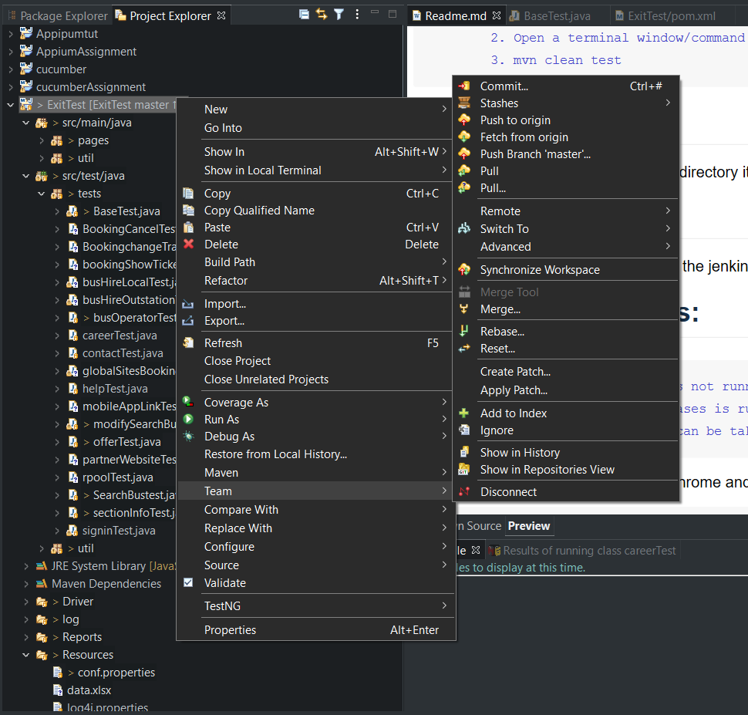

Step 4: Enter the git hub credentials.

Step 5: Push the changes

**Run it from the project location**

git status

git add .

git commit -m "Third Commit"

git push

**Jenkins**

*STEP 1: Start server using the below command from the location where the Jenkins is installed (default port 8080)*

**java -jar jenkins.war --httpPort=9090**

*STEP 2 : Start accessing the jenkins using website* [*http://localhost:9090/*](http://localhost:9090/) *and create new job and create freestyle project*

*STEP 3 : Add the GitHub repo* [*https://github.com/sodp/QAExitTestRedBusAutomation.git*](https://github.com/sodp/QAExitTestRedBusAutomation.git)

*STEP 4: Add the build step the windows batch command.*

*mvn clean test (to run the test cases)*

*STEP 5: Click on Build Now.*

*STEP 6: Click on the console check the logs.*

