ET 721
Prof: Huixin Wu
Feb 15, 2026

Project 1
Source Control using Git
Soe Kaythi (Student B)

Task 0 - Setup your local environment
Before you can make commits and contribute different versions of your code, you must set up your environment.
Step 1 - Install Git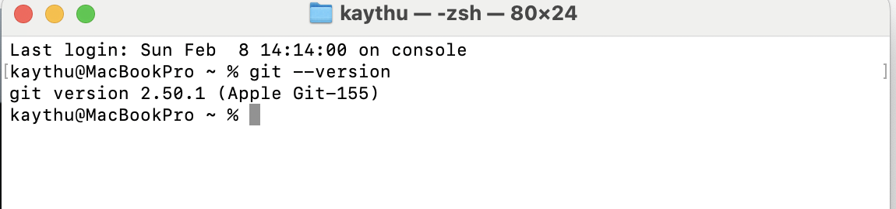

Step 2 - Change Bash prompt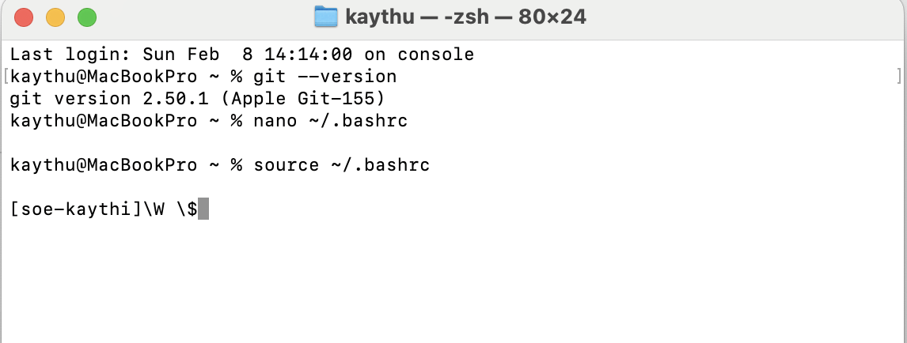

Step 3 - Create GitHub account
https://github.com/soe-student

Step 4 - Setup SSH authentication
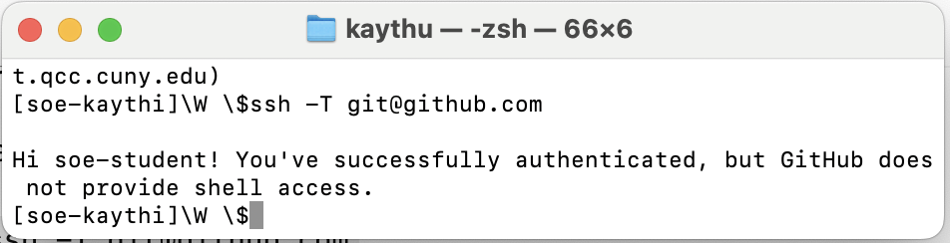

Step 5 - Clone repository

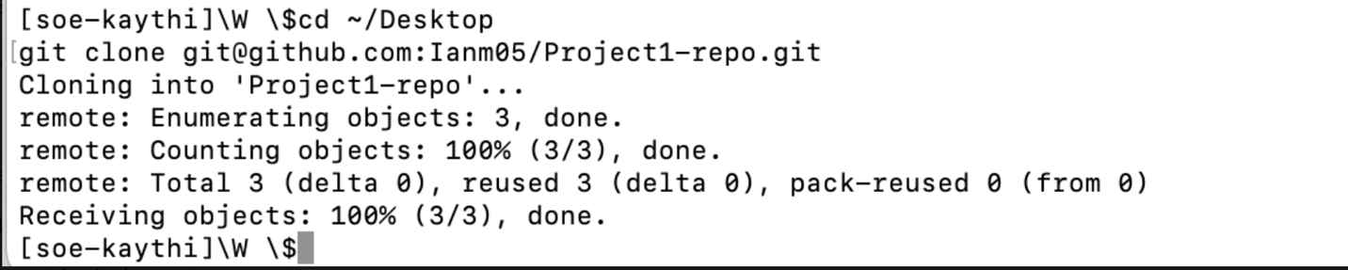

What is GitHub and why did you have to create a repository there?
Ans: GitHub is a platform for storing and managing code using Git. We created a repository to save our project, track changes, and share/submit work.

Why did you have to set up SSH and connect the public key to your account?
I set up SSH and added my public key so GitHub can securely recognize my computer and allow access without repeatedly entering my credentials.

Task 1 - Initial Commit and Push

Step 1 - Small change (Soe Kaythi-Student B)

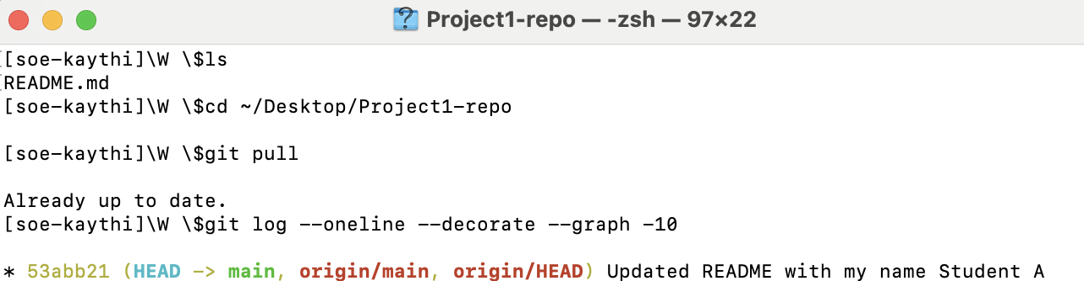

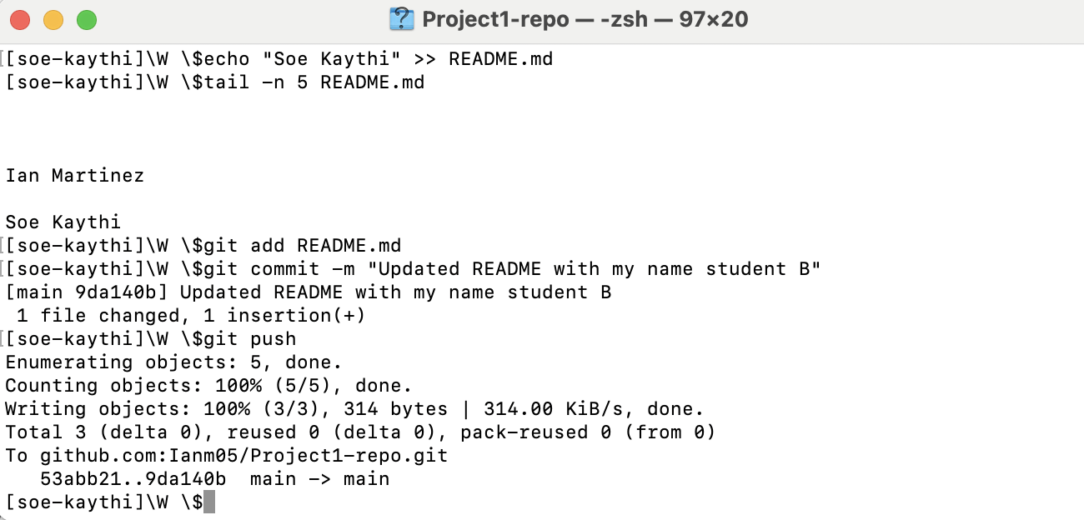

Step 2 – Bug Fixes

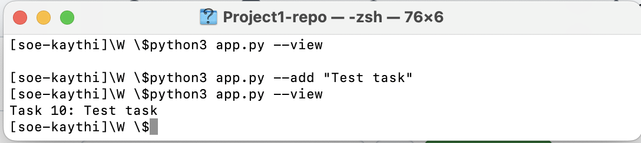
After Bug Fix
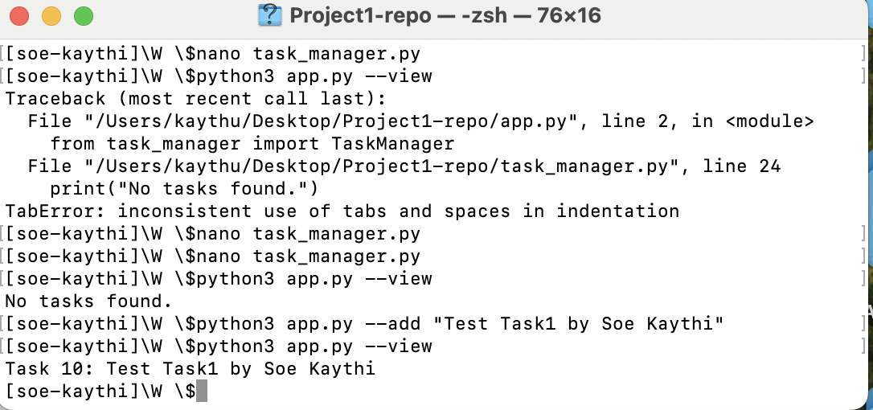

Task 2 - Branching and Pull Requests
● Link to the Pull Requests raised on GitHub and merged into main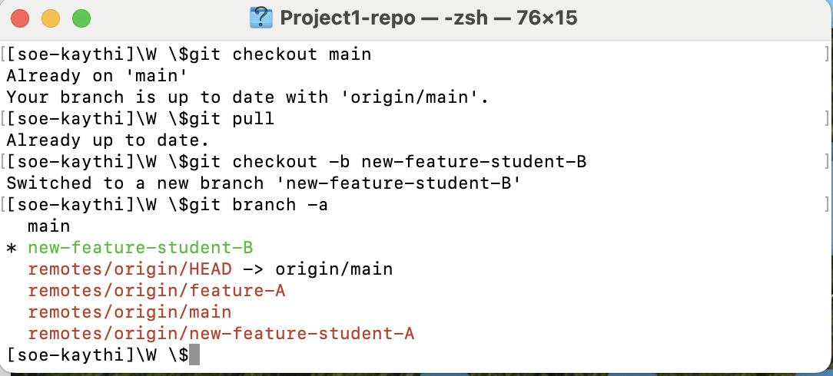
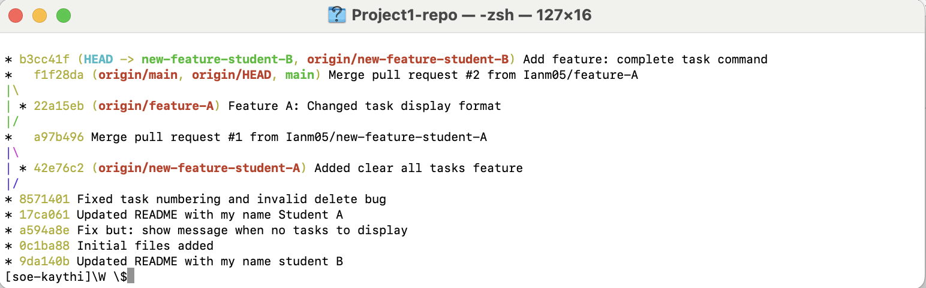
Purpose of Pull Requests and Branches
Branches let me work on my part of the project without changing the main version. Pull requests allow others to review my work before it is merged.

Task 3 - Using Git Stash
Git Stash is used for saving your modified and staged changes and reverting the working directory to a clean state. It's like a clipboard for uncommitted changes.
Step 1 - Stash and Pop
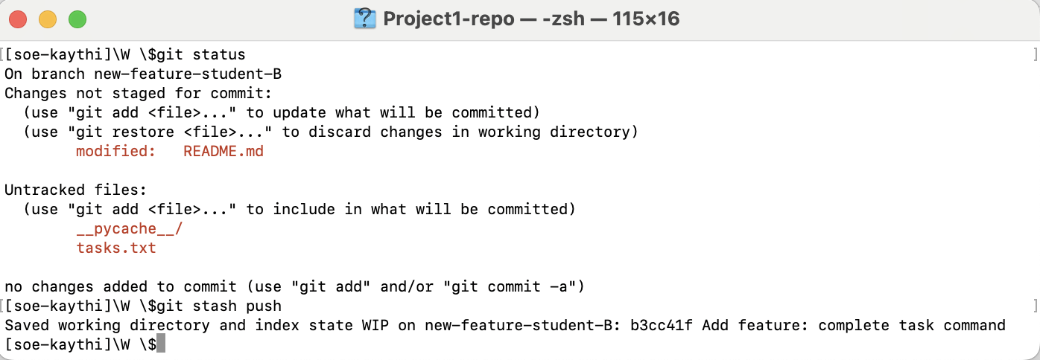
Take a screenshot showing the use of git stash pop, and save the image with your last name. For example, if your last name is Smith, then, save the image as screenshot8_Smith.jpg
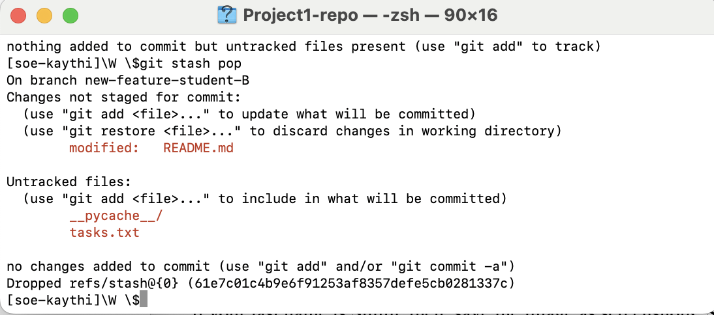
Explanation of when and why to use git stash
I use git stash when I need to temporarily save my uncommitted changes without committing them. This helps when switching branches or pulling updates while keeping my work safe.

Task 4 - Handling Merge Conflicts
Merge conflicts occur when different branches have conflicting changes in the same
part of the same file. They must be resolved manually before merging.
Step 1 - Checkout and Pull
Before you start, make sure you're on the main branch after you successfully merge
your pull requests: git checkout main & git pull
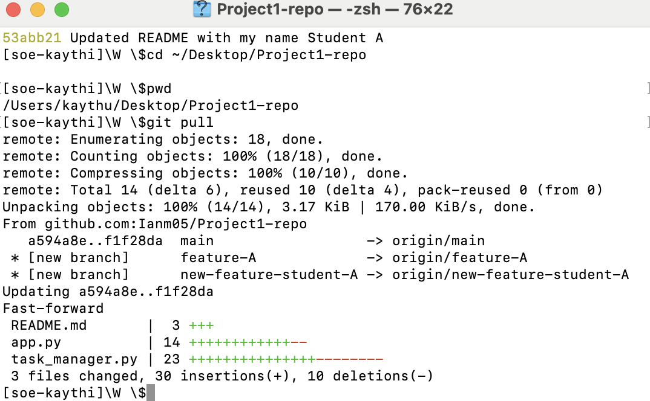

Step 2 – Each Create a New Branch
Student A and B: Create a New Branch Each:
● Student A: git checkout -b feature-A
● Student B: git checkout -b feature-B
Step 3 - Make Conflicting Code Changes
