DESIGN

# Introduction

The third phase in the software development life cycle is Design which is create to change requirements which is acknowledged during previous phases, into a detailed system architecture which is practical, strong and carries an incentive to the organization. Design is known as the blue print of the system where the overview of system is mentioned properly.

Design is important in my project because it helps to ensure that all the necessary requirements, features and operation of the project which is fulfilled in the final stage of the project life cycle has multiple design in a single project of the system.

# 3.1 Structural Modelling

The plan procedure of any structure begins with the choice of materials versus development innovation. Hence, the procedure to discover the safe, sturdy and efficient determinations of the structure including materials, innovation, and the extent of basic individuals adequate to convey heaps of structure during the existence time of the structure is known as structure design.

3.1.1 Final Class Diagram

It is a type of static view of the system that defines the whole structure by showing classes, attributes, method or operation and relationship between classes of the system. Within the SDLC (Software Development Life Cycle), it demonstrates and creates a functional diagram of the system classes and serves as a system development resource.

**Justification**

* Displays each class has each controller and the controller are directly linked with the database.
* Simple and easy to understand.
* It helps to model the static view of an application and describes the responsibilities of the system.
* It gives the detail insight into the structure of our systems but shows only the collaboration in between elements of the static view.
* In order to describe, visualize and document different features of the system.
* Base for component and deployment diagrams.

**Notation Used**

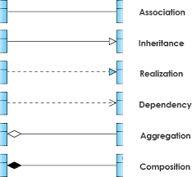

# 3.2. Behavior Modelling

Behavioral model is a set of techniques for persuasion. It’s anything but a system of compulsion. It is an innovation of conduct, not an innovation of power. To that degree, the procedure of behavioral design, and designer themselves, must regard individual’s inherent rights to opportunity of decision, self-governance and respect outline.

3.2.1 Activity Diagram:

The graphical picture of a completed set of technical system actions and considered a municipal chart diagram distinction. It is used to model a big activity’s consecutive work flow by concentrating on action orders and individual action beginning condition. It is an important flowchart diagram which shows the accomplishments completed by a system.

**Notation Used**

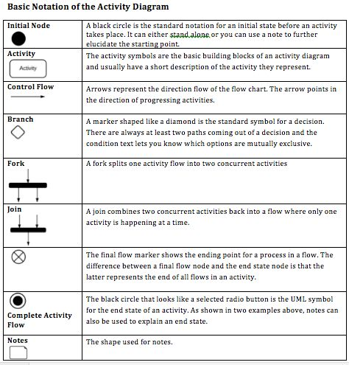

**ADMIN Activity diagram**

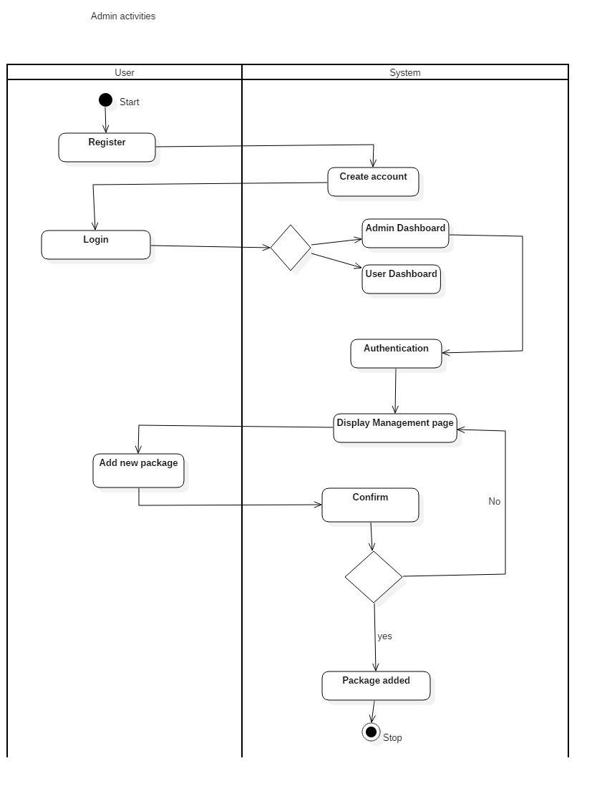

**JUSTIFICATION**

In the above given activity diagram, admin activities have been displayed. At first the user can register to create an account and login into the system. After the logged in user is valid as Admin then then the system will direct to Admin dashboard. In order to add new stock in the system, the admin sends the command and system confirms the request. If the request is accepted, it creates the new stock else it goes back to Admin dashboard.

* To define the branched, parallel and concurrent flow of a system.
* It deals with all different types of flow control, using different elements such as fork, join etc.
* Displays multiple different conditions and actors inside a work by using the swim lanes.

3.2.2 Sequence diagram

Sequence diagram is defined as the interaction diagrams which shows that how the operations are carried out in a system. They capture the interaction between objects in the context of association.

Sequence diagram is used in my project due to following reason:

* It can be used as a requirements document to communicate requirements for a future system implementation.
* It helps in documenting how my system should behave.

**Notation Used**

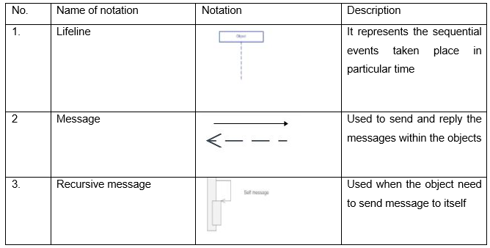

**Login sequence diagram**

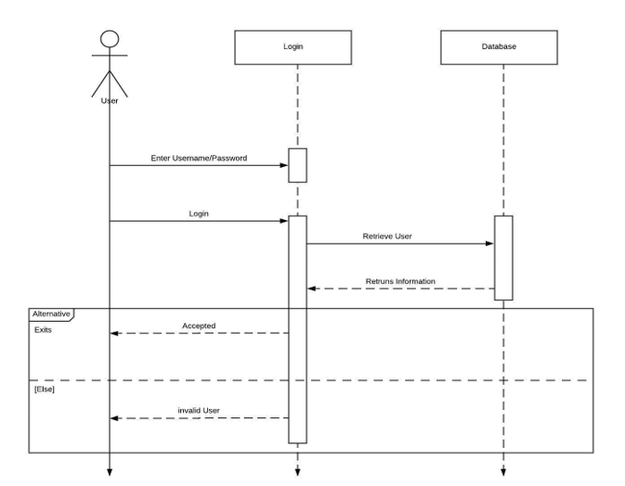

**Justification**

In the above diagram, login sequence diagram has been displayed. User enters the username and password where the database checks the information and give authorization of login the system accordingly.

* The sequence diagram displays an interaction in between the objects. (Sequential order).
* It is quite simple and easy understand.
* UML specification can be more of sequence diagram centric.
* It allows reverse engineering.
* It helps the developers and business analyst to get a common understanding.

**User sequence diagram**

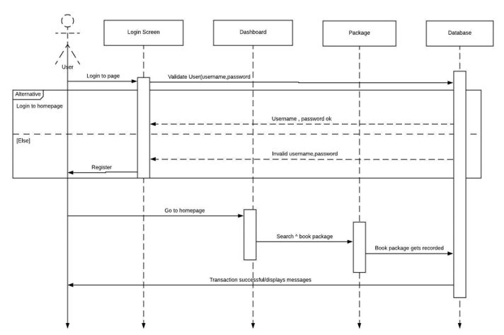

In the above sequence diagram, the user activity. The user can login in to the system and able to search and select the stock accordingly.

* The sequence diagram displays an interaction in between the objects. (Sequential order).
* It is quite simple and easy understand.
* UML specification can be more of sequence diagram centric.
* It allows reverse engineering. It helps the developers and business analyst to get a common understanding.

# 3.3 Database Modelling:

It is the process of designing, developing and implementing the data for proposed system. Its main aim is to produce a logical and physical model for any system. Since it is the first step of database design process, it is considered sometimes to be a high-level and abstract design phase.

3.3.1 Data dictionary:

A set of information, containing all the metadata of database of a system. It includes records, data relationship of the database, objects and is an important part of relational database, that helps in storing the data.

Users data dictionary

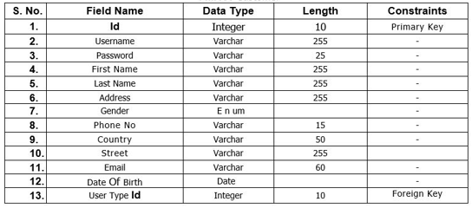

Item type

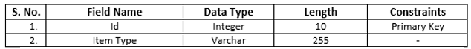

Receipt data dictionary

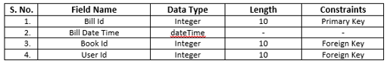

Order data dictionary

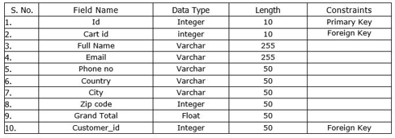

3.3.2 ER Diagram

ER diagram is the data modelling technique and graphical representation of the entities and their relationship with each other stored in the database. It is usually known as an advanced version of flowchart where it specializes the symbols with their unique meaning. The Entity Relationship Diagram helps in illustrating the logic of how entities work and its relationship with each other.

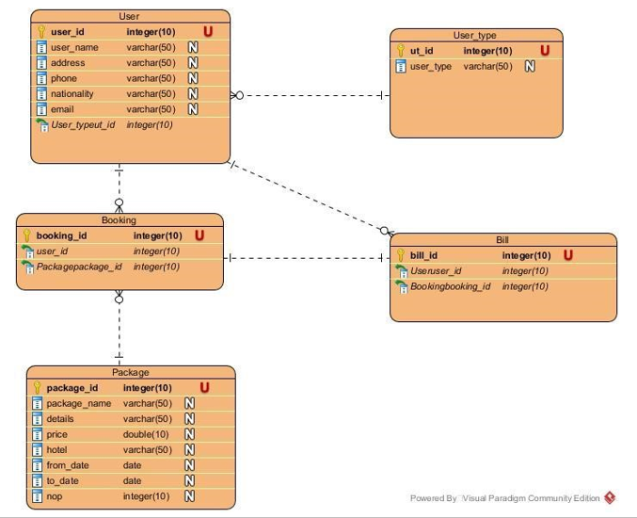

#### Justification

* It helps to find out the mistakes of the design, able to correct before implementing the changes in database.
* Easily the entities can be located via visualizing the database schema, attributes can be viewed and helps to identify the relationship.
* Better visual representation and simple if we know relationship between entities and attributes.
* An effective communication tool for database designer.
* Understanding the data structure clearly, minimizing the data redundancy.

# 3.4 UI Modelling

The process of making some Graphical User Interface for several software as well as machines with a focus on looks of the system in software or in paper is known as User Interface Design. UI design is important in my project because it helps in making design more easier to use and as it is a UI design it shows the project looks like and can have chance to make system more attractive and reliable by showing appropriate design for the project.

**Login Form**

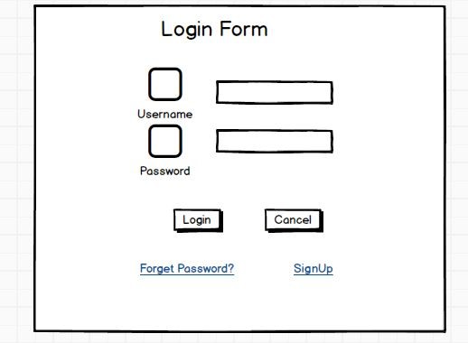

**Signup form**

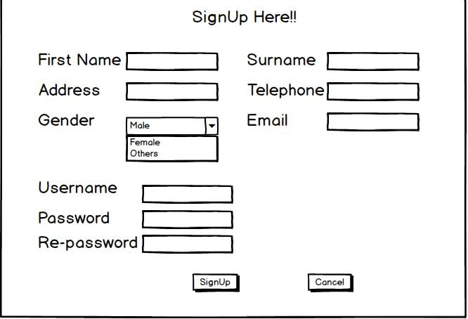

**Dashboard**

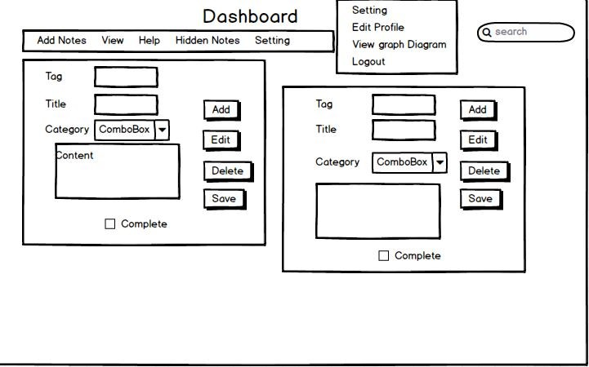

**Category form**

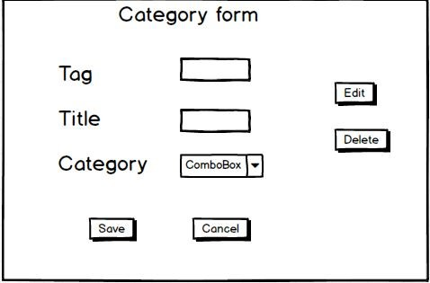

**Graph diagram form**

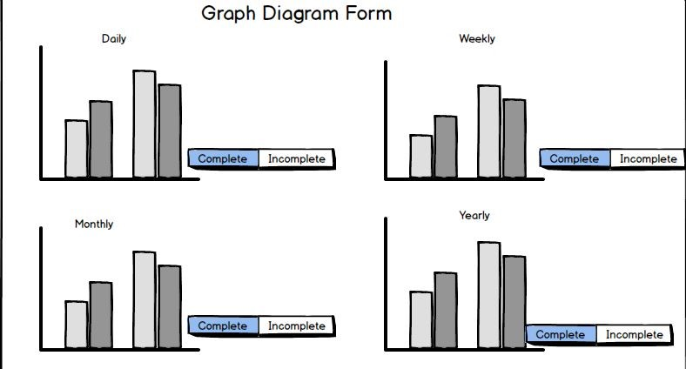

**Edit Profile form**

