HW1
114033623 周守恩
- Experiment Video Link: https://www.youtube.com/playlist?list=PLcSzPJYUM2p4
- Trial Data Table:
Trial | Average Distance (pixels) | Width (pixels) | Index of Difficulty (bits) | Average Time (milliseconds)
1 | 276.68 | 185 | 1.32 | 691.73
2 | 993.2 | 92 | 3.56 | 1074.9
3 | 927.6 | 185 | 2.59 | 858.3
4 | 647.9 | 92 | 3.01 | 860.1
5 | 592.2 | 277 | 1.65 | 599.2
6 | 265.9 | 92 | 1.96 | 693.8
7 | 750.8 | 277 | 1.89 | 760.4
8 | 608.1 | 185 | 2.1 | 857.4
9 | 347.1 | 277 | 1.17 | 592.1
10 | 282.05 | 185 | 1.34 | 587.45
11 | 265.9 | 92 | 1.96 | 599.1
12 | 572.8 | 185 | 2.03 | 655.9
13 | 535.8 | 277 | 1.55 | 575
14 | 997.4 | 92 | 3.57 | 910.3
15 | 641.6 | 92 | 3 | 887.9
16 | 349.2 | 277 | 1.18 | 502.9
17 | 891.9 | 185 | 2.54 | 862
18 | 827.6 | 277 | 2 | 863.4
19 | 291.05 | 185 | 1.36 | 550.73
20 | 901.5 | 185 | 2.55 | 748.9
21 | 381.9 | 277 | 1.25 | 443.8
22 | 778.5 | 277 | 1.93 | 670.3
23 | 639.9 | 92 | 2.99 | 731.6
24 | 547.3 | 277 | 1.57 | 570.1
25 | 609.3 | 185 | 2.1 | 586.1
26 | 272.9 | 92 | 1.99 | 594.4
27 | 1006.9 | 92 | 3.58 | 799.7
28 | 894.14 | 185 | 2.54 | 686.27
29 | 608.8 | 277 | 1.68 | 581
30 | 638.9 | 92 | 2.99 | 877.2
31 | 609.8 | 185 | 2.1 | 629
32 | 768.9 | 277 | 1.92 | 717
33 | 280.9 | 92 | 2.02 | 658.1
34 | 1012.3 | 92 | 3.59 | 890
35 | 328.4 | 185 | 1.47 | 725.3
36 | 338.9 | 277 | 1.15 | 500.8
37 | 577.23 | 277 | 1.62 | 544.64
38 | 278.4 | 92 | 2.01 | 937.7
39 | 600.2 | 185 | 2.09 | 619.5
40 | 318.8 | 185 | 1.45 | 599.6
41 | 921.7 | 185 | 2.58 | 729.4
42 | 645.2 | 92 | 3 | 866.4
43 | 353 | 277 | 1.19 | 579.2
44 | 999 | 92 | 3.57 | 1024.4
45 | 767.4 | 277 | 1.91 | 778.4
46 | 329.95 | 185 | 1.48 | 570.27
47 | 888.9 | 185 | 2.54 | 761.8
48 | 778.2 | 277 | 1.93 | 627.7
49 | 1010.6 | 92 | 3.58 | 882.3
50 | 560.5 | 277 | 1.6 | 628.7
51 | 617.5 | 185 | 2.12 | 627.8
52 | 643.9 | 92 | 3 | 771.3
53 | 277 | 92 | 2 | 642.2
54 | 330.7 | 277 | 1.13 | 520.3
55 | 302.77 | 185 | 1.4 | 507.45
56 | 277.8 | 92 | 2.01 | 535.5
57 | 604 | 185 | 2.09 | 641.9
58 | 894.8 | 185 | 2.55 | 699.1
59 | 1012.3 | 92 | 3.59 | 902
60 | 386.6 | 277 | 1.26 | 628.2
61 | 639.2 | 92 | 2.99 | 732.4
62 | 546.8 | 277 | 1.57 | 554.5
63 | 774.3 | 277 | 1.92 | 664.3
64 | 991.73 | 92 | 3.56 | 817.09
65 | 305.5 | 185 | 1.41 | 494.5
66 | 560.7 | 277 | 1.6 | 522.4
67 | 357.6 | 277 | 1.2 | 450.4
68 | 777.6 | 277 | 1.93 | 587.6
69 | 637.6 | 92 | 2.99 | 726.7
70 | 903.8 | 185 | 2.56 | 702.8
71 | 273.6 | 92 | 1.99 | 636.6
72 | 601.9 | 185 | 2.09 | 589.1
73 | 587.95 | 185 | 2.06 | 645.45
74 | 648.9 | 92 | 3.01 | 757
75 | 880.1 | 185 | 2.53 | 743.6
76 | 775.1 | 277 | 1.93 | 573.8
77 | 370 | 277 | 1.22 | 453.3
78 | 558.8 | 277 | 1.59 | 576.6
79 | 325.1 | 185 | 1.46 | 473.6
80 | 1008.3 | 92 | 3.58 | 851
81 | 268.7 | 92 | 1.97 | 608.7
82 | 886.14 | 185 | 2.53 | 804.18
83 | 782.9 | 277 | 1.94 | 609.1
84 | 570.3 | 277 | 1.61 | 558
85 | 599.5 | 185 | 2.08 | 623.3
86 | 307.9 | 185 | 1.41 | 490.6
87 | 1009 | 92 | 3.58 | 917.7
88 | 362.4 | 277 | 1.21 | 491.3
89 | 276.4 | 92 | 2 | 815.2
90 | 644.6 | 92 | 3 | 735.3
91 | 254.55 | 92 | 1.91 | 711.36
92 | 887.4 | 185 | 2.54 | 732.9
93 | 554.5 | 277 | 1.59 | 575.4
94 | 1004.9 | 92 | 3.58 | 871.1
95 | 601.8 | 185 | 2.09 | 604.1
96 | 771.7 | 277 | 1.92 | 563.3
97 | 633.4 | 92 | 2.98 | 745.9
98 | 341.9 | 277 | 1.16 | 442.8
99 | 323 | 185 | 1.46 | 517.7
100 | 895.41 | 185 | 2.55 | 743
101 | 602.6 | 185 | 2.09 | 633.6
102 | 774.7 | 277 | 1.92 | 548.5
103 | 317.3 | 185 | 1.44 | 581.3
104 | 259.8 | 92 | 1.94 | 574.2
105 | 640.9 | 92 | 2.99 | 780.3
106 | 363.5 | 277 | 1.21 | 460.4
107 | 551.7 | 277 | 1.58 | 600.6
108 | 1015.2 | 92 | 3.59 | 765.2

- Fitts’ Law Formula & Analysis:
$$MT=a+b\log_{2}(\frac{A}{W} +1)$$
Assume the index of difficulty
$$ID=\log_{2}(\frac{A}{W}+1)$$
Verified with my first data:
Variable | Data
Average Distance，$A$ | 276.68 pixels
Width，$W$ | 185 pixels

$ID= \log_{2}\left(\frac{276.68}{185} +1\right)=\log_{2}\left(2.4956\right) ≈1.32$bits
Same as my first data of ID. Therefore, the formula can also be shown as:
$$MT=a+bID$$
Let:
$$x_{i}={ID}_{i}= \log_{2}\left(\frac{A_{i}}{W_{i}} +1\right) , y_{i}= {MT}_{i}$$
It becomes:
$$y_{i}≈a+bx_{i}$$
Use least square method to find the slope:
$$e_{i}=y_{i}-(a+bx_{i})$$
$$\min_{a,b}{\sum_{i=1}^{108}{{{[y}_{i}-\left(a+{bx}_{i}\right)]}^{2}}}$$
Use the formula to calculate the slope b and intercept a:
$$\bar{x}=\frac{1}{108}\sum_{i=1}^{108}{x_{i}} , \bar{y}=\frac{1}{108}\sum_{i=1}^{108}{y_{i}}$$
Then calculate:
$$b= \frac{\sum_{i=1}^{108}{{(x}_{i}-}\bar{x}){(y}_{i}-\bar{y})}{\sum_{i=1}^{108}{{{(x}_{i}-\bar{x})}^{2}}} , a= \bar{y}-b\bar{x}$$
Take all my data in the formula, get:
Parameter | Result | Meaning
$b$：斜率 | $$156.43\text{ ms/bi}\text{t}$$ | 難度每增加 1 bit，預測時間  增加約 156.43 ms
$a$：截距 | $$337.00\text{ m}\text{s}$$ | 直線在 $ID=0$時的預測時間

$$MT=337.00+156.43\log_{2}(\frac{A}{W} +1)$$

- Scatter Plot:
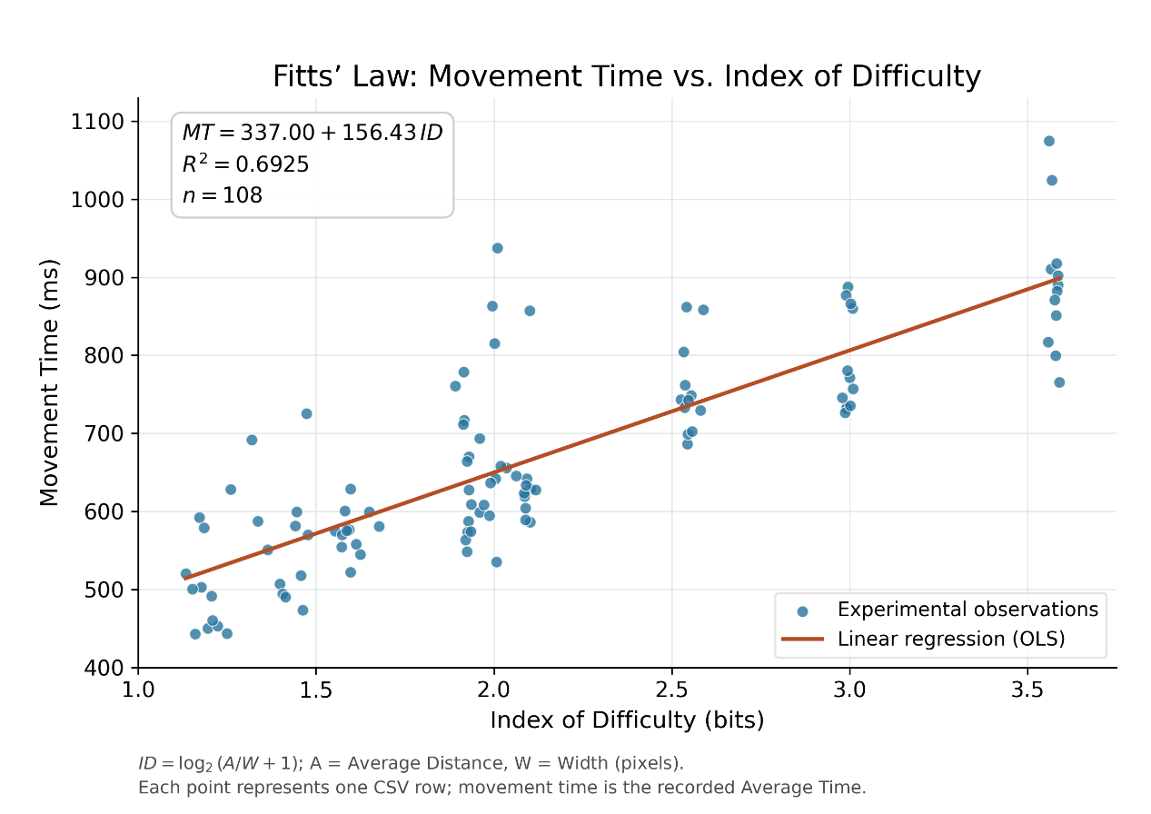
The model explains 69.25% of the variation in movement time.
$$R^{2}=0.6925$$

