Notes: The black line shows the unweighted average share of Communist votes across all communities. The solid and dashed gray lines show how communities with high levels of emigration to the West and communities with high levels of emigration to the East deviate from the overall trend. We plot residual shares of Communist votes controlling for the same set of premigration community-level variables as our baseline specification (see column 3 of Table A4 in the online Appendix) apart from the 1998 election results. Communities with high levels of emigration to the West (East) are defined as having an above median prevalence of westward (eastward) migration and above 50 percent share of westward (eastward) migrants among all migrants. Bars show the overall number of emigrants in stocks (in thousands). Data come from yearly waves of the Moldovan Labor Force Survey. Pre-2006 numbers of emigrants are adjusted to account for a change in the sampling method of the Moldovan Labor Force Survey. Data on emigration from Moldova before 1999 are not available. The first wave of the Moldovan Labor Force Survey was conducted in 1999, just after the unexpected Russian financial crisis hit Moldova in late 1998 and triggered the first big wave of emigration. Information on destination countries is not available in pre-2006 waves. The same trend in the number of migrants is observable using data on Moldovan immigrants from major destination countries. In 1998, for example, only 15 Moldovan immigrants were registered in Italy. This number increased to 40,000 by 2004. A similar development occurred in other destination countries such as Greece, Portugal, and Spain (see footnote 8 for sources and more details). The line segmented with diamonds shows the volume of international calls to Moldova (in 1,000 hours per week) using the International Traffic Database compiled by Telegeography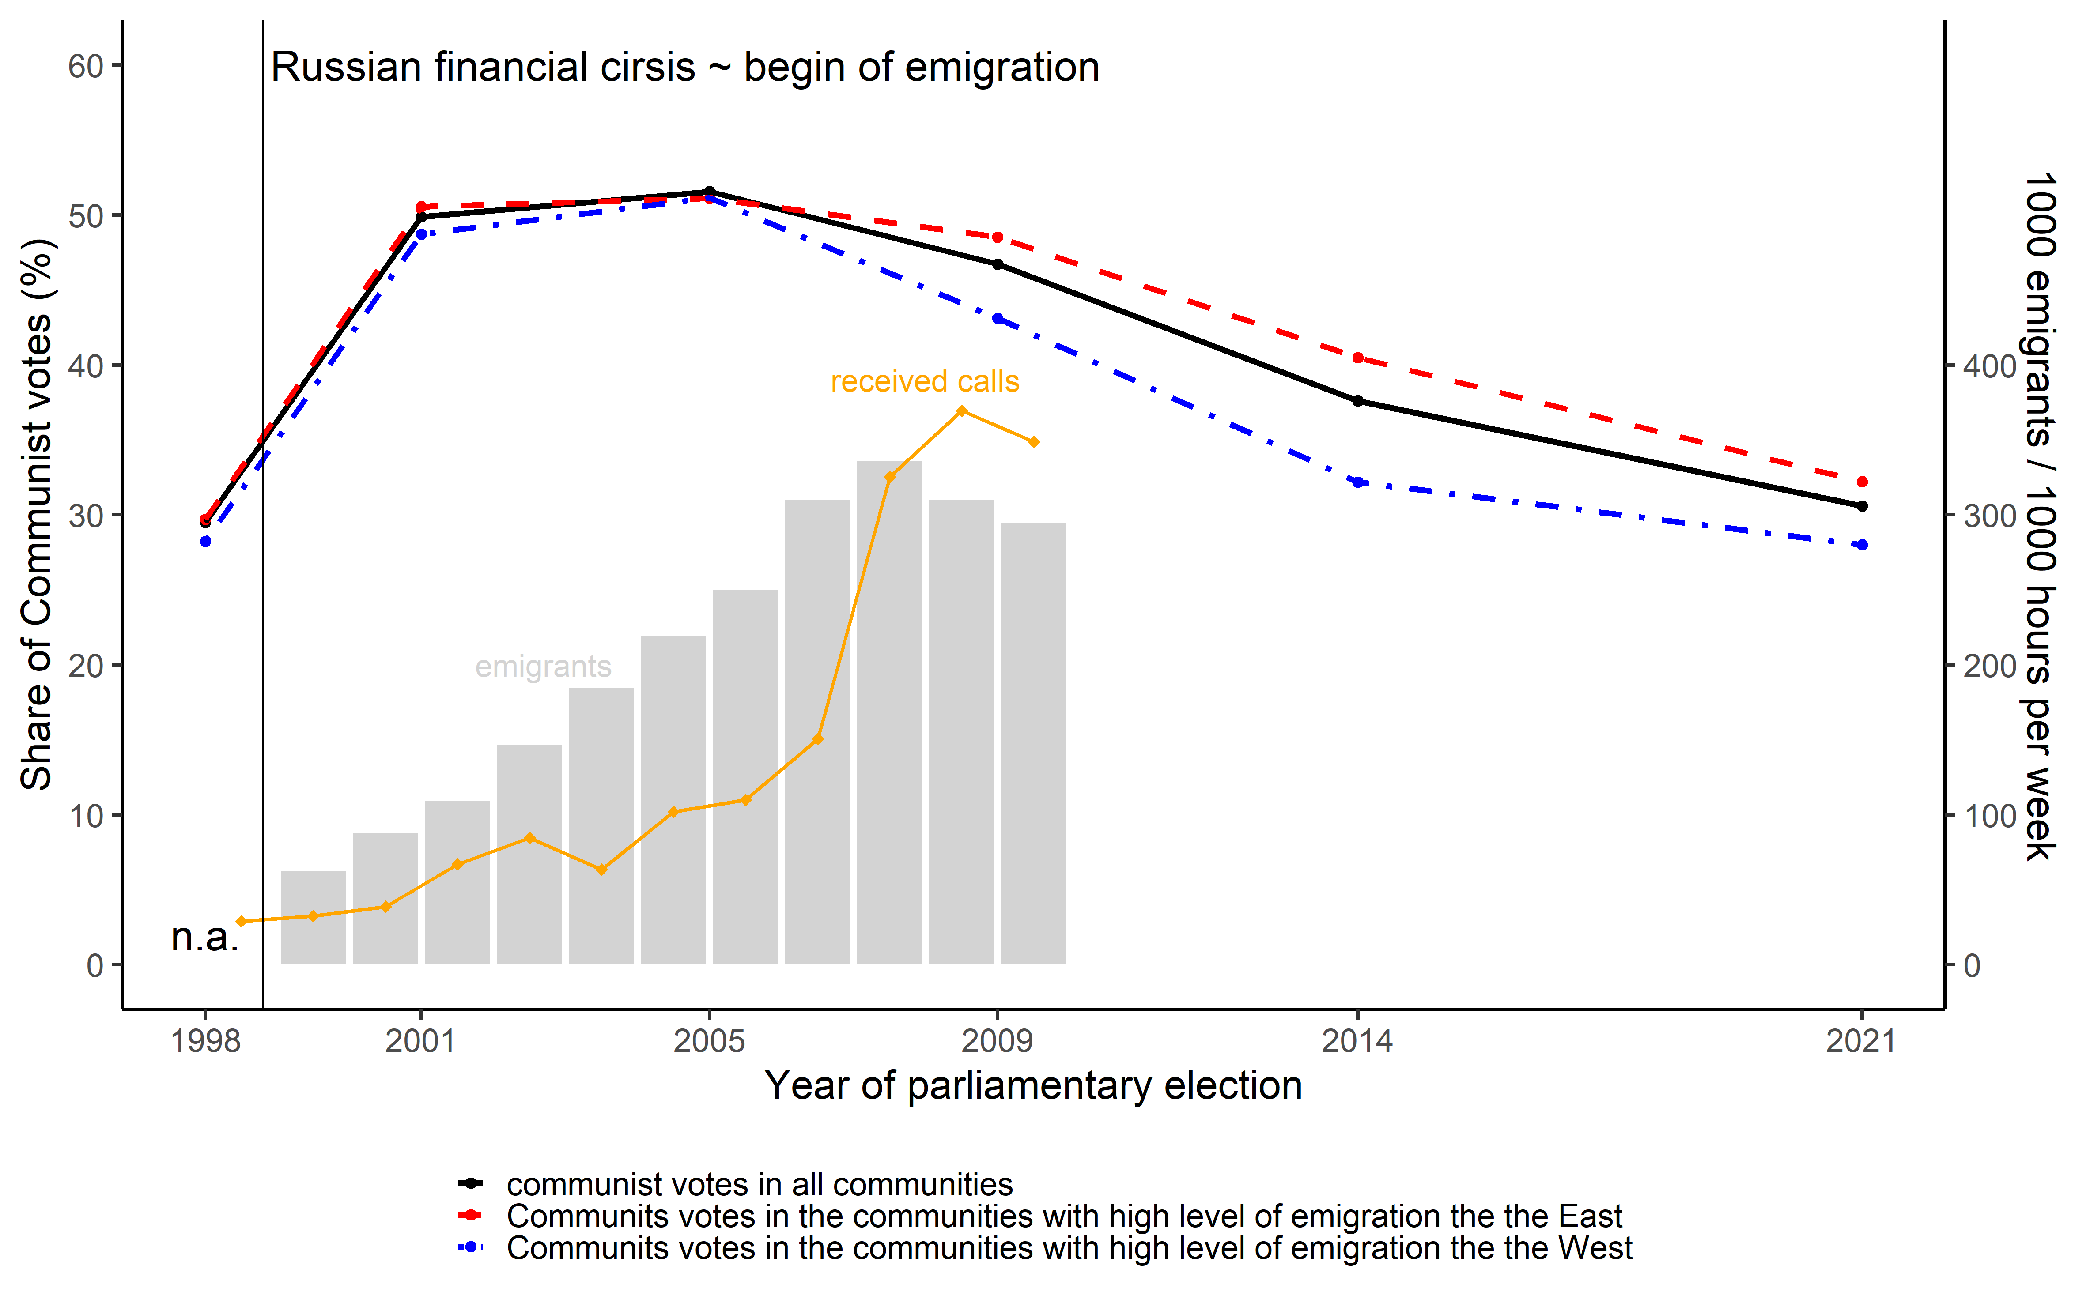

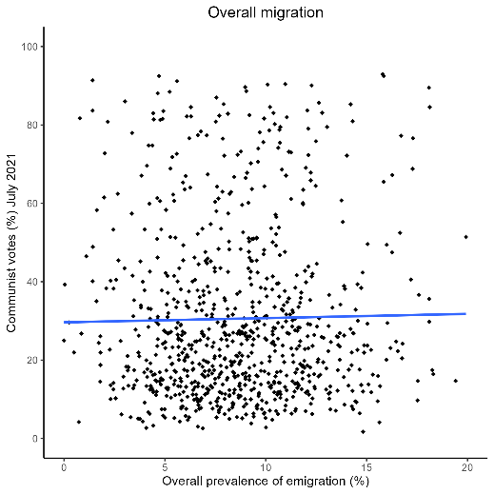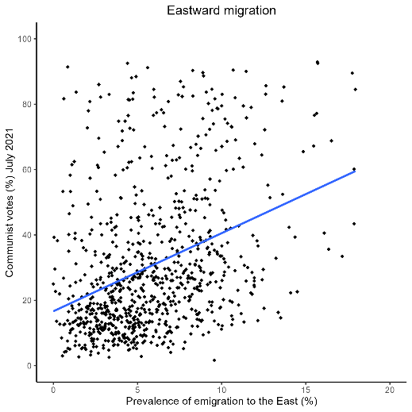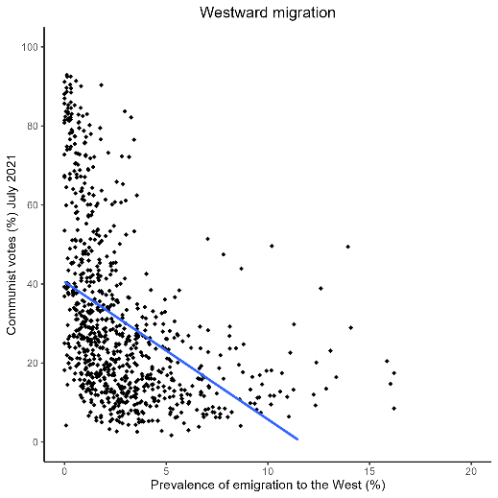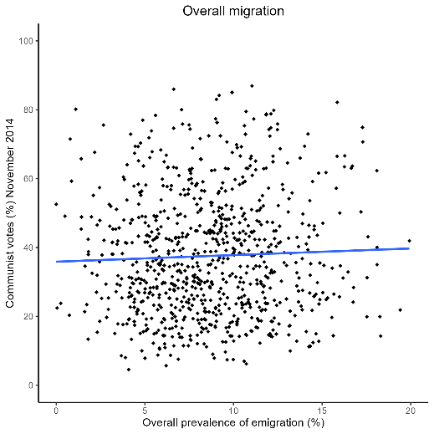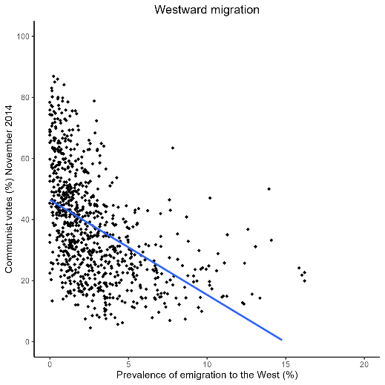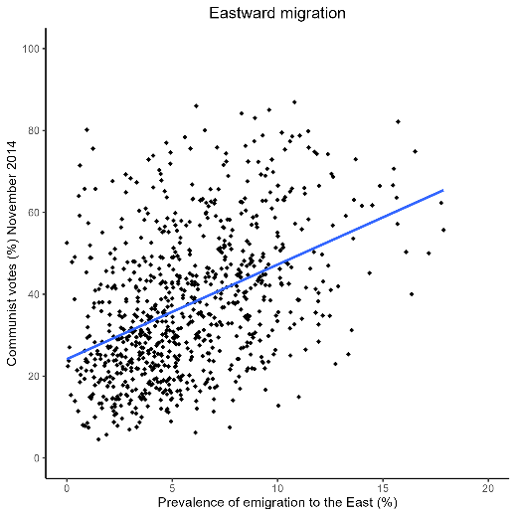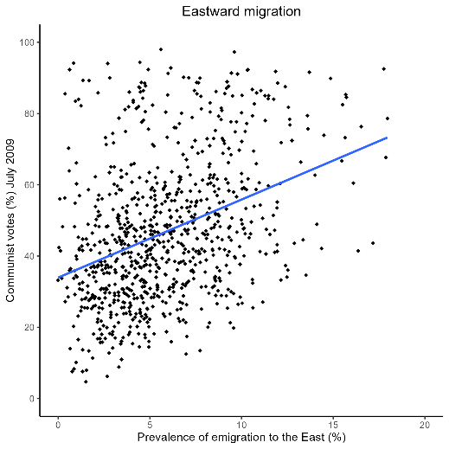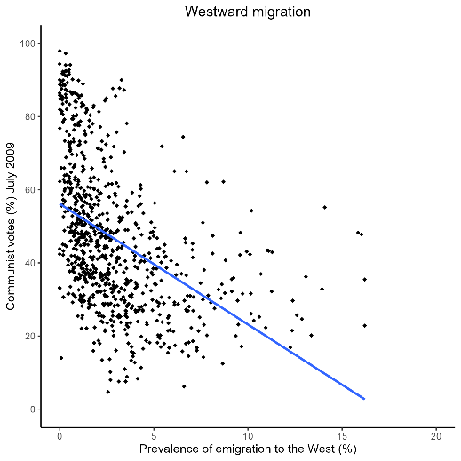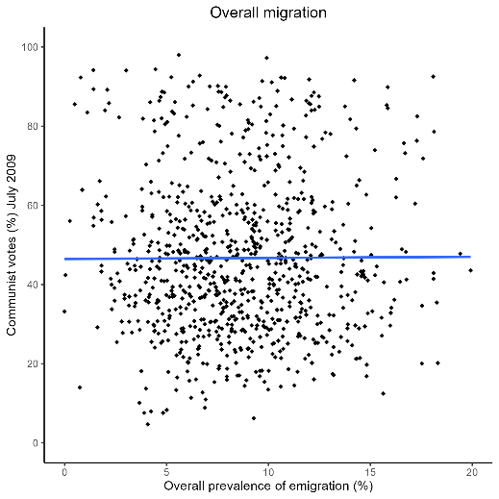

Notes: The figure shows the relationship between overall migration prevalence (panel A), migration prevalence to the West (panel B), migration prevalence to the East (panel C), and the share of Communist votes across 848 Moldovan communities. The horizontal axis measures the share of migrants as a percent of the total population (based on the 2004 population census). The vertical axis measures the share of Communist votes in the parliamentary elections of July 2009 (based on official election results). We only include votes cast in Moldova. Votes cast by migrants abroad are excluded.