
School of Management, Economics,
Law, Social Sciences, International Affairs and Computer Science

Accounting Research and Application

Hot Topics in Management Accounting Research

Submitted by:
Amir Sheikh-Manzoor – 21-613-310
Lucas Bank – 20-611-687
Max Steiner – 21-613-708
Nikolas Huber – 23-600-455
Sören Schlißke – 20-608-899

Supervised by:
Prof. Dr. Maël Schegg
Dr. Benedikt Müller-Stewens

Date of Submission:
20.04.2026

Abstract
This paper identifies and evaluates current hot topics in management accounting research through a dual-track methodology that combines top-down editorial analysis with bottom-up computational topic modeling. The top-down track synthesizes thematic signals from editorial statements, conference themes, and special issues of six leading accounting journals and three specialist management accounting journals. The bottom-up track applies BERTopic, a sentence-transformer-based topic model, to 314 abstracts from three specialist management accounting journals (MAR, JMAR, JOMAC) published between 2021 and 2026, yielding 13 coherent topic clusters. Supplementary analyses reveal that topic prevalence differs significantly across journals (χ²(24) = 66.8, p < 0.001), with JMAR concentrating on behavioral and contracting research, JOMAC on organizational control systems, and MAR exhibiting a broader scope. A methodology classification further shows that performance measurement, pay transparency, and subjective performance evaluation are predominantly experimental topics (≥60% of papers), while management control systems and management accountant identity research rely on qualitative approaches. The integration of both tracks points to sustainability, AI-driven digitalization, and pay transparency as the most prominent emerging themes in contemporary management accounting research.

Contents
1. Introduction 3
2. Research Context 5
3. Methodology 6
3.1 Top-Down 7
3.2 Bottom-Up 7
4. Results 10
4.1 Thematic Priorities in Editorial Discourse 10
4.2 Empirically Derived Topic Clusters 12
4.3 Journal-Topic Distribution 15
4.4 Research Methodology across Topics 16
5. Discussion 17
6. Conclusion 19
References XX
Appendices XXIII
L

List of Figures
Figure 1: Applied Methodology 6
Figure 2: Topic Distribution by Journal 15
Figure 3: Topic Distribution by Research Methodology 17

List of Tables
Table 1: Journals Covered by Bottom-Up Analysis 7
Table 2: Final Topic Overview 13

Introduction
Research invariably begins with a question. Yet before any question can be formulated, a research topic must first be identified, a step that is often treated as simple but rarely experienced as such in practice. At some point, nearly every researcher is confronted with this deceptively simple decision: what should one research and write about? Is the topic sufficiently relevant to the field, to practice, and to an audience beyond one’s own desk? Has it already been examined, and if so, to what extent? Most critically, is it genuinely researchable, or does it dissolve into ambiguity the moment it is pursued? What appears at first glance to be a straightforward starting point thus reveals itself as a complex and consequential, yet comparatively insufficiently reflected-upon challenge within the academic process.
This challenge takes on particular salience in the field of management accounting, where the discipline's dual orientation toward both academic rigor and practical applicability places distinctive demands on the selection of research topics (Van der Stede, 2015). Management accounting research is not only expected to advance scholarly knowledge but also to address the evolving concerns of organizations, managers, and regulators in a meaningful way (Hopper & Bui, 2015). Topics must therefore simultaneously contribute to theoretical development and demonstrate practical relevance, a requirement that considerably narrows the space of viable research directions.
Over the past decades, the field has developed a rich and well-established body of knowledge, supported by leading journals, established methodological approaches, and recurring theoretical frameworks (Bromwich & Scapens, 2016; Hopper & Bui, 2015; Van der Stede, 2014). This maturation has facilitated cumulative knowledge building and strengthened the discipline’s academic legitimacy. At the same time, however, the consolidation of dominant perspectives and research traditions has prompted growing reflection within the scholarly community. Several prominent scholars have raised concerns about whether the field's established research agendas may inadvertently limit intellectual openness and constrain the exploration of emerging or unconventional topics.
These critical voices converge on a shared diagnosis. Basu (2012) argues that accounting researchers tend toward incremental contributions rather than paradigm-shifting inquiry, attributing this tendency to incentive structures that reward methodological conformity over conceptual innovation (pp. 854). Hopper and Bui (2015) offer a broader critique of the field's intellectual trajectory, questioning whether management accounting research has engaged sufficiently with critical perspectives and whether its dominant frameworks adequately reflect the complexity of contemporary organizational life (pp.10-12, 27-28). Bromwich and Scapens (2016), reflecting on twenty-five years of Management Accounting Research, identify a persistent tension between theoretical ambition and empirical grounding, and call for greater attentiveness to real-world managerial challenges (pp. 4-8). Van der Stede (2015) similarly advocates for a reorientation of research priorities toward topics of demonstrated practical significance, warning against the self-referential tendencies of an increasingly insular academic community (pp. 3-5). Taken together, these contributions establish a clear normative case for periodically and systematically reassessing what the field regards as its most pressing and promising research directions.
Despite this widely acknowledged call for reflexivity in management accounting research, the field lacks a recent, systematic identification of its current “hot topics” grounded in actual publication patterns. Existing reflections on research priorities remain largely discursive, relying on the editorial judgment of senior scholars rather than on structured analysis of actual publication patterns. It is precisely this gap that motivates the present study. Accordingly, the paper addresses the following research question:
What are the current and emerging “hot topics” in management accounting research, and how can they be systematically identified and evaluated?
To answer this question, the paper adopts a dual methodological approach that integrates a top-down with a bottom-up perspective. The top-down perspective draws on the four foundational texts introduced above to derive a set of theoretically grounded criteria for evaluating what constitutes a “hot topic”, and to reconstruct the thematic priorities that leading scholars have articulated over the past decade. The bottom-up perspective complements this by applying sentence-transformer-based topic modeling (BERTopic) to titles and abstracts of 314 articles published between 2021 and 2026 in three VHB-ranked management accounting journals (MAR, JMAR, JOMAC), using AI-assisted labeling to derive interpretable topic clusters from actual publication patterns. This dual approach enables a critical comparison between what the field prescribes as important and what it demonstrably produces, revealing both convergences and blind spots in the current research landscape.
The contribution of this paper is threefold. First, it provides a structured, empirically grounded mapping of current “hot topics” in management accounting research, serving as an orientation resource for early-stage researchers navigating an increasingly complex field. Second, it critically interrogates the mechanisms through which research agendas are formed, with particular attention to the risk of disciplinary path dependency and the marginalization of genuinely novel topics. Third, it applies an established NLP pipeline, combining sentence-transformer embeddings, density-based clustering, and AI-assisted topic labeling, to management accounting literature, demonstrating how existing methods from computational text analysis can be transferred to produce scalable, transparent, and replicable insights in bibliometric accounting research.
The remainder of this paper is structured as follows. Chapter 2 provides the research context, reviewing the historical development of management accounting research. Chapter 3 outlines the methodology, comprising two complementary tracks: Subchapter 3.1 describes the analysis of editorial and scholarly signals drawn from leading journals and reflective publications, while Subchapter 3.2 details the computational topic modeling approach applied to recent management accounting abstracts. Chapter 4 presents the results of both tracks: Subchapter 4.1 reports the thematic priorities identified in editorial discourse, Subchapter 4.2 presents the empirically derived topic clusters, Subchapter 4.3 examines the distribution of topics across journals, and Subchapter 4.4 analyses the research methodologies used across topics. Chapter 5 discusses the findings by integrating and comparing the two perspectives. Chapter 6 concludes with a summary of key findings, an acknowledgment of the study's limitations, and directions for future research.

Research Context
The 1970s were laying the groundwork for the management accounting research field. In these years, management accounting research was based on neo-classical economic decision models that were sometimes mathematical in nature, however, not tested in practice. Hereby, scholars often did not consider the complexity of practice in an imperfect world that would not be in line with typical neo-classical economic assumptions. In the 1980s, management accounting scholars became more interested in the practice, which led them to do various surveys as well as case and field studies. Thereby, some scholars used those findings to highlight the perceived gap between theory and practice, while others used them to integrate organisational, social, and contingency theory. (Bromwich & Scapens, 2016, p. 2)
Over the years, management accounting became a very diverse research field, from a methodological, theoretical, and thematic lens, covering both conceptual and empirical work (Balstad & Berg, 2019, p. 360). This diversity, for instance, is evident in the development of the “Management Accounting Research” (MAR) journal. Since the 1990s, scholars have applied a wide variety of research methods such as qualitative case studies, literature-based approaches, surveys, analytical modelling approaches, experiments, market research, historical archival, and triangulations. (Hopper & Bui, 2015, p. 15) Further, during this time span, scholars based their papers on a wide range of theories, such as social and critical theories, contingency theory, economic theories, management control and systems theories, psychological and social psychological theories, and social network theory (Hopper & Bui, 2015, p. 17). Thereby, until 2014, topics were often centred around performance measurement and rewards, cost management, implementation and change, as well as management control systems, among others (Hopper & Bui, 2015, p. 18). Alongside this diversification, calls emerged for greater innovation in research design, arguing that accounting scholars should take more intellectual risks in their choice of questions and methods rather than defaulting to incremental extensions of existing work (Basu, 2012, p. 851).
It is against this backdrop, a diverse, methodologically pluralist field with recurring calls for innovation, that the present paper seeks to identify and evaluate current “hot topics” in management accounting research.

Methodology
This paper adopts a two-track research design to identify and evaluate “hot topics” in management accounting research. The first track is a top-down analysis, deriving thematic signals from editorial sources, namely the editorials and conference topics of leading accounting journals. The second track, a bottom-up analysis, applies computational text analysis to a corpus of peer-reviewed journal abstracts to inductively identify the topics researchers are actually publishing on. The two tracks are designed to be complementary: the top-down track captures what the field aspires to research, while the bottom-up track captures what it actually does. The comparison between the two constitutes a central analytical contribution of the paper.
Figure 1 visualizes the underlying logic of the chosen methodology. It should be noted that the top-down track draws on both general accounting and management accounting-specific journals, while the bottom-up analysis is restricted to the three dedicated management accounting outlets (MAR, JMAR, JOMAC). This asymmetry is intentional. Broadening the top-down scope ensures that empirical findings can be situated within the wider accounting research landscape, including the highest-ranked outlets, such as TAR, JAR, and JAE, whose editorial priorities shape the discipline as a whole and are highly regarded in the broader accounting research literature (see chapter 3.1). Restricting the bottom-up corpus to specialist journals, by contrast, keeps the computational analysis focused and homogeneous, ensuring all papers are unambiguously management accounting in character without requiring keyword filtering that could introduce content bias. The asymmetry is therefore a deliberate design choice: the top-down track provides the broader disciplinary context within which the bottom-up findings are interpreted.

Figure 1
Applied Methodology
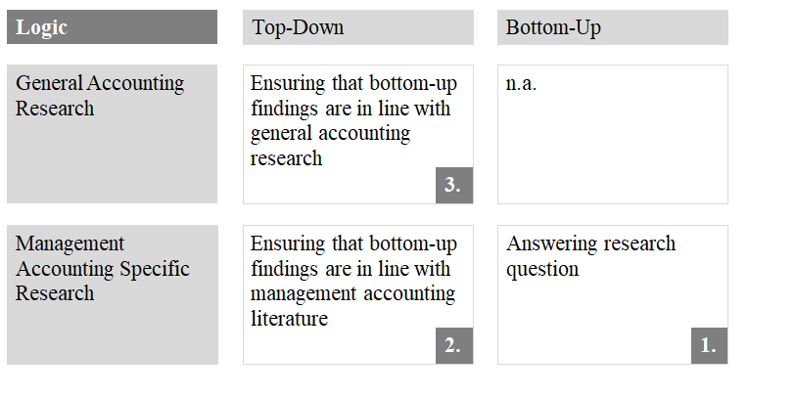
Note. Own work

3.1 Top-Down
Within the field of management accounting, scholars often argue that the so-called “Big 6 accounting research journals” are the most legitimate. They include four American journals (i.e., JAR, TAR, JAE and RAST) and two non-American journals (i.e., AOS and CAR). (Salterio, 2015, p. 154) At the same time, scholars such as Balstad & Berg (2019) argue that the elevated status of these six journals is often only vaguely explained or even taken for granted (p. 358). Given the broad, though not uncontested, acceptance of the “Big 6 accounting research journals” in the research community, this paper draws on multiple journal rankings to further substantiate their perceived legitimacy (i.e., triangulation of sources). Based on this justification, the six journals are used as the foundation for the top-down identification of “hot topics”.
To support this selection, several journal rankings are consulted through a unified access (i.e., Journal Rankings.com). This allows us to demonstrate that the “Big 6 accounting research journals” are not only highly regarded in the management research community in general (e.g., FT50) but also in the more specialized accounting research community (e.g., VHB Accounting). (see Appendix 1)

3.2 Bottom-Up
The empirical corpus for the bottom-up track was assembled from Scopus, a major academic literature database selected for its extensive coverage of relevant journals, its structured metadata export functionality, and its established use in prior bibliometric studies of accounting research (Balstad & Berg, 2019, pp. 372-373). Three journals were selected based on two criteria: (i) a minimum ranking of ‘B’ in the VHB-ranking, the leading quality benchmark for academic journals in the German-speaking research community (Geldermann et al., 2025, pp. 807-809), and (ii) exclusive focus on management accounting, ensuring full thematic alignment with the research objective without requiring post-hoc topical filtering. The journals are listed in Table 1.
Table 1
Journals Covered by Bottom-Up Analysis
Journal | Abbreviation | VHB-Ranking | Results
Management Accounting Research | MAR | A | 83
Journal of Management Accounting Research | JMAR | B | 144
Journal of Management Control | JOMAC | B | 88
Note. Own work
The time frame covers January 2021 to March 2026. It was chosen to capture the post-pandemic research landscape and to reflect the most current directions in the field, while providing sufficient volume for computational analysis. The initial Scopus export yielded 315 records. Since the export was configured to retrieve only journal articles, no further document-type filtering was required. One record was subsequently removed due to a missing abstract, yielding a final analytical sample of 314 articles across three journals covering the period 2021-2026. See also Appendix 4 for a paper count by journal and year.
The raw Scopus export was subjected to a structured pre-processing pipeline executed in Python using a reproducible Jupyter Notebook (GitHub [soerenssch], n.d.). Two text representations were prepared for each paper. First, a cleaned abstract was produced for keyword inspection and frequency analysis by lowercasing the raw text, removing special characters and HTML artefacts, and stripping domain-generic stopwords using both the standard English stopword list from the NLTK library and a custom accounting-specific list. Second, an uncleaned concatenation of each paper's title and abstract, referred to as text_for_modeling, was retained as the direct input to BERTopic's sentence-transformer embedding model. Natural language input is used deliberately here: BERTopic encodes semantic meaning from grammatically intact sentences, and pre-cleaning would remove contextual signals the model relies on.
Each document was encoded using the pre-trained sentence-transformer model all-MiniLM-L6-v2 (Reimers & Gurevych, 2019), producing a 384-dimensional dense vector representation per document. This model was selected for its balance of encoding quality and computational efficiency on corpora of this scale. Embeddings were computed once and cached to ensure identical vector representations across all subsequent modeling runs, so that variation in outcomes across configurations is attributable solely to clustering parameters rather than stochastic variation in the embedding step.
Topic modeling was applied to the pre-processed corpus using BERTopic (Grootendorst, 2022, pp. 2-3), selected for four reasons well-suited to the present research context. First, its sentence-transformer architecture encodes semantic meaning rather than surface-level word frequency, which is especially valuable for a corpus of academic abstracts in which the same underlying topic may be expressed through different terminology across journals or time periods. Second, BERTopic applies UMAP (McInnes et al., 2018) for dimensionality reduction followed by HDBSCAN (McInnes et al., 2017) for density-based clustering, an architecture that does not require the researcher to pre-specify the number of topics, the cluster solution emerges from the data's own structure. Documents that HDBSCAN cannot assign to any cluster receive a noise label (topic = -1), meaning they are flagged rather than distorted by forced assignment. Third, BERTopic represents each topic through its most distinctive keywords via a class-based TF-IDF procedure (Grootendorst, 2022), making topic content transparent and auditable, an important property when topic labels feed directly into an academic evaluation framework. Fourth, BERTopic has been validated specifically for short academic texts such as abstracts and has been applied to accounting research directly, demonstrating effectiveness in identifying coherent topic structures across a corpus of 306 public sector accounting papers (Kuroki & Hirose, 2025, pp. 12-13).
The high-dimensional embedding space was reduced to five dimensions prior to clustering using UMAP with the following parameters: n_neighbors = 15, n_components = 5, min_dist = 0.0, metric = cosine, and random_state = 42. Setting min_dist to zero encourages tight local cluster structure, which is appropriate for the subsequent density-based clustering step. Cluster assignments were then obtained via HDBSCAN with min_cluster_size = 8, min_samples = 1, cluster_selection_method = eom (Excess of Mass), and prediction_data = True to enable soft-probability assignment. Soft cluster probabilities were subsequently used to select the most representative documents per topic for the validation and labeling steps described below.
Prior to the final model run, a systematic sensitivity analysis was conducted across twelve hyperparameter configurations. A grid search varied three parameters simultaneously; n_neighbors ∈ {10, 15}, min_samples ∈ {1, 2, 3}, and cluster_selection_method ∈ {eom, leaf}, while holding min_cluster_size fixed at eight across all runs. All configurations reused the cached embeddings so that differences in outcomes are attributable solely to clustering behavior. Configurations were evaluated jointly on the number of substantive topics identified and the proportion of documents assigned to noise. The selected configuration is reported in Subchapter 4.2.
Following the initial model run, two clusters required manual post-processing after review of representative papers and keyword profiles. Topic 0, the largest BERTopic cluster with 60 papers, merged two conceptually distinct research streams under a shared governance-and-compensation vocabulary. It was split into two sub-clusters: Topic 0a, covering executive compensation and incentive contracting (17 papers), and Topic 0b, covering corporate governance and board oversight (19 papers). The remaining 24 papers from Topic 0 were reassigned to noise because they are primarily financial-accounting-adjacent, covering earnings management, financial reporting quality, transfer pricing, and market reaction studies, and do not constitute a coherent management accounting sub-cluster. Topic 2, comprising 37 papers, similarly merged two distinct streams and was split into Topic 2a, covering the role and identity of management accountants (5 papers), and Topic 2b, covering digitalization of the finance function (11 papers). The remaining 21 Topic 2 papers were reassigned to noise. All subsequent analyses use the manually revised topic assignments. The final solution comprises thirteen named topics covering 229 papers, with 85 papers (27.1% of the corpus) unassigned. The elevated noise rate relative to the initial model result of 12.7% reflects the deliberate reassignment of thematically heterogeneous papers from Topics 0 and 2.
Following the computational identification and manual post-processing of topics, an AI-assisted labeling procedure was applied to assign theoretically grounded, human-readable labels to each of the thirteen clusters. This step is necessary because BERTopic produces topic representations as ranked keyword lists, i.e., ‘performance, effort, information, team, managers, employees, feedback’, which, while indicative of content, do not constitute interpretable research topic labels suitable for academic discussion. The AI labeling procedure bridges this gap systematically and consistently across all topics simultaneously.
For each topic, a structured prompt is constructed containing: (i) the top ten c-TF-IDF keywords and (ii) the title and first 300 characters of the abstract of the three papers with the highest HDBSCAN soft-assignment probability for that cluster, that is, the papers most representative of the cluster's semantic center. This prompt is submitted to a large language model (Claude Sonnet 4.6) with the following instruction:
“You are an expert in management accounting research with deep familiarity with the journals Management Accounting Research (MAR), Journal of Management Accounting Research (JMAR), and Journal of Management Control (JOMAC). Below are topic clusters identified by a BERTopic model applied to 314 abstracts from these three journals (2021–2026). For each topic, provide: (1) a concise topic label of three to six words using standard management accounting research terminology; avoid generic terms such as 'management accounting research' or 'organizational study'; (2) a sub-field classification from the following list: Core MA, Incentives & Compensation, MCS & Control, Sustainability, Cross-cutting, FA-adjacent, or Analytical/Formal Theory; (3) the dominant theoretical framework or frameworks; and (4) a flag indicating whether the topic overlaps with financial accounting or corporate governance, with a brief explanation if so.”
The model's output is reviewed against the full list of papers assigned to each topic. This hybrid procedure, combining the scalability and consistency of automated initial labeling with domain-expert validation, follows established practice in computational literature reviews (Müller-Bloch & Kranz, 2015) and ensures that the final topic taxonomy reflects disciplinary expertise rather than purely algorithmic output.

Results
This chapter presents the findings of the two-track analysis. Subchapter 4.1 synthesizes thematic priorities as identified through editorial discourse and reflective scholarship, while Subchapter 4.2 reports the topic clusters empirically derived from computational analysis of 314 recent management accounting abstracts. Subchapter 4.3 then examines how topics are distributed across the three specialist journals, and Subchapter 4.4 profiles the methodological composition of each topic cluster. Together, these four sub-chapters offer both the substantive findings and the structural context needed to situate current hot topics within the broader landscape of management accounting research.

4.1 Thematic Priorities in Editorial Discourse
Desk research enabled an understanding of the journal's positioning, using the publicly communicated editorial focus, as well as emerging discussions, based on topics of recent (i.e., between 2022 and 2025).
General accounting research
Within the “Big 6 accounting research journals”, all journals are positioned as high-quality journals that aspire academic rigor in the field of accounting. While journals such as JAR or AOS explicitly encourage interdisciplinary research, other journals such as TAR or RAST do it rather implicitly. Overall, these journals include research topics that are important for management accounting (e.g., decision-making in accounting) as well as those that are not directly relevant (e.g., accounting regulations).
An examination of the conferences has revealed that the emerging discussions take place at various levels. First, methodological discussions are evident, such as at the 2023 JAR conference at the University of Chicago on the advancement of theory integration in research. Thereby, the objective is to improve the connection between theories and empirical work. Second, from a content perspective, technology and sustainability integration appear to be two essential topics that are relevant for management scholars. Within technology, certain discussions are rather broad in nature (e.g., the connection between accounting and innovation), and certain are dedicated to specific technologies (e.g., AI, LLM, and blockchain). It has to be highlighted that the discussions around AI mostly centre around its use cases and applications in accounting in practice, and not around AI usage for accounting scholars. Within sustainability, the AOS conference in Chicago in 2023 was fully dedicated to sustainability, highlighting its contemporary relevance. In other conferences, sustainability was combined with other topics such as capital markets or the COVID-19 pandemic. (see Appendix 2)
Management accounting research
The three dedicated management accounting journals, namely “Management Accounting Research” (MAR), the “Journal of Management Accounting Research” (JMAR), and the “Journal of Management Control” (JMC), share a common positioning that distinguishes them from the broader “Big 6 accounting research journals”. All three explicitly commit to bridging academic rigor and practical applicability. While MAR positions itself as an internationally oriented forum welcoming the full spectrum of empirical and conceptual methods, JMAR places particular emphasis on the interface between theory and practice, explicitly encouraging research that carries implications for managerial decision-making and performance measurement. JMC occupies a somewhat narrower position, focusing specifically on formal planning and control systems and the role of management accountants in organizational settings, while also explicitly requiring that submissions demonstrate both methodological quality and practical relevance. Taken together, the journals collectively cover the full breadth of management accounting and control, though with different emphases: MAR and JMAR tend toward a broader conception of management accounting, whereas JMC centers more specifically on control system design and use.
An examination of recent conference activity and special issues reveals emerging discussions at two levels. First, from a methodological perspective, the 2025 MAS Midyear Meeting in Austin featured a dedicated panel on how to produce practice-relevant management accounting research using a range of methodological approaches including archival analysis, theoretical modelling, experiments, and surveys rather than relying exclusively on field research. This discussion reflects a growing awareness within the community that the perceived trade-off between methodological rigor and real-world relevance is itself a subject requiring active reflection. Separately, the JMC launched a special issue dedicated to advancing experimental and replication-based research in management accounting and control, signaling an emerging methodological emphasis on replicability and robustness.
Second, from a content perspective, two themes appear to be particularly prominent. Within technology and digitalization, AI is becoming a prominent subject. Notably, at the 2025 MAS Midyear Meeting, discussions centered not only on AI applications in accounting practice but also on the use of generative AI as a research tool, accompanied by an AAA task force on disclosure requirements for AI-assisted research. Within sustainability, the JMC issued a dedicated call for papers on “Management Control Research on Sustainability”, covering topics such as the integration of sustainability into planning and risk assessment, sustainability-related incentive and reward systems, and stakeholder collaboration through management control. The 2025 MAS Midyear Meeting similarly featured sustainability as a prominent theme, with papers examining how incentive systems can be designed to encourage carbon-reduction behavior and how sustainability targets can be incorporated into performance target-setting alongside OKRs and AI-assisted approaches.
Additionally, performance targets and incentive design emerged as a recurring cross-cutting topic: the ACMAR 2025 Best Paper examined incentive and sorting effects of challenging performance targets using field data, and the JMAR Forum on target-setting addressed both traditional and sustainability-oriented target-setting mechanisms. This convergence suggests that the intersection of performance management, sustainability, and technology constitutes the most dynamic frontier in current management accounting research. (see Appendix 3)

4.2 Empirically Derived Topic Clusters
Applied to the 314-paper corpus described in Subchapter 3.2, the final topic solution comprises thirteen named clusters encompassing 229 papers (72.9% of the corpus), with 85 papers (27.1%) assigned to the noise category. The distribution of papers across topics is presented in Table 2 and Appendix 5, Appendix 6 shows the top keywords per topic, and the spatial arrangement of documents in the reduced embedding space is shown in the UMAP topic map in Appendix 7. Finally, topic development over time can be found in Appendix 8.
A grid search across twelve configurations was conducted prior to the final model run, varying n_neighbors ∈ {10, 15}, min_samples ∈ {1, 2, 3}, and cluster_selection_method ∈ {eom, leaf} while holding min_cluster_size fixed at eight. All runs used identical cached embeddings, ensuring that differences in outcomes reflect clustering behavior exclusively. The configuration with n_neighbors = 15, min_samples = 1, and the eom method was selected as the primary model: it achieved the lowest noise rate across the grid (12.7%, 40 papers) while producing eleven coherent topics, the most parsimonious outcome of any tested configuration. A consistent pattern emerged across the grid: all six eom-based configurations outperformed all six leaf-based configurations on the noise criterion, with leaf configurations producing noise rates between 25.2% and 37.9%. Within the eom configurations, increasing min_samples from one to three progressively raised the noise rate from 12.7% to 22.3% without a commensurate increase in topic quality, confirming the selection of min_samples = 1 as optimal for this corpus size.
The thirteen named topics are summarized in Table 2 and described in turn below. Figure A2 presents the c-TF-IDF keyword weights for each topic, and Figure A4 shows how topic publication volumes have evolved year by year over the study window.
Table 2
Final Topic Overview
Topic | n | Top keywords
1 | 51 | performance, effort, information, team, managers, employees, feedback
3 | 25 | pay, transparency, employees, dispersion, performance, workers, ai
4 | 24 | cost, stickiness, firms, supply, investment, cost behavior, supply chain
5 | 22 | risk, management, control, organizational, culture, management control
0b | 19 | board governance, internal control, csr, directors, governance diversity, oversight
0a | 17 | ceo compensation, executive pay, bonus plans, rpe, contract design, incentives
6 | 17 | sustainability, control, environmental, systems, innovation, management
2b | 11 | digital, analytics, automation, dashboard, textual analysis, digitalization
7 | 11 | budget, budgets, creativity, budgeting, diagnostic use, performance
8 | 10 | subjective, evaluation, evaluations, performance, procedural, subordinates
9 | 9 | trust, control, employees, partners, management control, experience
10 | 8 | allocations, optimal, compensation, decision-makers, choices, cost
2a | 5 | management accountants, identity, role, skills, influence, effectiveness
Noise | 85
Note. Own work
The largest cluster, Topic 1 (51 papers), centers on performance management, employee motivation, and feedback mechanisms, with a strong behavioral orientation toward how performance information affects effort and team dynamics. Topic 3 (25 papers) addresses pay transparency and compensation dispersion, covering how the disclosure or visibility of pay structures affects employee behavior and organizational outcomes; the appearance of the term ai in this cluster's keyword profile suggests an emerging strand examining algorithmic or AI-assisted compensation decisions. Topic 4 (24 papers) represents the cost behavior and cost stickiness literature, covering the asymmetric adjustment of costs to activity changes, with notable attention to supply chain and investment contexts. Topic 5 (22 papers) covers management control systems in relation to risk, organizational culture, and control design, reflecting the longstanding interest in how contextual factors shape MCS configuration.
Topic 0b (19 papers) captures corporate governance and board oversight research, including board composition, gender diversity in governance, and the integration of CSR considerations into oversight mechanisms. Topic 0a (17 papers) addresses executive compensation and incentive contracting, covering the design of bonus plans, relative performance evaluation schemes, and compensation disclosure practices. Topic 6 (17 papers) covers sustainability and environmental management control, encompassing both the integration of environmental considerations into control systems and the relationship between sustainability controls and organizational innovation.
Topic 2b (11 papers) addresses digitalization of the finance function, including studies of automation, business analytics, digital dashboards, and the organizational consequences of advanced analytics for controllers and management control departments. Topic 7 (11 papers) focuses on budgeting processes, with particular attention to the tension between diagnostic control use of budgets and creative performance outcomes. Topic 8 (10 papers) covers subjective performance evaluation, examining how evaluators integrate objective and subjective information and how procedural features of evaluation processes affect subordinate perceptions. Topic 9 (9 papers) addresses trust and control in inter-organizational and interpersonal relationships, examining how control mechanisms and trust interact in settings involving employees, partners, and supply chain relationships.
Topic 10 (8 papers) represents the analytical and formal theory strand of management accounting research, comprising papers that develop and test mathematical models of optimal contracting, cost allocation mechanisms, and performance target design under moral hazard and information asymmetry. Finally, Topic 2a (5 papers) constitutes the smallest named cluster, covering the role, identity, and professional effectiveness of management accountants a topic that, despite its modest representation in the corpus, addresses foundational questions about the function and positioning of management accounting as a profession.
Of the 314 papers in the corpus, 85 (27.1%) were not assigned to any named topic. As noted above, 45 of these were deliberately reassigned from Topics 0 and 2 following manual review; the remaining 40 represent the organically unclustered fraction identified by the initial HDBSCAN model. Inspection of a random sample of noise papers reveals several recurring reasons for non-assignment. A first group comprises papers that span multiple topics simultaneously, for instance, a paper examining the integration of CSR into management control systems in the context of SMEs touches on Topics 5, 6, and 0b without belonging exclusively to any of them. A second group comprises methodological and theoretical papers, such as studies of ethnographic research practice in management accounting or reflections on experimental methodology, whose primary contribution is disciplinary rather than thematic, and which therefore share vocabulary with the corpus as a whole rather than with any specific cluster. A third group consists of genuine outliers addressing topics with insufficient peers to form a cluster, including context-specific field studies and highly specialized sub-domain papers. The 27.1% noise rate is acknowledged as elevated relative to topic-modeling studies on larger corpora; however, given the deliberate restriction to 314 specialist journal abstracts and the methodological diversity characteristic of management accounting research, this rate is considered methodologically appropriate rather than indicative of model failure.
Following the computational identification and manual post-processing of topics, an AI-assisted labeling procedure was applied to assign human-readable labels to each of the thirteen topic clusters. For each topic, a structured prompt containing the top-ten c-TF-IDF keywords and the titles and first 300 characters of the three highest-probability abstracts was provided to the model (see Section 3.2 for the verbatim prompt). All model-generated labels were subsequently validated by the authors against the full list of papers in each cluster.
The resulting labels confirm and extend the narrative descriptions presented above. See Figure 2 for the topic labels by size, including the Topics by Journal.
Figure 2
Topic Distribution across Journals
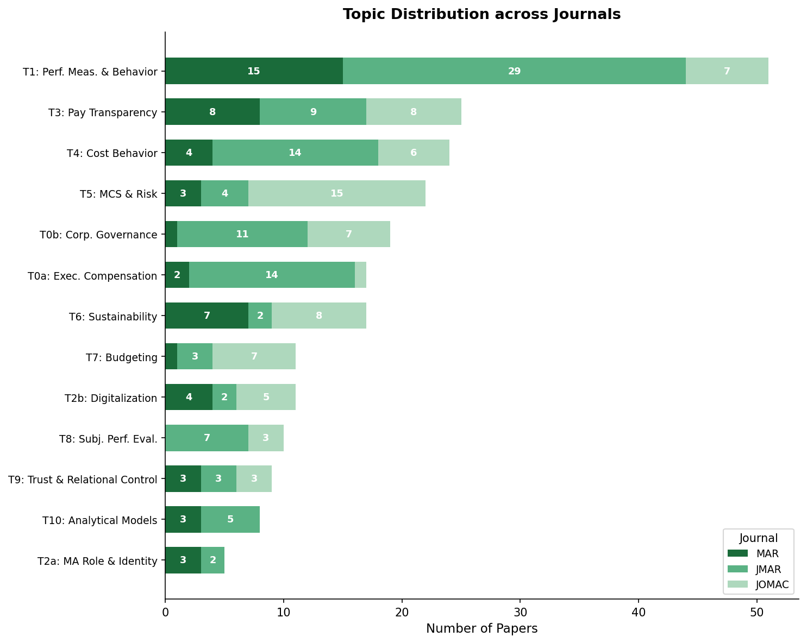
Note. Own work

4.3 Journal-Topic Distribution
A supplementary cross-tabulation examines whether topic prevalence differs across the three specialist journals. Paper counts by journal (MAR, JMAR, JOMAC) are cross-tabulated for each named topic. A chi-square test of independence confirms that the joint distribution is highly non-random (χ²(24) = 66.8, p < 0.001), indicating that the three journals pursue measurably distinct thematic agendas within the shared domain of management accounting research.
The results reveal clear thematic specializations. JMAR concentrates on topics with a behavioral and contracting orientation: Topic 0a (Executive Compensation & Incentive Contracting) is published almost exclusively in JMAR (82%), as are Topic 8 (Subjective Performance Evaluation & Procedural Fairness, 70%) and Topic 1 (Performance Measurement & Behavioral Management Control, 57%). This pattern is consistent with JMAR’s stated editorial commitment to behavioral research and incentive design. JOMAC gravitates toward organizational and systems-level topics: Topic 5 (Management Control Systems & Organizational Risk) draws 68% of its papers from JOMAC, as does Topic 7 (Budgeting Practices & Creative Performance, 64%), reflecting JOMAC’s organizational control systems tradition. MAR is the primary outlet for Topic 2a (Professional Role & Identity of Management Accountants, 60%), consistent with its attention to interpretive and critical perspectives.
Several topics exhibit relatively balanced journal distributions, suggesting that these themes cut across editorial traditions. Topic 3 (Pay Transparency & Compensation Dispersion) is distributed almost evenly across all three journals (MAR 32%, JMAR 36%, JOMAC 32%), as is Topic 9 (Trust & Relational Management Control). Topic 6 (Sustainability) is split primarily between MAR (41%) and JOMAC (47%), indicating that sustainability research has achieved genuine cross-journal legitimacy.

4.4 Research Methodology across Topics
A complementary analysis classifies each paper by its primary research methodology using a keyword-based classifier applied to abstract text. Five categories are identified: experimental, survey/field study, qualitative (case study, interview-based, or interpretive research), analytical (formal modelling), and archival. Papers whose abstract does not yield an unambiguous single-method signal are classified as Other/Mixed. Results should be interpreted as indicative of broad methodological tendencies, as abstract style varies considerably across journals.
The analysis reveals pronounced methodological specialization within topics. Three topics are dominated by experimental research: Topic 1 (Performance Measurement & Behavioral Management Control, 65%), Topic 3 (Pay Transparency & Compensation Dispersion, 64%), and Topic 8 (Subjective Performance Evaluation & Procedural Fairness, 60%). This concentration of experimental work around behavioral and incentive themes is consistent with the journal-level finding that JMAR, the dominant outlet for all three topics, pursues an explicitly behavioral research agenda. Qualitative methods are most prevalent in Topic 5 (Management Control Systems & Organizational Risk, 41%) and Topic 2a (Professional Role & Identity of Management Accountants, 40%), reflecting the organizational and interpretive traditions of these topic areas. Topic 7 (Budgeting Practices & Creative Performance) is predominantly survey-based (45%), in keeping with the tradition of field research on budgeting processes. Topic 10 (Analytical Models of Optimal Contracting & Allocation) shows the highest share of formal analytical work. The joint distribution thus reveals a disciplinary division of methodological labor that mirrors the editorial specialization described in Subchapter 4.3. See also Figure 3 for the visualisation of topic distribution by research methodology.
Figure 3
Topic Distribution by Research Methodology
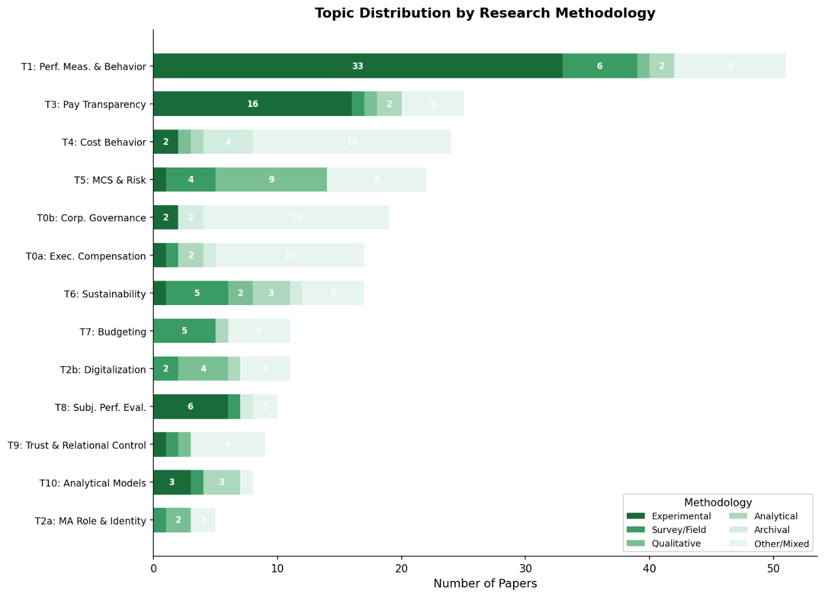
Note. Own work

Discussion
This paper set out to identify and evaluate current hot topics in management accounting research by combining a top-down editorial analysis with a bottom-up computational topic model. The two tracks converge on several recurring themes while also revealing instructive divergences that illuminate the structure of the field.
The clearest area with convergence of the top-down and bottom-up analysis is sustainability. Both tracks, the editorial analysis reflected in special issues and conference themes, and the computational analysis evidenced by Topic 6 (Sustainability & Environmental Management Control, 17 papers), identify sustainability as one of the most actively pursued and institutionally endorsed themes in contemporary management accounting research. The bimodal journal distribution of Topic 6, split between MAR (41%) and JOMAC (47%), indicates that sustainability research has achieved real recognition and legitimacy across journals, rather than being just an emerging topic.
Digitalization shows a more asymmetric pattern. The top-down track identifies AI and digital transformation among the most prominent emerging themes, particularly at recent conference venues such as the 2025 MAS Midyear Meeting. Yet the computational model produces only a modest cluster (Topic 2b, Digitalization of the Finance Function, 11 papers). This divergence between editorial signal strength and publication volume may reflect a temporal lag: editorial discourse typically anticipates rather than merely reflects research output, and the 2021-2026 window may be capturing digitalization at an early stage of its publication lifecycle. The predominance of qualitative approaches in this topic (36%) further suggests that much early-stage digitalization research takes an exploratory, case-based form, consistent with a topic that has not yet crystallized into standardized research designs.
Performance measurement and behavioral management control (Topic 1, 51 papers) represent the field’s single largest empirical cluster, and a genuine convergence point of both tracks. The top-down analysis identified performance targets, incentive design, and effort allocation as central editorial concerns; the bottom-up model confirms these as the modal research activity in the corpus. The dominance of experimental methods (65%) and JMAR as primary outlet (57%) underscores the degree to which this topic has coalesced around a shared methodological and editorial identity.
The journal-topic and methodology-topic analyses add a structural dimension. The empirical confirmation that JMAR concentrates on behavioral and contracting research while JOMAC gravitates toward organizational control systems provides empirical validation of historically stated editorial identities. More substantively, the even distribution of pay transparency research across all three journals suggests that this theme has achieved broader field-level recognition and is not primarily the property of any single editorial community.
Several limitations deserve acknowledgment. The bottom-up corpus is restricted to three specialist management accounting journals, excluding the broader accounting field and practice-oriented outlets. The time window (2021-2026) captures the post-pandemic landscape but cannot reveal longer-run trends. The AI-assisted topic labeling, while methodologically transparent and author-validated, involves interpretive judgment. Finally, the abstract-based methodology classifier is an approximation; papers with non-standard abstract structures are systematically misclassified into the Other/Mixed category, limiting the precision of the methodology-topic analysis.

Conclusion
This paper provides a structured, empirically grounded mapping of current and emerging hot topics in management accounting research. Combining editorial and scholarly signals with a BERTopic analysis of 314 specialist journal abstracts, it identifies thirteen coherent topic clusters and examines their distribution across journals and research methodologies.
Three themes emerge as the most prominent hot topics by the convergence of both tracks: sustainability and environmental management control, behavioral aspects of performance measurement and incentive design, and the digitalization of the finance function. Performance measurement occupies the largest publication volume with a stable experimental methodology and a clear journal home in JMAR. Sustainability shows the broadest institutional endorsement across journals and editorial venues. Digitalization represents the fastest-moving frontier, with editorial attention running ahead of settled publication output, a divergence that indicates research opportunity precisely because the topic is not yet saturated.
The supplementary journal-topic and methodology-topic analyses contribute a structural layer to the findings. The three specialist management accounting journals occupy distinct and empirically confirmed thematic niches: JMAR pursues a behavioral and contracting agenda, JOMAC an organizational systems orientation, and MAR a broader and more pluralistic scope. This editorial division of labor maps onto a corresponding methodological division: behavioral topics are pursued experimentally, organizational topics qualitatively or through surveys. For researchers entering or repositioning within the field, these patterns provide practical guidance on both topic choice and appropriate research design.
Future research could extend the present approach in several directions. A larger corpus spanning additional journals would improve coverage of the broader accounting field. A longitudinal design tracking topic emergence and decline over multiple decades would reveal how hot topics evolve. A more refined methodology classifier, leveraging full-text rather than abstract-level information, would produce more accurate method-to-topic mappings. The full replication pipeline, including pre-processed data, model code, and topic labeling inputs, is publicly available (GitHub [soerenssch], n.d.) to facilitate verification and extension.

References
Accounting, Organizations and Society. (n.d.). Elsevier. https://www.sciencedirect.com/journal/accounting-organizations-and-society
ACMAR. (n.d.). WHU. https://www.whu.edu/en/news-insights/events/whu-acmar/
American Accounting Association. (2025a, January 9–11). 2025 Management Accounting Section midyear meeting: Research conference, IMA doctoral colloquium, and CGMA teaching and practice symposium. https://aaahq.org/Meetings/2025/MAS-Midyear-Meeting
American Accounting Association. (2025b, December). The Accounting Review: Editorial policy [PDF]. https://aaahq.org/portals/0/documents/journals/Editorial-Policies/2025/TAR_Editorial_Policy%2012-2025.pdf
American Accounting Association. (n.d.). Guide for authors: Journal of Management Accounting Research. https://aaahq.org/Research/Journals/Journal-of-Management-Accounting-Research/Guide-for-Authors
Balstad, M. T., & Berg, T. (2019). A long-term bibliometric analysis of journals influencing management accounting and control research. Journal of Management Control, 30(4), 357–380. https://doi.org/10.1007/s00187-019-00287-8
Basu, S. (2012). How can accounting researchers become more innovative? Accounting Horizons, 26(4), 851–870. https://doi.org/10.2308/acch-10311
Bisbe, J., Bui, B., & Hoozée, S. (2024). Call for papers: Special issue on "Management control research on sustainability". Journal of Management Control. Springer Nature. https://link.springer.com/journal/187/updates/26045952
Bromwich, M., & Scapens, R. W. (2016). Management Accounting Research: 25 years on. Management Accounting Research, 31, 1–9. https://doi.org/10.1016/j.mar.2016.03.002
Canadian Academic Accounting Association. (2025). Call for papers: 40th Annual Contemporary Accounting Research Conference, Milan, Italy, October 24–25, 2025 [PDF]. https://www.caaa.ca
Canadian Academic Accounting Association. (n.d.). CAR editorial policies. https://www.caaa.ca/car-editorial-policies
Christensen, H., Hales, J., O'Dwyer, B., & Peecher, M. (n.d.). Sustainability conference [Special issue]. Accounting, Organizations and Society. Elsevier. https://www.sciencedirect.com/special-issue/109SSGVKV8K
Geldermann, J., Koziol, C., & Volling, T. (2025). The VHB-Rating 2024 – more than Just Another Rating. Schmalenbach Journal of Business Research, 77(4), 793–815. https://doi.org/10.1007/s41471-025-00217-6
GitHub [soerenssch]. (n.d.). GitHub. https://github.com/soerenssch/AFA
Grootendorst, M. (2022). BERTopic: Neural topic modeling with a class-based TF-IDF procedure. arXiv. https://arxiv.org/abs/2203.05794
Hopper, T., & Bui, B. (2015). Has Management Accounting Research been critical? Management Accounting Research, 31, 10–30. https://doi.org/10.1016/j.mar.2015.08.001
Journal of Accounting and Economics. (n.d.). Elsevier. https://www.sciencedirect.com/journal/journal-of-accounting-and-economics
Journal of Accounting Research. (n.d.). Author guidelines. Wiley Online Library. https://onlinelibrary.wiley.com/page/journal/1475679x/homepage/ForAuthors.html
Journal of Management Control. (n.d.). Aims and scope. Springer Nature. https://link.springer.com/journal/187/aims-and-scope
Journal Rankings. (n.d.). https://www.journal-rankings.com/
Kuroki, M., & Hirose, Y. (2025). Topic Classification of Public Sector Accounting Research: A BERT-Based Approach. Journal of Emerging Technologies in Accounting, 1–16. https://doi.org/10.2308/jeta-2024-019
Management Accounting Research. (n.d.-a). Elsevier. https://www.sciencedirect.com/journal/management-accounting-research
Management Accounting Research. (n.d.-b). Special issues. Elsevier. https://www.sciencedirect.com/journal/management-accounting-research/special-issues
McInnes, L., Healy, J., & Astels, S. (2017). hdbscan: Hierarchical density based clustering. The Journal of Open Source Software, 2(11), 205. https://doi.org/10.21105/joss.00205
McInnes, L., Healy, J., Saul, N., & Großberger, L. (2018). UMAP: Uniform manifold Approximation and Projection. The Journal of Open Source Software, 3(29), 861. https://doi.org/10.21105/joss.00861
MIT Sloan School of Management. (2023, October 27–28). 2023 Journal of Accounting and Economics conference schedule [PDF]. https://mitsloan.mit.edu/sites/default/files/inline-files/2023%20JAE%20conference%20schedule%2010.11.2023.pdf
Reimers, N., & Gurevych, I. (2019). Sentence-BERT: Sentence Embeddings using Siamese BERT-Networks. Proceedings of the 2019 Conference on Empirical Methods in Natural Language Processing and the 9th International Joint Conference on Natural Language Processing, 3980–3990. https://doi.org/10.18653/v1/d19-1410
Review of Accounting Studies. (2025). RAST 2025 conference. Springer Nature. https://link.springer.com/journal/11142/updates/27733774
Review of Accounting Studies. (n.d.). Springer. https://www.springerprofessional.de/en/review-of-accounting-studies/10877358
Salterio, S. E. (2015). Barriers to Knowledge Creation in Management Accounting Research. Journal of Management Accounting Research, 27(1), 151–170. https://doi.org/10.2308/jmar-51056
Stanford Graduate School of Business. (2024, October 18–19). Journal of Accounting and Economics conference. https://www.gsb.stanford.edu/events/jae-conference
University of Chicago Booth School of Business. (n.d.). Ray Ball JAR Conference. Chookaszian Accounting Research Center. https://www.chicagobooth.edu/research/chookaszian/events/jar-conference
Van Der Stede, W. A. (2015). Management Accounting: where from, where now, where to? Journal of Management Accounting Research, 27(1), 171–176. https://doi.org/10.2308/jmar-51059
Wharton School, University of Pennsylvania. (2025). Conference schedule: Journal of Accounting & Economics 2025 conference. Accounting Department. https://accounting.wharton.upenn.edu/jae-2025/conference-schedule/

Appendices
Appendix 1
Journal Rankings of the “Big 6 Accounting Research Journals”
Journal Rankings (/ best ranking) | Journal of Accounting Research (JAR) | The Accounting Review (TAR) | Journal of Accounting and Economics (JAE) | Review of Accounting Studies (RAST) | Accounting, Organizations and Society (AOS) | Contemporary Accounting Research (CAR)
Consensus Score (/ 100) | 98 | 98 | 98 | 94 | 96 | 94
VHB (/ A+) | A+ (Accounting A+) | A+ (Accounting A+) | A+ (Accounting A+) | A (Accounting A) | A (Accounting A+) | A (Accounting A+)
ABDC (/ A*) | A* | A* | A* | A* | A* | A*
ABS (/ 4*) | 4* | 4* | 4* | 4 | 4* | 4
HCERES (/ A) | A | A | A | A | A | A
SJR (/ Q1) | Q1 | Q1 | Q1 | Q1 | Q1 | Q1
JUFO (/ 3) | 3 | 3 | 3 | 3 | 3 | 3
FT50 (/ Yes) | Yes | Yes | Yes | Yes | Yes | Yes
UTD (/ Yes) | Yes | Yes | Yes | No | No | No

Note. (Journal Rankings, n.d.)

Appendix 2
Emerging Topics of the “Big 6 Accounting Research Journals”
Between 2022 and 2025 | Journal of Accounting Research (JAR) | The Accounting Review (TAR) | Journal of Accounting and Economics (JAE) | Review of Accounting Studies (RAST) | Accounting, Organizations and Society (AOS) | Contemporary Accounting Research (CAR)
Editorial focus  (Journal positioning) | Accounting and accounting related topics (incl. finance, economics, statistics, psychology, and sociology); information and measurement of organizations (Journal of Accounting Research, n.d.) | Accounting; informing practice and regulation; decision making tool (American Accounting Association, 2025b) | Application of economic theory to accounting phenomena (Journal of Accounting and Economics, n.d.) | Must contribute to the discipline of accounting (Review of Accounting Studies, n.d.) | Interdisciplinary coverage of accounting, human behaviour, organizational and institutional structures and socio-political environment of enterprise (Accounting, Organizations and Society, n.d.) | Role of accounting in organizations, markets or society (Canadian Academic Accounting Association, n.d.)
Topic of conference  (emerging discussion) | Ray Ball JAR Conference (University of Chicago): 2025: “AI and LLM in accounting (research)”; 2023: Integrating Theory; 2022: ESG and COVID-19 (University of Chicago Booth School of Business, n.d.) | AAA annual meetings cover broad topics | Wharton 2025: Accounting function as information system incl. under new technologies (e.g., blockchain), different institutional contexts (private firms, informal economies) (Wharton School, University of Pennsylvania, 2025); Standford 2024: Policy, law and regulations (Stanford Graduate School of Business, 2024); MIT 2023: Managerial behaviour, quality of accounting signals, innovation , capital markets (incl. ESG) (MIT Sloan School of Management, 2023) | Indian School of Business, 2025: Valuation and accounting quality, fintech, CSR, sustainability reporting, disclosure, auditing and tax (Review of Accounting Studies, 2025) | Chicago 2023: Sustainability conference (Christensen et al., n.d.); | Bocconi 2025: General accounting (Canadian Academic Accounting Association, 2025)
Note. Own work ([sources within the table])

Appendix 3
Emerging Topics of MAR, JMAR, and JMC
Between 2022 and 2025 | Management Accounting Research (MAR) | Journal of Management Accounting Research (JMAR) | Journal of Management Control (JMC)
Editorial focus  (Journal positioning) | International forum for original scholarly work in management accounting; welcomes all empirical methods as well as analytical and conceptual contributions; covers management accounting practices and systems in any type of organization globally (Management Accounting Research, n.d.-a) | Advance the theory and practice of management accounting; role of accounting information in decision-making and performance measurement; interface between internal and external reporting and taxation; encourages new theories, topical areas, and methods with implications for practice (American Accounting Association, n.d.) | Formal, information-based routines and procedures managers use to maintain or alter organisational activities; emphasis on operational and strategic planning and control systems and their management accounting processes; role of management accountants and their interactions across functions (Journal of Management Control, n.d.)
Topic of conference  (emerging discussion) | Annual Conference for Management Accounting Research (ACMAR) at WHU Vallendar 2026: broad management accounting research; special issues on digitalization in management accounting & control, corporate governance and management control, Performance Measurement & Strategic Management Accounting, Public Sector & Government Accounting, Sustainable Development (Management Accounting Research, n.d.-b; ACMAR, n.d.) | AAA Management Accounting Section Midyear Meeting, Austin 2025: AI in accounting research, practice-relevant methodologies, international collaborations; JMAR Forum on target setting incl. OKRs, sustainability targets, and AI-agent target setting (American Accounting Association, 2025a) | Special issues on: “Management Control Research on Sustainability” (open CfP); digitalization and management control systems; risk management controls; recently upgraded to VHB B-journal (2024) (Bisbe et al., 2024)
Note. Own work ([sources within the table])

Appendix 4
Paper Count by Journal and Year
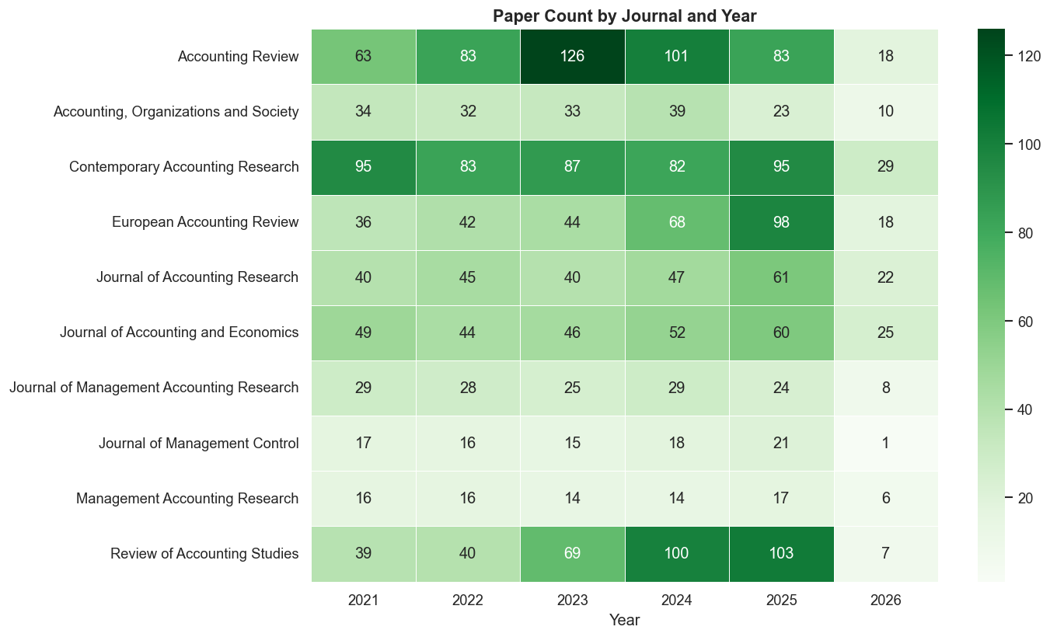
Note. Own work

Appendix 5
Papers across Topics
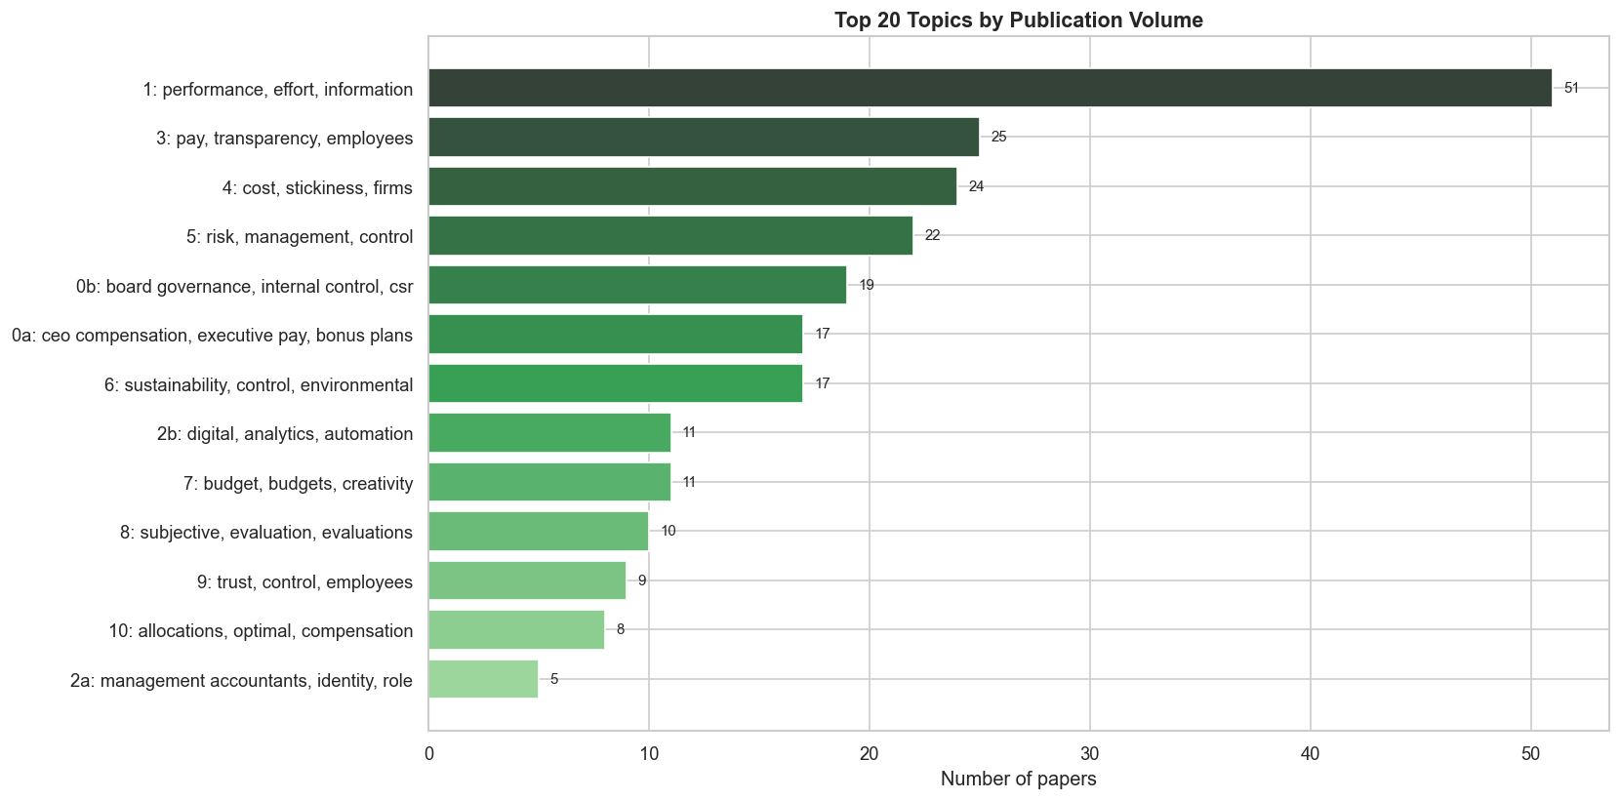
Note. Own work

Appendix 6
Top 8 Keywords per Topic
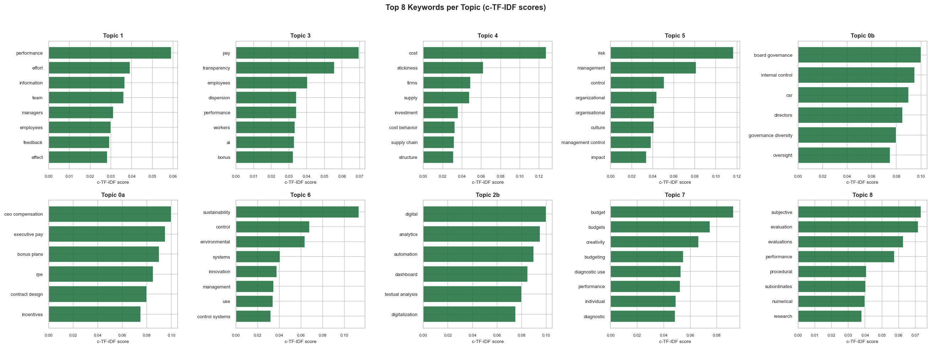
Note. Own work

Appendix 7
UMAP Topic Map
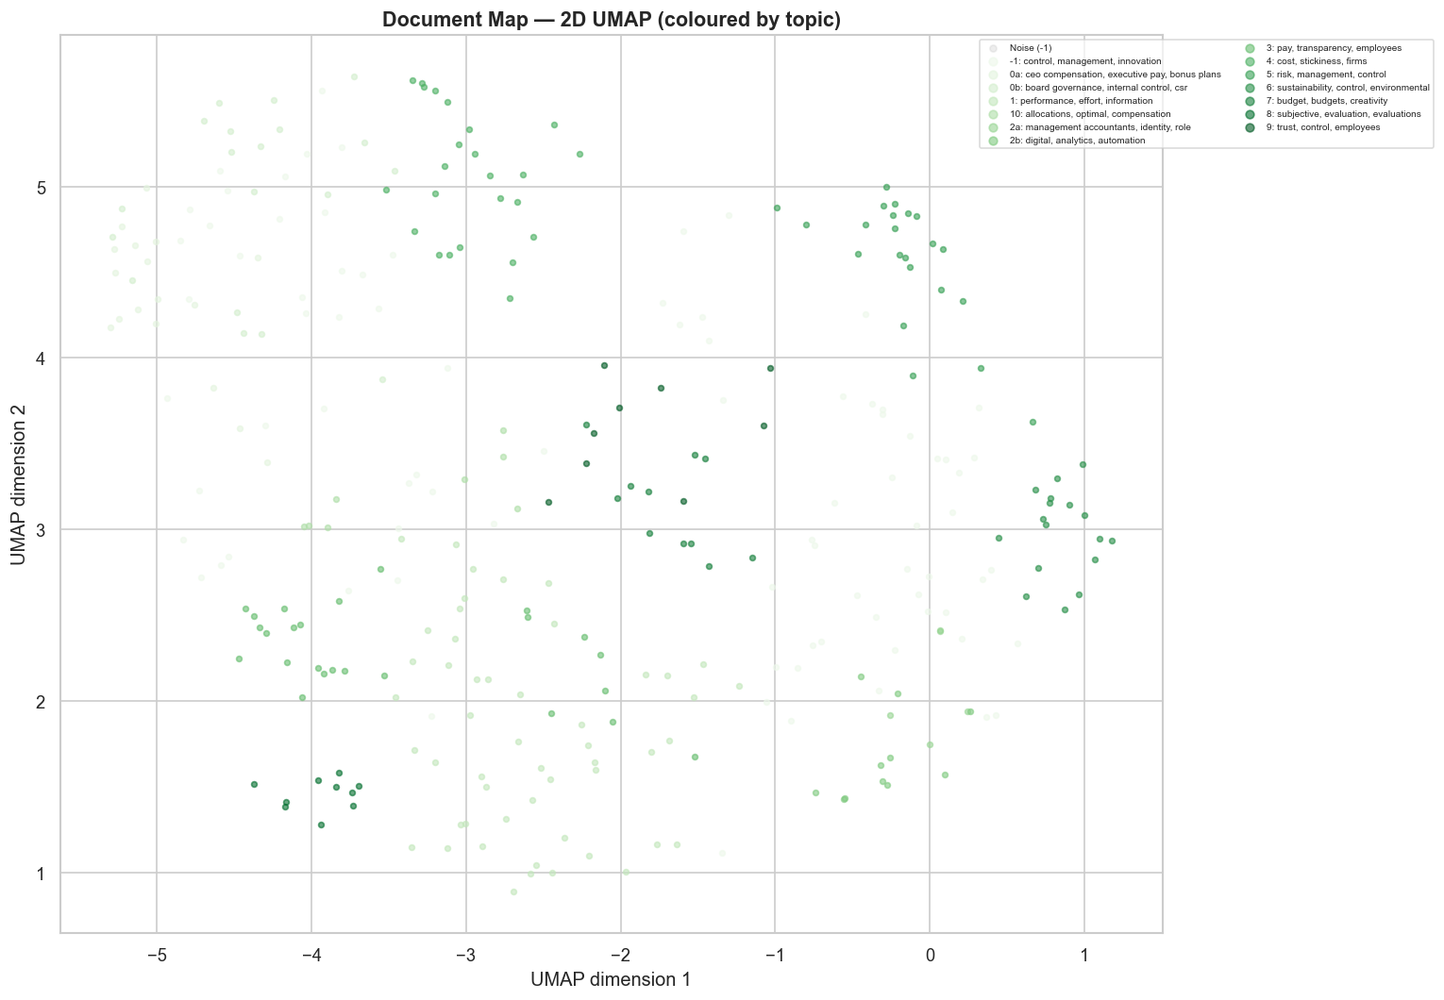
Note. Own work

Appendix 8
Topics over Time
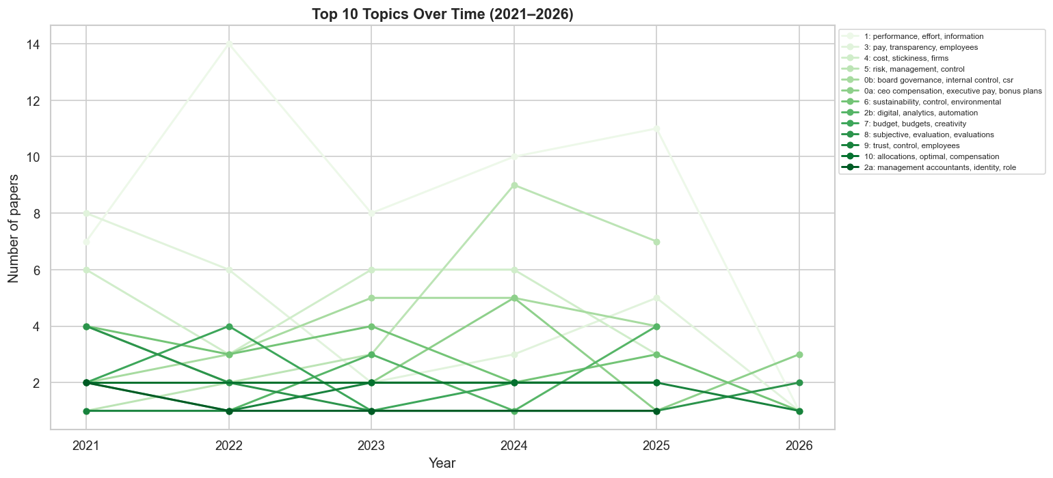
Note. Own work

Aids Directory
Aid | Usage | Affected parts
ChatGPT-5 | Translations and rewordings | Whole paper
Claude Cowork  (version 1.1.8629) | Spelling and grammar check,  wording optimisation and  check for logical errors | Introduction
Claude Code | Code debugging | Juypter Notebooks (GitHub [soerenssch], n.d.)
DeepL | Translations | Whole paper
Grammarly | Grammar check, spelling & rewording | Whole paper

Declaration of Authorship
We hereby declare,
- that we have written this thesis independently,
- that we have written the thesis using only the aids specified in the index;
- that all parts of the thesis produced with the help of aids have been declared;
- that we have handled both input and output responsibly when using AI. We confirm that we have therefore only read in public data or data released with consent and that we have checked, declared and comprehensibly referenced all results and/or other forms of AI assistance in the required form and that we are aware that we are responsible if incorrect content, violations of data protection law, copyright law or scientific misconduct (e.g. plagiarism) have also occurred unintentionally;
- that we have mentioned all sources used and cited them correctly according to established academic citation rules;
- that we have acquired all immaterial rights to any materials we may have used, such as images or graphics, or that these materials were created by us;
- that the topic, the thesis or parts of it have not already been the object of any work or examination of another course, unless this has been expressly agreed with the faculty member in advance and is stated as such in the thesis;
- that we are aware of the legal provisions regarding the publication and dissemination of parts or the entire thesis and that we comply with them accordingly;
- that we are aware that our thesis can be electronically checked for plagiarism and for third-party authorship of human or technical origin and that we hereby grant the University of St.Gallen the copyright according to the Examination Regulations as far as it is necessary for the administrative actions;
- that we are aware that the University will prosecute a violation of this Declaration of Authorship and that disciplinary as well as criminal consequences may result, which may lead to expulsion from the University or to the withdrawal of my title.
By submitting this thesis, we confirm through our conclusive action that we are submitting the Declaration of Authorship, that we have read and understood it, and that it is true.
St. Gallen, 20.04.2026

Amir Sheikh-Manzoor | Lucas Bank | Max Steiner | Nikolas Huber | Sören Schlißke
 |  |  |  | 

Remark on the format: Figures and tables that enhance the flow of the text are included in the main body of the paper; the remaining figures and tables are included in the appendix.

