

**Adama Science And Technology University**

**Department Of Computer Science And Engineering**

**Information Storage And Retrival Assignment**

**NAME**

1)Sofoniyas Kedir UGR/25339/14

**Section: 4**

**Submitted to: Mis.Melkamu**

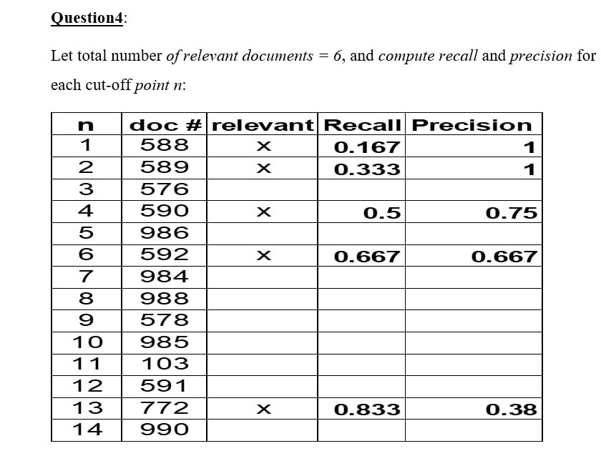

Answer:-

