

**SOFTWARE ARCHITECTURE – SSE4350**

UML Assignment

SOFEA EZZATY BINTI MOHD KHUSRI

207084

**Selected System : Online shopping system**

1. **Package diagram**

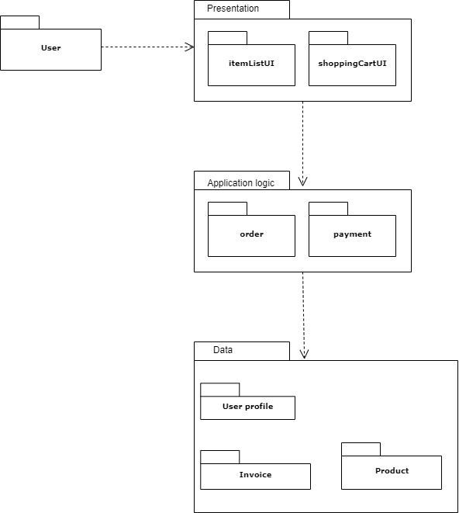

1. **Deployment Diagram**

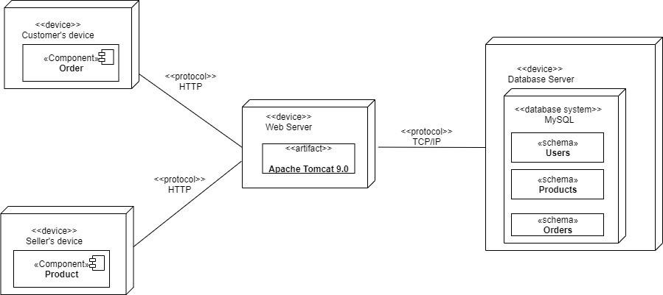

In a online shopping system, these 3 quality attributes is important:

**Security :** All payments must be secured and confident to be used as a buyer.**Usability:** Easy to use, not fancy but I can find the product easily and purchase it.

**Availability:** No too much server down experiences, available 24 hours for user to make purchase.

Therefore,

**Architecture styles applies**: **3-tier architecture.**

which is the **presentation layer**, **business logic layer, data layer**

Each tier is separated, therefore if one of them experienced failure, the others would remain available. This architecture also provides enhanced security as 3 tiers which is presentation tier, logic tier and data tier could not communicate directly. User interface is separated so that it is easy to develop a high usable interface for the users