MINISTRY OF EDUCATION AND SCIENCE OF UKRAINE

NATIONAL TECHNICAL UNIVERSITY

“KHARKIV POLYTECHNIC INSTITUTE”

DEPARTMENT OF SOFTWARE ENGINEERING AND MANAGEMENT INFORMATION TECHNOLOGIES”

Report of laboratory work № 3

Discipline «Software Engineering»

Executed by: Student of group KN-224b.e

Khyzhnychenko S.

Checked by: Associate professor

Melnyk K.V.

Kharkiv

2024

**Theme**: GitHub usage

**Work objective**: Create a repository for the code from previous laboratory work.

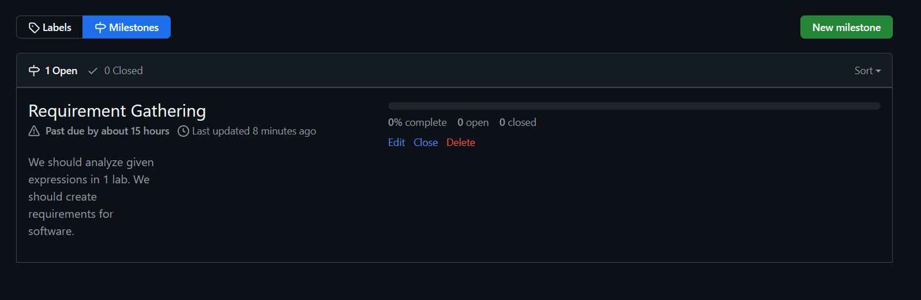

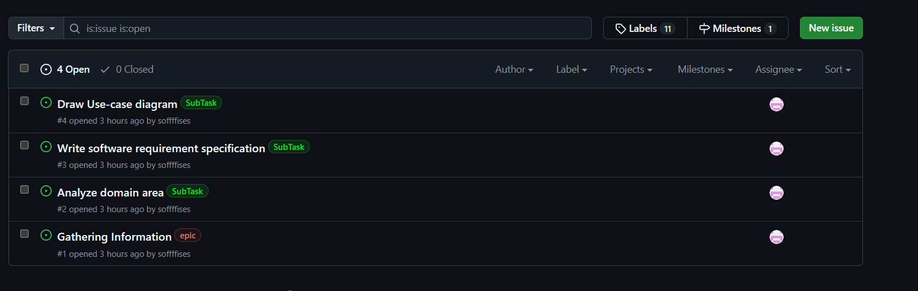

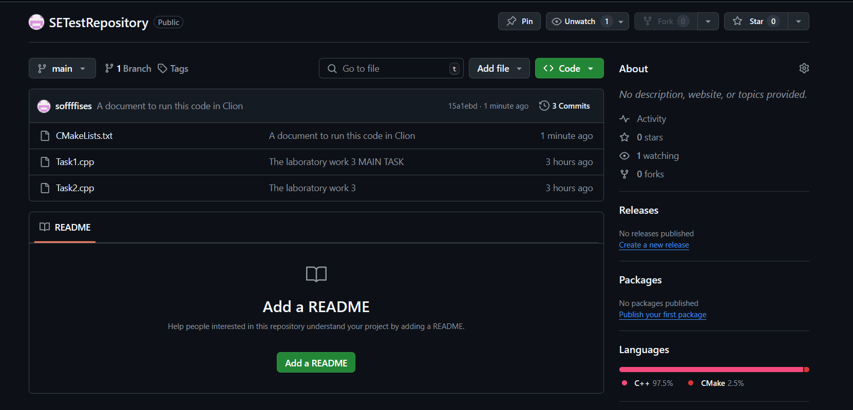

**Summary**: As a result of the implementation of this plan, the basic skills of working with the project tracking system, in particular on the GitHub platform, were obtained. Successfully created a GitHub account, a repository, added a user as a contributor, and developed and assigned key tasks through the Milestones and Issues system. With the help of these tools, the process of teamwork and project organization was worked out. Working with the Git repository made it possible to get acquainted with the basic operations for code version control. At the end, a report was prepared reflecting the results of the completed tasks and the experience gained**.**