Ficheiro:Pporto.png – Wikipédia, a enciclopédia livre

Academic Year 2021/2022

Master’s Degree in Informatics Engineering

Specialization in Graphic Systems and Multimedia

1st Year – 2nd Semester

SERIOUS GAMES

**ASSIGNMENT 1.8.**

Random Tic-Tac-Toe with Unity

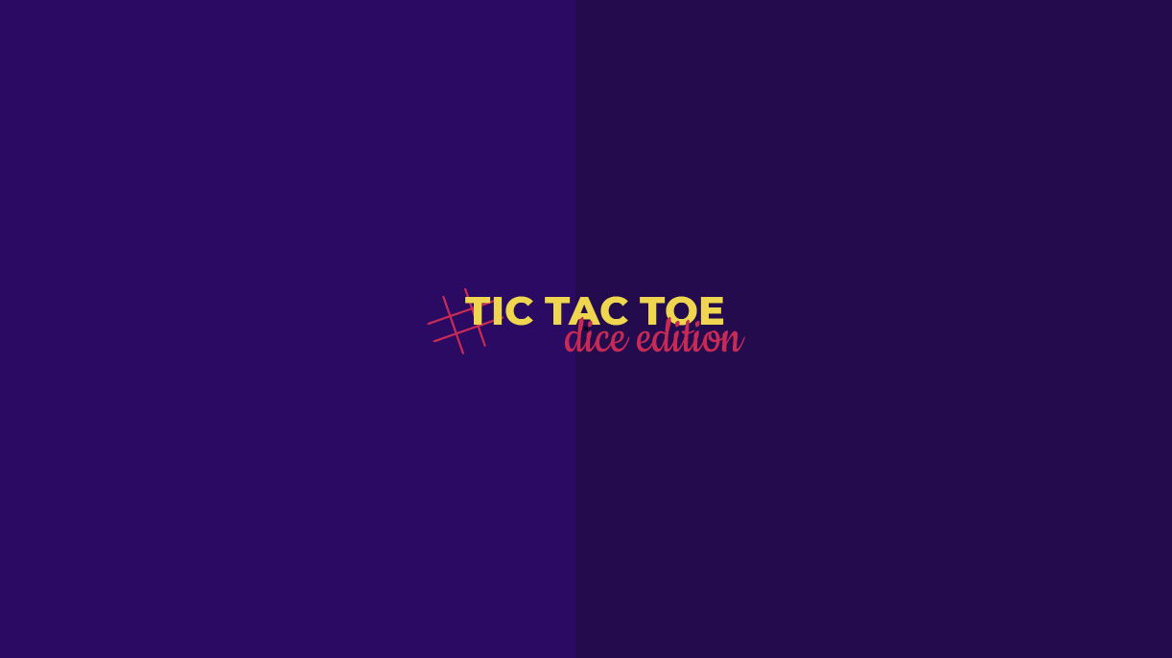

**AUTHORS**

Francisco Dias | [1180615@isep.ipp.pt](mailto:1180615@isep.ipp.pt)

Sofia Canelas | [1200185@isep.ipp.pt](mailto:1200185@isep.ipp.pt)

**ORIENTATION**

Professor Carlos M. Carvalho | [cmc@isep.ipp.pt](mailto:cmc@isep.ipp.pt)

**Setup**

To play “Tic Tac Toe – Dice Edition” each player must roll one dice and the player with the highest number gets a turn in the tic tac toe. In case of tie, the players must roll their dices again until one player gets a higher number. To play the tic tac toe, there must be drawn a grid with 9 squares, as shown in the picture below:

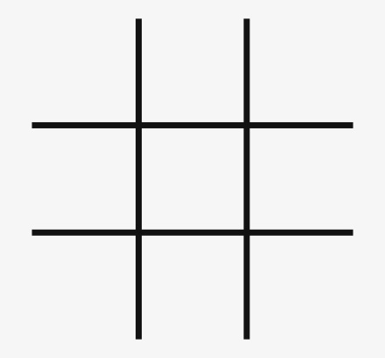

**Victory**

The first player to get 3 of his marks in a row (up, down, across, or diagonally) is the winner.

**Progression of Play**

This game is a turn based multiplayer game that must be played with 2 players only.

The game must start with one player, chosen randomly, and then proceed in turns. After rolling the dices, the chosen player should put his mark - X or O - in one of the empty squares. When all 9 squares are full, the game is over and should be restarted, as it is a tie.